LIGO Laboratory / LIGO Scientific Collaboration

LIGO- T2600067-v1 Cosmic Explorer (CE) 1 Mar 2026

LIGO Beam Tube
Dynamic Analysis
LIGO Laboratory
Dennis Coyne

Distribution of this document:
LIGO Scientific Collaboration

This is an internal working note
of the LIGO Laboratory.

California Institute of Technology  LIGO Project | Massachusetts Institute of Technology  LIGO Project
LIGO Hanford Observatory | LIGO Livingston Observatory
http://www.ligo.caltech.edu/

Table of Contents
1 Introduction 3
2 Beamtube slab compliance 3
3 Expansion joint spring rates 3
3.1 EJMA guidance regarding axial spring rate 4
3.2 LIGO Bellows Spring Rate Measurements 7
4 Fixed Support Stiffness 8
4.1 Fixed Support 9
4.2 Beam Tube Anchors 10
4.2.1 Expansion Anchor Pre-load & Strength 10
4.2.2 Expansion Anchor Stiffness 12
5 Effect of pre-load and baseplate stiffness on beam tube support compliance 14
6 Simple mass-spring model 14

List of Figures
Figure 1 Beam Tube Slab 3
Figure 2 General Curve of Bellows Force vs Deflection (Figure 4.12 of EJMA Standards, 10th edition) 5
Figure 3 FEA calculation of axial spring rate 7

List of Tables
Table 1 Comparison of calculations of the theoretical, initial, elastic, axial spring rate 6

Introduction
Reference Robert Scofield’s measurements and Fabrice Matichard’s analysis and the discrepancy..

Beamtube slab compliance
The boundary conditions for the finite element model in LIGO-T1400698 was for the bases (bottom faces) of the Fixed Support and Guided Support to the clamped (fixed). These bases are in fact bolted to the cement slab which rests upon the ground.
The beam tube supports are anchored with 8 Hilti expansion anchors (Hilti KB II 5/8-6 carbon steel, zinc plated) with 4 inch embedment into the concrete slab (Figure 1).
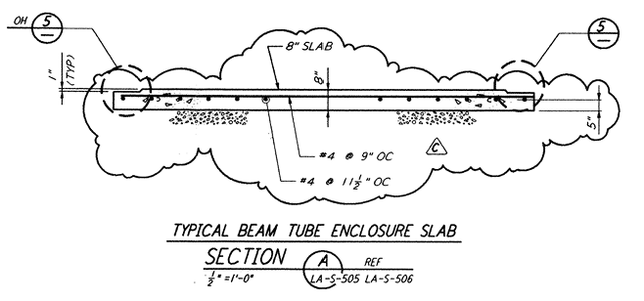  LIGO-D961240-C | 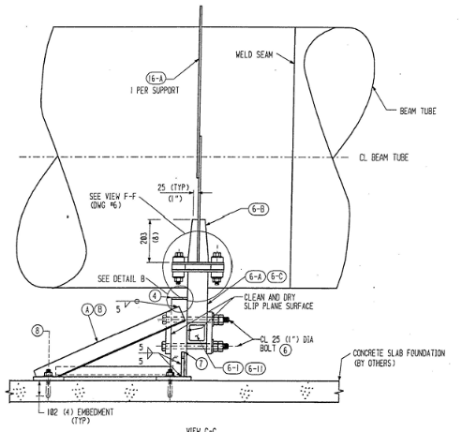  LIGO-D950037-10-B
Figure 1 Beam Tube Slab
Hilti product literature gives the pull-out and shear strength of these fasteners in concrete (cracked or uncracked). The stiffness of these connections to the concrete slab …
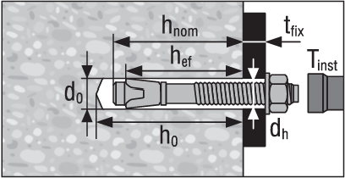 | h_{ef} = 4 in (102 mm)  d_{h} = 5/8 in (15.875 mm)

Expansion joint spring rates
EJMA.

EJMA guidance regarding axial spring rate
The guidelines from the Expansion Joint Manufacturers Association, states that the curve of axial force vs. axial deflection for most bellows extends into the plastic range (as shown by the line with upward facing arrows in Figure 2). The straight portion of this curve (marked “A”) is the initial elastic response, and its slope is the initial (first stroke) elastic spring rate. The initial elastic spring rate value (f_{i}) can be determined analytically with reasonable accuracy from equations based on elastic theory or from a finite element analysis.
When the axial force is released, the curve again becomes linear until the applied force is zero at which point the residual deflection of the bellows still has a positive value. To return the bellows to its initial position, a restoring force must be applied in the opposite direction (as shown by the curve with downward facing arrows in Figure 2).
Lines B and C in Figure 2 represent working spring rates (f_{w}) for bellows with operating deflections in the plastic range. The working spring rate can be considerably lower than the initial elastic spring rate. Line B (drawn from the origin to the point of maximum force and deflection) is used as the bellows working spring rate (f_{w}) but has the disadvantage of underestimating the actual force over the full range. Line C (drawn from the point of maximum force and deflection to the value of the restoring force required to return the bellows to zero deflection) becomes line C' when transferred to the origin. A working spring rate based on line C' can be used. This reduces the discrepancy between the indicated and true values although the difference can still be significant.
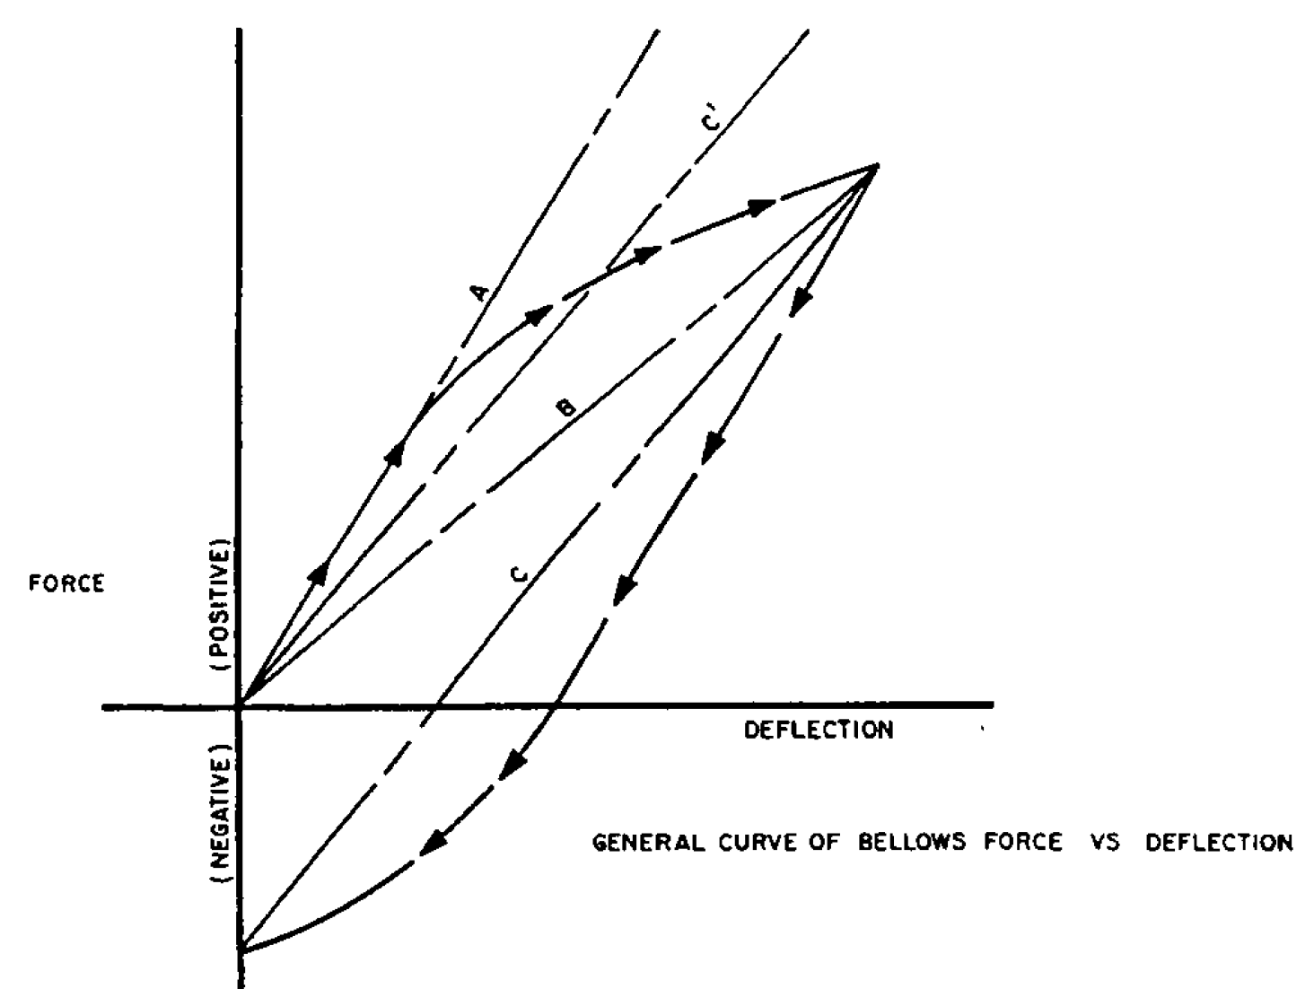
Figure 2 General Curve of Bellows Force vs Deflection
(Figure 4.12 of EJMA Standards, 10th edition)

For an unreinforced, cylindrical expansion joint (bellows), the theoretical initial elastic spring rate per convolution is:
$$f_{iu}=1.7\frac{D_{m}E_{b}t_{p}^{3}n}{w^{3}C_{f}}=10,679\frac{lbf}{in}=(1.87E6\frac{N}{m})$$
where
D_{b} = 1238.25 mm, inside diameter of cylindrical tangent and bellows convolutions
D_{m} = Db+w+n t = 1317.12 mm, mean diameter of bellows convolutions
E_{b} = 200,0 GPa @70F, elastic modulus of the bellows material at design temperature
t = 2.667 mm, bellows nominal material thickness
t_{p} = $t\sqrt{{D_{b}}/{D_{m}}}$ = 2.586 mm, bellows material thickness, corrected for thinning during forming
n = 1, number of bellows material plies
w = 76.2 mm, convolution height
C_{f} = 1.56, Factor used in design calculations to relate U-shaped bellows convolution segment behavior to a simple strip beam (see accompanying excel sheet)
The theoretical, initial, elastic, axial spring rate as calculated from several sources is compared in Table 1. The FEA calculations in LIGO-T1400698 were performed with a shell model as well as a solid model with the same result. Since this result is much different than the EJMA calculations and the FEA performed for this memo, different (likely incorrect) parameters (dimensions or material properties) must have been used for LIGO-T1400698.

Table 1 Comparison of calculations of the theoretical, initial, elastic, axial spring rate
Source | Axial Spring Rate
Source | (lbf/in) | (MN/m)
EJMA calculation (this memo) | 10,679 | 1.87
CBI EJMA calculation (LIGO-E950010-00-B) | 10,202 | 1.77
Ansys FEA (this memo) | 11,670 | 2.04
Ansys FEA (LIGO-T1400698) | 21,127 | 3.7

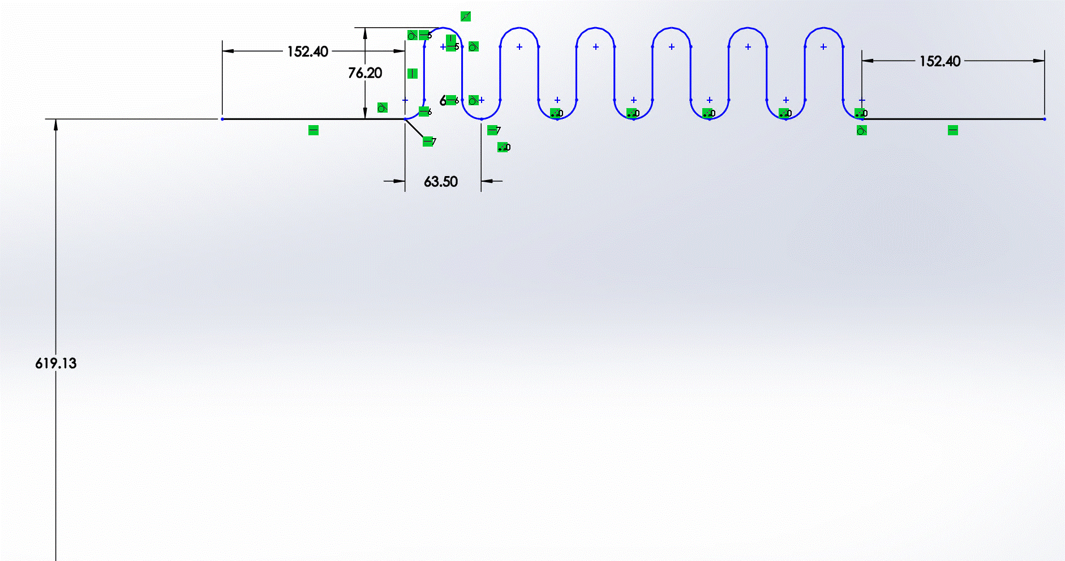
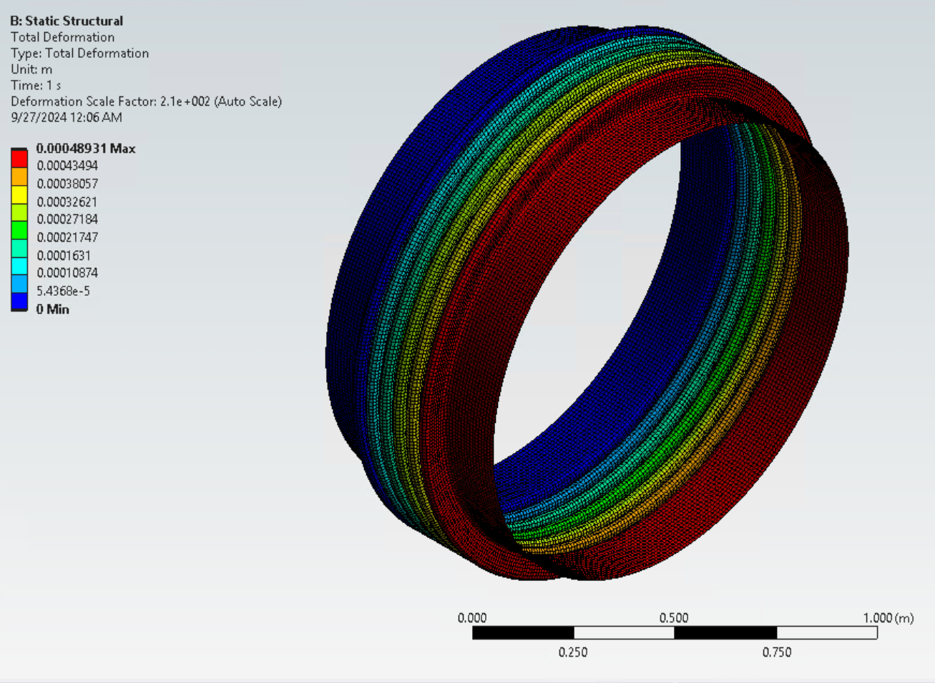 | 48.75 in ID  0.105 in thick  U-shape corrugation  2.5 in pitch  3 in depth  6 corrugations  15 in convolution length
Figure 3 FEA calculation of axial spring rate

The working spring rate (line B) is:
$$f_{w}=\left\{\begin{aligned}f_{i} for S_{t}≤1.5 S_{y} \\ 0.67 f_{i} for S_{t}>1.5 S_{y}\end{aligned}\right.$$
where
S_{t} = total stress range
The total stress range (S_{t}) for the LIGO bake out condition is calculated to be 100,657 psi (694 MPa), as shown in the accompanying Excel workbook. The yield strength for dual rated 304/304L material) is typically ~205 MPa. Consequently, the working spring rate is ~0.67 x 1.8 MN/m = 1.2 MN/m.
$$x=L\left(3±\sqrt{3}\right)/6$$

LIGO Bellows Spring Rate Measurements
Measurements of the spring rates of the first 125 bellows given on pg. 3 of LIGO-L970041. (The total number of bellows required is ~200 per observatory.) These measured spring rates range from 4340 to 5309 lbs/in, or 4824 lbs/in (0.845 MN/m) ± 10%. Unfortunately, I am unable to find spring rate measurements for the balance of the LIGO bellows.
Spring rates for the bellows installed in module HY2 (the module on the Hanford Y-arm spanning from the mid-station to the end station) are given in LIGO-L980509. For the bellows with serial numbers ≤ 125, the spring rates recorded in LIGO-L980509 match those listed in LIGO-L970041. Unfortunately, I am unable to find the serial numbers of the installed bellows in the other LIGO beamtube modules.
The working spring rate calculation in section 3.1 (1.2 MN/m) is still high compared to the measurements (0.845 MN/m ± 10%), but much closer than shown in LIGO-T1400698.

Fixed Support Stiffness
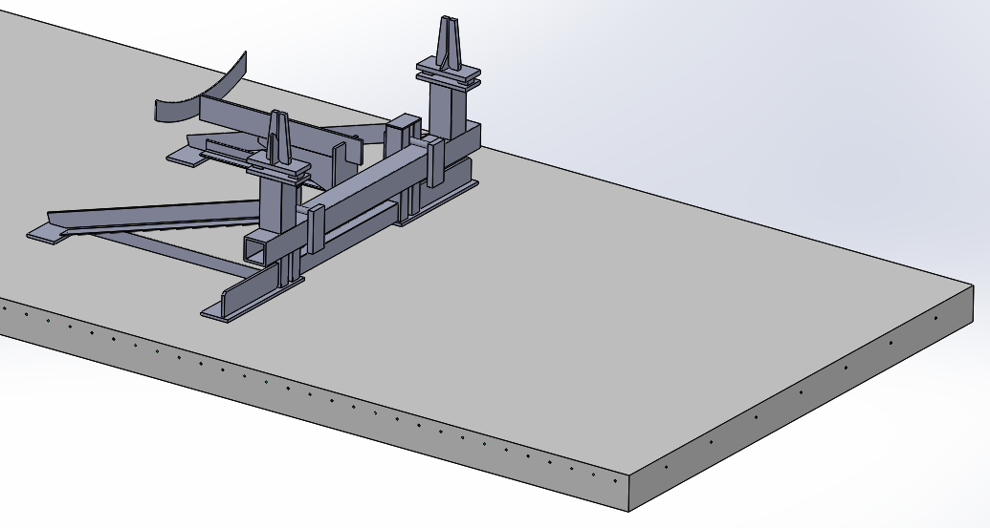

Fixed Support
Model | Response to 1N horizontal force
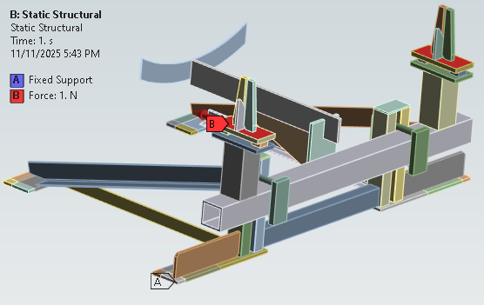  - Fixed base plates | 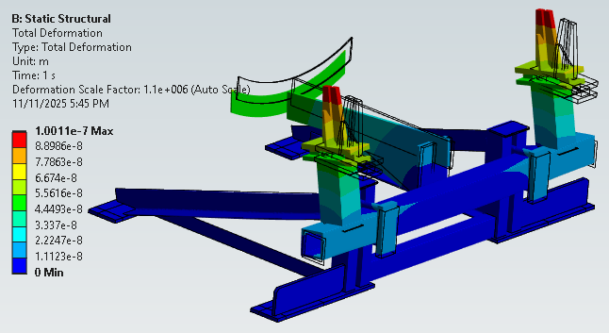  - Effective horizontal spring rate = 1.0E7 N/m
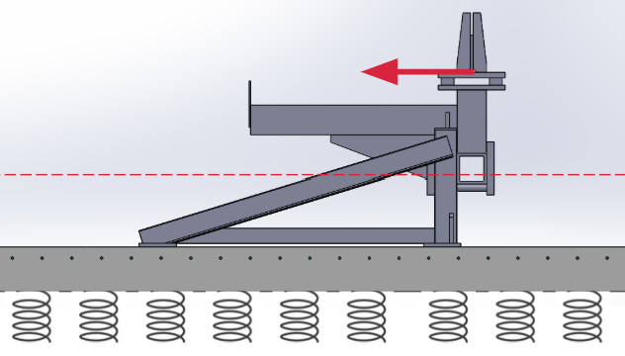  - Reinforced cement slab modeled with transformed section method plus soil modeled as elastic foundation | 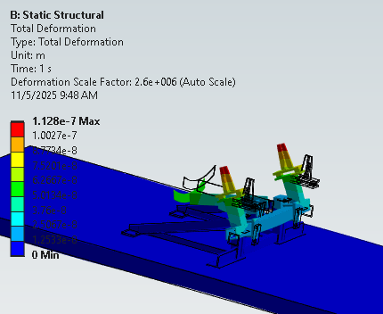  - Effective horizontal spring rate = 8.8E6 N/m
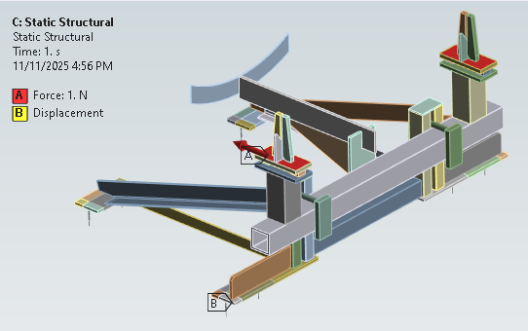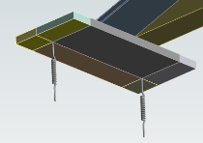  - 8 anchor bolts each modeled as vertical springs with rate 18.9 kN/m (tension & compression) | 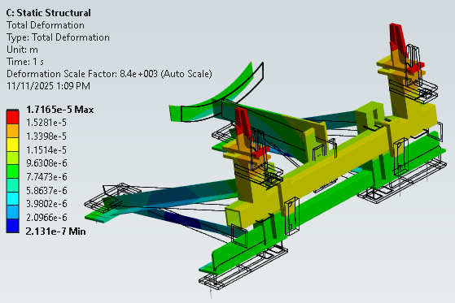  C) Effective horizontal spring rate = 5.83E4 N/m
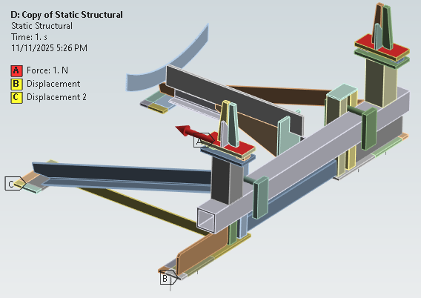  - 4 (forward) anchor bolts modeled as vertical springs with rate 18.9 kN/m (tension)  4 (aft) anchor bolts modeled as pinned connections | 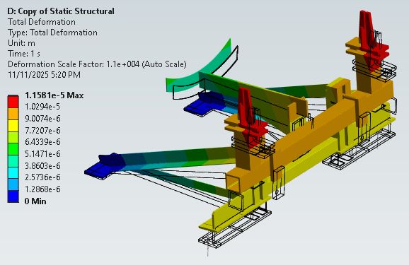  D) Effective horizontal spring rate = 8.63E4 N/m

Beam Tube Anchors
MUCH of the following is redundant with T2500383 - rewrite
The specified anchors for the Fixed Supports are Hilti KB II 58-6 with an embedded depth of 4”. These are 5/8” diameter by 6” long expansion-type anchors introduced by Hilti in the mid 1990s. These anchors pre-date the Hilti Kwik Bolt 3 (introduced ~2010) and Kwik Bolt TZ2 (introduced 2021) anchors.
The specified anchors for the Guided Supports are Hilti HY-l50 l/2" diameter adhesive anchors with an embedment depth of 4.25".

Expansion Anchor Pre-load & Strength
The anchor pre-load which results from the initial torque applied at the time of installation reduces over time to 40% to 50% of the initial pre-load, as indicted in Figure X. Re-torquing the anchor will precipitate a repetition of the relaxation process, but the percentage loss of pre-stress after each torquing is diminished. As far as we are aware re-torquing the BT anchors has never occurred.
Anchors designed for use in cracked concrete, such as the Hilti Kwik Bolt TZ2, are specifically engineered with follow-up expansion to maintain holding force in these conditions. (Older expansion anchors such as the Hilti KB II anchor may not have “follow-up expansion”.)
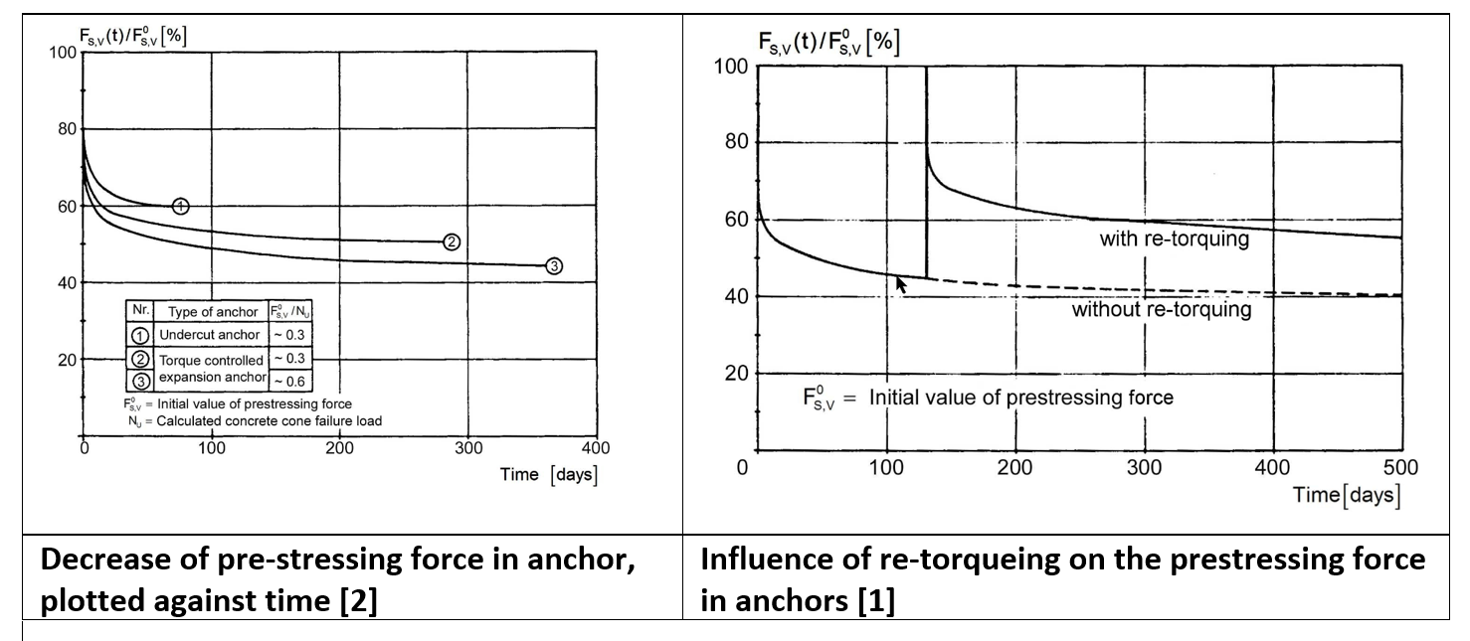
Applying the manufacturer’s specified installation torque expands the anchor's wedges, creating an initial tension pre-load and a compression clamping load between the fixture and the concrete. This pre-load helps to reduce anchor displacement under loading and fatigue under cyclic loads, as well as initially setting the anchors wedge. The CBI documentation does not call out a specific torque value. For example, the installation specification E950049-07-B, Beam Tube Can Section Installation Sequences, dated 7/22/98 (and also C982575) states:
- for Fixed supports, pg. 18, paragraph 4.4, “Install and tighten the nuts on the anchor bolt.” The drawing for the fixed support lug assembly (Pc Mk 8-A or 8-B), D#?, does not give a torque value either.
- Guided supports, pg. 19, paragraph 4.9 calls out Hilti HIT-HY 150 adhesive epoxy. Paragraph 4.10 states “Tighten the bottom nut to anchor the base plate to the concrete.” No torque spec value is given.
Although the CBI documentation does not call out a torque specification (and their procedure for
It is important to apply a proper amount of torque (pre-load) at the time of initial installation so as to expand the wedges and clamp the anchor to the concrete. However, pre-load (torque) is not considered to influence the ultimate strength of the anchor in cracked concrete. The ultimate strength is based on the anchor's performance after the potential loss of pre-load. Anchoring-to-concrete strength design provisions (such as ACI 318 or Hilti documentation) for tension and shear failure modes assume that the initial pre-load or clamping load between the fixture and the concrete has relaxed considerably; In the case of Hilti to 50% of the initial torque value. The design is based on the anchor acting directly on the concrete elements under ultimate load conditions.

Expansion Anchor Stiffness
Axal stiffness of Red Head Trubolt+ wedge anchor (5/8” diameter x 4.25” effective embedment depth in cracked cement) = 20,000 lbf/in (2.3 kN/m).
Axial stiffness of Hilti KB-TZ2 wedge anchor (5/8” diameter x 4” embedment in cracked cement) = 167,367 lbf/in (18.9 kN/m)
Hilti PROFIS Engineering software calculates the stiffness of wedge anchors in concrete as part of its analysis. The software uses stiffness values derived from load-displacement curves obtained from independent laboratory tests to perform its calculations.
In contrast, consider this approximate equation for axial stiffness of cast-in-place anchors:
$$K_{t}=\frac{E_{s}A_{r}}{0.8 n d_{r}+L_{r}}=182 MN/m$$
where
E_{s} = steel elastic modulus = 200 GPa
E_{c} = cement elastic modulus = 21.5 GPa
n = E_{s}/Ec = modular ratio = 9.3
d_{r} = rod diameter = 5/8” = 16 mm
A_{r} = cross-sectional area of the steel rod = 201 mm²
L_{r} = stressed rod length = 4 in. = 102 mm

The CBI Final Design Review Data Package (C1900321), in the file “LIGO_DRD_9_ITEM_2.pdf” (final design review data package, CDRL#15, DRD#9, Item 2, dated April 11, 1994) states that the support lug assemblies transfer all loads from the support frame to the foundation with six 5/8” diameter Hilti expansion anchors with an embedment depth of 2.75”.
Design Review Data Package (C960535, DRD#5, CDRL#26, 3/13/96):
pg. 124: termination support frame uses threaded anchor rods epoxied into holes drilled into the termination foundation.
Pg. 129: termination support anchors are epoxied into the foundation block
Pg. 136, guided support frames are anchored to the slab with epoxied anchors.
D950042-03, guided support drawing dated 3/14/1994: HILTI KB II 58-434
Fabrication/Installation Procedure - Beam Tube Interface with the Beam Tube Slab , E970033-01-B, 2/7/97:
Fixed supports are anchored to the beam tube slab with expansion-type to the anchors in holes drilled into the slab during the installation of the supports. Hilti Kwik Bolt II 5/8" diameter expansion anchors with an embedment depth of 4".
Guided supports are anchored to the beam tube slab with anchor bolts epoxied into drilled holes during the installation of the supports. Hilti HY-l50 l/2" diameter adhesive anchors with an embedment depth of 4.25".
Fabrication/Installation Procedure - Beam Tube and Termination Support, E970025-02-B, 2/7/97:
Each base plate is attached to the foundation block with L6) of the following anchors: Hilti 7/8" Diamter HY-150 Anchors with 7 1/2" Embedment
Each termination support is anchored to the foundation block with (8) of the following anchors: Hilti l" Diameter HY-150 Anchors with 12 3/S" Embedment

Hilti documentation for the Kwik Bolt TZ2 5/8 carbon steel x 4” embedment in 3,000 psi (cracked) concrete:
Torque to 40 ft-lbf (54 Nm)
4,840 lbf (21.5 kN) design tensile strength based on concrete failure modes
10,430 lbf (46.4 kN) design shear strength based on concrete failure modes
13,150 lbf (58.5 kN) design tensile strength based on steel failure
6,665 lbf (29.6 kN) design shear and seismic shear strength based on steel failure
Load adjustment factors for spacing?
Hilti documentation for the Kwik Bolt 3 5/8” diameter carbon steel x 4” embedment in 3,000 psi (cracked) concrete:
Torque to 60 ft-lbf (81 Nm)

Effect of pre-load and baseplate stiffness on beam tube support compliance
TBW Use Professor Slocum’s formulation to properly account for the composite stiffness of the anchor bolts and baseplate.

Simple mass-spring model
TBD

Section 3.3.5 Kwik Bolt TZ2 Expansion Anchor, North American Product Technical Guide, Volume 2: Anchor Fastening, Edition 22, https://productdata.hilti.com/APQ_HC_RAW/ASSET_DOC_LOC_21606451.pdf
Section 4.12.1.7, “Bellows Spring Rate”, Standards of the Expansion Joint Manufacturers Association, Inc., 10th edition, Apr 2019.
This discussion on working spring rate vs initial, elastic spring rate was cited in a letter from CBI, (LIGO-C962923) which cites the EJMA.
Reference 1, equation 4-45.
Hilti, “Torque loss over years”, https://www.hilti.ae/engineering/question/torque-loss-over-years/1df7kd which in turn references the following two sources: [1] Seghezzi (1986): Effects of load history and environment. Manuskript der Vorlesungsreihe Befestigungstechnik und der ETH Zürich, SS 1986, pp.8.1-8.10, not published, in German [2] Burdette,Perry,Runk (1987): Load relaxation tests for anchors on concrete. In: Hasselwander, G.B. (editor): Anchorage to concrete. ACI SP-103, pp. 297-312, American concrete institute, Detroit
Richard Morgan, “How Installation Torque Can Affect Expansion Anchors”, Structure, April 2017, https://www.structuremag.org/article/how-installation-torque-can-affect-expansion-anchors/
Hilti, Mechanical Anchor Installation, https://www.hilti.com.au/engineering/question/mechanical-anchor-installation/dhisiq
https://www.itwredhead.com/portals/0/fmproductcatalog/documents/products/40/trubolttechnicaldata-1.pdf
Hilti, Applicability of The KB-TZ2 Anchor, Aug 2021
Equation (12) of K. Tsavdaridis, et. al., Analytical approach of anchor rod stiffness and steel base plate calculation under tension, Structures, v5 (2016), pp. 207-218.

