LIGO Laboratory / LIGO Scientific Collaboration

LIGO-T2500372-v1 Advanced LIGO 4 November 2025

Fast Digital Servo: Timing Diagrams

Daniel Sigg

Distribution of this document:
LIGO Scientific Collaboration

This is an internal working note
of the LIGO Laboratory.

California Institute of Technology  LIGO Project – MS 18-34  1200 E. California Blvd.  Pasadena, CA 91125  Phone (626) 395-2129  Fax (626) 304-9834  E-mail: info@ligo.caltech.edu | Massachusetts Institute of Technology  LIGO Project – NW22-295  185 Albany St  Cambridge, MA 02139  Phone (617) 253-4824  Fax (617) 253-7014  E-mail: info@ligo.mit.edu
LIGO Hanford Observatory  P.O. Box 1970  Richland WA 99352  Phone 509-372-8106  Fax 509-372-8137 | LIGO Livingston Observatory  P.O. Box 940  Livingston, LA 70754  Phone 225-686-3100  Fax 225-686-7189
http://www.ligo.caltech.edu/

Overview
This document shows proposed timing diagrams to communicate with the converters in the fast digital servo board. The main clock is assumed to be 2²⁸ Hz (or roughly 268 MHz), which is derived from the 2²⁶ Hz timing clock through the help of a PLL.

ADAQ23876 and ADAQ23878 ADCs
These ADCs have an LVDS interface that can be clocked at rates up to 400 MHz. Since we are using two lanes to transfer the data a 134MHz clock frequency is sufficient.
See Figure 1 for the ADAQ23876, and figure 2 for the ADAQ23878.
A full conversion plus readout takes 32 cycles and supports a 2²³ Hz (8.4 MHz) conversion clock.

AD3551R and AD3552R
These DACs have quad SPI interface that can be clocked at rates up to 66 MHz. This is slightly lower than a 2²⁶ Hz (67.1 MHz) clock, which means that we cannot easily support the AD3552R in a non-streaming mode unless we run the interface 1.6% faster than recommended. For the AD3551R we can use 6 clock cycles at 268 MHz for one SPI clock cycle which results in a 44.7 MHz SPI clock.
See Figure 3 for the AD3551R, and figure 4 for the AD3552R.
A full conversion plus readout takes 32 cycles and supports a 2²³ Hz (8.4 MHz) conversion clock when the AD3552R is operated at 67.1 MHz. In principle, it is possible to run these devices in streaming mode that does not require a full address/data cycle but instead keeps sending the data only. This would allow the AD3552R to meet the timing requirements but could result in prolonged invalid data outputs if a SPI cycle is ever missed.

DAC11001B
These DACs have SPI interface that can be clocked at rates up to 50 MHz assuming DV_{DD} is 5V and IOV_{DD} is 3.3V. Since 32 bits need to be transmitted per conversion cycle, we can support a 2²⁰ Hz (1 MHz) sampling clock for the precision DAC.
See Figure 5 for the DAC11001B timing diagram.
We again use 6 clock cycles at 268 MHz for one SPI clock cycle resulting in a 44.7 MHz SPI clock. Since this interface is single lane, without DDR and requires 32-bits per cycle, we can support a 2²⁰ Hz (1 MHz) sampling clock. With a reduced IOV_{DD} at 2.5V or 1.8V we would have to half the sampling clock.

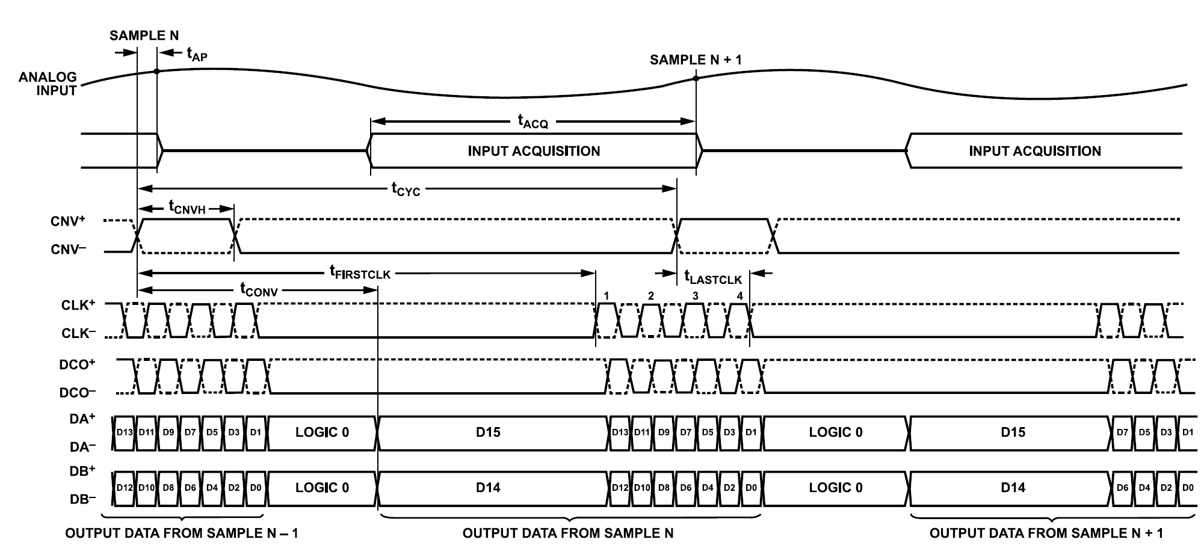
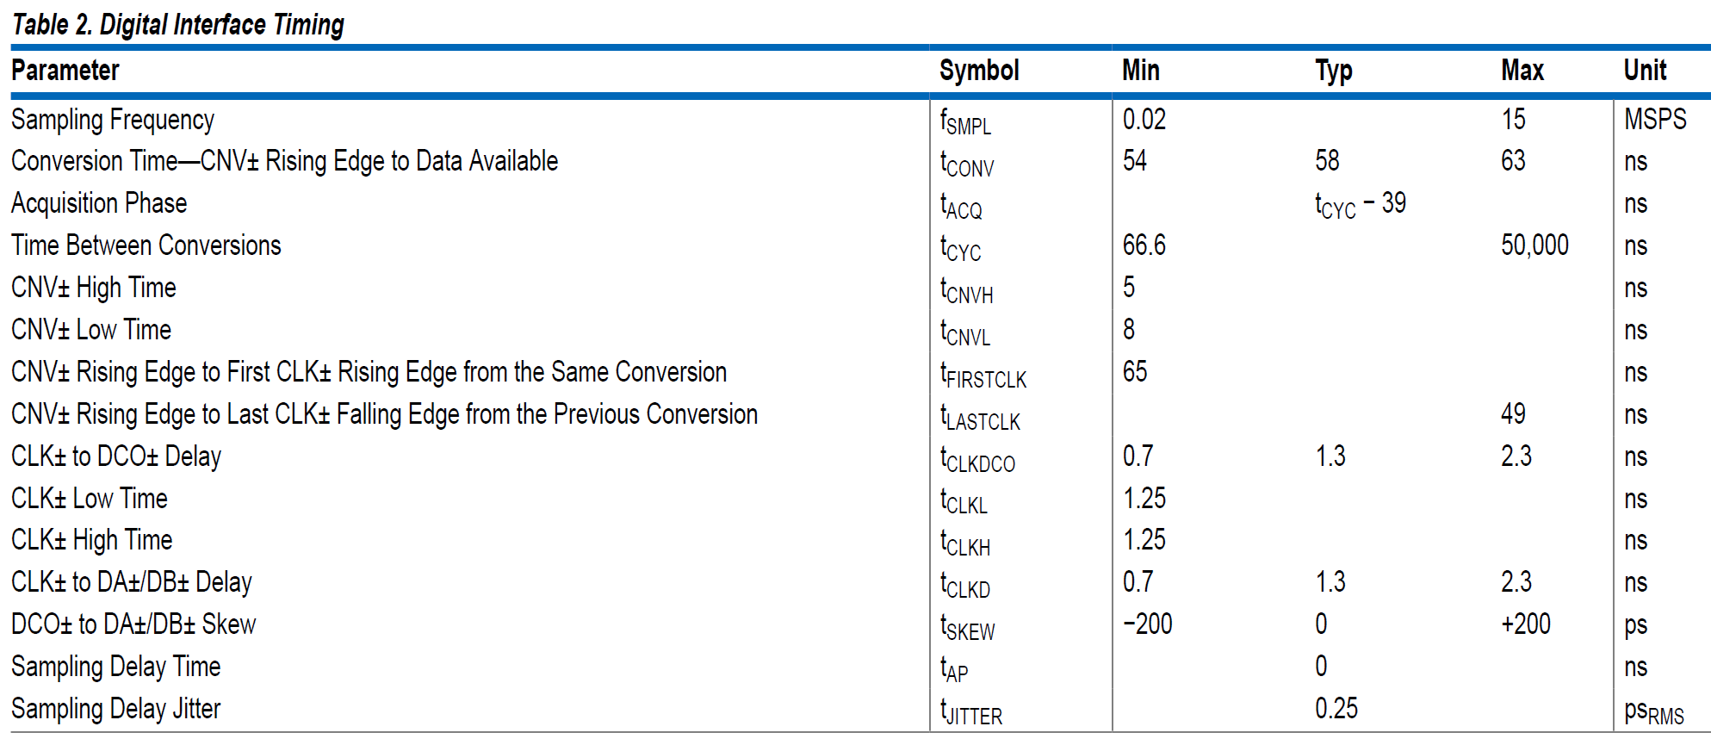
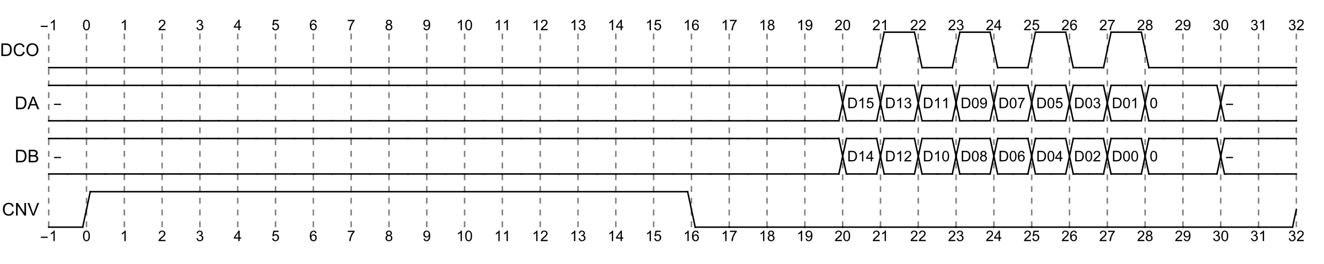
Figure 1: Timing diagram from the ADAQ23876 data sheet (top), timing requirements (middle) and proposed FPGA timing.

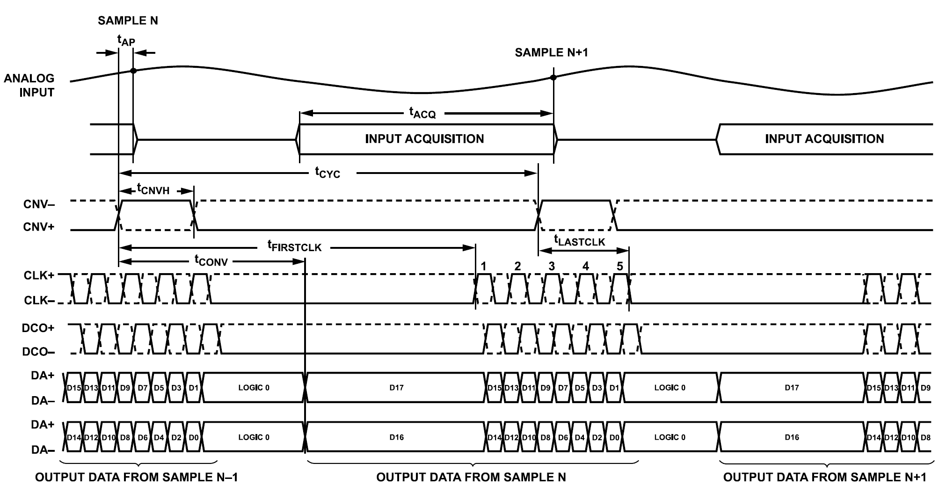
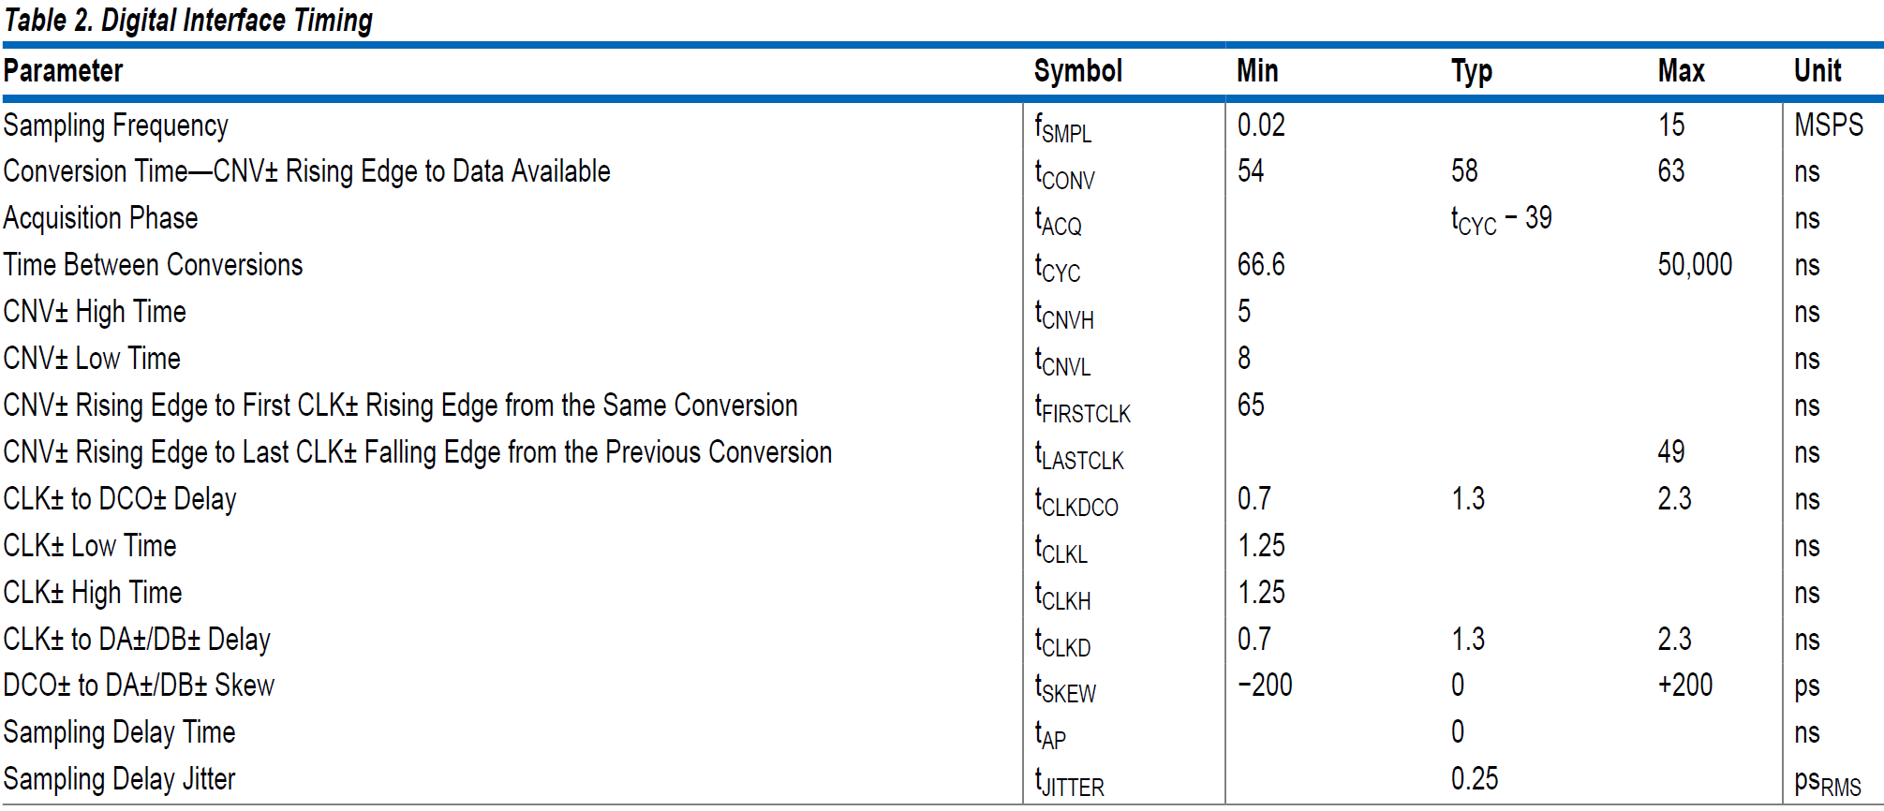
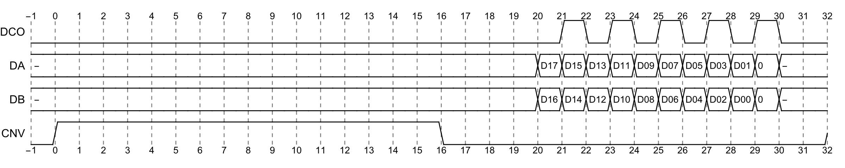
Figure 2: Timing diagram from the ADAQ23878 data sheet (top), timing requirements (middle) and proposed FPGA timing.

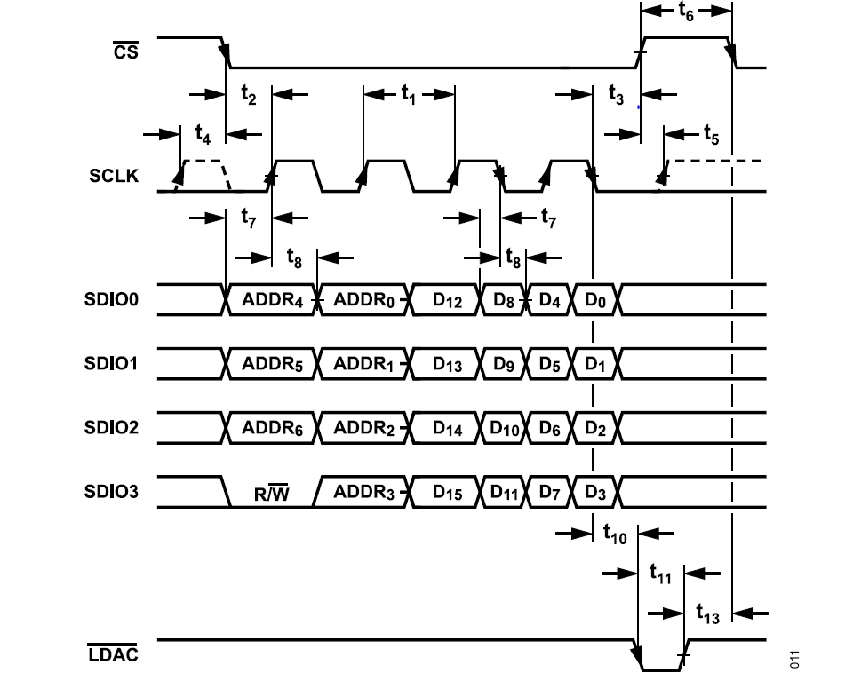
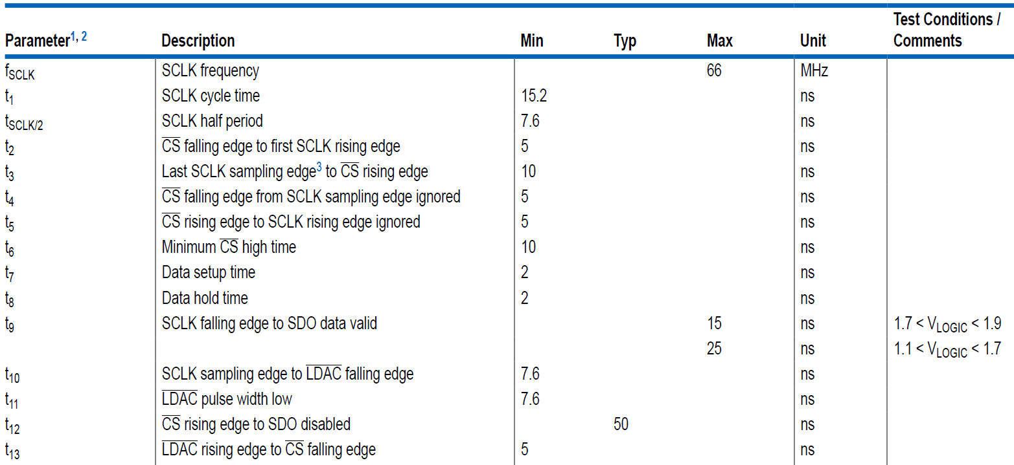
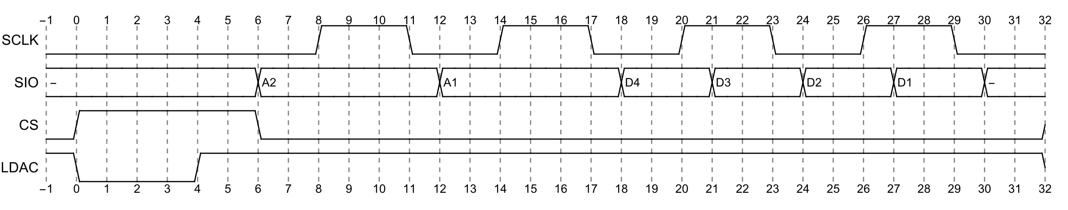
Figure 3: Timing diagram from the AD3551R data sheet (top), timing requirements (middle) and proposed FPGA timing.

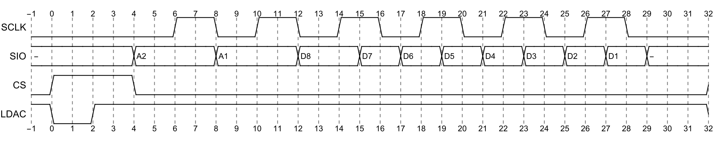
Figure 4: Timing diagram from the AD3552R data sheet (top), timing requirements (middle) and proposed FPGA timing. Notice the slight timing violation.

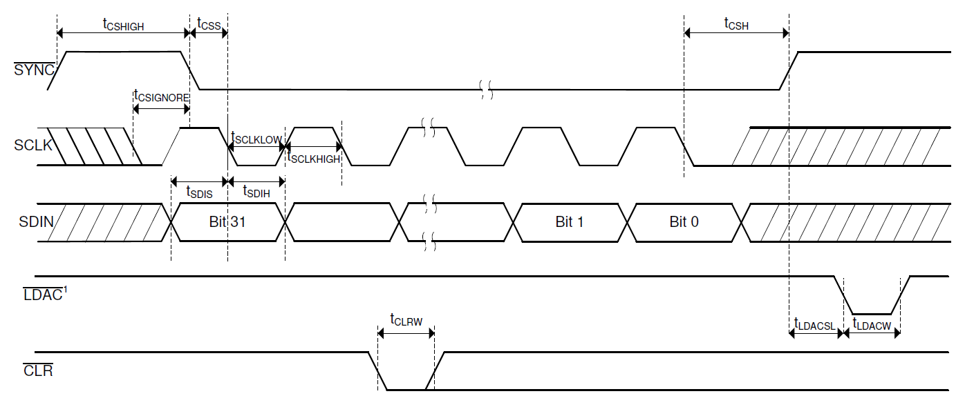
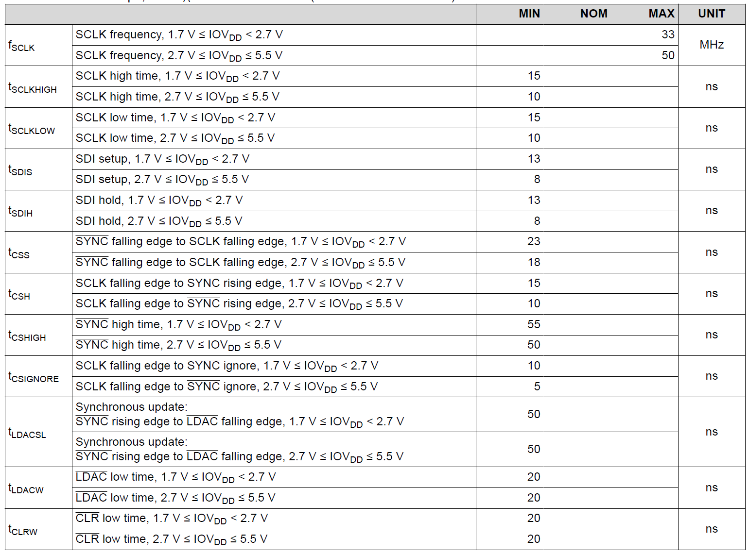
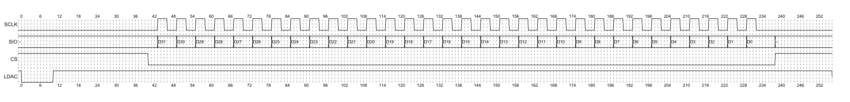
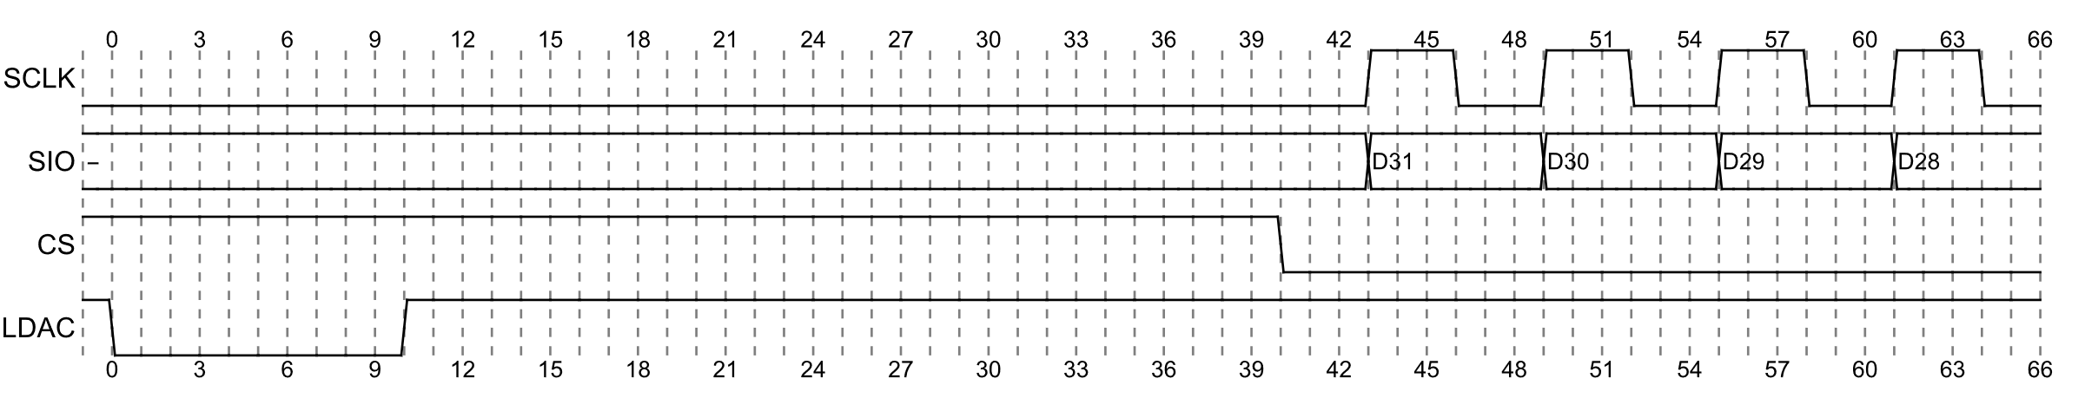
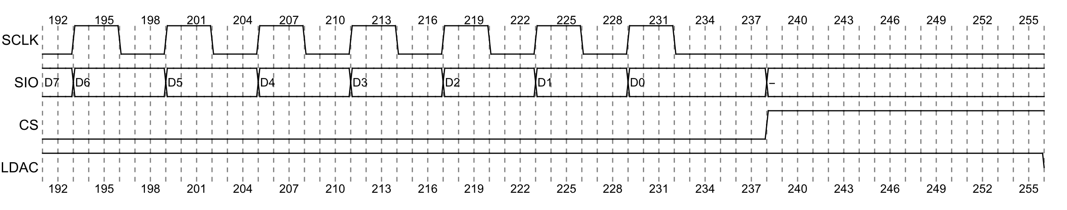
Figure 5: Timing diagram from the DAC11001B data sheet (top), timing requirements (second) and proposed FPGA timing (full acquisition cycle, zoomed in at start of acquisition cycle and end of acquisition cycle).

