Application for the release of multicomponent seismometer datasets from LLO and LHO sites

Babatunde Isaac Rotimi, Joshua B Russell
January 4, 2025

Site characterization and microzonation greatly benefit from the horizontal-to-vertical spectral ratios of microtremors (HVRM), which are widely used to identify a site's dominant frequency. Traditional interpretations of HVRM suggest it reflects either the Rayleigh-wave ellipticity (e.g., Horike, 1980; Lermo and Chávez-García, 1994; Satoh et al., 2001; Malischewsky and Scherbaum, 2004) or the direct S-wave amplification in horizontally layered structures (e.g., Nakamura, 1989, 2000; Bonnefoy-Claudet et al., 2008; Herat, 2008). While the amplitude of Rayleigh-wave ellipticity in H/V cannot be directly used, the ratio of horizontal to vertical components of surface waves (primarily Rayleigh waves, with contributions from Love waves) has been employed to infer subsurface velocity models and natural frequencies of soil structures. Arai and Tokimatsu (2004) developed a method that incorporates the relative contributions of Rayleigh and Love waves to reproduce the HVRM amplitude, considering site-specific environmental factors. Conversely, HVRM can also indicate direct S-wave amplification, which is simple to implement but highly dependent on-site conditions.

Microtremor, comprising both body and surface waves, is best analyzed using a full-wave approach, such as the diffuse field approximation. This concept, rooted in acoustics and formalized for elasticity by Weaver (1982), has origins in Aki's seminal 1957 work employing ambient seismic noise (ASN) in the spatial autocorrelation (SPAC) method. The diffuse field approximation allows the recovery of Rayleigh wave phase velocity from the short-range cross-correlations of noise in small arrays and their azimuthal averages. ASN provides practical applications for Green’s function recovery via cross-correlations of motions recorded in a diffuse seismic field (e.g., Shapiro et al., 2005; Sabra et al., 2005). The diffuse field assumption has been extensively studied (e.g., Weaver and Lobkis, 2001; Sánchez-Sesma and Campillo, 2006; Sánchez-Sesma et al., 2008) and is associated with conditions such as multiple scattering and earthquake coda waves (e.g., Shapiro et al., 2000; Hennino et al., 2001; Margerin, 2009). Despite critiques (e.g., Mulargia, 2012), ASN exhibits significant imaging capabilities. Under the diffuse field assumption, when the source and receiver coincide in position and direction, the directional energy density becomes proportional to the Green’s function's imaginary part (Sánchez-Sesma et al., 2008). This robust theoretical framework underpins the use of microtremor HVSR for estimating the fundamental frequencies of subsurface structures.
While there is a standardized approach for estimating a site’s fundamental frequencies, variations in energy densities over time, arising from sensor malfunctions or near-field anthropogenic sources are not always captured effectively. These variations can lead to inconsistencies in the estimated predominant site frequency. We earlier introduced an algorithm to improve stability of the amplification factor estimation of the HVSR method by recalculating computed HVSR under the diffuse field assumption to access discrepancies in predominant frequency estimation. We applied this algorithm to the LIGO Livingston and Hanford station datasets to investigate variations in the fundamental frequencies of both stations throughout the year and found some exciting variations.

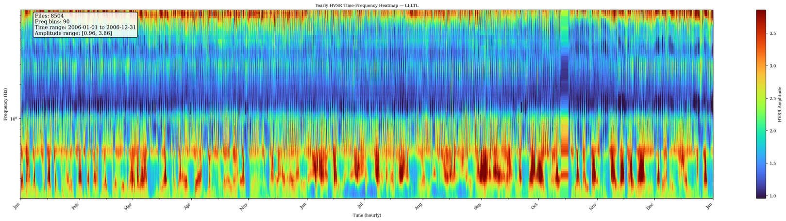
Figure 1 showing the monthly computed HVSR amplitude variations for LIGO Livingston. Highest amplitudes are concentrated at the lower frequencies with higher amplitudes in September to October in the primary microseism range (0.1-0.3Hz). There are also visible weekly and daily variations which can be linked to human and cultural noises around the area.

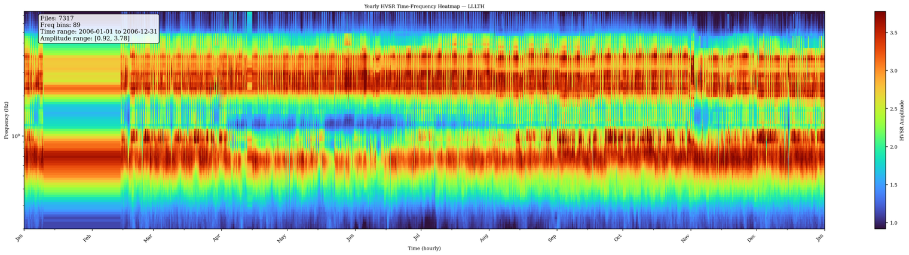
Figure 2 showing monthly computed HVSR amplitude variations for LIGO Hanford. High amplitudes are concentrated both at low frequencies and in the mid–high frequency range (~2–5 Hz and above). In the low-frequency band, the strongest enhancements occur in winter (Dec–Feb) within the primary microseism band (0.1–0.3 Hz), consistent with North Pacific storm activity, with the secondary microseism (0.3–0.6 Hz) also intensifying during this period. In addition, a broad and persistent band of elevated amplitudes is visible at mid–high frequencies, suggesting contributions from local site resonance, continuous anthropogenic sources, or environmental forcing (e.g., wind, infrastructure vibrations). Hanford shows a combination of seasonal low-frequency variability and sustained high-frequency energy, distinguishing it from Livingston, which is more strongly dominated by cultural noise and regional storm bursts.

Sequel to these two observations, we are requesting full seismic datasets within the LIGO arms at all axes during the 04 observing run, so we can process these datasets using the same approach to study and compare the variations between stations inside the observatories and those installed outside the observatories. We are broadly interested in the effect of seasonal variations and noise from anthropogenic sources, and how these affect the efficiency of the observatories (mirror?). The requested channels are in the form;
For LHO
H1:PEM-EY_SEIS_VEA_FLOOR_(X,Y,Z)_DQ 256

H1:PEM-CS_SEIS_LVEA_VERTEX_(X,Y,Z)_DQ 256

H1:PEM-EX_SEIS_VEA_FLOOR_(X,Y,Z)_DQ 256

H1:PEM-VAULT_SEIS_1030X195Y_STS2_(X,Y,Z)_DQ 256

H1:PEM-MX_SEIS_VEA_FLOOR_X_DQ 256

H1:PEM-MX_SEIS_VEA_FLOOR_Y_DQ 256

H1:PEM-MX_SEIS_VEA_FLOOR_Z_DQ 256

H1:PEM-MY_SEIS_VEA_FLOOR_X_DQ 256

H1:PEM-MY_SEIS_VEA_FLOOR_Y_DQ 256

H1:PEM-MY_SEIS_VEA_FLOOR_Z_DQ 256

For LLO

L1:PEM-EY_SEIS_VEA_FLOOR_Z (X,Y,Z) 256

L1:PEM-CS_SEIS_LVEA_VERTEX_Z (X,Y,Z) 256

L1:PEM-EX_SEIS_VEA_FLOOR_Z (X,Y,Z) 256

We hope that by processing and analyzing these datasets, It will help inform the site selection process for the cosmic explorer.

References:
Horike, M. (1980). Estimation of phase-velocity and transfer-function of microtremor, Zisin 2 33, no. 4, 425–442 (in Japanese with English abstract).
Lachet, C., D. Hatzfeld, P.-Y. Bard, N. Theodoulidis, C. Papaioannou, and Savvaidis (1996). Site effects and microzonation in the city of Thessaloniki (Greece): Comparison of different approaches, Bull. Seismol. Soc. Am. 86, no. 6, 1692–1703.
Lermo, J., and F. J. Chávez-García (1994). Are microtremors useful in site response evaluation? Bull. Seismol. Soc. Am. 84, no. 51350–1364.
Malischewsky, P. G., and F. Scherbaum (2004). Love’s formula and H/Vratio (ellipticity) of Rayleigh waves, Wave Motion 40, no. 1, 57–67.
Margerin, L., M. Campillo, B. A. van Tiggelen, and R. Hennino (2009). Energy partition of seismic coda waves in layered media: Theory and application to Pinyon Flats observatory, Geophys. J. Int. 177, 571–585.
Matsushima, S., T. Hirokawa, F. Nagashima, Y. Nitta, F. J. Sánchez-Sesma, and H. Kawase (2011). Microtremor measurements in Mexico Basin and verification of the velocity structure using H/V spectral ratio, Annu. Disast. Prev. Res. Inst., Kyoto Univ. 54B, 23–28 (in Japanese with English abstract).
Nakamura, Y. (1989). A method for dynamic characteristics estimation of subsurface using microtremor on the ground surface, Q. Rep. Railway Tech. Res. Inst. 30, no. 1, 25–30.
Nakamura, Y. (2000). Clear identification of fundamental idea of Nakamura’s technique and its applications, in Proc. 12th World Conf. Earthquake Eng., Auckland, New Zealand, Paper Number 2656 (available on CD-ROM).
Perton, M., F. J. Sánchez-Sesma, A. Rodríguez-Castellanos, M. Campillo, and R. L. Weaver (2009). Two perspectives on equipartition in diffuse elastic fields in three dimensions, J. Acoust. Soc. Am. 126, no. 3, 1125–1130.
Prieto, G. A., and G. C. Beroza (2008). Earthquake ground motion prediction using the ambient seismic field, Geophys. Res. Lett. 35, no. 14, L14304, doi: 10.1029/2008GL034428.
Shapiro, N. M., and M. Campillo (2004). Emergence of broadband Rayleigh waves from correlations of the ambient seismic noise, Geophys. Res. Lett. 31, no. 7, L07614, doi: 10.1029/2004GL019491.
Snieder, R., Y. Fan, E. Slob, and K.Wapenaar (2010). Equipartitioning is not sufficient for Green’s function extraction, Earthq. Sci. 23, 403–415, doi: 10.1007/s11589-010-0739-1.
Stehly, L., M. Campillo, B. Froment, and R. L.Weaver (2008), Reconstructing Green’s function by correlation of the coda of the correlation (C3) of ambient seismic noise, J. Geophys. Res. 113, no. B11, B11306, doi: 10.1029/2008JB005693.

