|  |  |
| --- | --- |
| *Title* | *Vacuum Cleaning of Photodiodes* |
| *Author* | *R. Abbott, Caltech* |
| *Date* | *16 August 2022* |

# Overview

Various types of commercial photodiodes are commonly used within the LIGO vacuum volume. These types of diodes are typically housed within a hermetically sealed metal can with a brazed glass window. Glass seals are used to insulate the leads as they penetrate the envelope of the hermetic can.

It is necessary to clean and prepare these devices to render them acceptable for use within the LIGO vacuum volume. In broad terms, there are several steps involved in processing photodiodes as seen in the summary outline below. Each step is further expanded in the procedures that follows.

* Initial electrical characterization (diode leakage current and forward barrier voltage at specific temperature)
* Part serial numbers or identifying markings
* Removal of ink or markings (eraser or solvents)
* Rendering the device electrically safe for processing
* Exterior cleaning (solvent, methods)
* Air drying
* Venting or glass window removal
* Vacuum baking (temperature, duration)
* RGA and analysis
* Final electrical characterization

# Product Images

Shown below are some typical images of photodiodes used within the LIGO vacuum volume.

Figure OSI Optoelectronics

Q3000 in a TO8 package

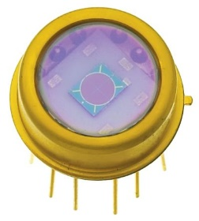

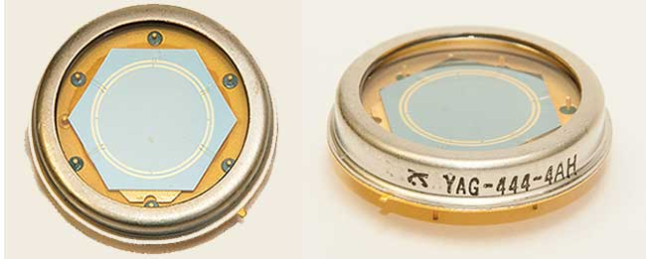

Figure Excelitas YAG-444-4AH in a TO36 package

Figure Excelitas C30642GH in a TO18 package

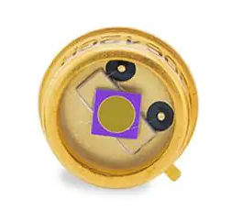

# Procedure

## **Initial Electrical Characterization –** Prior to any processing, it is good practice to verify that the photodiodes are electrically performing as expected. In some cases, this may require assignment of a serial number as detailed in the next step.

## **Part Serial Numbers or Identifying Markings –** It may be necessary to uniquely identify photodiode parts such that they can be associated with specific testing results. If this is the case, engrave the parts with a serial number on the underside of the can (where the leads stick out). Scratching or engraving are the only options available at this time as any type of ink is not compatible with vacuum service.

## **Removal of Ink or Markings –** Most devices are marked with a part number. Some devices may also have a serial number. If the photodiode has an inked marking, it should be removed. If the part is laser etched, removal is not necessary, although it may be difficult to ascertain which marking method was used. Methanol, IPA, and Acetone can be tried to remove ink-based markings. A pen eraser can also be used to abrade the ink and aid mechanical removal.

## **Rendering the Device Electrically Safe –** Photodiodes can be damaged by inadvertent electrostatic discharge (ESD). When possible, during handling and processing, poke the leads of the photodiodes through aluminum foil to short the leads together. IPA is electrically conductive, so any immersion of the part in IPA is intrinsically safer from an ESD standpoint as the electrically conductive liquid maintains the leads at the same electrical potential.

## **Exterior Cleaning (Solvents and Methods) –** The parts can be immersed in IPA for bulk cleaning. Manual agitation is allowed, but ultrasonic cleaning is not permitted due to the fragile glass seals and possible damage to the bond wires and semiconductor die. Once clean, the parts can be wiped down with a lint free cloth. To the extent practical, keep the leads shorted with foil when possible.

## **Air Drying –** Once cleaned, the parts should be air dried to remove any cleaning solution present on the exterior surfaces. 30 minutes on a flow bench is sufficient.

## **Venting or Glass Window Removal –** In all cases, it is standard procedure to poke a vent hole through the sidewall of the metal can. A dedicated tool has been created for this wherein a steel needle is slowly forced through the metal can. Alternatively, the entire glass window can be cut off by use of a photodiode can cutter. This task is done by the electrical engineer responsible for the photodiode and is decided on a case-by-case basis depending on the intended application.

## **Vacuum Baking –** Once again ensure the leads of the photodiodes are safely shorted together. Place into a vacuum oven and bake at 120 C for 48 hours (hold) with a 3-hour ramp up and down for 54 hours total. Do not remove from oven until RGA scan has been approved.

## **RGA Scan and Analysis –** After the oven is cool, perform an RGA analysis and subsequent approval of the cleanliness results. The devices should then be removed from the oven and packaged/labeled for transport as detailed in E960022 for class A/B parts

## **Final Electrical Test –** The parts should undergo a final electrical test in a cleanroom environment to ensure there was no damage during the cleaning process. This task is usually performed by the cognizant electronics engineer.