*LIGO Laboratory / LIGO Scientific Collaboration*

LIGO-T2100411-v1 *LIGO* 10/6/21

Upgrade Procedure for IO Chassis V4 to V5

Marc Pirello, Daniel Sigg

Distribution of this document:

LIGO Scientific Collaboration

This is an internal working note

of the LIGO Laboratory.

|  |  |
| --- | --- |
| **California Institute of Technology**  **LIGO Project – MS 18-34**  **1200 E. California Blvd.**  **Pasadena, CA 91125**  Phone (626) 395-2129  Fax (626) 304-9834  E-mail: info@ligo.caltech.edu | **Massachusetts Institute of Technology**  **LIGO Project – NW22-295**  **185 Albany St**  **Cambridge, MA 02139**  Phone (617) 253-4824  Fax (617) 253-7014  E-mail: info@ligo.mit.edu |
| **LIGO Hanford Observatory**  **P.O. Box 159**  **Richland WA 99352**  Phone 509-372-8106  Fax 509-372-8137 | **LIGO Livingston Observatory**  **P.O. Box 940**  **Livingston, LA 70754**  Phone 225-686-3100  Fax 225-686-7189 |

http://www.ligo.caltech.edu/

# Introduction

This procedure describes the steps to upgrade your V4 IO Chassis to V5. Tools required are as follows.

* Medium Cross Tip Screw Driver
* Medium Flat Tip Screw Driver
* 8mm Nut Driver
* Wire Stripper
* Snips for cutting zip ties

Parts required are as follows:

* PCIe Timing Interface Card D2000329
* New LVDS Backplane D2000297
* Short ATX Cable for Backplane to Adnaco-4 connection
* New Power Fanout D2100068
* Power Fanout Timing Cable DKY M3CCA-1020K-ND
* Power Fanout Standoffs McMaster Carr PN: 93505A112

# Modify ADNACO’s

Remove link LED’s from each ADNACO. There are 4 link LED’s on each ADNACO, J1-J4 shown in figure 1 between the red tags. Set DIP switches to 1-4 ON and 5-8 OFF for each ADNACO. Remove the 2pin power switch cables from each ADNACO and set aside. Move front LED cable from ADNACO1 to ADNACO2 and route under the new power fanout. Connect to the Power LED section of the ADNACO2.

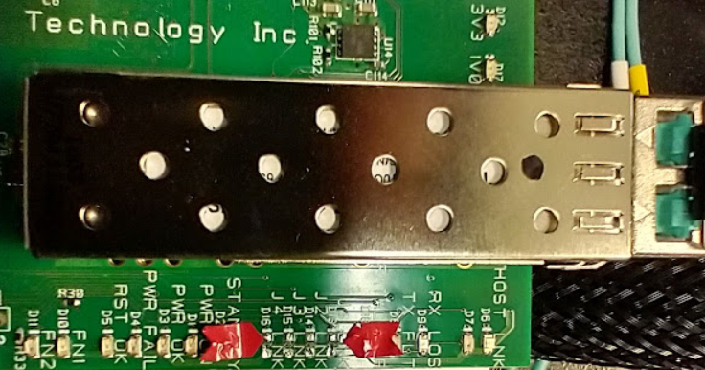

Figure 1 – Removal of Blinking LED’s

# Remove Old Duotone Timing System

Remove the old duotone timing system and all associated cabling. Save duotone system as a spare. There should be one 40 pin IDC cable, one 4 pin molex cable, one 2 pin power cable with screw terminal plugs on both ends (save screw terminals), and four 2 pin connectors used in the old power on system. Reroute the timing fiber under the power fanout

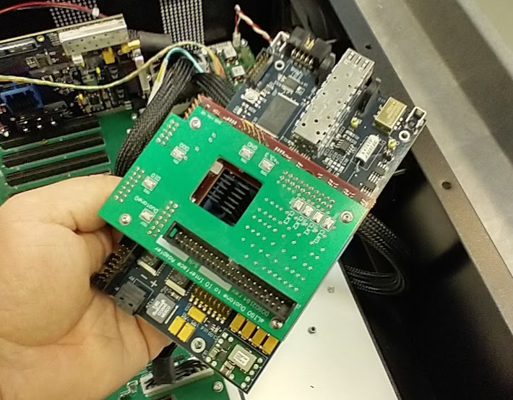

Figure 2 – Removal of Old Duotone

# Replace Backplane

Remove Old Backplane, install the new LVDS Backplane. Flip DB37 cable around. Use short ATX cable to jump power from the left side ATX power connector to the 4th Adnaco.

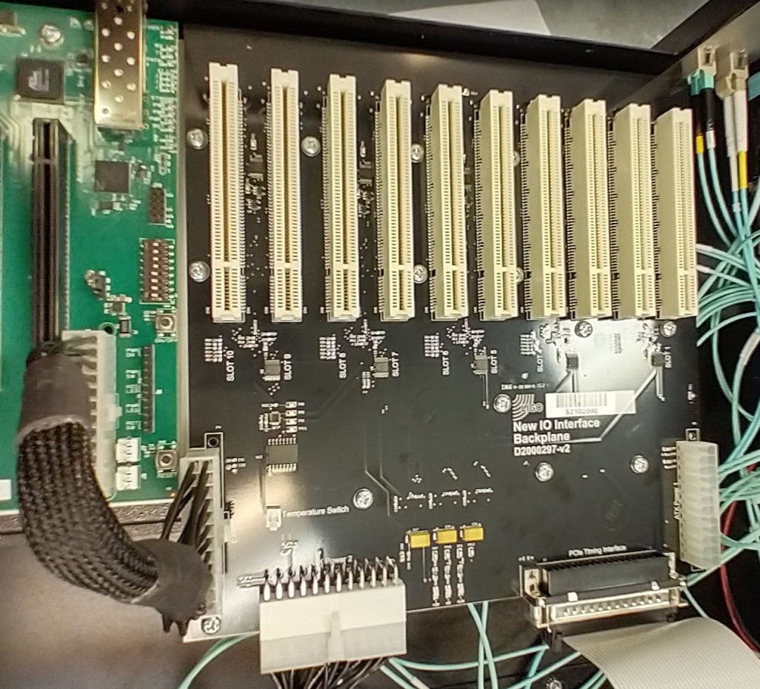

Figure 3 – New Backplane Installed

# Replace Power Fanout

Remove old Fanout and Power Board. Unscrew 24V power cables from the old power board and attach to 2 pin plug recovered from the old backplane / timing board, you may need to trim the ends so that they fit nicely into the screw terminals. Ensure polarity is correct, it is clearly marked on the PCB.

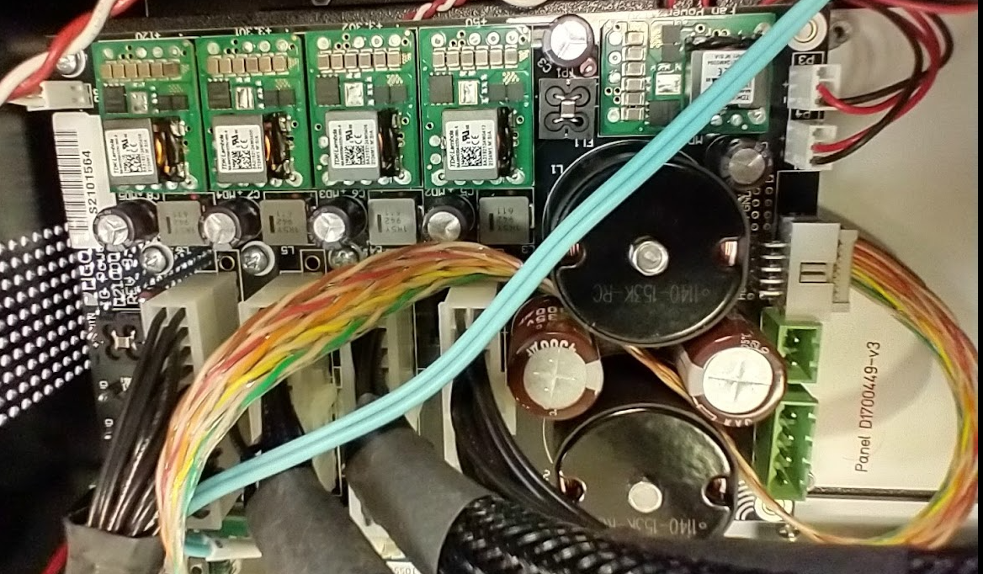

Figure 4 – New Power Fanout Installed

# Install PCIe Timing Interface

Install PCIe card to slot 1 on 1st ADNACO. Relocate SFP from the Duotone Timing System to the PCIe timing interface. Connect timing fiber. Connect power supply timing cable and attach to power fanout timing input. Ensure that all dip switches are in the off position (up)

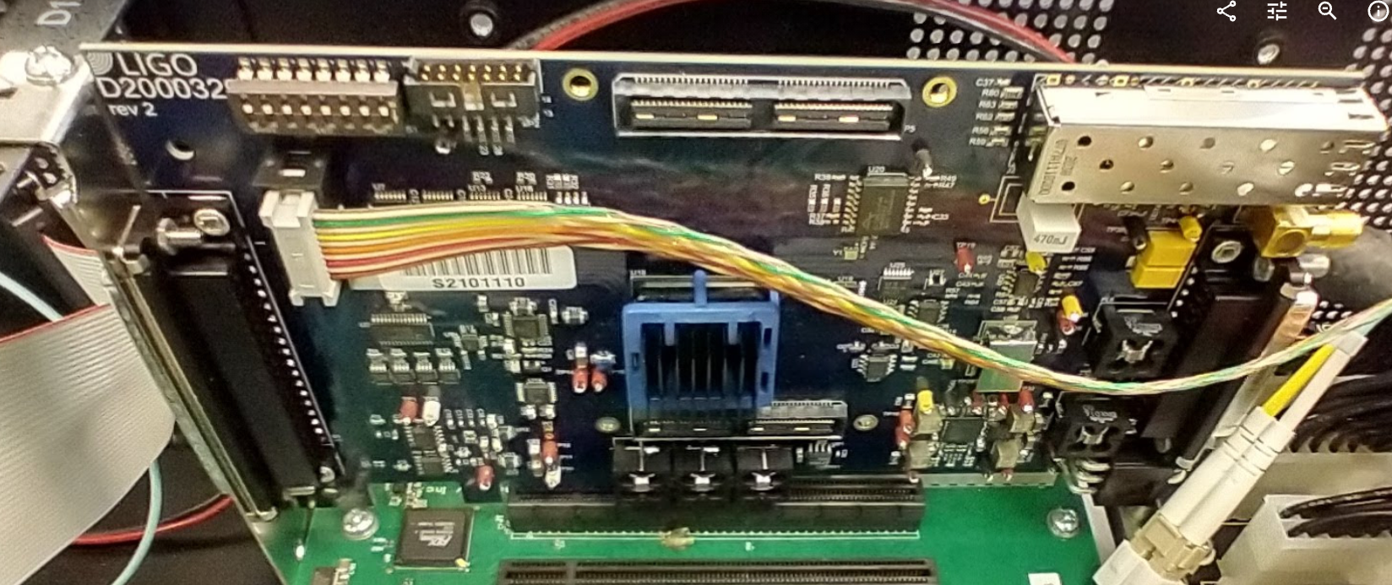

Figure 5 – PCIe Timing Interface Card

# Final Checks

## Power Check

Check that the power cable is attached correctly to the power fanout board. Check that the 24V external connector is not loose. Apply 24V power and ensure that the system powers up. There are no fuses on the power fanout board, and it is not protected from reverse voltage, so be very careful when applying power to the system. The power fanout does have polarity markings on the PCB.

## DIP Switch Check

Make sure that all the dip switches are in the correct positons. Adnaco DIP 1-4 ON, 5-8 OFF.

PCIe Timing Interface DIP 1-8 OFF.

## SFP Check

Make sure that the SFP is the same frequency at both ends, this can be accomplished by reusing the existing SFP from the prior install. Make sure that the SFP connects before closing up the chassis.

## Cable Check

Make sure that all cables are attached including the cable from the PCIe Timing Interface to the Backplane. Also the timing cable from the PCIe Timing Interface to the Power Board.

## Self Sync Jumper Check

Make sure that the jumper J1 on the Power Board is not installed (this one is hidden between the big inductors and big capacitors. This jumper is only used for SELF SYNC, when used with a timing card and timing cable it is required to synch to the timing system.