Advanced LIGO+(A+)/Advanced Virgo+(AdV+) Coating Report
October 2021

Introduction
The panel listed at the end of this report were invited by the A+ and AdV+ leadership to evaluate proposals from the major low-coating-thermal-noise (CTN) Coating R&D centers, describing the properties and maturity of the promising candidates that have emerged from ongoing R&D towards a new practical coating material for use in the O5 observing run of A+ and AdV+.
The proposed evaluation process and charge to the panel are given in LIGO-M2100135/VIR-0938A-21. The charge to the panel requests that it:
- Evaluate and compare proposed coating solutions for projected CTN strain spectral density in AdV+/A+ deployment, and for expected optical conformance with LIGO and Virgo core optic requirements
- Consider the relative maturity and completeness of the experimental data, modeling and reference literature underpinning these projections.
- Evaluate comparative readiness of each proposed solution for scaling to full aperture, and also for achieving the necessary uniformity, predictability, and quality to support production coating on ITM/ETM substrates.
- Highlight any unproven performance requirements or other future risks associated with each approach, as well as the feasibility of addressing these risks in parallel with industrialization.
- Summarize the findings in a report addressed to AdV+ and A+ leadership. A consensus report is requested.
The panel received presentations from representative of the coating R&D centres on September 14, 8:00 PT, 17:00 CET, about SiN (presentation from Massimo Granata: https://dcc.ligo.org/LIGO-G2102033) and September 17, 8:00 PT, 17, CET, about Ti:Ge (presentation from Gabriele Vajente https://dcc.ligo.org/G2102042). Each presentation was given to a meeting open to all members of the LIGO, Virgo and Kagra Collaborations which included an open Q&A session.
These materials and activities provided the panel with the material required to inform its assessments and findings reported below.

SiN:

Status and characteristics
LMA has been developing ion-beam sputtered (IBS) silicon nitride (SiNx) coatings since late 2016 (G1701420, G1701598 / VIR-0847A-17 / https://hal.archives-ouvertes.fr/tel-02475821), and published first results in 2019 (doi.org/10.1364/AO.377293). The loss angle of silicon nitride coatings was shown to be a factor 3 lower than that of tantala-titania layers of advanced detectors, but their optical loss was considerably higher.
Since 2019, some campaigns of optimization were performed (though most of the effort was concentrated in the time period from February to July 2021), by changing the growth parameters of the thin films: single layers and high-reflection ETM coatings were produced and characterized for optical absorption, scatter, mechanical loss. Annealing tests at high temperatures (500 to 1000 °C) were also performed. As a result of the last optimization campaign in 2021, the refractive index of as-deposited single SiNx layers increased to 2.05 at 1064 nm, and their extinction coefficient due to optical absorption decreased to 1.2e-5; after annealing, their extinction decreased by a factor of 2.
Before annealing, SiNx/SiO2 ETM coatings (designed for T = 5 ppm at 1064 nm) feature an absorption of 44 +/- 2 ppm, and 60 +/- 15 ppm of scatter, likely due to the many observed point-like defects (with a radius of the order of 1 to 10 microns). After annealing, their optical loss increased and some small defects of circular delamination (‘bubble-like’) appear: about 10 of such defects (with a radius of about 10 to 50 microns) were observed on 1” samples after treatment at 900 °C. A summary of results obtained on SiNx coatings is available in VIR-1032A-21.

Coating Thermal Noise
Based on past experience, which showed that measured CTN of HR stacks was always sensibly higher than what expected from loss angle measurements of single layers, the Virgo Coating R&D Collaboration (VCR&D) chose not to predict the CTN associated with its SiNx/SiO2 ETM coatings. Instead, several SiNx/SiO2 ETM coating samples were produced and treated at different temperatures for direct CTN measurements in a specific facility at MIT. Samples will be available at MIT by the first half of November 2021.

Readiness
IBS SiNx must be further optimized, in order to decrease their optical loss and to remove the few remaining defects after annealing. Nevertheless, provided that the issue of delamination defects is solved, IBS SiNx coatings could be immediately used in a multi-material ternary design of low optical loss and CTN reduced by a factor of 2 in power, even at their current development stage: see VIR-1032A-21, G2101842, G2101040, G2100429, G2100124, G2000218 and doi.org/10.1103/PhysRevResearch.3.023172 for more details.

Risks and unknowns
Although some problems have already been identified and will be treated in the short-term future, the cause of high optical loss in IBS SiNx coatings has not been unequivocally identified yet. Similarly, although some hypotheses are being tested right now, the cause of delamination defects upon annealing is unknown to date.

Pros

Advantages of IBS SiNx developed at LMA include:

high refractive index,

low mechanical loss (a factor of 3 lower than high-index layers used in current detectors) and

phase stability up to at least 1000 °C.

This latter point implies that SiNx/SiO2 ETM coatings can be annealed at 900 °C or higher without crystallization, the upper limit temperature being rather set by the softening point of the substrate. The consequence of such high-temperature annealing would be a further decrease of CTN in the ETM stacks, due to a relevant decrease of the loss angle of SiO2 layers as well.

Cons

Disadvantages of IBS SiNx developed at LMA include:

high optical absorption and scatter,

presence of some defects after annealing.

Ti:GeO2

Status and characteristics

Thin films containing a mixture of titanium oxide (titania) and germanium oxide (germania) have been co-sputtered, using a Veeco Spector system at Colorado State University (CSU). Metal targets were used for both materials, sputtered with an Argon ion beam in a reactive oxygen atmosphere. Several different concentrations of titanium oxide were initially tested, and the best one, in terms of lowest predicted Brownian noise, was found to be 44% titania and 56% germania (atomic percentage). The content of the film was measured by Rutherford Backscattering Spectrometry.

The lowest mechanical loss angle, for a film that is still amorphous, was obtained after annealing the material at 600^{O}C for 100 hours. The main results are reported in [1]. The mechanical losses of the materials were measured from thin films (few hundred nanometers) deposited on 75-mm-diameter and 1-mm-thick disks, using a gentle nodal suspension to measure modal ringdowns [2]. The ringdown data were analyzed with a model that could extract independently the bulk and shear loss angles [3,4]. Figure 1 shows the best fits to the measured data, including the loss angle for a silica film annealed in the same way. Table 1 summarizes all the optical and mechanical properties measured on the single layer films.
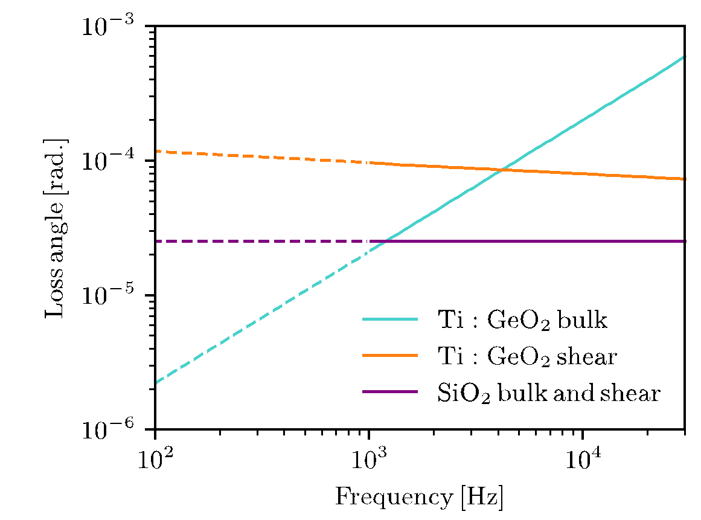
Figure 1. Estimated bulk and shear loss angles, from measurements on single layers of titania-germania and silica, annealed at 600^{O}C for 100 hours. Loss angles were measured in the frequency range indicated by the solid lines, while the dashed lines are extrapolations.
Table 1. List of measured properties for titania-germania and silica thin films, both after annealing at 600^{O}C for 100 hours

SiO2 property | Value
Refractive index at 1064 nm | 1.45 ± 0.01
Young’s modulus | 73.2 ± 0.6 GPa
Poisson ratio | 0.11 ± 0.01
Loss angle | $ϕ_{μ}=ϕ_{K}={2.6}_{-0.6}^{+0.5}×{10}^{-5}$
TiO2:GeO2 property | Value
Cation concentration Ti/(Ti+Ge) | 44.5 ± 0.3 %
Refractive index at 1064 nm | 1.88 ± 0.01
Optical absorption for a QWL | 2.3 ± 0.1 ppm
Density | 3690 ± 100 kg/m³
Young’s modulus | 91.5 ± 1.8 GPa
Poisson ratio | 0.25 ± 0.07
Bulk loss angle $ϕ\left(f\right)=a$(f/10kHz)^{m} | $a_{K}=({22.0}_{-12.5}^{+10.6})×{10}^{-5}$  $m_{K}={1.04}_{-0.36}^{+0.40}$
Shear loss angle $ϕ\left(f\right)=a$(f/10kHz)^{m} | $a_{μ}=({8.4}_{-4.0}^{+2.9})×{10}^{-5}$  $m_{μ}={-0.06}_{-0.30}^{+0.15}$

Coating Thermal Noise
Based on the measured refractive index, ITM and ETM coatings were designed with a target transmission of 1.4% for the ITM and 5 ppm for the ETM. The ITM is a stack of 22 layers, the top being 0.5λ of silica, and the others alternating 0.193λ of titania-germania and 0.313λ of silica. The ETM is a stack of 52 layers, the top being 0.5λ of silica, and the others alternating 0.223λ of titania-germania and 0.281λ of silica.
We computed the coating Brownian noise based on this design, the measurements from the single layer reported above, and the model from [3]. Figure 2 shows that the predicted Brownian noise, extrapolated down to 100 Hz, meets the Advanced LIGO+ requirements.

  - 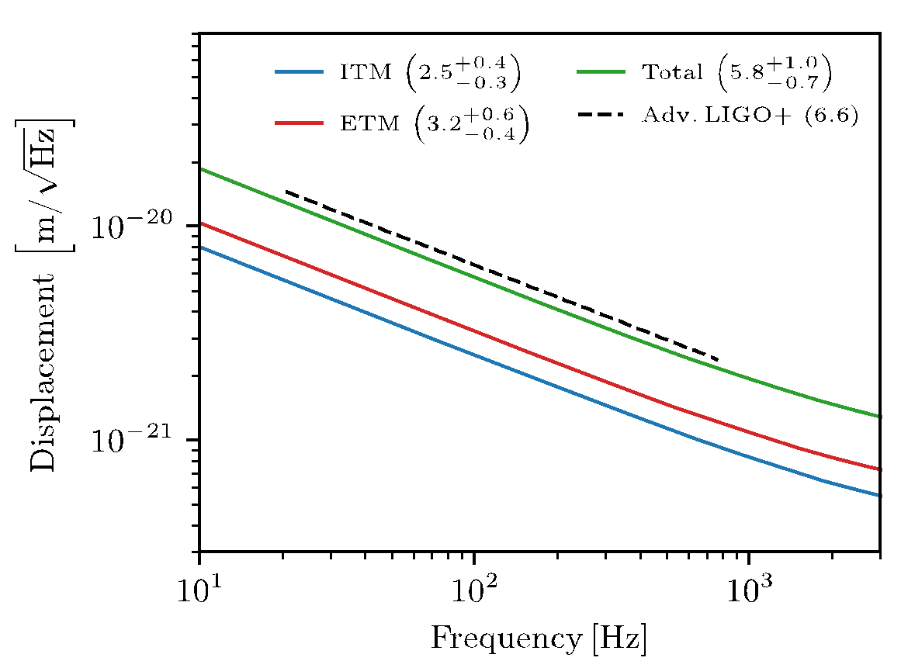
Figure 2. Predicted Brownian noise for ITM and ETM stacks made of alternating layers of titania-germania and silica.

Readiness
Titania-germania films with good optical quality and low optical absorption can be produced by ion beam sputtering and the deposition procedure should be easily transferable to industrial systems. The level of optical absorption obtained for a full CSU HR stack was 3-3.5 ppm after 600 C annealing. This is comparable to what could be achieved in other oxides in the LMA Spector system, for materials that were then pushed under 1 ppm absorption in the LMA Grand Coater.
An HR stack (Ti:GeO2 and SiO2) was also produced by Cutting Edge Coatings (54 layer quarter-wave stack, T = 6 ppm). This mirror was measured in the MIT Coating Thermal Noise (CTN) setup. After the 600 C/100 hr annealing, the thermal noise was measured to be 75% of the current Ti:TaO5 coatings, although at that point the coating showed lots of bubbles/blistering (see below). The measurement setup also inferred an absorption of 0.14 ppm, although this was not a direct measurement and has not been verified via Photothermal Common-path Interferometry (PCI).

Risks and unknowns
The main problem now is that multilayer stacks, when annealed at temperatures above about 500^{O}C, form a lot of bubbles: small defects (one to a few mm) where the coating is delaminated. Research is ongoing to understand the origin of this problem. There is evidence that the amount of blistering is lower when the substrate surface has higher quality (lower RMS). The most likely causes for the formation of those bubbles is stress in the film as deposited or after annealing, and/or accumulation of argon trapped in the coating.
Additionally, the mechanical loss angles have been measured at 1 kHz and above, so the Brownian noise prediction is an extrapolation from the frequency dependence of the loss angles. A direct measurement of thermal noise on a defect-free annealed sample has not been possible yet.

Pros
- The material is a standard oxide based on commonly used metals, so it should be easily adapted to any deposition chamber.
- The optical absorption is as low as expected when deposited in the CSU Spector system.
- The Brownian noise is predicted to meet the A+ goal, based on thin film mechanical loss measurements.

Cons
- The lower refractive index means that all coatings will be thicker and will require longer deposition times, increasing the risk that something could go wrong during a coating run.
- The issue of blistering in high reflection stacks when annealing is still unsolved.
- The thermal noise prediction (factor of 2 reduction) has not been demonstrated yet in a HR mirror.
- Absorption at the 0.5 ppm level has not yet been verified.
- The coatings need to be annealed at higher than usual temperature (though not approaching any annealing limitations, so this is a minor point).

Conclusions and summary
We note that, to date, research on both coatings considered in detail here has yielded interesting results with both candidates considered, showing promise as full-scale coatings. However, neither of the coating candidates are yet at a stage where all performance targets have been met, or where all risk has been removed. Evaluation of the findings leads to an option to ramp up R&D on one coating to accelerate progress.

SiN:
We consider at this point that it is harder to implement the needed developments in a short timescale in the large coater (with use of this coater required for full-scale development). This would require hardware modification to the coating system and new process software - each of which would take time and resource (in the form of both person-power and cost). The development path for SiN is likely to be longer than for Ti:Ge. Moreover, in this case, optical absorption is about two orders of magnitude higher than required and this appears difficult to improve sufficiently in time to be ready for O5.

Ti:Ge:
We consider the development status to be slightly more advanced than SiN, and that the technical steps required to proceed with accelerating pathfinder R&D are simpler for Ti:Ge.
In particular we note the only significant coating chamber modification needed to enable development of Ti:Ge-based coatings is a change of target. Preliminary tests for optimum deposition conditions could be done in a relatively short time. Further tests are needed regarding understanding of the source of the bubbles noted in current developmental coatings and of techniques for their prevention.
Further, we note the pathfinder development process should benefit from a joint approach combining the expertise of the Collaborations in a focused development program to reach a common solution.
We additionally note that continued pursuit of these and other coating designs (including those not considered in detail here) is envisaged as appropriate ongoing risk reduction and planning for observational runs beyond O5/future detectors.

evaluation panel
- Sheila Rowan, co-chair
- Helios Vocca, co-chair
- Peter Fritschel
- Laurent Pinard
- Raffaele Flaminio, AdV+ (ex-officio)
- GariLynn Billingsley, A+ (ex-officio)

