APPROVALS | DATE | REV | DCN NO. | BY | CHECK
For approvals see DCN

Description
50 mm Ø Plano-concave mirrors @ 1064nm, p-polarization.

Material
Corning HPFS 7980, or equivalent, (high purity fused silica, UV grade)
Grade 4G or better, (or equivalent)

Dimensions
Diameter: 50.0 mm +0.00/− 0.1 mm
Thickness (at center): 4.84 mm ± 0.075 mm (R2)
4.92 mm ± 0.075 mm (R4)
(See section 5 for specification of R2 and R4)
Chamfers: minimal to prevent chipping (goal of < 0.25 mm width)

Radius of Curvature (ROC) for Plano concave case
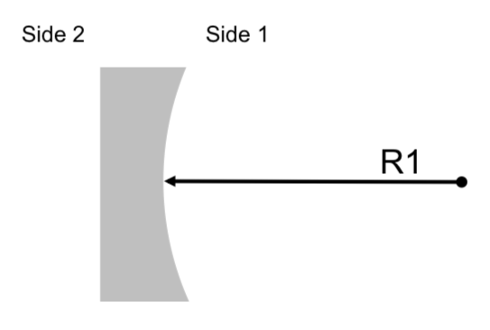
Fig1: This picture has the only purpose of identifying the ROC of the optic and the two sides.

Wedge: < 1’ arc. (Defined as the angle between the optical axis, defined by line connecting centers of curvature of the optical surfaces, and the mechanical axis, defined by the outer edge used for mounting. )

Substrates

E2100053-R2
Side 1: ROC R1 = 2.00 m ± 0.02 m (concave)
Side 2: Flat

E2100053-R4
Side 1: ROC R1 = 4.00 m ± 0.020 m (concave)
Side 2: Flat

Side 1 Radius of Curvature values are defined over the central 30 mm diameter of the optic.

Surface Roughness & Quality
General: all surfaces shall appear transparent with no grey, checks or fractures visible to the naked eye when viewed in normal room light against a black background.

Side 1:
Super-polished: no more than 1 Angstrom RMS over central 30 mm diameter
There shall be no scratches, sleeks or point defects within the central 30 mm diameter, visible by naked eye. The examination should be done in a dark room against a dark background using an illumination system of at least 150 W total power.
20-10 scratch-dig outside central 30 mm diameter.

Side 2:
Commercial-polish: no more than 5 Angstrom RMS over central 80% of diameter

Edges (barrels) and Chamfers:
Commercial-polish (clear finish required for UHV use)

Surface Figure
Side 1
Over central 30 mm diameter:
Deviation from sphere or flat: < λ/20 PV at 632.8 nm

Coatings
Wavelength: 1064nm
Ion Beam Sputtered coatings

Side 1: HR coating
Two coatings: HRA, and HRB differ by angle of incidence both with
R > 99.98% @ 1064nm and p-polarization.

Side 2: AR coating
Two coatings: ARA and ARB differ by angle of incidence both with
R < 0.2% @ 1064nm, and p-polarization.

Coatings are to be designed and applied according to the following table:
Mirror name | Substrate | Angle of Incidence | Side 1 | Side 2
E2100053-A1 | R4 | 9.7° | HRA | ARA
E2100053-A2 | R2 | 9.7° | HRA | ARA
E2100053-B1 | R4 | 4.9° | HRB | ARB
E2100053-B2 | R2 | 4.9° | HRB | ARB
Note 1: Angle of incidence is the design value. The coating reflectivity specification should be met for the given angle ± 0.5°. Coatings should be combined into fewer runs if the requirements can be met across the required range of angles of incidence.

Serial numbers and marks
- Each optic shall be laser engraved on Side 2 of the optic for in-vacuum use — no pencil marks shall be present
- Each optic shall be labelled as follows:
  - The engraving shall be on Side 2, in the annular region between 40 mm diameter and 50 mm diameter
  - Label: E2100053-YY-nn
    - with ‘YY’ the alphanumeric mirror designator (i.e., A1, A2, B1, B2), given in the table above,
    - with ‘nn’ starting at 01 for each type.

Test data to be provided:
- Final substrate diameter and thickness at edge: pass/fail; measured dimensions may be supplied,
- Side 1 interferogram to be provided, with
- confirmation of RoC for concave surfaces (pass/fail),
- confirmation of surface figure within central 30mm zone (pass/fail)
- confirmation of surface roughness Side 1, central region, may be batch tested (pass/fail),
- HR coatings: spectrophotometer scans showing residual transmission,
- AR coatings: spectrophotometer scans showing residual reflection.

