LIGO LABORATORY
California Institute of Technology
1200 E. California Blvd.
Pasadena, CA 91125

Statement of Work
C-1900390-v2

- Scope (LIGO Aplus Vacuum System)
This Statement of Work (SOW) is for the manufacture and procurement of conflat flanges (CF) and associated electrical vacuum feedthroughs as required for use in the Ultra-high Vacuum System (UHV) related to the LIGO A+ upgrade. Various types of UHV feedthroughs will be needed as detailed in the following SOW.

- Document Access
Many supplemental documents and specifications are incorporated into and made a part this Statement of Work. Click on the document links to access these documents from the LIGO Document Control Center (DCC) or go on line to the LIGO Public DCC at https://dcc.ligo.org/ to access the DCC#.

- Commercial Terms and Applicable LIGO Specifications:

Note: The documents listed below are invoked for this Statement of Work and comprise additional requirements which are integral to this Statement of Work.

- LIGO-C080185-v2 LIGO Commercial Items or Services Contract General Provisions
- LIGO-Q0900001-v5 Advanced LIGO Supplier Quality Requirements
- LIGO-Q1100003-v1 Acceptable Quality Level (AQL) for Inspection of LIGO Components
- LIGO-E2000003-v2 Aplus Vacuum Feedthrough Mechanical and Electrical Performance Requirements

- Quality System:
Referring to the above referenced LIGO Specification Q0900001, Suppliers should include a copy of their current ISO 9001, AS9100, or TS16949 certification in their bid package. Suppliers lacking current certification should send a copy of their Quality Manual with their bid package.

- Parts/Assemblies to be manufactured, Quantity Required, and Inspection requirements:
Note: refer to Section 8.0 for delivery schedule and location. Dimensional inspection frequency is specified in Table 2. All other inspections are detailed in section 3.0 by following LIGO-E2000003-v1.

Table 1
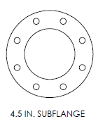  Figure 1 | 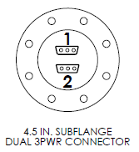  Figure 2 | 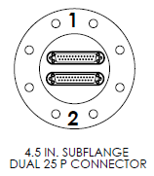  Figure 3
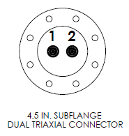  Figure 4 | 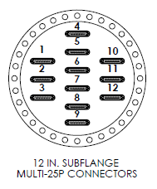  Figure 5 | 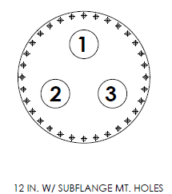  Figure 6
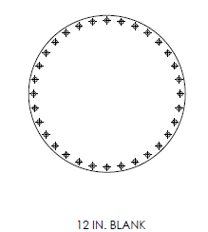
Figure 7

Table 2
Figure Reference | Part Description | Total Qty: | Dimensional check Frequency AQL Number
Figure 1 | 4.5 Inch CF (Blank Off) | 6 | 5
Figure 2 | 4.5 Inch CF with Dual 3-pin Power Dsub | 16 | 5
Figure 3 | 4.5 Inch CF with Dual 25-Pin Dsub | 48 | 5
Figure 4 | 12 Inch CF with (12) 25-pin Dsub | 10 | 5
Figure 5 | 4.5 Inch CF with Dual Triaxial Connectors | 16 | 5
Figure 6 | 12 Inch CF with (3) 4.5 Inch CF Subflanges | 26 | 5
Figure 7 | 12 Inch CF (Blank Off) | 6 | 5
Note: refer to LIGO-Q1100003-v1 for the AQL table.

- Manufacturing:

  - Requirements:

Suppliers must refer to the LIGO Specifications referenced in section 3 for additional, and in some cases, non-industry standard requirements.

  - Sub-Contracted Work:
- LIGO expects that at least 2/3 (by dollar value) of the contracted work be performed by the Supplier named on the Purchase Order. The Supplier shall be responsible for all sub-contracted work.
- The Supplier’s quote shall state their intent to sub-contract any welding operations performed on components intended for Vacuum use.

  - Precedence:
The drawings typically represent the finished part as needed for use in service. There may be requirements on the drawing (such as coatings) which are specifically defined as not the responsibility of the supplier in this SOW. Suppliers should always contact a LIGO representative to resolve any discrepancies uncertainties in the documentation or instructions.

  - Special Instructions:

None

  - Exclusions:

None

- End Item Data Package:
Before delivery of the parts, the Supplier shall provide the following data, as a minimum:
- Specific to each serial number part 100% testing for continuity on all pins that are part of the electrical feedthroughs
- Specific to each serial number part 100% HIPOT testing of all pins to the metal body of each conflat flange.
- Specific to each serial number part 100% testing of hermeticity
- Specific to each serial number part 100% visual inspection for damage to the knife edge of all conflat flanges
- Any as-built modifications (with approval of the LIGO Contracting Officer) as mark-ups to the drawings
- Material certifications
- Inspection reports of all dimensional features for the number of parts specified per the AQL number and referenced in the AQL table LIGO-Q1100003-v1 and any other inspection requirements detailed in Section 5 of this SOW
- Certificate of compliance for each part number stating conformance to contract and drawing requirements

- Delivery Requirements:

  - Shipping Containers and Packaging:
The contractor is responsible for providing shipping containers and transportation which protects these parts from damage from the transportation environment (weather, handling, accidents, etc.). Mating edges of parts should be especially protected from damage during shipping.

  - Shipping Destination(s):
The deliveries are FOB at these destinations, i.e. the Supplier has the responsibility for shipping title and control of goods until they are delivered, and the transportation has been completed. The contractor selects the carrier and is responsible for the risk of transportation and for filing claims for loss or damage.

Once manufactured, the order will be split equally and shipped to:

LIGO Livingston Observatory (LLO) LIGO Hanford Observatory (LHO)
Attn: Scott McCormick Attn: Chandra Romel
19100 LIGO Lane 127124 North Route 10
Livingston, LA 70754 Richland, WA 99354

  - Delivery Schedule:
8 weeks ARO

