*LIGO Laboratory / LIGO Scientific Collaboration*

LIGO- T1900628-v1 *LIGO* 16 Sep 2019

Beam Tube Support Loads

Dennis Coyne

Distribution of this document:

LIGO Scientific Collaboration

This is an internal working note

of the LIGO Laboratory.

|  |  |
| --- | --- |
| **California Institute of Technology**  **LIGO Project** | **Massachusetts Institute of Technology**  **LIGO Project** |
| **LIGO Hanford Observatory** | **LIGO Livingston Observatory** |

http://www.ligo.caltech.edu/

Table of Contents

1 Introduction 3

2 General Comments 3

2.1 Final published load values 3

2.2 Load calculations 3

3 Attempt to reconstruct the final design loads on each BT support 4

3.1 Termination Supports 4

3.2 Fixed Supports 4

3.3 Guided Supports 5

4 Wind and Snow Loads 6

5 Thermal (bake out) Load 7

6 Vacuum Load 7

7 Dead Weight Load 8

8 Seismic Loads 8

9 Settlement Loads 8

10 Horizontal Alignment 8

# Introduction

The source and derivation of the loads for the final design of the Beam Tube (BT) support structures seems to be missing from the archives (24 years ago) for initial LIGO. The purpose of this memo is to serve as a guide to the initial LIGO documentation in the LIGO Document Control Center (DCC) regarding loads on the BT supports, and to attempt to provide an accurate synopsis of the loads and their derivation.

# General Comments

## Final published load values

One might reasonably expect that the final load estimates on the BT supports should be given in the tables embedded in the latest versions[1] of these two drawings:

* [D950029](https://dcc.ligo.org/LIGO-D950029)-C for fixed and guided supports
* [D950093](https://dcc.ligo.org/LIGO-D950093)-C for termination supports

These two drawings are included in document [E950089](https://dcc.ligo.org/LIGO-E950089)-0. These documents were released between Nov 15 and Nov 28, 1995. The initial versions, [D950029](https://dcc.ligo.org/LIGO-D950029)-0 and [D950093](https://dcc.ligo.org/LIGO-D950093)-0, were created Jul 19 and Jul 20, 1995 respectively.

However there were at least two updates to the BT support thermal loading subsequent to the release of [D950029](https://dcc.ligo.org/LIGO-D950029)-C and [D950093](https://dcc.ligo.org/LIGO-D950093)-C:

1. The first update was based on revised estimates of the BT expansion joint (bellows) spring rates, as well as a realization that the outermost fixed supports have higher loads. The update is given in documents [C951392](https://dcc.ligo.org/LIGO-C951392)-x0/0[2] (12-Dec-1995) and [E950105](https://dcc.ligo.org/LIGO-E950105)-x0/0 (20-Dec-1995).
2. The second update was captured in revision 2 to the BT module detailed design calculations document ([C960366](https://dcc.ligo.org/C960366)-v1) on 22-May-1997. This update was based on measured expansion joint (bellows) spring rates for the first 111 expansion joints. These revised loads were also captured in the “Interface Control Document for the Beam Tube and the Beam Tube Slab”, [C960739](https://dcc.ligo.org/LIGO-C960739)-x0 (dated 11-Apr-1996).

## Load calculations

The documents which best define the methodology for calculating the loads, as well giving an initial set of parameters for the load calculations, are the documents [T940074](https://dcc.ligo.org/LIGO-T940074)-v1 (dated 11-Mar-1994) and [C960366](https://dcc.ligo.org/LIGO-C960366)-v1 (dated 22-May-1997). Document [T940074](https://dcc.ligo.org/LIGO-T940074)-v1 is an update to the load calculations shown in CB&I's preliminary design calculations, [C930063](https://dcc.ligo.org/LIGO-C930063) (dated 15-Nov-1993). However the load values in [T940074](https://dcc.ligo.org/LIGO-T940074)-v1 are not the final values; The most recent design calculations appear to be given in [C960366](https://dcc.ligo.org/LIGO-C960366)-v1 (CB&I revision 2, dated 22-May-1997) but this document is apparently an update to document CB&I’s document “Final Design Review Data Package (CDRL 15, DRD 09, for the “BT design and qualification” contract). Unfortunately this document is not in the electronic DCC and I’ve been unable to find it in the paper archives at Caltech.

In the following sections, I attempt to give the derivation of the final load values. However there are many caveats.

# Attempt to reconstruct the final design loads on each BT support

In the accompanying Excel workbook I have tried to capture the parameters, equations and document sources for calculating the loads for each of the three types of beam tube (BT) supports. I was unable to find the original source for many of the calculations and there are a lot of caveats in these calculations. Nonetheless they may be of some value to our LIGO India colleagues especially as a starting point. The spreadsheets in the Excel workbook have notes explaining the calculations. Here I just present my best estimate of the final loads.

However note that these values should be independently checked. The original CB&I calculation of the support loads was based on a beam analysis. A better approach today would be to create a finite element model of a representative length of beam tube, including the bellows and the first few fixed and guided supports in order to calculate the loads transfer to the supports.

## Termination Supports

The last published values for the loads on the termination slab are as follows:



My attempt at reconstructing the loads for the termination slab is as follows:



For more details see the accompanying Excel workbook.

## Fixed Supports

The last published values for the loads on the fixed support slab are as follows:



My attempt at reconstructing the loads for the fixed support slab is as follows:



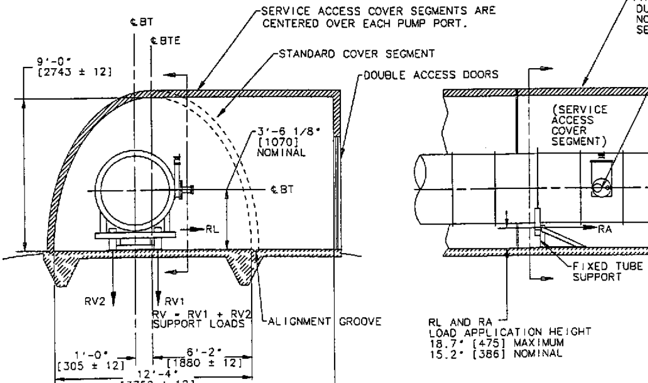

Figure Fixed Support (from D950029-C, found in E950089-0)

For more details see the accompanying Excel workbook.

## Guided Supports

The last published values for the loads on the guided supports are as follows:



My attempt at reconstructing the loads for the guided supports is as follows:



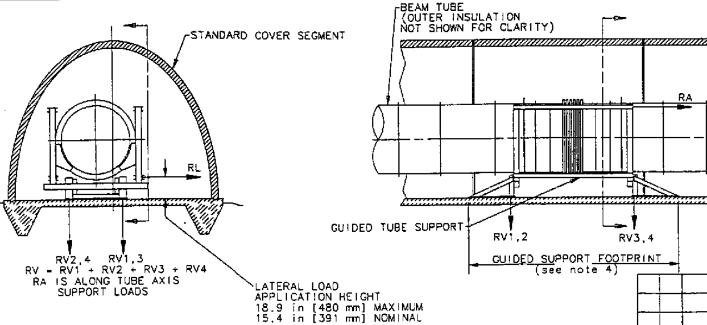

Figure Guided Support (D950029-C, found in E950089-0)

For more details see the accompanying Excel workbook.

# Wind and Snow Loads

The original proposal for the LIGO Observatory (initial LIGO, [M890001](https://dcc.ligo.org/LIGO-M890001)) calls out a Beam Tube Enclosure (BTE). However note that in both documents [C930063](https://dcc.ligo.org/LIGO-C930063)-x0 and [T940074](https://dcc.ligo.org/LIGO-T940074)-x0, snow loads are calculated for Hanford, WA, but are not included in the load tables of [D950029](https://dcc.ligo.org/LIGO-D950029) and [D950093](https://dcc.ligo.org/LIGO-D950093). There was a time when the project considered leaving the tube uncovered. (Fortunately this idea was abandoned.) Design and construction of a Beam Tube Enclosure (BTE) was explored in the period 16-Jun-1994 through 27-Feb-1995 ([C940099](https://dcc.ligo.org/LIGO-C940099), [C950118](https://dcc.ligo.org/LIGO-C950118)) resulting in a bid from Parsons Engineering finally on 14-Nov-1995. So, when documents [E950089](https://dcc.ligo.org/LIGO-E950089), [D950029](https://dcc.ligo.org/LIGO-D950029) and [D950093](https://dcc.ligo.org/LIGO-D950093) were being updated the project had decided to incorporate a BTE and so the snow loads and wind loads disappeared ... except for the residual reference to wind load in the table embedded in [D950093](https://dcc.ligo.org/LIGO-D950093)-C.

Why might [D950093](https://dcc.ligo.org/LIGO-D950093)-C indicate wind load on the termination support? Either lack of removal of the wind load from the table was an oversight or perhaps the construction sequence would leave some length of the tube unprotected before the building was built. I think it was an oversight. If the LIGO-India project intends to cover the Beam Tube as it is welded in place (as LIGO-US did), so that no length of BT is exposed to the wind, then the wind load on the supports is zero.

As for the method used to calculate the wind loads, this is clearly defined on page 4 of document [T940074](https://dcc.ligo.org/LIGO-T940074); The wind load estimate is based on ASCE 7-88 with winds of 45 mph. Note that on page 10 and page 227 of [C930063](https://dcc.ligo.org/LIGO-C930063), the wind is specified to be 70 mph for Hanford, WA and 100 mph for Livingston, LA.

# Thermal (bake out) Load

The radial load (RA) at the fixed support is indicated to be 5188 lbf (2353 kgf) on drawing [D950029](https://dcc.ligo.org/LIGO-D950029)-C, whereas [T940074](https://dcc.ligo.org/LIGO-T940074) indicates a thermal load of 5959 lbf on the fixed supports, based on the following parameters:

* maximum expansion joint spring rate, K = Kej * (1 + Eej) = 10062 lbs/in
* thermal expansion, x = 3.257 in.
* longitudinal force, Pbc = K * x = 32776 lbs (axial force on termination foundation)
* fixed support axial load, Rfz9 = 2 * Eej * Kej * x = 5959 lbs

The load update in documents [C951392](https://dcc.ligo.org/LIGO-C951392)-0 (12-Dec-1995) and [E950105](https://dcc.ligo.org/LIGO-E950105) (20-Dec-1995) indicates:

* maximum expansion joint spring rate[3], K = 8000 lbs/in
* thermal expansion x = 3 in
* longitudinal force, Pbc = K * x = 24000 lbs (axial force on termination foundation; as shown in D950093-C)

Why an expansion joint (bellows) compression of only 3 inches is given in these documents, when other documents/calculations indicate 3.25 inches, I do not know. Round off I guess.

Based on these values, and Eej = 10% variation in spring rates (as assumed in [T940074](https://dcc.ligo.org/LIGO-T940074)) one calculates the fixed axial support load as:

* fixed support axial load, Rfz9 = 2 * Eej * K * x = 5200 lbs (if x = 3.25 in)

While this load does not numerically match the load in [D950029](https://dcc.ligo.org/LIGO-D950029)-C (5200 vs 5188 lbs), it is closer to this value than shown in [T940074](https://dcc.ligo.org/LIGO-T940074). I suspect a number of small changes in parameters are the cause of these differences. For instance, the spring rates of the BT bellows (expansion joints), at various bake (or operating) temperatures, were made available from the bellows manufacturer in Mar-1995, in document [E950010](https://dcc.ligo.org/LIGO-E950010). These spring rates are somewhat different than assumed in previous calculations.

As explained in [E950105](https://dcc.ligo.org/LIGO-E950105), and in [C951392](https://dcc.ligo.org/LIGO-C951392), there are actually two types of load conditions for the fixed support shown in [D950029](https://dcc.ligo.org/LIGO-D950029). Most of the fixed supports (all but 2) are supporting 65 ft. long tube sections. The two outermost fixed supports are supporting shorter tube sections, which causes higher loads (from adjoining, longer tubes) during bake. These load conditions are shown in the mark ups to [D950029](https://dcc.ligo.org/LIGO-D950029) included in [E950105](https://dcc.ligo.org/LIGO-E950105).

The calculations of these revised loads are not shown in either [E950105](https://dcc.ligo.org/LIGO-E950105) or [C951392](https://dcc.ligo.org/LIGO-C951392). However [C951392](https://dcc.ligo.org/LIGO-C951392) indicates that the change in thermal loads on the intermediate fixed supports (from 5188 lbs to 5566 lbs) was as a result of using "current bellows spring rate specification".

# Vacuum Load

The vacuum load is (almost entirely) reacted by the termination supports. While the termination support load should be simply equal to the tube interior area times the maximum atmospheric pressure, I was not able to find CB&I’s source calculation, nor was I able to accurately match the vacuum load value published; I suspect an overly conservative estimate was used.

# Dead Weight Load

The dead weight loading on the supports was calculated by CB&I using a beam analysis code called RISA-2D[4] (mentioned on pg 6 of [T940074](https://dcc.ligo.org/LIGO-T940074)). The results of this beam analysis were reported in CB&I’s document “Final Design Review Data Package (CDRL 15, DRD 09, for the “BT design and qualification” contract). Document [C960366](https://dcc.ligo.org/LIGO-C960366)-v1 uses the beam analysis from these original design calculations (cited on last page, CDRL#15, DRD#9, Item IV, section 5).

Rather than re-calculate the reaction forces, I’ve used the results from the CB&I beam analysis in the accompanying Excel workbook. The distribution of dead weight loads on each reaction point, of each support type, was calculated by simple static load balancing, with the addition of a gate valve/flange load near each fixed support.

# Seismic Loads

The seismic loads are based on the earthquake conditions for Hanford, WA and calculated using the methodology in the Uniform Building Code (UBC), likely the 1994 version. The UBC was replaced in 2000 by the new International Building Code (IBC) published by the International Code Council (ICC). According to wikipedia (I have not confirmed), It has been adopted for use as a base code standard by most jurisdictions in the United States. The [latest version of the IBC is 2018](https://codes.iccsafe.org/public/document/IBC2018).

The reaction loads on the BT supports are calculated with the results of the beam tube analysis. Then the distribution of seismic loads on each reaction point, of each support type, was calculated by simple static load balancing.

# Settlement Loads

The maximum allowable differential settlement is derived on page 145 of [C960366](https://dcc.ligo.org/LIGO-C960366)-x0 as 0.556 inches. The total vertical load on the fixed BT supports due to this settlement is derived from the shear diagram given in [C960366](https://dcc.ligo.org/LIGO-C960366)-v1, sketch #2, pg 40.

# Horizontal Alignment

The lateral force required to correct a BT non-linearity of 0.160 inch is given as 341 lbf at each fixed support, in document [C960366](https://dcc.ligo.org/LIGO-C960366)-0 on pg 149. The resulting vertical forces are derived from a simple statics balance.

The lateral force required to make the same correction at the guided supports is scaled from the calculations in document [L960370](https://dcc.ligo.org/LIGO-L960370)-01, and then distributed to the reaction points using statics balancing.

1. At the time we were using numbered revisions for drafts and lettered revisions for releases. For example D950029-0 (1st draft), D950029-1 (2nd draft), D950029-A (1st release), D950029-B (2nd release), etc.
2. Paper documents in the old DCC which are imported as electronic files (generally as bit-scanned files) are designated revision "x0“. An x0 entry in the DCC can contain multiple versions such as -0, -1, -A, etc. For this particular document the x0 entry contains the -0 version.
3. Note that the maximum spring rate of 8000 lb/in is consistent with the spring rate acceptance criteria mentioned in the test report which is included in document [C940116](https://dcc.ligo.org/LIGO-C940116).
4. Rapid Interactive Structural Analsyis – 2 Dimensional: <https://risa.com/p_risa2d.html>