LIGO HANFORD OBSERVATORY
PO BOX 159
RICHLAND WA 99352

TEL: 509.372.8106
FAX: 509.372.8137

MEMORANDUM

DATE: May 1, 2018

TO: | ISC/IO/PSL team
FROM: | Daniel Sigg
SUBJECT: | Modifications to the location of the EOM drivers
Refer to: | LIGO-T1800196-v1

As part of the implementation of the new alignment scheme requiring a 118 MHz modulation, we retuned the three EOM electrodes for 9.1 MHz, 118 MHz and 45.5 MHz. The forth modulation is added to the 45.5 MHz signal using an RF combiner/amplifier, D1800116.
We will take this opportunity to make the LHO setup the same as the LLO one, by moving the EOM driver electronics outside the PSL enclosure. We use an 8U space at the bottom of the PSL-R1 rack to install a RF patch panel, D1101479, the RF combiner/amplifier and the 2 EOM drivers for 9.1 and 45.5 MHz, D0900760.

9 | Unused (ventilation)
8 | EOM Driver 9 MHz, D0900760 | EOM Driver 45 MHz, D0900760
7
6 | Unused (ventilation)
5 | RF combiner/amplifier, D1800116
4
3 | RF patch panel, E1101479
2
Figure 1: Bottom of PSL-R2 Rack

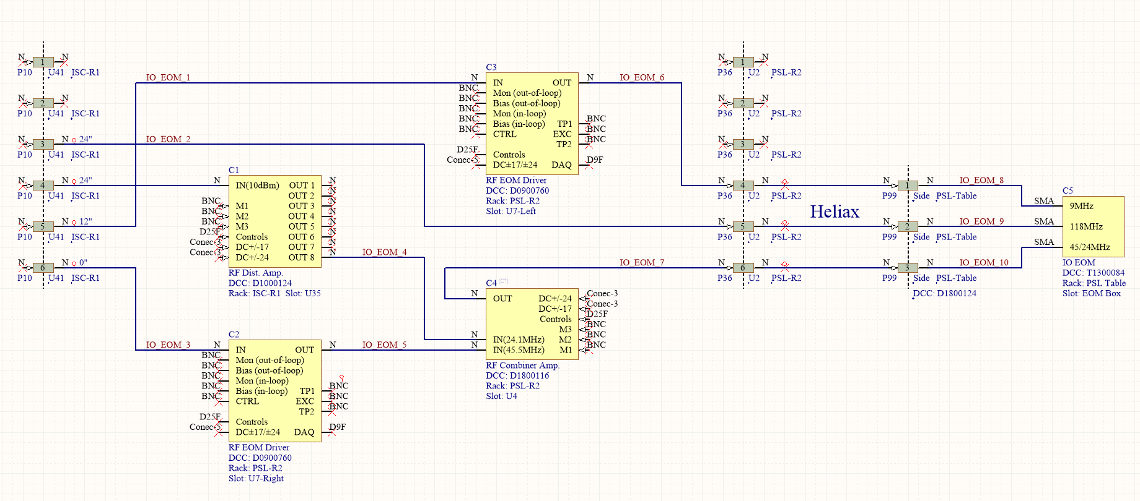
Figure 2: Schematics of the EOM Driver Setup

