LIGO Laboratory / LIGO Scientific Collaboration

LIGO-T1700542-v1 LIGO Date

Jitter Attenuation Cavity Design

Jian Liu, Rick Savage, Kentaro Mogushi, Daniel Sigg.

Distribution of this document:
LIGO Scientific Collaboration

This is an internal working note
of the LIGO Laboratory.

California Institute of Technology  LIGO Project | Massachusetts Institute of Technology  LIGO Project
LIGO Hanford Observatory | LIGO Livingston Observatory
http://www.ligo.caltech.edu/

Introduction
This document is a follow-up of the original Jitter Attenuation Cavity (JAC) design by D.Sigg [1]. The detailed design of JAC including cavity configuration choosing, mode matching and detailed layout of all the related optics are described. Issues related to the JAC performance are also discussed. The theoretical estimation of JAC performance shows that it meets the jitter noise requirements.

Jitter noise in aLIGO
Beam jitter is the variation of the beam position and propagation direction and the fluctuation of beam size, it is a critical technical noise in aLIGO which can limit the sensitivity of aLIGO. Beam jitter couples higher order optical modes with fundamental optical mode in the interferometer though misalignment of any of the optical components and mode mismatching between two arm cavities. In the DC read-out scheme, the jitter contaminated light will pass the output mode cleaner and get detected in the detection port, resulting jitter noise in the signal [2].
During the aLIGO second observation run (O2) in LIGO Hanford observatory, jitter noise exceeded the requirement (safe factor of 10) and showed up as a broad band hump in the differential arm (DARM) signal from tens of Hz to kHz. Highest noise hump was seen around 400 Hz which is about a factor of 3 above the short noise level. The jitter noise in DARM is highly correlated with accelerometers located on PSL table and the input periscope [3] and the beam size jitter is also witnessed by the bull’s eye sensor. The jitter noise source in Hanford is believed to be mainly caused by the cooling water flow in the high power oscillator (HPO), which causes the beam size jitter and vibrates the PSL table at the same time. The pre-mode-cleaner (PMC) attenuates some of the jitter from HPO. However, the optical components after PMC pick up the vibration from the table and couple it to the laser beam when the laser beam bounces off the optical surface. A point absorber was found in ITMX which made the jitter problem even worse [4]. This pointer absorber not only confused the wave front sensor and cause the interferometer misalignment, but also caused mode mismatch between the two arms. Both of these effects increased the jitter coupling. The higher beam jitter in the IO laser beam and higher coupling induced by the point absorber together made the sensitivity of LIGO Hanford worse then the expectation. While at the same time,
Great efforts had been made to reduce the jitter noise. Moving the beam position on the mirror surface to avoid the point absorber reduces the jitter coupling [5]. However, this method has a side-effect of reducing the power recycling gain. They need to be compromised to achieve the best sensitivity. Jitter noise contaminated data can be cleaned by offline noise subtraction [6] by using some auxiliary channels such as PSL bull’s eye sensor and the IMC wave front sensor as jitter witnesses. During the upgrading between O2 and O3, a 70 W laser amplifier will be installed to replace the problematic HPO. This will reduce the water flow and thus reduce the beam jitter. Its performance will remain unknown until the detector back to commissioning mode again [7]. The ITMX has been replaced recently to get rid of the point absorber [8].
However, these approaches may solve the jitter problem temporarily for now. If the detector operation power increases or squeezing is applied, the noise floor would drop, which will make the beam jitter a problem again. Here in this document, we propose to add a jitter attenuation cavity (JAC) in HAM1 before the input mode cleaner to solve the jitter problem. The proposed JAC will reduce the beam jitter by a factor of 40, which would be enough for higher power operation in O3. Together with other even jitter reduction methods, JAC would even be suitable for A+ upgrade as well.

Cavity optical design

Requirements
The detailed requirements of the JAC can be found in Daniel’s original document [1]. Based on the target sensitivity and misalignment of the interferometer, the estimated JAC attenuation factor for first order mode and second order should be no less that 40 and 60 respectlvily.

Number of mirrors
S-polarization light flips the phase each time when it bounces off a mirror surface, while the p-polarization doesn’t. Even number mirror cavity like the aLIGO PMC and OMC will have both the two polarization states resonating in the cavity at the same time, which would introduce intensity noise. Odd number mirror cavity can break the degeneracy of two polarization states. So we decide to make the JAC a triangular cavity. S-polarization light will be used since it has higher reflectivity and thus the cavity finesse is higher. This may require polarization rotation to match the polarization all the way from PMC to IMC.

Round-trip Gouy phase
The cavity round-trip Gouy phase determines the frequency mode-spacing between different order of transverse modes. Together with the cavity finesse, the cavity round-trip Gouy phase affects the capability of JAC to attenuate higher-order-modes (HOM).
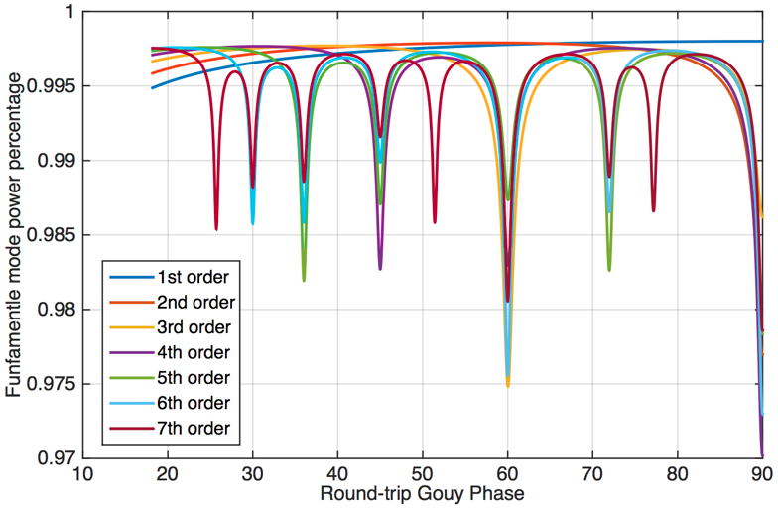
A simulation by injecting a combination of higher order modes together with fundamental mode into the JAC and then analysis the mode contents in the cavity transmission for different cavity round-trip Gouy phase was carried out by Kentato. In the simulation, we assume that 90% of the total input power is fundamental mode and the rest 10% of power is evenly distributed into higher order modes. The JAC output modes contents is shown in the figure. We sweet the cavity length from 0.1 m to 2 m, corresponding to the cavity round-trip Gouy phase change from 17 degrees to 90 degrees. If we only inject fundament mode and first order mode, there is no deep in the sweeping range of Gouy phase. If we inject fundamental mode together with first and second order modes, a deep occurs at 90 degrees. This is because if the round-trip Gouy phase is 90 degrees, TEM11 mode will have a phase shift of 360 degrees. This results in the degeneracy of fundamental mode and TEM11 mode, thus TEM11 mode is not attenuated at all. Same story happens if we inject third order of modes together with all the lower order modes, a deep occurs at 60 degrees due to the degeneracy of fundamental mode and TEM03 and TEM21 modes. It is easy to understand that the deep at 45 degrees, 36 degrees (72 degrees), 30 degrees and 26 degrees (52 degrees and 78 degrees) are caused by degeneracy of fundamental mode with 4th ,5th, 6th and 7th order of modes respectively.
If we want to maximize the attenuation factor of JAC, we would like to avoid the deeps in the figure above. The initial LIGO triangular and aLIGO bowtie PMC has different Gouy phase separation of 55.3 and 100 degrees. They not only avoid accidental resonances of HOM, but also give good attenuation of HOM and suppression of laser noise at the RF modulation frequency. The JAC round-trip Gouy will be chosen from these two values.

Mirrors
For JAC mirrors, higher reflectivity index brings higher cavity finesse, thus better attenuation factor. But this also increases the circulating power inside the cavity which can potentially damage the mirror coating and causing strong thermal effect. The JAC finesse is defined by equation below:
$$F= \frac{π}{2\sin^{-1}(\frac{1-r_{1}r_{2}r_{3}}{2\sqrt{r_{1}r_{2}r_{3}}})}$$
Here r1 r2 and r3 are the amplitude reflectivity of individual mirrors in JAC. The curved mirror will be a super polished high reflectivity coated mirror with only a few tens of ppm transmission. So the JAC finesse is determined by the two flat mirrors. We choose to use the same flat mirror as used in the aLIGO PMC with the power transmission coefficient T equals 2.48% at 1064 nm wavelength. This gives a cavity finesse of 125, which is similar aLIGO PMC. As for the curved mirror, it will be easier and more economical if the same mirrors (ROC = 3 m) as aLIGO PMC are used. However, smaller curvature mirror means more compact configuration which may benefit us in installation. In the next section, cavity configurations using different curvature mirrors and target round-trip Gouy phase are discussed.

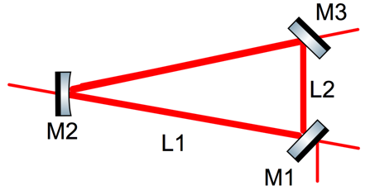
Cavity size
The JAC configuration is shown in the figure below, M1 and M3 are the input and output coupler. M2 is the curved mirror. The distance between flat mirror and curve mirror is L1 and the distance between the flat mirror and curve mirror is L2. The incident angle on the curved mirror is chosen to be 5 degrees.
The round-trip ABCD matrix of JAC is defined as blow [9]:
$${RT}_{±}=S\left(L_{1}\right)M_{±}F\left(R_{±}\right)S\left(L_{1}\right)M_{±}S\left(L_{2}\right)M_{±}=\left(\begin{matrix}A & B \\ C & D\end{matrix}\right)$$
The round-trip Gouy phase $ζ$ is then given by the ABCD matrix:
$$ζ=sign\left(B\right)∙\cos^{-1}\left(\frac{A+D}{2}\right)$$
Here S and F are ABCD matrix of a free space and a curved mirror respectively.
$$S\left(L\right)= \left(\begin{matrix}1 & L \\ 0 & 1\end{matrix}\right)$$
$$F\left(R\right)= \left(\begin{matrix}1 & 0 \\ -2/R & 1\end{matrix}\right)$$
M± is the reflect matrix which represents the the phase flip of the horizontal modes when the beam id reflected from a mirror surface, the signs + and – corresponds vertical and horizontal modes respectively. The definition of M± is:
$$M_{±}=\left(\begin{matrix}±1 & 0 \\ 0 & ±1\end{matrix}\right)$$
M± is important for an odd-number-mirror cavity, it results in the phase separation of pi between same order horizontal and vertical polarized modes, making the cavity mode structure more complicated. Besides, the curved mirror behaves as an astigmatic mirror due to the non-zero incident angle. The effective radius of curvature of vertical and horizontal modes are:
$$R_{±}=R∙{\left(\cos{θ}\right)}^{±1}$$
Using the equations above, we can derive the round-trip Gouy phase of the JAC is:
$$ζ_{+}= \cos^{-1}\left(1- \frac{L_{2}+{2L}_{1}}{Rcosθ}\right)$$
$$ζ_{- }=\cos^{-1}\left(1-\frac{{(L}_{2}+2L_{1})∙cosθ}{R}\right)$$
It shows that the round-trip Gouy phase is a function of the cavity round-trip length and the ROC of the curved mirror. Different target round-trip Gouy phase and mirror ROC are used to obtain the cavity configuration, the results are shown in the table below:
If the vertical modes are our target modes ( $ζ_{+}$= target Gouy phase)
ROC(m)  RT,L1,L2(m)  Gouy(deg) | 3 | 2 | 1 | aLIGO PMC
$ζ_{+}=$55.3 | 1.2872  0.5920  0.1032 | 0.8582  0.3947  0.0688 | 0.4291  0.1973  0.0344 | 0.51 (long arms)  0.10 (short arm)
$ζ_{+}=$100 | 3.5075  1.6132  0.2812 | 2.3384  1.0755  0.1875 | 1.1692  0.5377  0.0937
If the horizontal modes are our target modes ( $ζ_{-}$= target Gouy phase)
ROC(m)  RT,L1,L2(m)  Gouy(deg) | 3 | 2 | 1 | aLIGO PMC
$ζ_{+}=$55.3 | 1.2971  0.5966  0.1040 | 0.8647  0.3977  0.0693 | 0.4324  0.1989  0.0347 | 0.51 (long arms)  0.10 (short arm)
$ζ_{+}=$100 | 3.5344  1.6255  0.2833 | 2.3563  1.0837  0.1889 | 1.1781  0.5418  0.0944
If no astigmatism
ROC(m)  RT,L1,L2(m)  Gouy(deg) | 3 | 2 | 1 | PMC
55.3 | 1.2922  0.5943  0.1036 | 0.8614  0.3962  0.0691 | 0.4307  0.1981  0.0345 | 0.51 (long)  0.1 (short)
100 | 3.5210  1.6193  0.2823 | 2.3473  1.0795  0.1882 | 1.1736  0.5398  0.0941
It can be seen from the table that if the curved mirror ROC is 3 m or 2 m it is better to set the target Gouy phase to be 55.3 degree, otherwise the cavity size will be too big, which will make it hard to install it in HAM1. If the mirror ROC is 1 m, then 100 degrees would be a better choice than 55.3 degree. Because the flat mirror separation is too small for two 1in mirrors. Since astigmatism affects only a little of the cavity configuration. We decide to use the the configurations shown in table 3.

Power density
Once the cavity configuration is decided, the beam size on each mirror is fixed. Table blow shows the beam size along the prorogation in the JAC.
ROC (m) | 3 | 2 | 1 | aLIGO PMC
Waist size (mm) | 0.6458 | 0.5277 | 0.4085 | 0.548/0.711
Beam size on cured mirror (mm) | 0.7287 | 0.5957 | 0.6338 | 0.72
Beam size on flat mirror (mm) | 0.6464 | 0.5282 | 0.4104 | 0.57

As can be seen from the table above, the beam on the flat mirror is smaller than that on the curved mirror. The maximum power density on the flat mirror should below the coating damage threshold. It is hard to know the exact damage threshold power of the mirror coating so we use aLIGO PMC as a good reference since they share the same flat mirror. If the maximum power density on the JAC flat mirror is similar to that for aLIGO PMC, we consider it is safe. The power density on the mirror can be calculated by using the equation blow by assuming the maximum input power for PMC and JAC is 180W and 160W respectively:
$$Power density=\frac{P_{in}∙Finesse}{{(π∙ω)}^{2}}$$
ROC (m) | 3 | 2 | 1 | PMC
Maximum power density (kW/mm²) | 4.85 | 7.26 | 11.8 | 7.02
When the curved mirror ROC is 2 m, the maximum power density on the flat mirror is close to the PMC. The cavity configuration of using 2 m curvature mirror is more compact than the other two options, so the curved mirror with 2m ROC will be the final choice. It is also important to point out that, unlike the PMC, the JAC will be installed in a high vacuum chamber. The heat dispassion is not as efficient as PMC. The accumulated heat would damage the mirror even the power density is similar to PMC. More investigation about the thermal effect needs to be carried out to make sure the JAC will be safe to operate at full power.

Mode structures
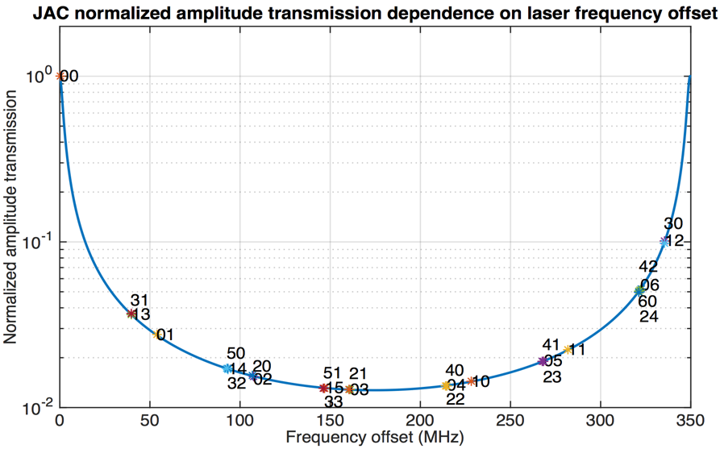
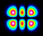
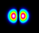
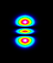
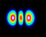
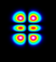
Unlike the four-mirror aLIGO PMC, the JAC optical mode structure is more complicated. The JAC mode structure needs to be checked carefully to make sure that no higher-order modes resonant in the bandwidth of fundamental mode. The figure blow shows the JAC (ROC = 2 m) amplitude transitivity within a FSR. Frequency spacing between high-order and fundamental optical modes are shown in the plot as well. There are no high-order modes which lies within the line width of the fundamental mode. The transmission value at each high-order mode frequency is actually the JAC attenuation factor for that mode. For example, the attenuation factor for TEM01 and TEM10 and TEM20 mode are 40 (2.7% transmission), 60 (1.6% transmission) and 70 (1.4% transmission) respectively.

Summary of the JAC parameters.
Parameters | Value | Units
Number of mirrors | 3
Polarization | ‘S’
ROC of curved mirror | 2 | m
Flat mirror transmission | 2.48 | %
Curved mirror transmission | 80? | ppm
Finesse | 125
Power build-up | 40
Round-trip length | 0.8614 | m
FSR | 348.27 | MHz
Cavity pole frequency | 1.393 | MHz
Long arm length | 0.3962 | m
Short arm length | 0.0691 | m
Incidence angle on flat mirror | 44.75 | Deg.
Incidence angle on curved mirror | 5 | Deg.
Waist size | 0.5277 | mm
Waist position | mid-way flat mirrors
Beam size on curved mirror | 0.5957 | mm
Beam size on flat mirror | 0.5282 | mm
Maximum power density (assuming max input = 160 W) | 7.27 | kW/mm2
Rayleigh range | 0.821 | m
Round-trip Gouy phase for horizontal modes | 55.413 | Deg.
Round-trip Gouy phase for vertical modes | 55.184 | Deg.
Attenuation at modulation frequency 9.1 MHz | 15 | %
Attenuation at modulation frequency 45.5 MHz | 3 | %
Attenuation of TEM01 mode (parallel to polarization) | 2.7 | %
Attenuation of TEM10 mode (perpendicular to polarization) | 1.6 | %
Attenuation of TEM20 mode | 1.4 | %

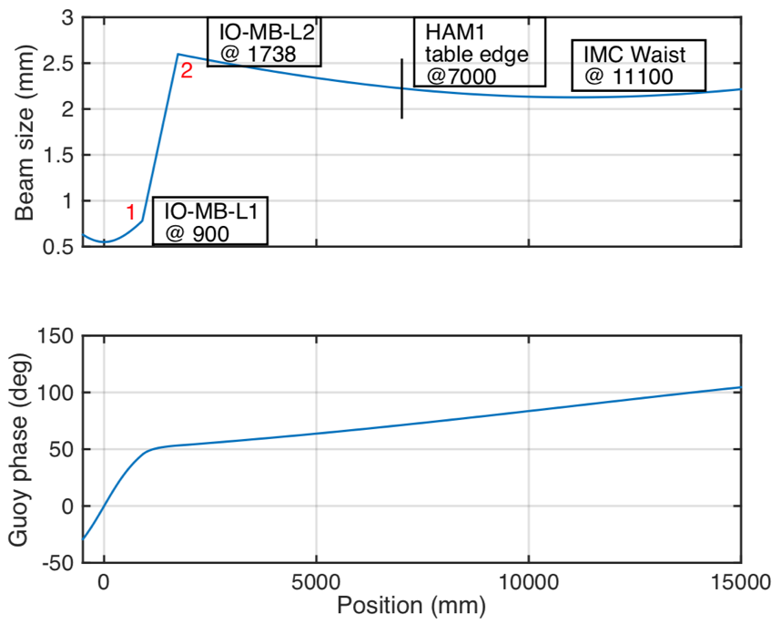
Mode matching
Currently, the PMC is mode matched to IMC using a two lens telescope, a combination of positive and negative lenses is used to reduce the distance required to mode match. This result is selected to reduce the sensitivity of mode matching to positioning and ROC errors. The layout of the mode matching from PMC to IMC is shown in figure below. The measured as-built distance between components are also shown as well. Specifications of the two lenses can be seen in E1100118-v2. Both lenses are industrial standard (CVI laser catalog) and will be kept on the PSL table in order to maintain the beam size properties on the PSL table. The optical distance of the edge of HAM1 table (including an 8 inches’ optical height periscope to lower the beam to 4 inches above the table) is about 7 meters away from the PMC waist. The mode matching telescope from PMC to JAC will be located after this point.
Mode matching from PMC to JAC is done in the same way as that from PMC to IMC, both using a combination of negative and positive lenses. The result can be seen from the figure below. Depending on the way input beam direction into the JAC, the mode matching strategy is slightly different. If the optical path in JAC will be such that the beam goes to the far end mirror first instead of going to the mirror which is close to the input mirror, so the target waist here we are matching to is the conjugate waist of JAC which is located before the JAC input mirror HR surface at the same distance as the real inner waist (midway between two flat mirrors HR surfaces). If the optical path will be the other way that the beam goes to the output coupler first, then the target waist will be the real inner waist. The lenses chosen here are from the super polished lenses which are left form iLIGO and squeezing. It is important to point out that the first lens should be a two inch lens to enable easy aiming of the input beam from the PSL.
Mode matching from JAC to IMC is easier compared with that from PMC to JAC, the only constrain here would be that the optical distance from JAC to IMC should be larger than the physical distance between HAM1 center and HAM2 center plus the two periscope height. There will be plenty of space in HAM1 for installation of JAC mode matching lenses to IMC. But in order to save space for future use, the solution with minimum possible optical path is chosen. An in-vacuum modulator will be placed after the JAC output mirror as well as PZT mirrors is necessary, so the solution must allow enough space for them.
The completed mode matching from PMC to JAC and then to IMC is shown in the figure below.
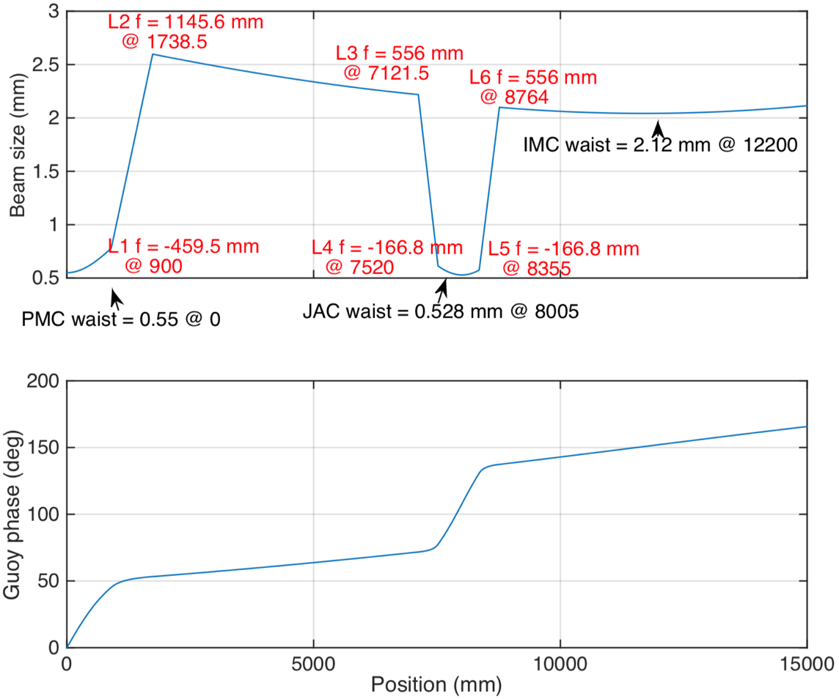

Lay-out in HAM1
HAM1 table is not very crowded currently, there is enough space for JAC installation. However, the layout should be space efficient incase there will be more future installations. The proposed layout in HAM1 table is shown below. Minimum number of mirrors are used to avoid the affection of any imperfections of mirror surface.
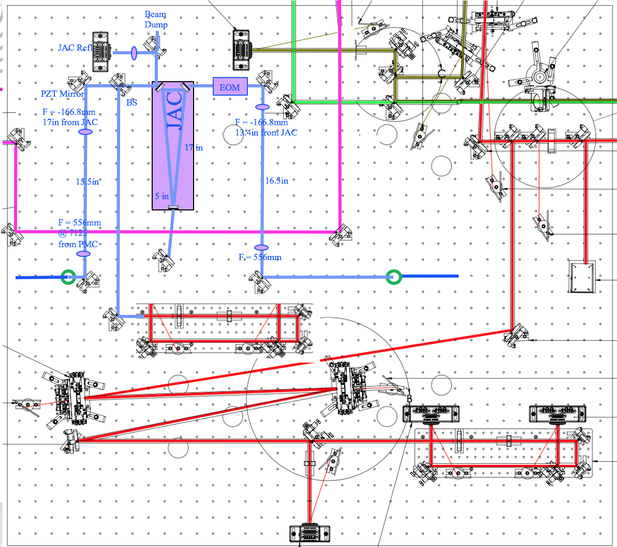

Issues

High power beam dump
When JAC is unlocked, almost all of the input laser power (about 160 W if the HPO is running at the full power) is directly reflected from the JAC input mirror. Some of this reflected beam is picked off and then focused to a photo detector whose signal will be used for JAC locking. The rest of the power needs to be dumped appropriately. It is better to dump the beam outside the chamber in order to reduce the strong heating effect that may affect the other optics. The proposed way of dump this beam is to direct the beam out through the lower right-hand side window on the chamber door. A high power beam dump will be mounted outside the window.

JAC Locking
Modulation frequency and depth? Requirements for the locking loop?

Alignment sensing and control
Input alignment from PSL to JAC, PZT feed back loop, requirements for the control bandwidth. Align the beam from JAC to IMC, Strain gauge PZT or just picometer?

In-vacuum modulator
Koji

Feed throughs
Enough?

In-vacuum jitter measurement
Jitter measurement after JAC or after IMC? Necessary?

HAM1 table motion
The HAM1 and HAM2 relative motion needs to be taken into consideration in order to determine the method that the out put beam from JAC is directed to IMC. If the motion is below some threshold, then picometers will be enough to maintain good input alignment. However, if the motion is large, a feedback control loop utilizing PZT mirrors will be needed to keep the input alignment. Here the threshold motion is defined as the motion that the motion induced misalignment would result the IMC power fluctuation by one percent.
Currently, there is no motion sensors on H1 HAM1 table. In L1 there are two vertical L4C sensors on the HAM1 table. Together with the PEM accelerometer on the ground close to HAM1, the transfer function of motion from the ground to HAM1 table at Z direction can be compute. Assuming the vibration HEPI systems in the two sites behaves similar and using the ground motion data from the HAM1 side sensor in H1, the motion of HAM1 table in vertical degree of freedom can be computed.
The involved channels are listed blow:
L1: HP1-HAM1_TTL4C_V1_IN1_DQ,
L1: HP1-HAM1 _TTL4C_V2_IN1_DQ,
L1: PEM_CS_ACC _LVEAFLOO R _HAM1_Z_DQ.
All these channels need to be calibrated from CDS counts to physical units before analyzed.

Thermal effect

References
[1], Daniel Sigg, etc. Jitter Attenuation Cavity (JAC) design, LIGO-T1600595-v3.
[2], Guido Mueller. Beam jitter coupling in advanced LIGO. Optical Express, Vol.13, No. 18, 7118, 2005.
[3], R, Schorfield, LHO alog#36742.
[4], A, Brooks, LHO alog#36467.
[5], S, Dreyer, LHO alog#36957
[6], J. C. Driggers, LIGO-P1700260-v9
[7],
[8], B, Weaver, LHO alog#38873.
[9], Koji

