Title | Heater Driver Test Procedure
Author | Luis E. Sánchez, Caltech-LIGO
Date | 2 February 2017
Hardware Version | PCB D1600454-v1 in Chassis Assembly Drawing D1700493-v1

Overview
This procedure is used to verify proper operation of the Heater Driver Chassis. This chassis operates at voltages of ±18VDC (that can be increase to a limit of ±24VDC); portions of this procedure assume that the person performing the test be familiar with voltage circuit testing, SR785 Dynamic Signal Analyzer and Keithley 2450 Source Meter. The Test Technician or Engineer MUST be a LIGO approved Qualified Electrical Worker specifically authorized to work on energized equipment.

Table 1
Chassis Serial Number
Date
Tested By
Overall Test Result | PASS | FAIL
 | ☐ | ☐

DC Measurements Section

Power ON
Use power supply to verify that modules are power up by inspecting that front and rear panel led are lightning on after the main power switch is turn on. Remove the positive power rail and check if the led are off in both rear and front panel locations. Connect the positive rail and proceed to remove the negative power rail and verify that the led are off in both the rear and the front panel locations. Record the results in the following table; mark each measurement as Pass or Fail.
Table 2 Power Rail
Power Rail(v) | Specified Value | Measured Value | LED | Pass | Fail
±18v supply ON | ±18v +/- 0.5v |  | ON | ☐ | ☐
+18V Supply OFF | 0v |  | OFF | ☐ | ☐
-18V Supply OFF | 0v |  | OFF | ☐ | ☐

Quiescent current draw
External to the chassis under test insert a Fluke Multi-meter in series with each power form and measure the power supply current. Record the results in the following table. Mark each measurement as Pass or Fail.
Table 3 Quiescent Current Draw
Quiescent Current Draw (mA) | Specified Value | Measured Value | Pass | Fail
+18V Supply | 200mA +/- 5mA |  | ☐ | ☐
-18V Supply | -230mA +/- 5mA |  | ☐ | ☐

Electronic Fuse, current limit verification
Set Keithley 2450 to verify current limit. During this test unplug the power connection from Marchand PM21 board and Heater driver board. Only Electronic Fuse and Power Protection circuit must be connected to power. Connect the Keithley as the image below.
Table 4 Electronic Fuse Current Limit Draw
Quiescent Current Draw (mA) | Specified Value | Measured Value | Pass | Fail
+18V Supply | 930mA +/- 5mA |  | ☐ | ☐
-18V Supply | 880mA +/- 5mA |  | ☐ | ☐
-I
Electronic FUSE
+V
-I
Electronic FUSE
-V
Set-up to measure the current for the short circuit protection characteristic of the Electronic Fuse, using the Keithley 2450. Positive voltage, sourcing current measuring voltage a), and Negative voltage, sourcing current measure voltage b).
a)
b)
Keithley 2450
Keithley 2450

Test Procedure
Attach a 75Ω test load to the Heater Driver output, 4 pin CPC Connector, label as “To SR3 Heater”.
Connect Breakout Board – DB9 (D0901868) to “I/V Monitor to ADC” and “From DAC” on chassis. Test as in Table 5, Injecting voltage to “From DAC” pins and Monitoring on “I/V Monitor to ADC” pins.
Table 5
Front Panel “From DAC”  (Input Voltage) |  | “I/V Monitor to ADC”  (Differential Output Voltage) |  |  |  | Specified Result  1-6 & 3-8 | Measured Value  1-6 & 3-8  ±0.2v | Specified  Result  Voltage  Load(75Ω) | Measured  Voltage  At Load(75Ω) ±0.3v v | Pass | Fail
 |  | +V(volts) |  | -V(volts)
Pin | Volts(DC) | Pin | Volts(DC) | Pin | Volts(DC) | Volts(DC) | Volts(DC) | Volts(DC) | Volts(DC) | Test | Test
3-8 | 1 | 1-6 | +2 | 3-8 | -2 | ±2 |  | 6 |  | ☐ | ☐
3-8 | 2 | 1-6 | +4 | 3-8 | -4 | ±4 |  | 12 |  | ☐ | ☐
3-8 | 3 | 1-6 | +6 | 3-8 | -6 | ±6 |  | 18 |  | ☐ | ☐
3-8 | 4 | 1-6 | +8 | 3-8 | -8 | ±8 |  | 24 |  | ☐ | ☐
3-8 | 5 | 1-6 | +10 | 3-8 | -10 | ±10 |  | 30 |  | ☐ | ☐

To verify currents, see test on Table 6.

Table 6

Front Panel “From DAC”  (Input Voltage) |  | “I/V Monitor to ADC”  (Differential Output Current) |  |  |  | Specified Result  2-7 & 4-9 | Measured Value  2-7 & 4-9  ±.3v | Specified  Result  Load (75Ω) | Measured  Current  At Load(75Ω)  ±.02mA | Pass | Fail
 |  | Current Monitor in Volts
Pin | Volts(DC) | Pin | Volts | Pin | Volts | Volts | Volts(DC) | Amperes | Amperes | Test | Test
3-8 | 1 | 2-7 | 1.5 | 4-9 | -1.5 | ±1.50 |  | 0.08 |  | ☐ | ☐
3-8 | 2 | 2-7 | 3 | 4-9 | -3 | ±3.0 |  | 0.16 |  | ☐ | ☐
3-8 | 3 | 2-7 | 4.5 | 4-9 | -4.5 | ±4.5 |  | 0.24 |  | ☐ | ☐
3-8 | 4 | 2-7 | 6 | 4-9 | -6 | ±6.0 |  | 0.32 |  | ☐ | ☐
3-8 | 5 | 2-7 | 7.5 | 4-9 | -7.5 | ±7.5 |  | 0.40 |  | ☐ | ☐

Set Up the SR785 to take the transfer function from Whitening Filter located in Heater Driver board.
For each channel, verify that the transfer function and noise spectra are in conformance with the following data. For the transfer function the input signal need to be injected at pins 1 and 6 of J1 and the relay jumper needs to change to 2-3 position. Remember to set it back when the test is finalized.

Table 7, Transfer Function with relay jumper on 2-3 position.

Pins |  | Predicted at 100Hz |  | Measure at 100Hz |  | Pass | Fail
DAC IN | OUT(I/V Mon.) | Gain (dB) | Phase(°) | Gain (dB) ±2dB | Phase(°)±2° | Test | Test
Pins 1-6 | 1 | 48 | -1 |  |  | ☐ | ☐
Pins 1.6 | 6 | 48 | -1 |  |  | ☐ | ☐
Pins 1-6 | 3 | 48 | -1 |  |  | ☐ | ☐
Pins 1.6 | 8 | 48 | -1 |  |  | ☐ | ☐

Table 8, Noise Predictions with “From DAC” input pins 3 – 8 grounded.

GND Pins  DAC IN | Pins  “I / V  Monitor to ADC” | Predicted  Noise at 100Hz (µV/√Hz) | Measure  Noise at 100Hz(±5µV/√Hz) | Pass | Fail
1-6 | 1 | 27 |  | ☐ | ☐
1-6 | 6 | 27 |  | ☐ | ☐
1-6 | 3 | 27 |  | ☐ | ☐
1-6 | 8 | 27 |  | ☐ | ☐

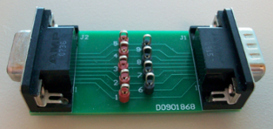 |  | 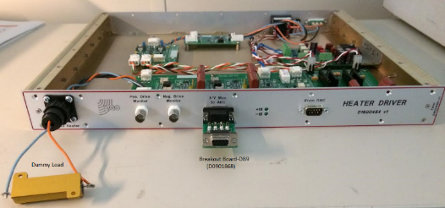
Figure 1 shows the DB9 (D0901868) breakout board used in this test. |  | Figure 2 shows the dummy load, 75Ω, connected to the heater driver output, CPC connector, label as “to SR3 Heater”. Also the breakout board –DB9 (D0901868) is seen connected to the “I/V Monitor to ADC”.
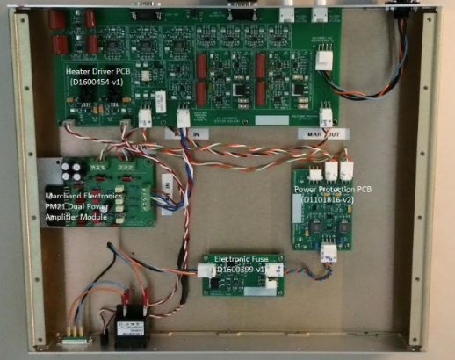
Figure 3 shows the heater driver setup inside the chassis, in this shows the heater driver pcb (D1600454-v1), the power protection circuit (D1101816-v2), the electronic fuse (D1600399-v1), and the Marchand Electronics PM21 dual power amplifier module. | Figure 4 shows the voltage response when the limit has been reach at the positive rail of the Electronic Fuse.

Figure 5 shows the floor noise of the SR785 Dynamic Signal Analyzer and noise from the heater driver (Differential Reading).

