Test Date | Jul. 14-17, 2017
Author(S) | Liyuan Zhang, GariLynn Billingsley
Approval(s)
Specification Doc. | LIGO-E0900041 | Specification | < 50 ppm
Procedure Doc. | LIGO-E1000863 | Mean ± Error* | 48 ± 5 ppm
Conclusion | Qualified
* Error is the sum of calibration error (~2%) and stray light.
Discussions and Comments:
The scan was done over a 160 mm diameter aperture with the beam and step sizes of 1 mm and positioning arrow on barrel at Y+ direction. The calibration is done by normalizing the AR reflection signal to the signal from a 1” HR mirror (T=70 ppm) and the variation of laser power during scan is monitored and corrected, the result is summarized in Fig.1.
The shallow fringes seem to be caused by interference between the AR reflection and the tail of strong beam of HR reflection. Since the wedge angle is only 0.07~0.1º (D080657), the separation of the two beam was not large enough in the measurement.

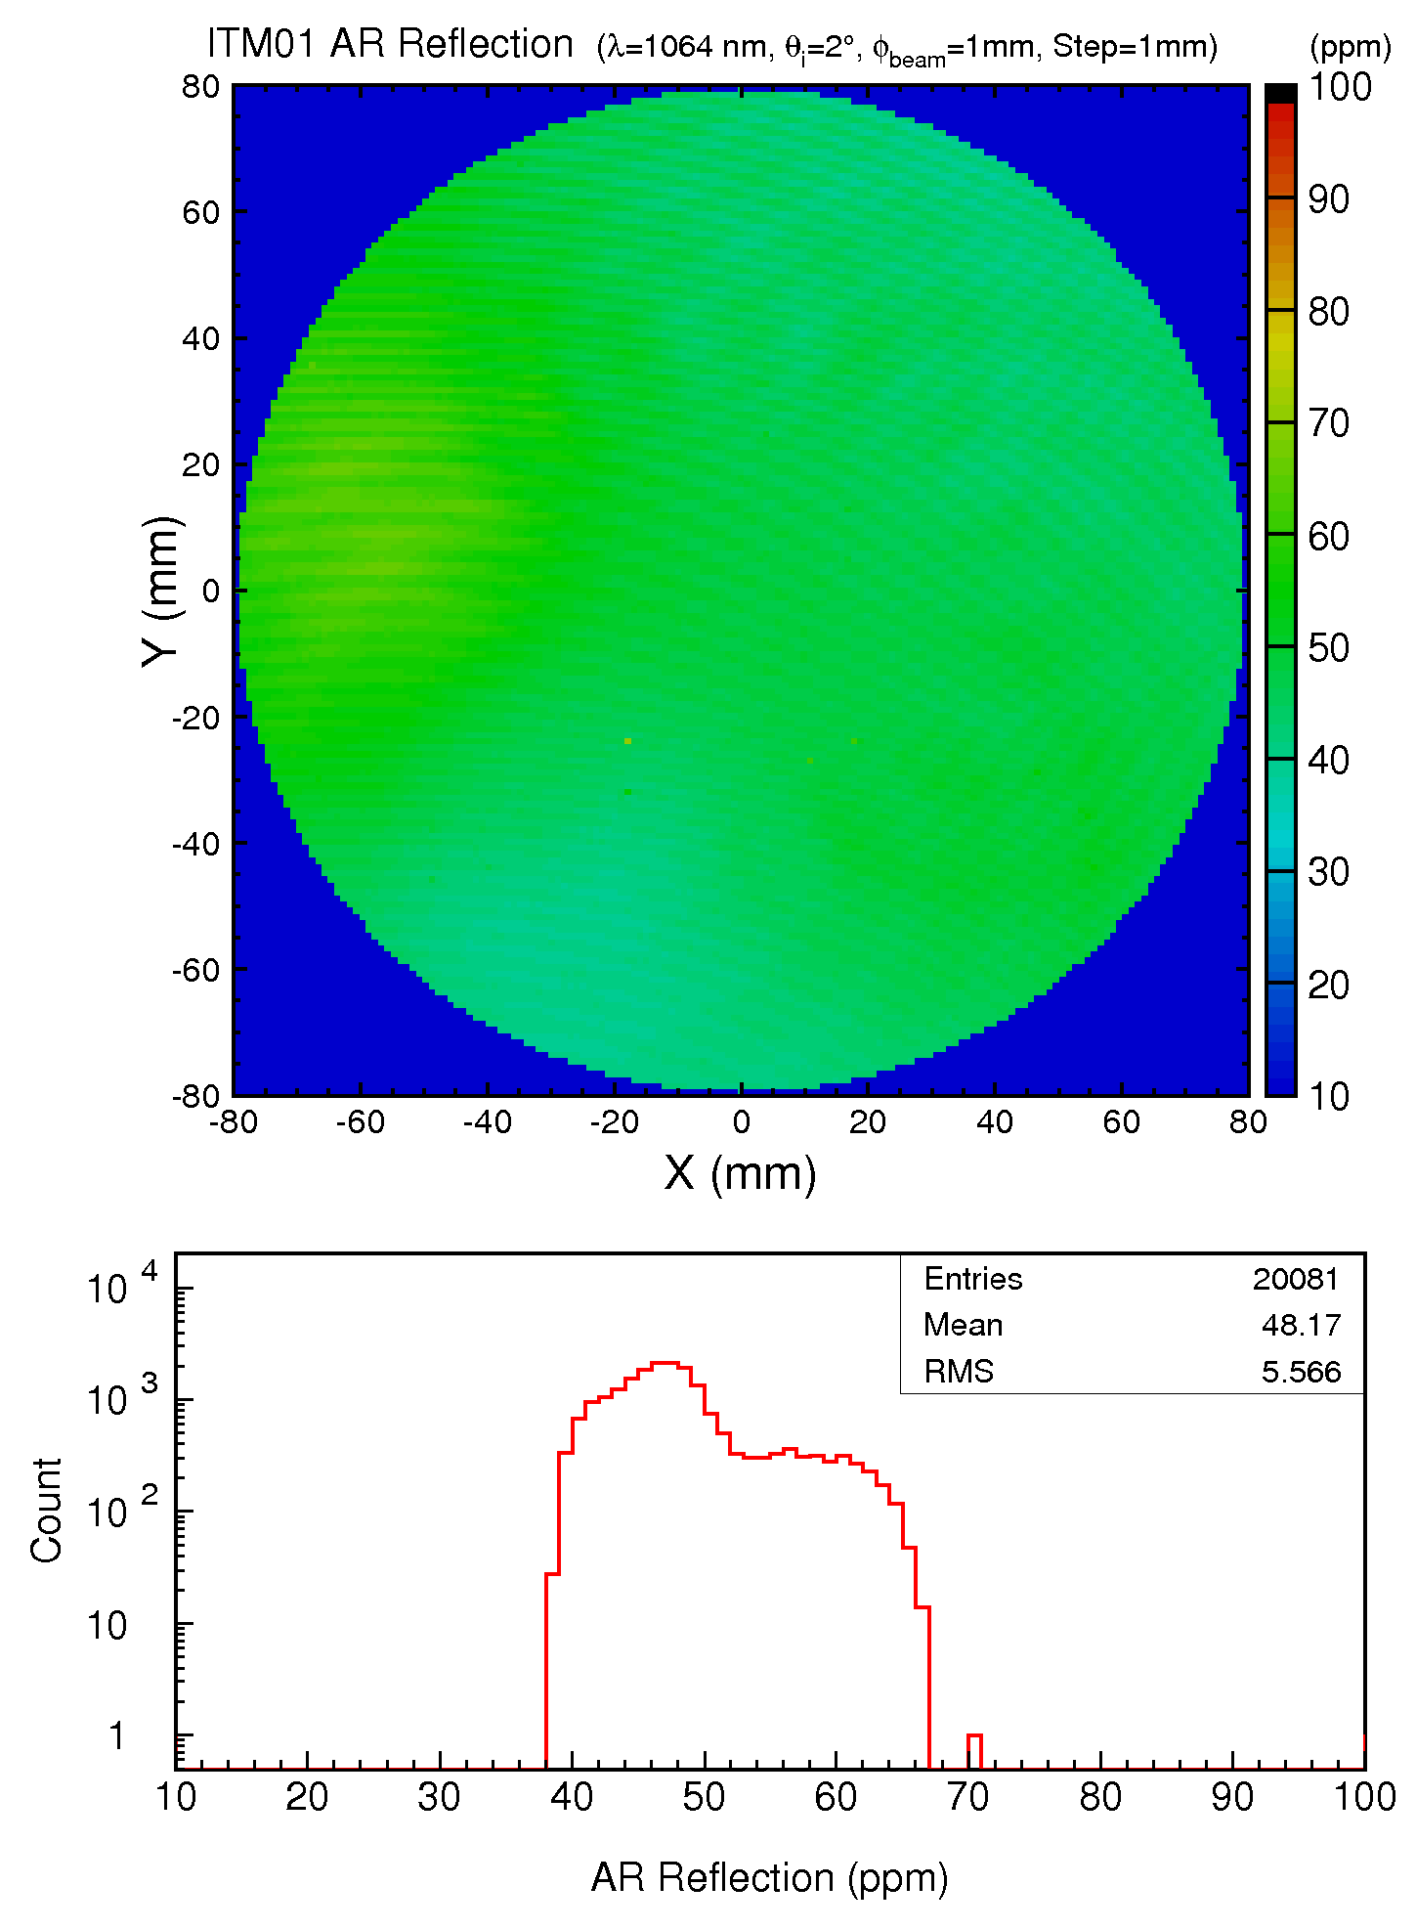
Fig. 1 ITM01 S2 AR reflection over a 160 mm diameter aperture.

