Test Date | May 15-19, 2017
Author(s) | Liyuan Zhang, GariLynn Billingsley
Approval(s)
Specification Doc. | LIGO-E0900041 | Specification | Not specified in E0900041
Procedure Doc. | LIGO-E1000863
1st Scan (Mean ± Error*) | 13.1 ± 2 ppm
2nd Scan (Mean ± Error*) | 13.8 ± 2 ppm
Conclusion | Qualified.
*An estimated systematic error from previous multiple measurements with one LIGO-1 mirror.
Discussions and Comments:
Two scans of TIS measurement are carried out on HR surface with positioning the arrow on barrel at Y+ direction. One is a full coverage scan over a 48 mm diameter aperture with the beam and step sizes of 0.3 mm and other a sampling scan over a 160 mm diameter aperture with the same beam size of 0.3 mm and step size of 1.0 mm, as shown in Figs. 1 and 2 respectively. The system was checked and calibrated with a 1” HR mirror (No.8128).

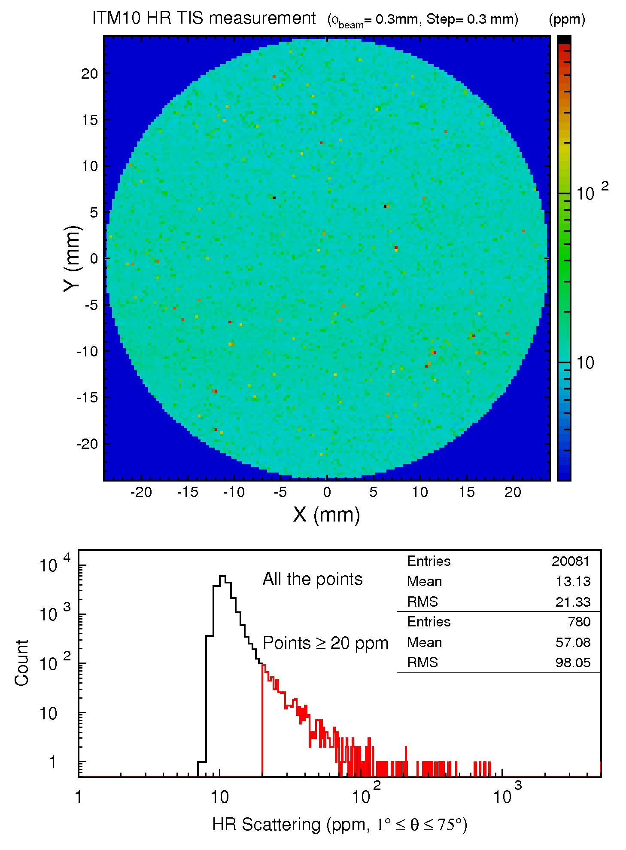
Fig. 1 ITM10 HR TIS measurement over a 48 mm diameter aperture.

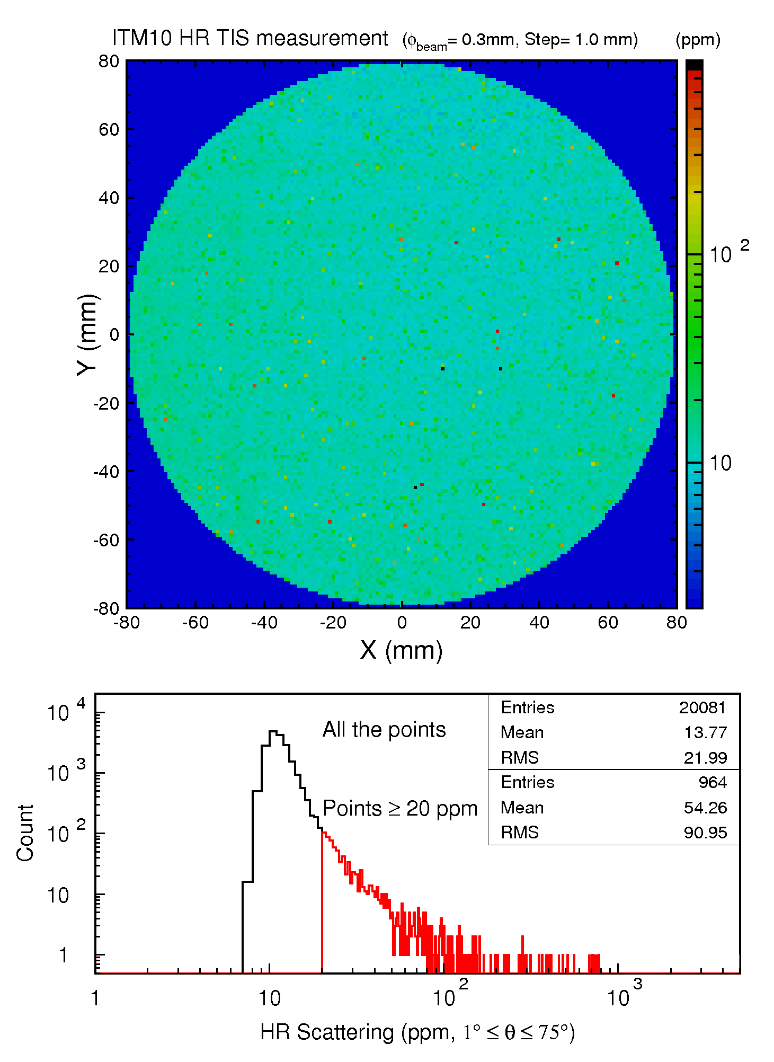
Fig. 2 ITM10 HR TIS measurement over a 160 mm diameter aperture.

