LIGO HANFORD OBSERVATORY
PO BOX 159
RICHLAND WA 99352

TEL: 509.372.8106
FAX: 509.372.8137

MEMORANDUM

DATE: June 5, 2017

TO: | ISC team
FROM: | Daniel Sigg
SUBJECT: | Modifications to the slow generic filter stage
Refer to: | LIGO-E1700187-v1

The slow generic filter stage of the revision E of the common mode board (D040180) contains a layout error with a missing junction/connection. This problem only manifests itself, if the generic stage uses either the Z2 or Z3 impedance circuit blocks.

To modify the PCB orient the board with the component side up and with the TNC/BNC connectors located at the top.

Solution A: Install a jumper or short between the left pads of C232 and R153. This will implement the missing junction/connection.

Solution B: Install a jumper or short between the left pad of C232 and the right pad of R149.This will connect Z3 to the negative input of the operational amplifier. The servo boards for the squeezer are using this solution to implement a lead filter.
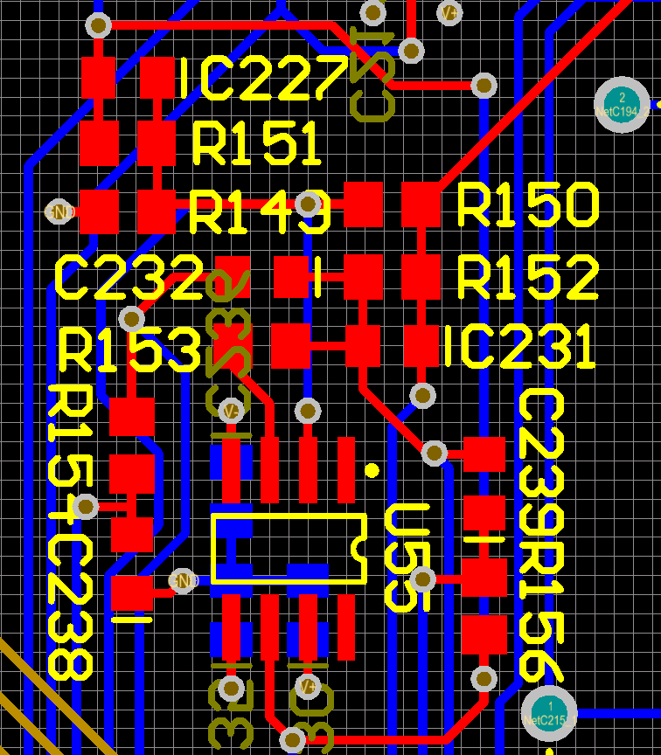
Solution A
Install short/jumper between left pads of C232 and R153.
Install short/jumper between left pad of C232 and the right pad of R149.
Solution B

