LASER INTERFEROMETER GRAVITATIONAL WAVE OBSERVATORY
-LIGO-

CALIFORNIA INSTITUTE OF TECHNOLOGY

MASSACHUSETTS INSTITUTE OF TECHNOLOGY

COLUMBIA UNIVERSITY IN THE CITY OF NEW YORK

Technical Note LIGO-T1700077-v1 Monday, February 20, 2017
Timing Witness Signals Indicate Trustworthy Timing for G274296, a Burst Event Candidate

Stefan Countryman, Zsuzsa Márka, Kenneth Rainer Corley
Columbia University

This is a working note
of the LIGO Project
https://dcc.ligo.org/ LIGO-T1500516

California Institute of Technology
LIGO Project – MS 51-33
Pasadena CA 91125
Phone (626) 395-2129
Fax (626) 304-9834
E-mail: info@ligo.caltech.edu
Massachusetts Institute of Technology
LIGO Project, MIT NW22-295,
185 Albany St.,Cambridge, MA 02139 USA
Phone (617) 253 4824
Fax (617) 253 7014

E-mail: info@ligo.mit.edu

Columbia University
Columbia Astrophysics Laboratory
Pupin Hall - MS 5247
New York NY 10027
Phone (212) 854-8209
Fax (212) 854-8121

E-mail: geco.cu@gmail.com

WWW: http://markalab.org/ http://www.ligo.caltech.edu

Synopsis

Advanced LIGO data is taken by a DAQ that is directly driven in hardware by the Advanced LIGO Timing Distribution System that ensures end-to-end hardware-based timing signal integrity between the received GPS signal and the ADC boards. The Advanced LIGO Timing Diagnostic System is a separate additional hardware that provides additional layers of timing information and crosschecks to enable us to have versatile diagnostic information.

As an extra precaution, we examined the timing witness signals to ensure that the aLIGO datastream’s timing was perfect around Event Candidate G274296, observed at 1171346771= Fri Feb 17 06:05:53 UTC 2017. We found that the DuoTone witness indicated excellent timing performance on the sub-microsecond level and the IRIG-B signals indicated precise second decoding.

- Introduction

The advanced LIGO timing system is implemented in hardware. Each and every board in the chain was tested multiple times in different environments, including end-to-end test using long fibers - it performs for tens of ns and the GPS is rated for few hundred ns. This is the primary performance measure of the well-working timing system that is below 1μs.

Additionally, independent hardware generated GPS synchronized timing witness channels are recorded along with the aLIGO datastream: the DuoTone and the IRIG-B datastreams at each end-stations. The phase of the DuoTone signals allows sub-microsecond accuracy determination of the datastream’s shift from the perfect agreement with the GPS time. Since the DuoTone signal is repeated in every second, it is prudent to also look at the IRIG-B signal that has a phase allowing time verification on the ms level and a full timecode allowing the determination of absolute YEAR:MONTH:DAY-HOUR:MINUTE:SECOND. Therefore the DuoTone and IRIG-B signals together cover all possible timeshifts, and the most feared small shifts redundantly.
In this document we provide visual proof that the phase of the witness signals did not move from the nominal value even for a second during the hour surrounding the G274296 event.

- DuoTone Signal Measurements

Each aLIGO ADC chassis contain a timing Slave board with a DuoTone daughterboard installed. The Slave-DuoTone assembly pairs provide the precise pulses that allow the ADC to record the aLIGO data at 65536Hz rate; the phase of this low phase noise ADC clock is synchronized to the GPS 1PPS rising edge. Besides this mission critical functionality, each DuoTone board provide a so called DuoTone diagnostic signal(Y):
Y1 = A * sin(2 * pi * 960 * ( T + ΔT ) );
Y2 = A * sin(2 * pi * 961 * ( T + ΔT ) );
Y = Y1 + Y2 + ΔA;
960Hz is chosen as it is a harmonic of 60Hz, to further preserve GW signal frequency space. The identical individual amplitude A is nominally 2.5V centered around ΔA =0V and ΔT describes the position of the GPS 1PPS rising edge compared to the 0° common phase of the generated DuoTone, which we call the ‘coincident zero crossing’ (the time where the phase of both sinusoidal components becomes zero). The coincident zero crossing clearly and unambiguously repeats once in every second. The sinusoids produced by the slave-duotone timing stack (see e.g. LIGO-E0900019) are thus hardware synchronized to the GPS time in every second with a well-characterized delay of ΔT for the zero crossing (see LIGO-T1500513), and therefore even order of ~>microsecond deviations in timing performance would result in alteration of duotone signal shape and change in zero crossing time.

We checked for deviations in duotone signal shape by ‘stacking’ 1 second long consecutive segments of duotone signals (i.e. plotting each 1 second long segments on top of each other). The data covered two half-an-hour long time intervals closest to the event candidate time. On figures 1-4, each consecutive second of the measured DuoTone signal was plotted and stacked on top of each other for a 30 minutes long data window. The x axis represents one second duration of DuoTone segments. Since the DuoTone repeats its waveform every second, ideally all DuoTone curves on the plot are identical to each other, and they should look like a single curve on the plot even though the plot has 30x60=1800 curves plotted on top of each other. If there are seconds where the timing of the DuoTone signals are shifted from the nominal value, or where the signal suffered some sort of degradation, noise, or glitching, the stacked signal’s curve would no longer resemble a single waveform, lose fidelity and the deviation from normal would be clearly visible to the human eye. In the next 4 pages (figures 1-4) we show the stacked curves for the X-end-stations of the LLO and LHO aLIGO observatories. There are no visible deviations from the normal—as intended, the signal is periodic to a high degree of accuracy, giving the stacked plots the appearance of a single second of DuoTone signal.

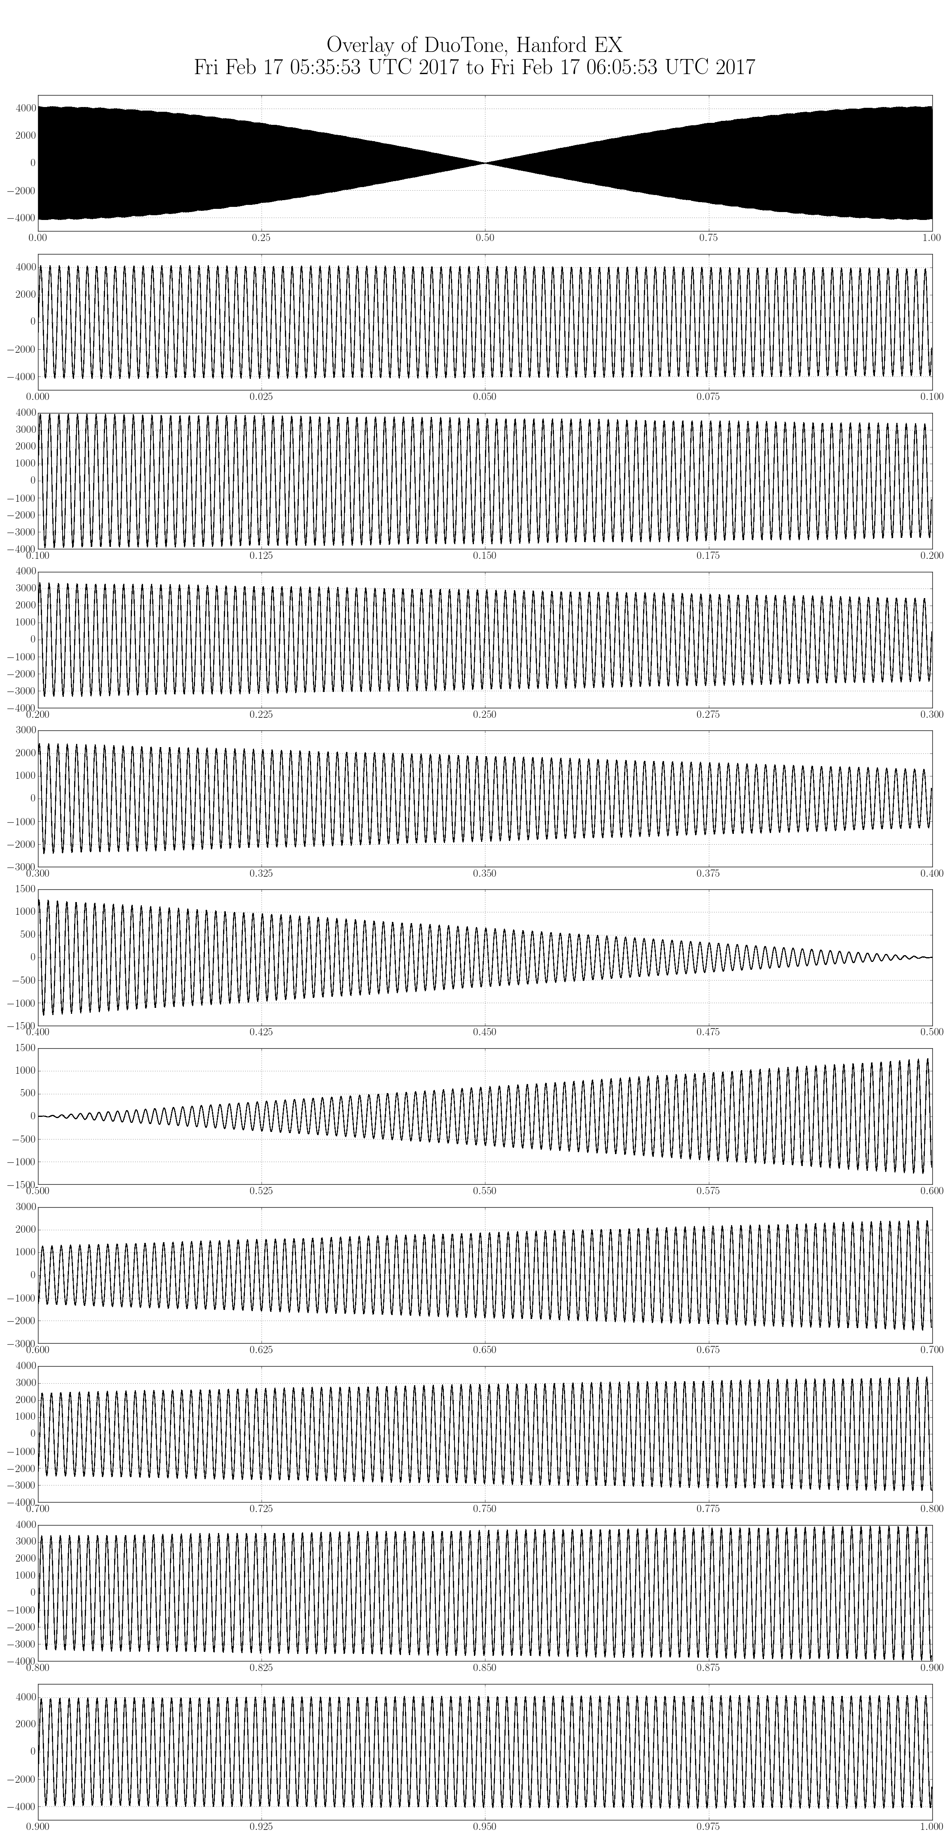
Figure 1
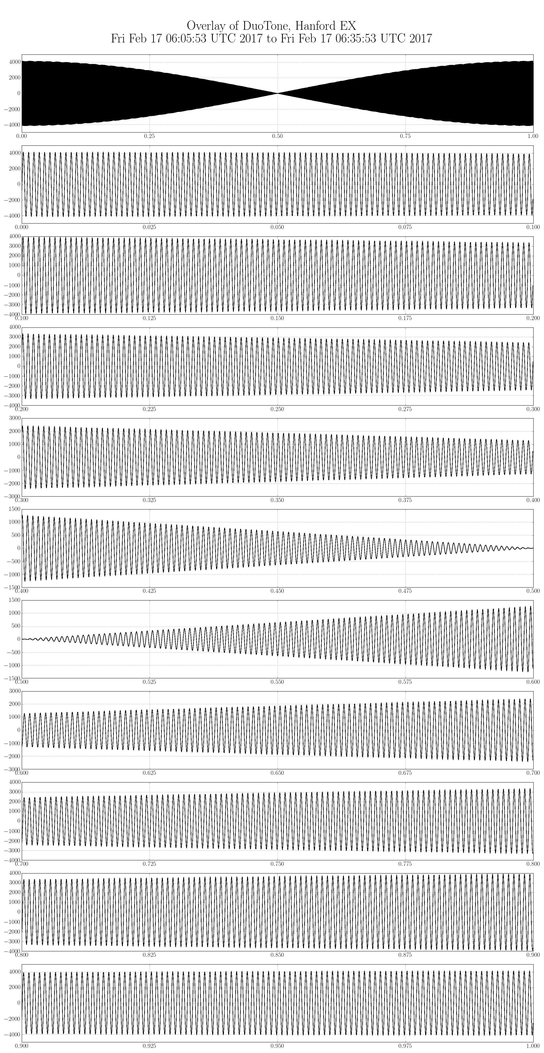
Figure 2
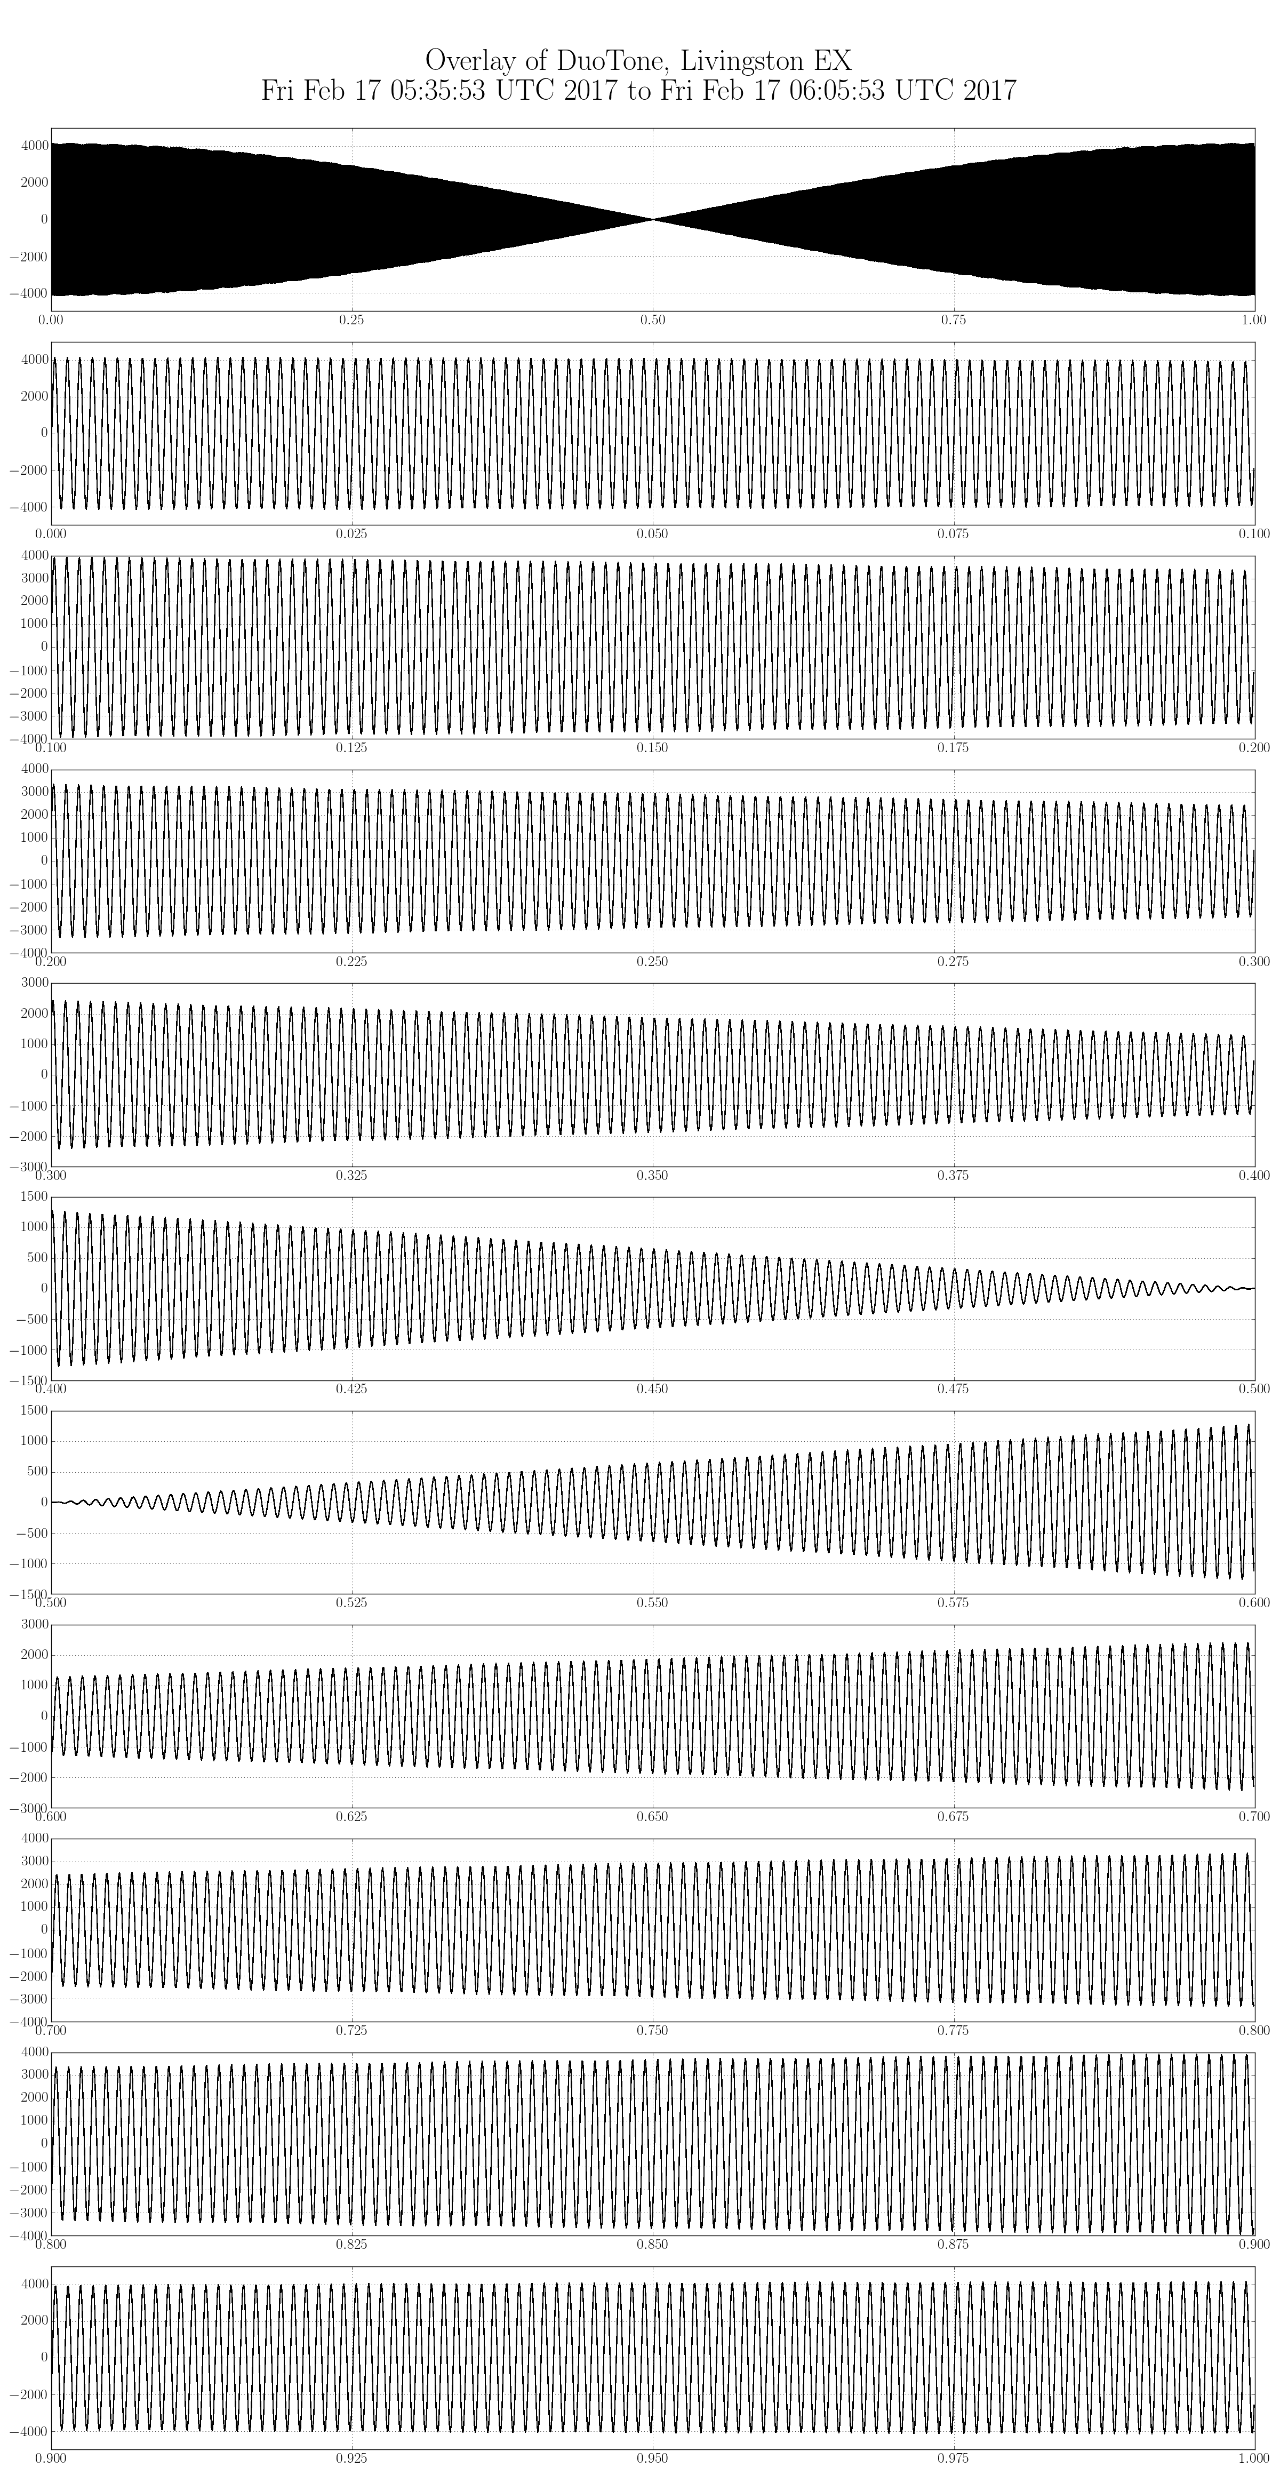
Figure 3
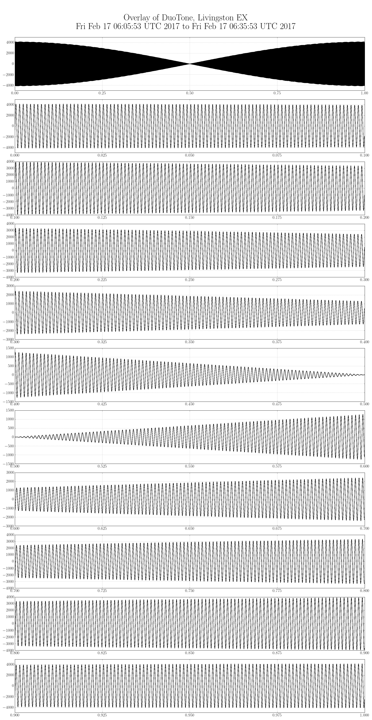
Figure 4

- DuoTone Signal Phase

Beyond stacking 1 second long segments of duotone signals on top of each other (see section 2), we also averaged the one second long waveforms and plotted the averaged DuoTone signal to verify the agreement and errors to higher accuracy.

The following 6 pages (figures 9-14) show the zero crossing region of the second-to-second average of the DuoTone witness signals around the second edge, zoomed-in at different magnifications in the x-axis. When the DuoTone signals are symmetric around the 0V level, the zero crossing should be delayed compared to the second tic of the datastream by ~63μs (6.7μs of this is due to and inherent delay on the timing Slave-DuoTone stack (see LIGO-T1500513), and the rest is due to 65536Hz to 16384Hz decimation filter (see Section 6 below).

On the figures the open circles reflect the average signal, the green error bars indicate the standard deviation, and the ends of the fine black error bars show the maximum/minimum for each data point. The line through the data points guide the eye to help visualize the zero crossing, which is most visible at the medium timescale plotted, and is at a bit above 63μs. The plots indicate precise agreement with the expected place of the zero crossing and confirm the independent verification measurement by LHO and LLO rapid response team discussed in Section 6 of this document.

The purpose of this study was not the measurement of the already known DuoTone delay, but to verify the stable microsecond-level performance of the timing system at around the time of the candidate event. The DuoTone witness signals indeed indicate very small errors: The highest magnification of a representative data point (the last plot of three for each detector) shows in green the standard deviation of measurements for the point closest to the zero crossing for the hour surrounding the G274296 event candidate and the error bars indicate the observed maximum and minimum.
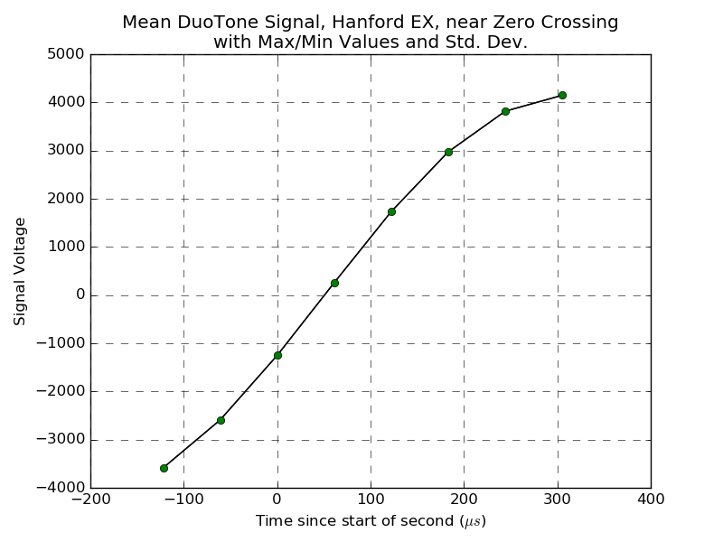
Figure 5: Zero crossing region of the second-to-second average of the DuoTone witness signals around the second edge at Hanford EX for the hour surrounding the G274296 event candidate. The line through the data points guide the eye to help visualize the zero crossing. Please note that the errors on each point are so small that they are covered by the circular symbol.

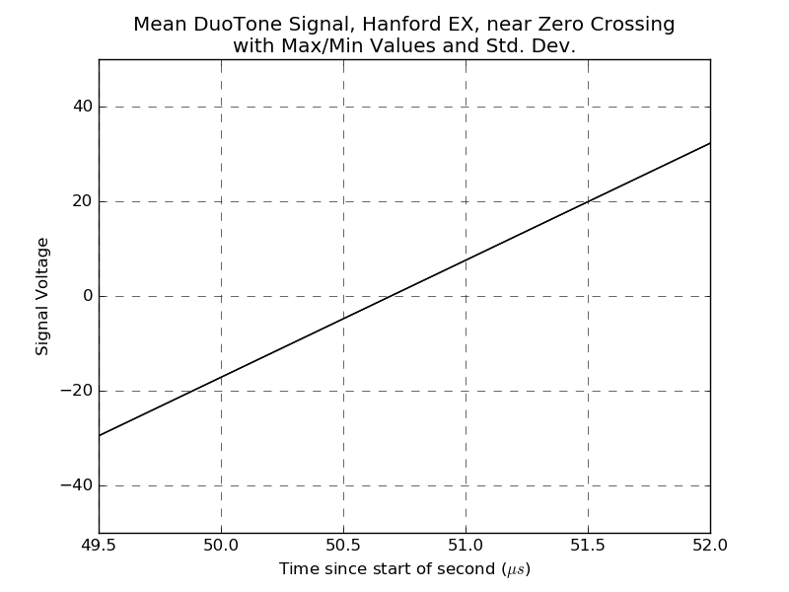
Figure 6: Zero crossing region of the second-to-second average of the DuoTone witness signals around the second edge at Hanford EX for the hour surrounding the G274296 event candidate. Open circle reflect the average signal, the green error bars indicate the standard deviation, and the ends of the fine black error bars show the maximum/minimum for each data point. Please note that the green error bar is so small that it is still covered by the circular symbol. The line through the data points guide the eye to help visualize the zero crossing which is best visible on this magnification setting and is at ~ 63.3μs, out of which 62.6μs =6.7μs (DuoTone generation delay) + 55.9 μs (decimation filter delay) is accounted for.
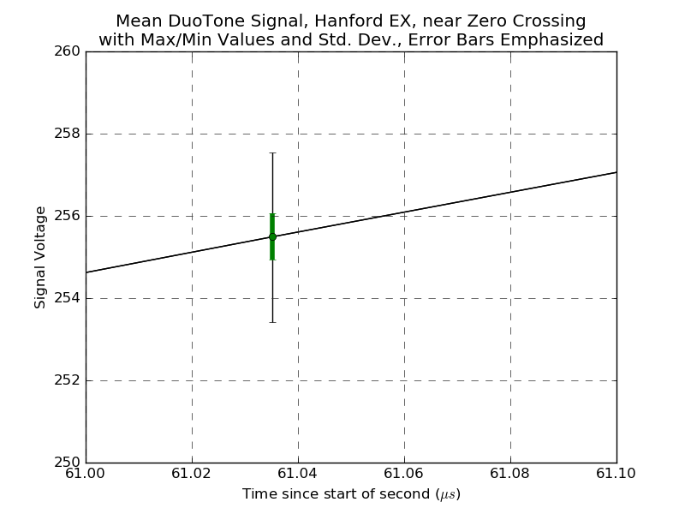
Figure 7: Zero crossing region of the second-to-second average of the DuoTone witness signals around the second edge at Hanford EX for the hour surrounding the G274296 event candidate. The open circle reflect the average signal, the green error bar indicates the standard deviation, and the ends of the fine black error bar shows the maximum/minimum for the data point. The size of the green error bar indicates very small error on the zero crossing.

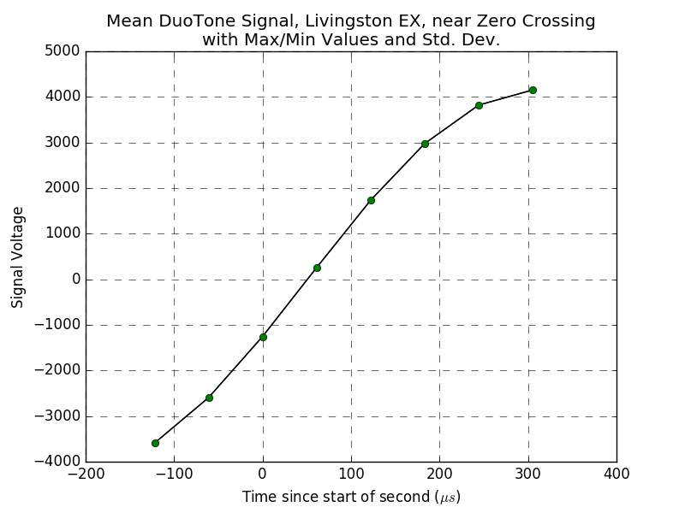
Figure 8: Zero crossing region of the second-to-second average of the DuoTone witness signals around the second edge at Livingston EX for the hour surrounding the G274296 event candidate. The line through the data points guide the eye to help visualize the zero crossing. Please note that the errors on each point are so small that they are covered by the circular symbol.
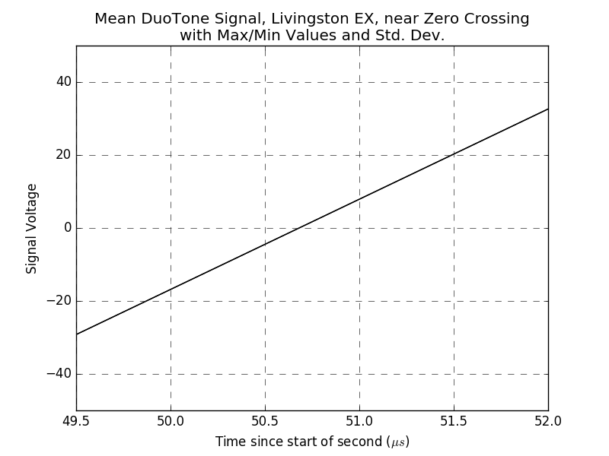
Figure 9: Zero crossing region of the second-to-second average of the DuoTone witness signals around the second edge at Livingston EX for the hour surrounding the G274296 event candidate. Open circle reflect the average signal, the green error bars indicate the standard deviation, and the ends of the fine black error bars show the maximum/minimum for each data point. Please note that the green error bar is so small that it is still covered by the circular symbol. The line through the data points guide the eye to help visualize the zero crossing which is best visible on this magnification setting and is at ~63.3μs, out of which 62.6μs =6.7μs (DuoTone generation delay) + 55.9 μs (decimation filter delay) is accounted for.
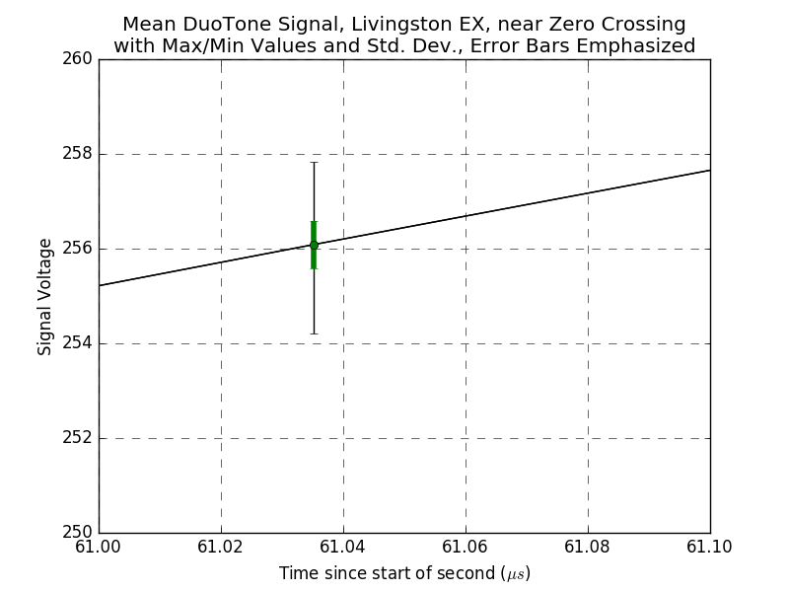
Figure 10: Zero crossing region of the second-to-second average of the DuoTone witness signals around the second edge at Livinston EX for the hour surrounding the G274296 event candidate. The open circle reflect the average signal, the green error bar indicates the standard deviation, and the ends of the fine black error bar shows the maximum/minimum for the data point. The size of the green error bar indicates very small error on the zero crossing.
- IRIG-B Signal Decoding

The IRIG-B signal from independent GPS clocks was digitized and recorded at each site in order to provide an independent cross-check for the aLIGO Timing System’s absolute timestamp. These signals were decoded (as specified in Timing IRIG-B Signal Decoding Test, T1500391) and plotted for the time of the candidate event G274296, observed at 1171346771= Fri Feb 17 06:05:53 GMT 2017. The time code was found to be in agreement with the timestamp of the datastream (note that Hanford’s IRIG-B signals are in GPS time; the 18 second difference with UTC is due to leap seconds). Figures 11 through 14 below show the externally generated IRIG-B signals at Hanford and Livingston along with their decoded times. They are consistent with the aLIGO Timing System’s timestamp as used by the aLIGO framewriting computers.

Figure 11
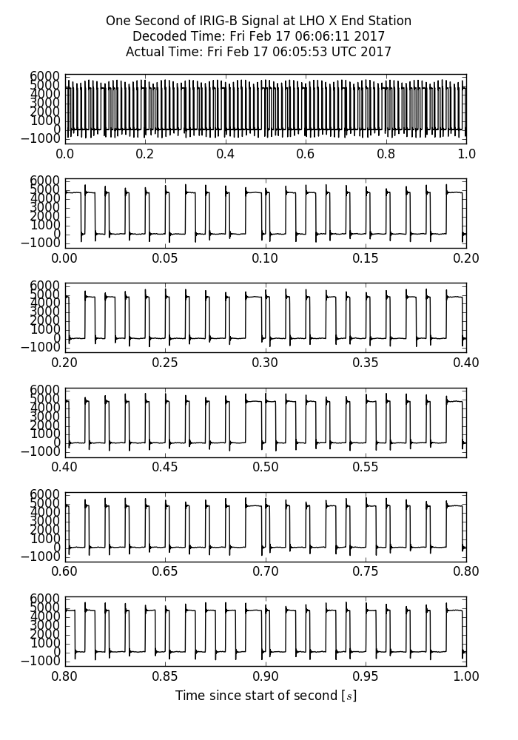

Figure 12
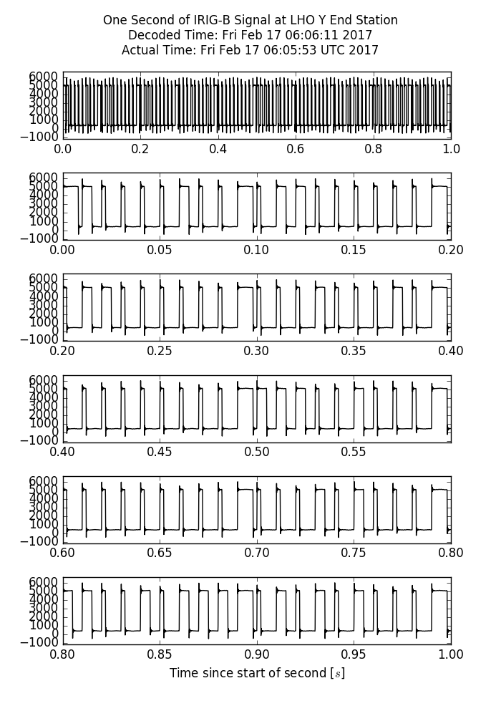

Figure 13
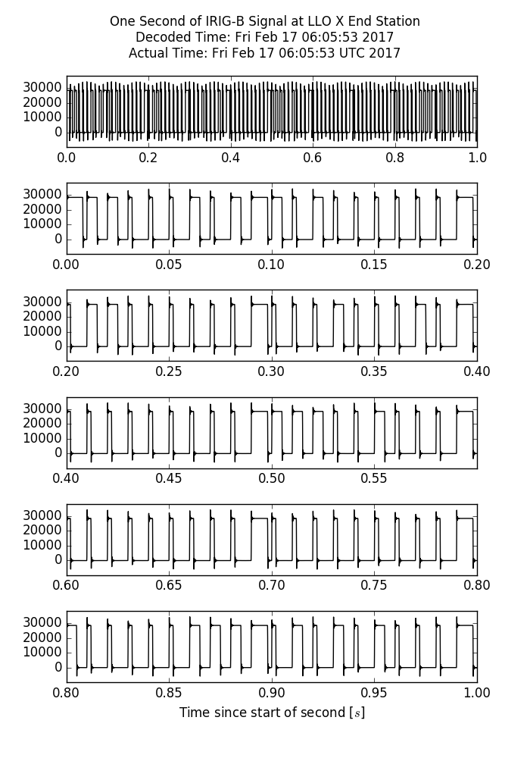

Figure 14
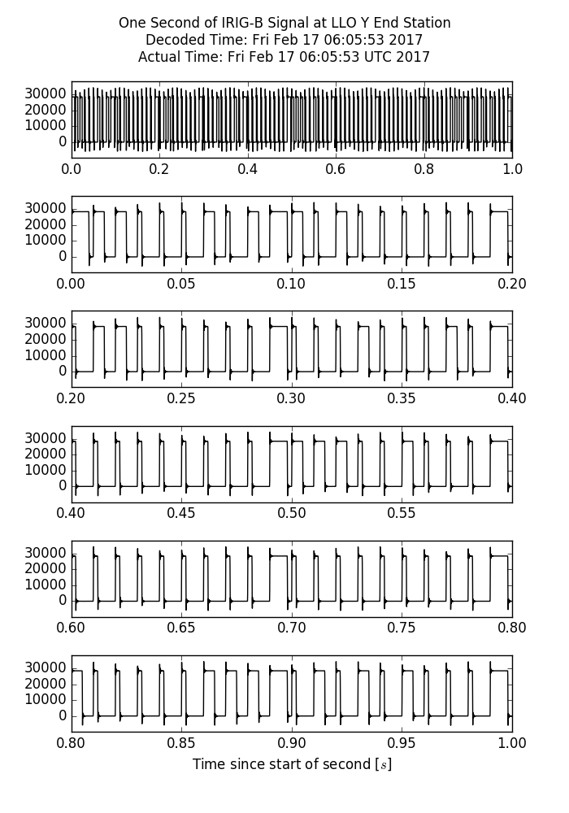

- Conclusion

All the sanity checks shown in this document indicate that the timing performance of the aLIGO detectors around the candidate event G274296, observed at 1171346771= Fri Feb 17 06:05:53 GMT 2017 is according to specifications.

