LASER INTERFEROMETER GRAVITATIONAL WAVE OBSERVATORY

-LIGO-

CALIFORNIA INSTITUTE OF TECHNOLOGY

MASSACHUSETTS INSTITUTE OF TECHNOLOGY

Document Type  Test Procedure | DCC Number  T1600542-v1 | Nov. 16th, 2016
TCS Laser Chiller Chassis Gain Revisions

B. Abbott

Distribution of this draft:
This is an internal working note of the LIGO Laboratory

California Institute of Technology Massachusetts Institute of Technology
LIGO Project – MS 18-33 LIGO Project – MS 20B-145
Pasadena, CA 91125 Cambridge, MA 01239
Phone (626) 395-2129 Phone (617) 253-4824
Fax (626) 304-9834 Fax (617) 253-7014
E-mail: info@ligo.caltech.edu E-mail: info@ligo.mit.edu

http://www.ligo.caltech.edu/

- Overview
The Thermal Compensation System (TCS) Laser Chiller Summing Chassis (D1500268-v1) houses a TCS Laser Chiller Summing Board (D1500265-V1), and a Chassis Power Supply Board (D1000217). It’s function is to supply a DC level and sum it in with the DAC command, to allow the DAC level to be near zero under normal operating conditions, and maintain its level when the DAC freezes up. Revisions are needed to lower the summing weight of the DAC path, so that the chiller does not trip the laser when the DAC is restarted.

Revisions to the TCS Laser Chiller Summing Chassis:
Pin 6 removal to stop grounding the negative DAC leg:
With a pair of needle-nosed pliers, forcibly extract pin 6 from the “From X-Arm DAC”, and “From Y-Arm DAC” connectors on the front of the TCS Laser Chiller Summing Chassis:

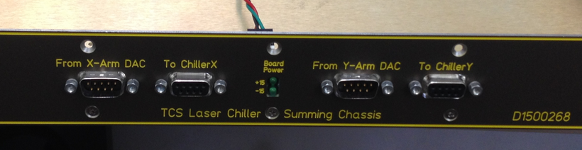
Here is a representation, using a different board as an example: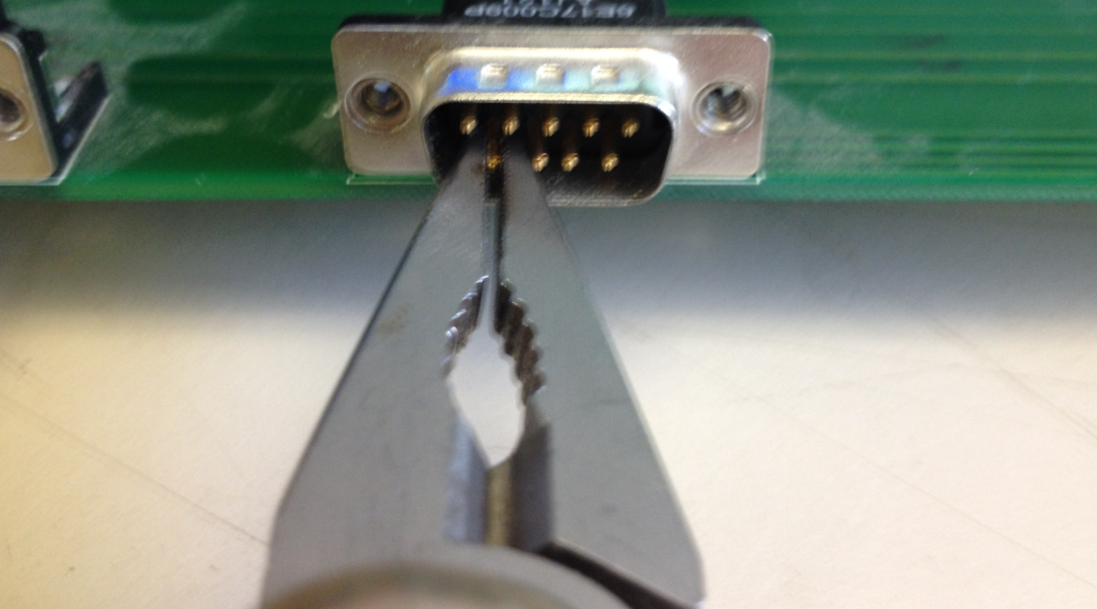

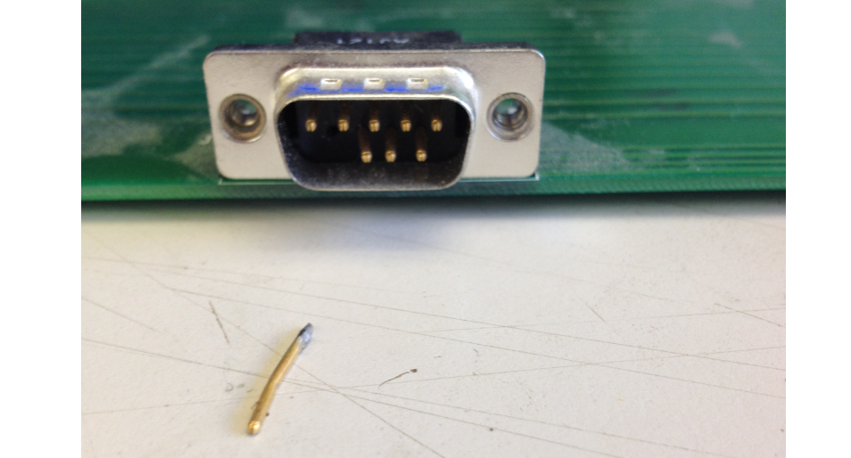

Discard the pin and remove the front panel, to expose the internal board:

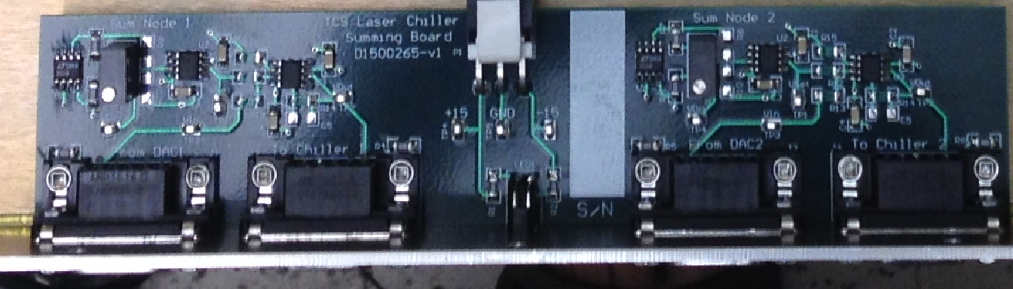

Four resistors need to be changed for each chiller (8 resistors total), to reduce the gain of the DAC path: R12, R13, R14, and R15. Here are the new values:
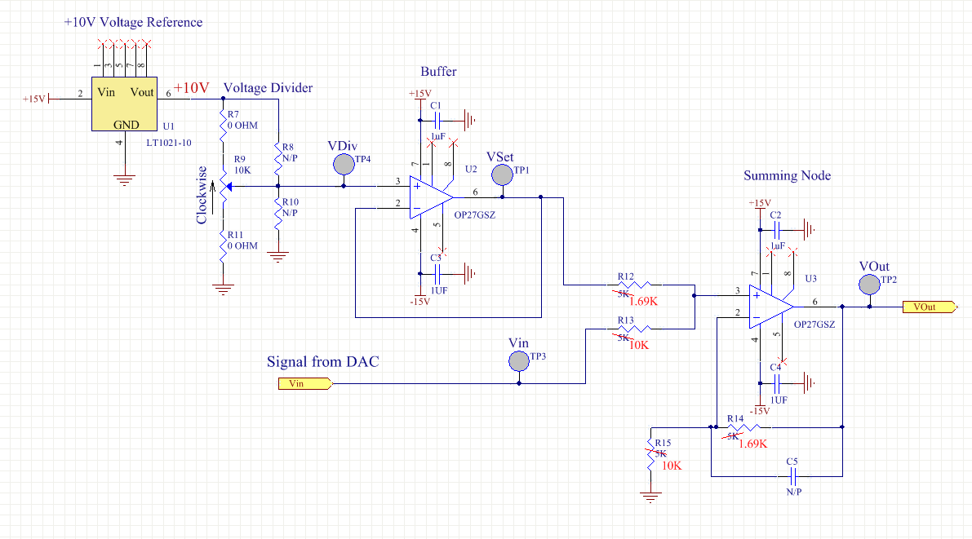
Example part numbers from Digikey are: (1.69K) P1.69KBCCT-ND and (10K) TNP10.0KACCT-ND.
Re-assemble the chassis, and check that the gain of the DAC path is 0.17V/V.

