Title | ETM Driver Noise vs. DAC Filter Usage
Author | R. Abbott, Caltech
Date | 26 October 2016

Overview
A quick note to describe the effect on output noise resulting from varying the number of DAC filter stages in the ETM LV Driver. The filter stages in question provide filtration of the intrinsic DAC noise present in the voltage spectrum of the LV ETM Driver (D1500016) DAC inputs.
Text three files containing the output noise spectra scenarios are located at the DCC file card associated with this document.

Section 1
The nominal transfer function from the DAC drive inputs to the wires leading to the ETM associated with the individual quadrant drives is shown below. This reflects being in the LV drive mode for the ETM LV Driver. All following plots include the effect of drive cable capacitance which is estimated at 1.5nF.

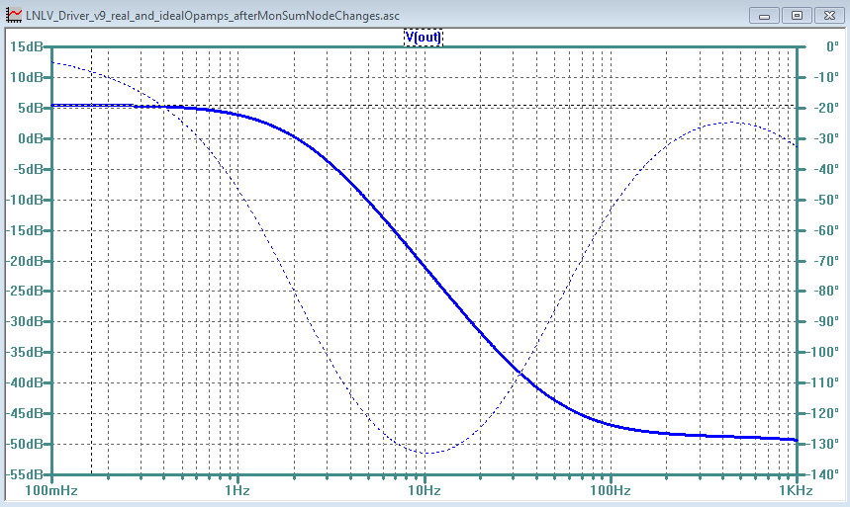

The resulting output noise spectrum for the nominal configuration is shown below.

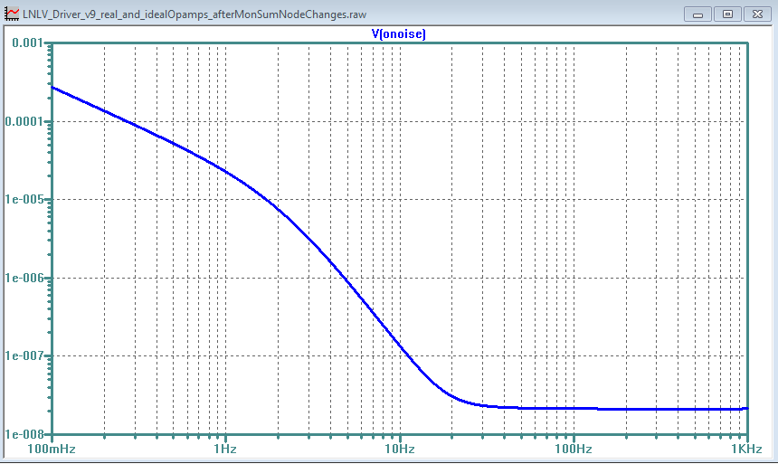

With only one stage of filtration (dewhitening) the resulting output voltage noise spectrum looks as shown below.

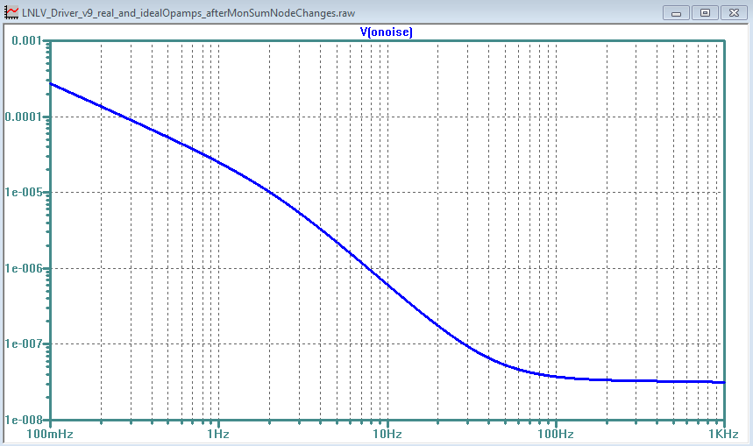

With no filter stages engaged, the output noise voltage spectrum is as shown below.

