Progress Report
2

Udochu, Ogbonnaya

SURF- LLO

Through the month of July, I engaged in and helped out with other vacuum related tasks. I made new tags for the large gate valves and attached these tags to the corresponding gates. These tags contain information about each large gate valve and will help for future documentation purposes. I also helped leak check BSC 2. There was no actual leak found but BSC 2 is being monitored. Finally, I aided in monitoring the rough down of BSC 4 and 5. Excel files we generated for the roughing down and also for the large gate valve tags. These files were later passed over to the vacuum review board for documentation.

Picking up from the last progress report, it should be noted that the RGA manifold has already been built. With the help of members from the vacuum team at LLO, we installed the RGA manifold pictured below unto HAM 6 located in the LVEA. Another RGA was built and installed unto the vertex. Since the RGAs are going to be introduced to the main volume, their installation was done in a clean room with the parties involved wearing a full bunny suit. To also prevent contamination of the main volume, there is a gate valve in-between the RGA manifold that was installed on HAM 6.

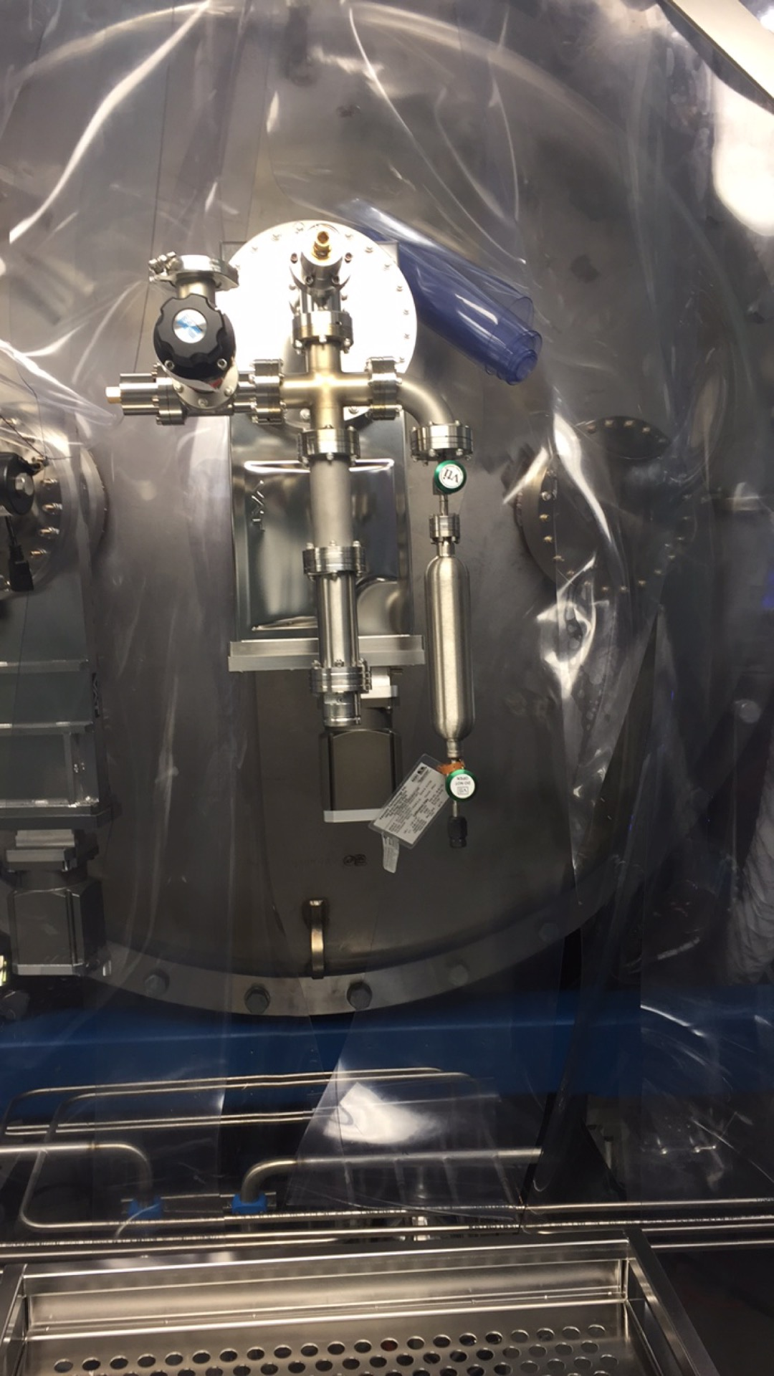
Fig 1: RGA manifold on HAM 6

After the installation, we prepared the RGA for baking by wrapping it in heat tape and foil. A cold cathode gauge as well as a turbo pump was used to pump down and monitor the pressure of the RGA during baking. Also, temperatures in Fahrenheit and Celsius were monitored as baking is to be done at a temperature of about 150ºC. Prior to baking, scans were taken for understanding as well as to know if the RGA was functioning properly.
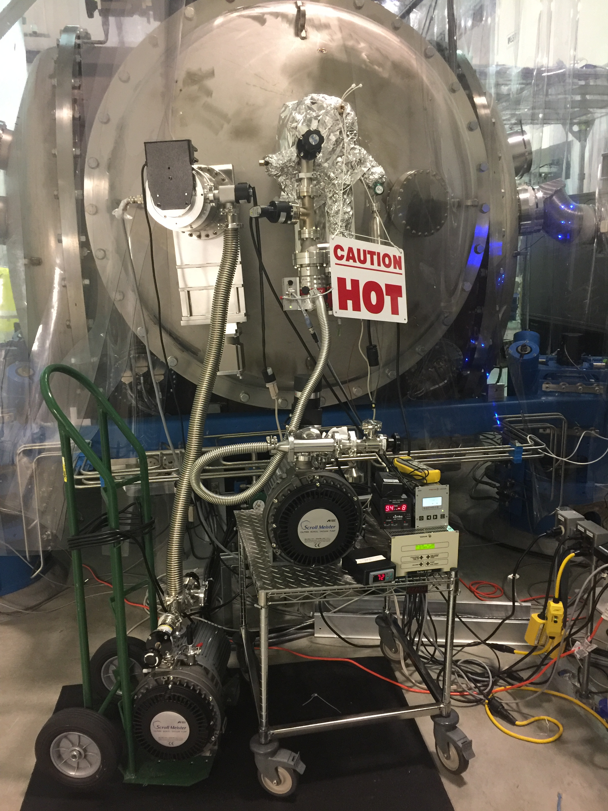
Fig 2: Baking of RGA
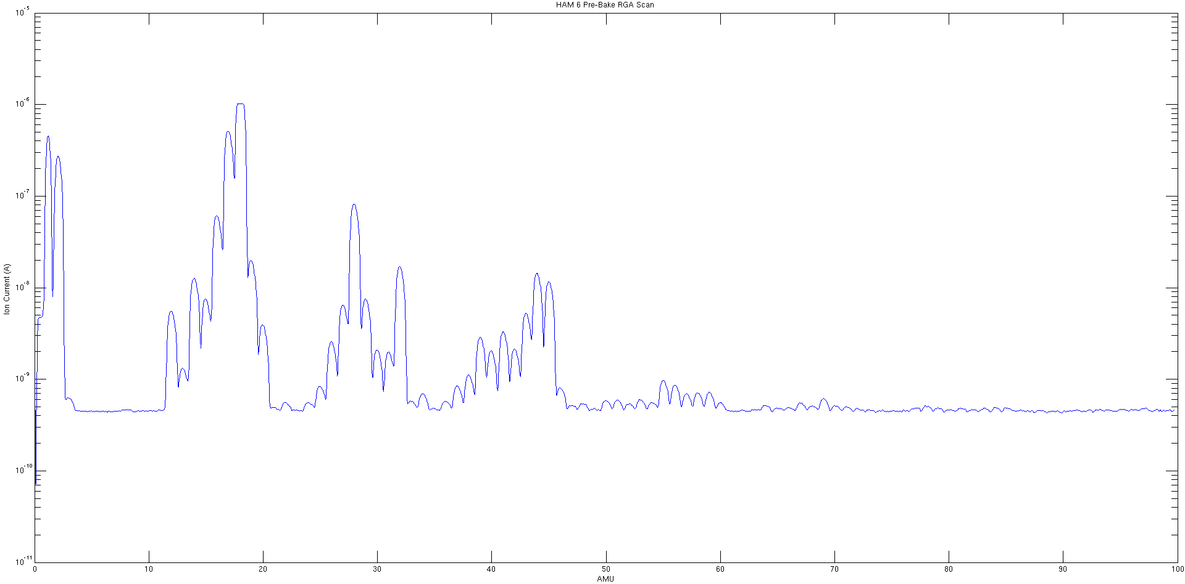
Fig 3: Pre bake scan of RGA

