LIGO Laboratory / LIGO Scientific Collaboration

LIGO-T1600204-v1 ADVANCED LIGO June 6, 2016

Mirror loss estimates for
aLIGO Pre-mode Cleaners

Liyuan Zhang, Rick Savage, Masayuki Nakano, Malik Rakhmanov

Distribution of this document:
LIGO Scientific Collaboration

This is an internal working note
of the LIGO Laboratory.

California Institute of Technology  LIGO Project – MS 18-34  1200 E. California Blvd.  Pasadena, CA 91125  Phone (626) 395-2129  Fax (626) 304-9834  E-mail: info@ligo.caltech,edu | Massachusetts Institute of Technology  MIT NW22-295  185 Albany Street  Cambridge, MA 02139 USA  Phone (617) 253-4824  Fax (617) 253-7014  E-mail: info@ligo.mit.edu
LIGO Hanford Observatory  P.O. Box 1970  Mail Stop S9-02  Richland WA 99352  Phone 509-372-8106  Fax 509-372-8137 | LIGO Livingston Observatory  P.O. Box 940  Livingston, LA 70754  Phone 225-686-3100  Fax 225-686-7189
http://www.ligo.caltech.edu/

Introduction
Two PSL pre-mode cleaners (PMCs) failed at LLO in 2015 [1], one (PMC-08) had a faulty PZT and other (PMC-10) significant loss in optical efficiency after operating for a short period. The design and specifications of the aLIGO PMCs are documented in [2]. This note is to report the efforts that were performed at LHO to measure the mirror losses of the faulty and spare PMCs, aiming to understand the problem and establish a test setup to evaluate and qualify PMCs.

Test and Measurements
A measurement bench was set up in LHO optical lab in the Staging Building using a 2-W NPRO laser (Innolight Mephisto 2000 NE LIGO) to measure the cavity loss of PMCs, as shown in Fig. 1. The polarization of the laser output is set by two polarizers (P1 and P2), modulated by two electro-optic modulators (phase EOM and amplitude EOM), mode-matched by two lenses (L2 and L3), and divided equally (BS) for the two PMCs to be measured. With independent diagnostic components (photodiodes and camera etc.), each PMC can be easily locked by sharing one Pound–Drever–Hall (PDH) servo. Fig. 2 shows a schematic of the PDH servo.
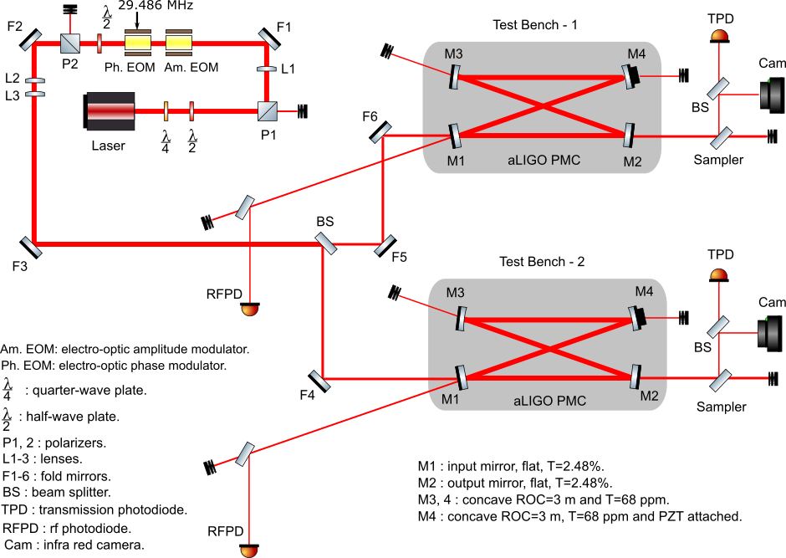
Fig. 1: Optical layout of the measurement setup.
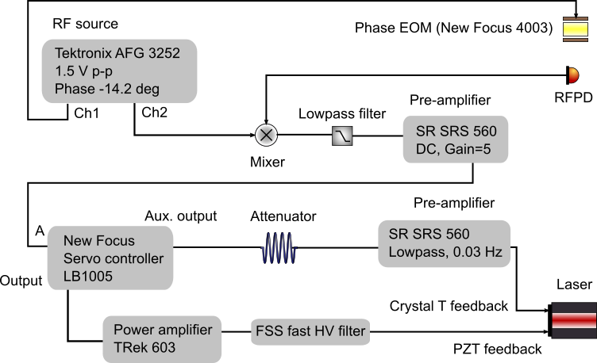
Fig. 2: Schematic of the Pound–Drever–Hall servo.
In principle, if the cavity bandwidth, input power and output powers from the four mirrors of the PMC can be measured accurately, the cavity loss (scattering and absorption) can be calculated, using a method similar to that described in [3] for the LIGO-1 three-mirror PMCs. The three-mirror Matlab have been modified for the four-mirror aLIGO PMCs as shown in the appendix. And, an important modification to the code that renders it valid for low-finesse cavities such as the aLIGO PMCs was implemented. Basically this modification just accounts for non-modematched light that is transmitted through the input mirror. As implemented, the expression for the cavity visibility changes from V = 1 - P_{refl} / P_{laser} to V = 1 - P_{refl} / (R₁ x P_{laser}).
To correct input power fluctuation and minimize the systematic error, two integrating spheres of 4” in diameter with readout photodiodes with integrated preamplifiers were used as power detectors. These power sensors have a large dynamic range and are not sensitive to the incident angle and position. When the PMC at Test Bench-1 is measured, one integrating sphere is used to measure the powers at different ports of the PMC while the other integrating sphere placed in the beam for Test Bench-2 as an input (laser) power monitor ( and vice versa).

Results and Discussion
With the cavity locked, the power budgets for PMC-08 and PMC-09 were measured three and six times respectively. Using the nominal 1.19 MHz bandwidth, the loss per mirror, transmittance of each mirror, visibility, mode-matching factor and cavity transmittance are calculated as summarized in Table I. PMC-09, one of the units designated for the 3rd interferometer, is supposed to be clean, its six measurements show an average loss per mirror of 47 ppm with a standard deviation of 8.6 ppm. PMC-08 was swapped out from LLO after operating for more than a year because of a faulty PZT. Its average loss per mirror of 46 ppm is consistent with that of PMC-09.
Table I Summary of aLIGO PMC loss measurements with the cavity locked.

Meas.  No. | L (ppm) | M1 T (%) | M2 T (%) | M3 T (ppm) | M4 T (ppm) | Visibility | Mode-matching | Cavity T
PMC-08, with a faulty PZT.
1 | 43.0 | 2.471 | 2.471 | 73.8 | 109.0 | 0.7976 | 0.7976 | 0.7864
2 | 55.2 | 2.468 | 2.468 | 74.3 | 109.7 | 0.7931 | 0.7932 | 0.7805
3 | 40.6 | 2.471 | 2.471 | 74.4 | 109.8 | 0.7917 | 0.7917 | 0.7809
Avg. | 46.3 | 2.470 | 2.470 | 74.2 | 109.5 | 0.7941 | 0.7942 | 0.7826
Std Dev | 7.8 | 0.002 | 0.002 | 0.3 | 0.4 | 0.0031 | 0.0031 | 0.0033
PMC-09, spare unit at LHO.
1 | 55.4 | 2.470 | 2.470 | 74.5 | 74.5 | 0.9089 | 0.9090 | 0.8956
2 | 52.4 | 2.470 | 2.470 | 74.4 | 74.4 | 0.9092 | 0.9091 | 0.8962
3 | 52.5 | 2.470 | 2.470 | 74.5 | 74.5 | 0.9088 | 0.9088 | 0.8959
4 | 48.0 | 2.471 | 2.471 | 74.4 | 74.4 | 0.9085 | 0.9086 | 0.8963
5 | 41.2 | 2.472 | 2.472 | 80.2 | 80.2 | 0.8433 | 0.8434 | 0.8325
6 | 32.6 | 2.474 | 2.474 | 80.4 | 80.4 | 0.8406 | 0.8406 | 0.8309
Avg. | 47.0 | 2.471 | 2.471 | 76.4 | 76.4 | 0.8866 | 0.8866 | 0.8746
Std Dev | 8.6 | 0.002 | 0.002 | 3.0 | 3.0 | 0.0346 | 0.0345 | 0.0332

To-do list
- PMC-10 was swapped out at LLO because a significant degradation of the transmitted power was observed. By sweeping the laser frequency and measuring the resonant peak, it was estimated the loss per mirror in PMC-10 is about 1000 ppm. It would be interesting to measure it again using the existing locking technique to validate this measurement.
- Implementing the bandwidth measurement by using the amplitude EOM, this would improve the measurement accuracy.
- Implementing one more DAQ channel would further decrease systematic error. Because of only two integrating spheres and DAQ channels, the powers at different ports were measured at different time, which could introduce a systematic error because of servo offset variations.
- Measuring all the 4 PMCs at LHO.
- Replacing the faulty PZT of PMC-08 and measuring PMC-08.
- Replacing the contaminated mirrors of PMC-10.

Appendix

% pmc_calc2.m

%paramPMCLHO010a; % known parameters and measurement results
paramPMC09_042116_5; % known parameters and measurement results

% calculation of round-trip reflectivity (r = r1 * r2 * r3 * r4)

f = fsr/fw; % finesse
F = (2 * f/pi)^2; % coefficient of finesse
r = (F + 2 - 2 * sqrt(F + 1))/F; % r.t. reflectivity

V = 1 - Pref/ Plas; % fringe visibility

Tcav = Ptr / Plas; % transmission through output mirror
% initial guess. Should be Ptr/(R1*Plas), butu we don't have R1 yet.

Tleak = Pleak / Plas; % transmission through back mirror
Tpzt = Ppzt / Plas; % transmission through back mirror

%%%%%%%%%%%%%%%%%%%%%%%%%%%%%%%%%%%%%%%%%%%%%%%%%%%%%%%%%%%
%
% solution of a system of nonlinear equations by iteration
% technique
%
%%%%%%%%%%%%%%%%%%%%%%%%%%%%%%%%%%%%%%%%%%%%%%%%%%%%%%%%%%%

M = 0.90; % initial value (guess) needed to start iterations

J = 6; % total number of iterations

for j=1:1:J

% find mirror transmissions

T1 = sqrt(Tcav / M) * (1 - r);
T2 = T1;
T3 = Tleak * (1 - r)^2 /(T1 * M);
T4 = Tpzt * (1 - r)^2 /(T1 * M);

% estimate average loss per mirror

pmc_findLiRi_1;

% calculate cavity reflectivity for fundamental mode

rho = r1 - T1*r2*r3*r4/(1-r1*r2*r3*r4);
Rcav = rho^2;

% calculate modematching factor
% first calculate correct V

V = 1 - Pref/ (Plas*R1);

M = V/(1 - Rcav/R1);

% output the results on the screen
% (need to see them for convergence)

[M, T1, T2, T3, T4, Li]

end

% write final results

format short e

modematching = M
transmission1 = T1
transmission2 = T2
transmission3 = T3
transmission4 = T4
averageLosses = Li
visibility = V
modematching = M
Trans = Ptr/Plas
Finesse = f
NumMirRefl = f/pi*4

% pmc_FindLiRi_1.m
%
% MATLAB program from Rick Savage
%
% calculates losses for given "r" and T1, T2, T3

R = r^2;

% an estimate for total losses

sumLi = 1-R-(T1+T2+T3+T4)+(T1*T2+T2*T3+T3*T1+T2*T4+T1*T4+T3*T4);

% average losses per mirror (1st estimate)

Li = sumLi/4;

% a correction due to nonlinear dependence (not necessary)

corr = 6 * Li^2 + 2 * Li * (T1 + T2 + T3 + T4);

sumLi = sumLi + corr;

% average loss per mirror (2nd estimate)

Li = sumLi/4;

% check of perturbation analysis (should be close zero)

eps = R - (1-T1-Li)*(1-T2-Li)*(1-T3-Li)*(1-T4-Li);

% find mirror reflectivities

R1 = 1 - T1 - Li;
R2 = 1 - T2 - Li;
R3 = 1 - T3 - Li;
R4 = 1 - T4 - Li;

r1 = sqrt(R1);
r2 = sqrt(R2);
r3 = sqrt(R3);
r4 = sqrt(R4);

% paramPMC09_042116_5
%
% 4/21/2016 measured parameters for aLIGO PMC-09.

c = 299792458; % speed of light in vacuum in m/s

% pre-modecleaner distances (from N.Uehara)

d = 2.02;

% pre-modecleaner length and FSR

n0 = 1.00029; % index of refraction of air
L = n0 * d; % optical path length in m
T = L/c; % light transit time in the cavity in s
fsr = 1/T; % free spectral range in Hz

% measured parameters

fw = 1.19e6; % width of resonance (FWHM) in Hz (LZH laser FAST coeff = 1.10 MHz/V)

Plas = 1.0; % power into the PMC in W

% the following number refer to the in-lock cavity state

Pref = 8.7705e-2*1.0172; % reflected power (locked) in W
Ptr = 8.9629e-1; % transmitted power in W
Pleak = 0.0027; % power leaking from HR mirror
Ppzt = 0.0027; % power leaking from PZT HR mirror

References
- Mattew Heintze, “Information regarding the two failed PSL Pre-mode cleaners (PMC’s) at LLO”, LIGO-T1500492-v1.
- Jan Hendrik Põld, “aLIGO bow-tie Pre-Modecleaner document”, LIGO-T0900616-v3.
- M. Rakhmanov and R. Savage, “Characterization of the Pre-modecleaner for the Pre-stabilized Laser on the Hanford 4-km Interferometer”, LIGO-T010037-00-W.

