**LASER INTERFEROMETER GRAVITATIONAL WAVE OBSERVATORY**

**-LIGO-**

**CALIFORNIA INSTITUTE OF TECHNOLOGY**

**MASSACHUSETTS INSTITUTE OF TECHNOLOGY**

|  |  |  |
| --- | --- | --- |
| Document Type  Quick Start Guide | DCC Number  **T1500518**-v1 | Oct. 5th, 2015 |
| **TMDS Interface Chassis Quick Start Guide** | | |
| B. Abbott | | |

Distribution of this draft:

This is an internal working note of the LIGO Laboratory

**California Institute of Technology Massachusetts Institute of Technology**

**LIGO Project – MS 18-33 LIGO Project – MS 20B-145**

**Pasadena, CA 91125 Cambridge, MA 01239**

Phone (626) 395-2129 Phone (617) 253-4824

Fax (626) 304-9834 Fax (617) 253-7014

E-mail: info@ligo.caltech.edu E-mail: info@ligo.mit.edu

<http://www.ligo.caltech.edu/>

1. **Overview**

The Test Mass Discharge System (TMDS) Interface Chassis (D1500152-v1) houses a TMDS Interface Board (D1500107-V2), a PSoC Board, a variable transformer, DC Power supply, and a Neon Sign Transformer. The function of this chassis is to Interface the user with an aLIGO, Surface Charge Control Ionizer (D1400331-v6), and allow control and readback of the ion production.

There are some relevant instructions that should be viewed and understood before using this box. These are:

**E1500252-v1** TMDS - Basic Operation Procedure (Switch on and shutdown)

**T1400497-v2** Steps in operation of the ionizer

**T1500400-v1** TMDS Surface Charge Control Ionizer Test Procedure

**T1500486-v1** TMDS Interface Chassis Test Procedure

**D1500107-v2** TMDS Interface Board Schematic

1. **Preliminaries**
   1. Perform visual inspection of the Chassis to make sure nothing looks overtly broken.
2. **Powering up:**
   1. Back Panel:

Plug in the wall plug, and turn on the “Main Power” switch. There should now be 110V power going to the box, and the “High Voltage Present” light should come on.

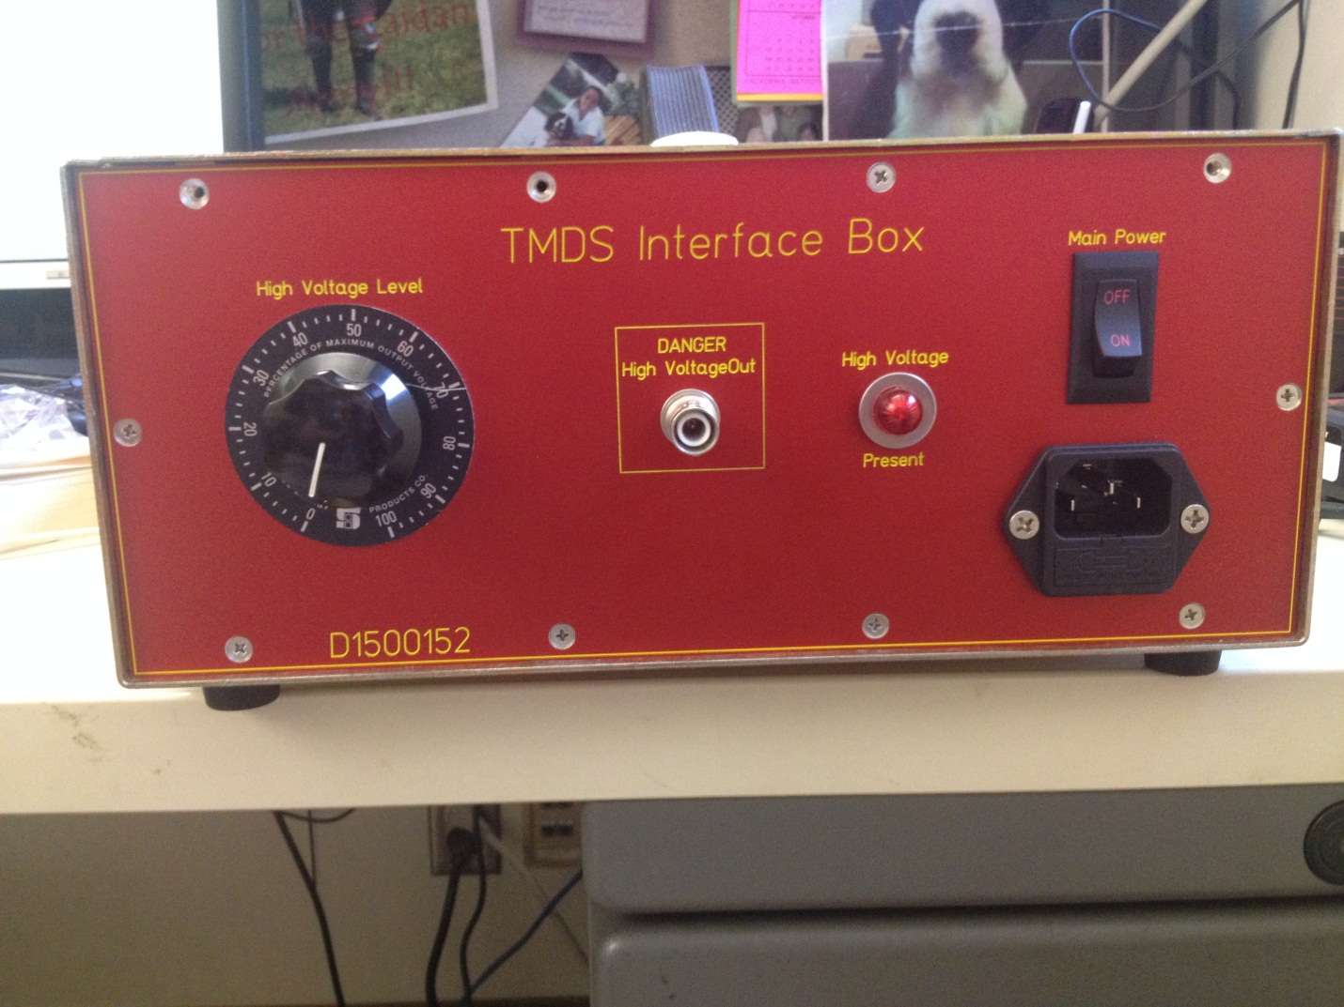

* 1. Front Panel

The “+15” and “-15” green LEDs should be lit, and the LCD should come up with the current code revision on it for a few seconds (currently revision 1.0), then go to the readout state, where it will display the Electrometer Positive voltage (P=) in mV, the Electrometer Negative Voltage (N=) in mV, The High Voltage current (I=) in µA, and the square wave voltage (SqV=) in Volts.

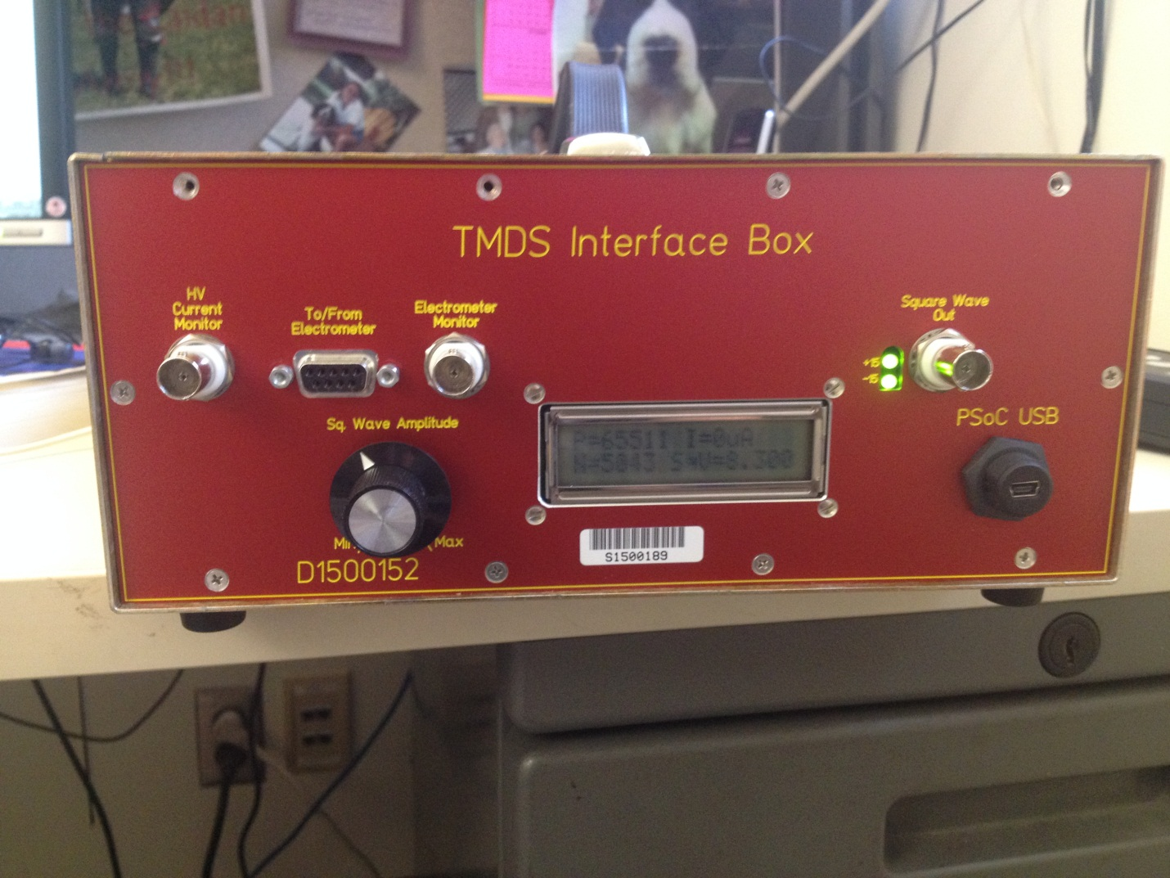

1. **Use**

Before it can do anything useful, the Interface Chassis must be cabled up to the various parts of the Test Mass Discharge System, and some meters and scopes. Taken one at a time, the connections are as follows:

* 1. HV Current Monitor – This should be split, using a BNC “Tee”, with one signal going to an oscilloscope (triggered off the line voltage), and one going to a DMM reading the rms AC voltage. This Voltage should be divided by the 300Ohm readout resistor to compare it to the LCD reading in µA. (Schematic from D1500107-v3)



* 1. To/From Electrometer –This needs a Male/Male 9-pin Dsub cable to connect it to the Electrometer Pod (D1500103) that is attached to the ionizer. This provides power to the pod (+/- 15V), and reads back the electrometer reading (+/- 13.5V Maximum, +/-4V typical running value). (Schematic from D1500107-v3)



* 1. Electrometer Monitor – This can be read out on a scope or DMM to check on the ADC conversion accuracy as displayed on the LCD. The absolute value of the positive and negative signals should correspond with the P= and N= reading in mV.
  2. Square Wave Out – This BNC should be cabled to the BNC on the electrometer labeled “Square Wave In”. This is the square wave that drives the electrometer collection of ions. Its amplitude can be varied using the “Sq. Wave Amplitude” knob, and the output value is read out on the LCD. The output should vary from approximately +/-0V to +/- 22V.
  3. PSoC USB – This micro-USB connector is used to program the internal PSoC board, and doesn’t need to be connected any other times.
  4. Danger High Voltage Out – This back panel SHV Connector should be cabled to the SHV connector on the top of the TMDS to provide ions for the discharging. Its amplitude can be varied using the “High Voltage Level” knob on the back panel. Usually a maximum of 30% - 40% will give you good ion production, much more than that can cause corona discharge, and potentially damage the needles over time. This output can vary from a 0V to a maximum of 4KVrms, and is a 60Hz sine wave.