Title | Observations on RF Cable Terminations
Author | R. Abbott, B. Abbott, Caltech
Date | 19 August 2015

Overview
Various means are commonly used at LIGO to terminate RF cables in an effort to strike a best balance between RF performance and audio (ground loop) performance. This note shows a set of measurements of apparent cable radiation (mechanism not yet understood) for each type of cable termination. The drive frequency of the cable under test was explored at other frequencies than those presented below to see if a resonant condition in the cable under test had an impact on the relative results. No such relationship was noted.

Test Setup
A ~2m section of high quality coaxial RF cable (Times Microwave, LMR-195 Foil/Braid Coaxial Cable) was selected. A 40cm section of insulated 20awg wire was taped parallel to side of the coaxial RF cable as shown in the figure below. The intent is that this section of cable would act as an antenna of sorts, and that the wavelength of this antenna be relatively short as compared to analysis frequencies. An effort was made to keep the test setup physically the same for each analysis case to preclude geometric variations in induced signal levels.

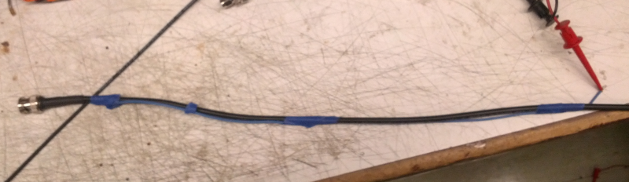

An RF signal generator was used to apply +13dBm signals to the far end (not shown in above photo) of the ~2m coaxial cable shown above. An RF spectrum analyzer was used to measure the amplitude of the signal induced in the sense wire (antenna).

Measurements results
Numerical results are presented for each physical termination case. A photograph is included to show the test setup for each test case.

Table 1 Data Table
Case | RF Drive Frequency/Power | Induced Signal Amplitude in Sense Wire (antenna)
Cable open | 45MHz, 13dBm | -70.2dBm
Cable terminated in 50 ohms | 45MHz, 13dBm | -70.6dBm
Cable terminated in open BALUN | 45MHz, 13dBm | -49.7dBm
Cable terminated with BALUN that was terminated in 50 ohms | 45MHz, 13dBm | -45.3dBm
Cable terminated in typical LIGO 1:1 RF transformer with capacitors to ground on the cable side windings | 45MHz, 13dBm | -22.2dBm

Photos of Different Measurement Cases
To aid in understanding the physical setup that yielded the numerical results recorded above.

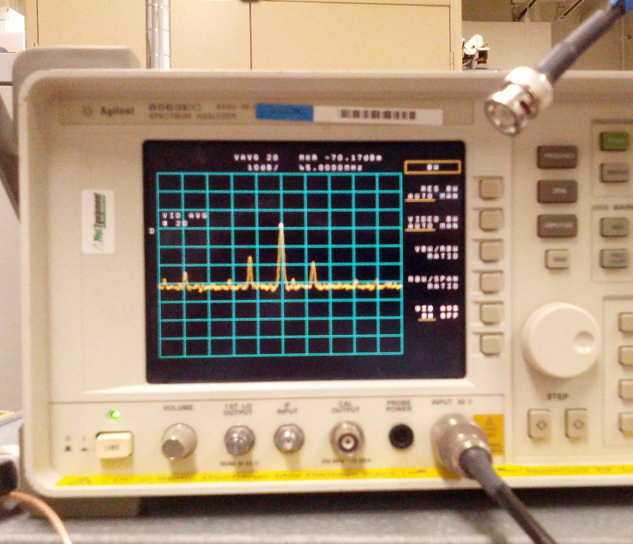

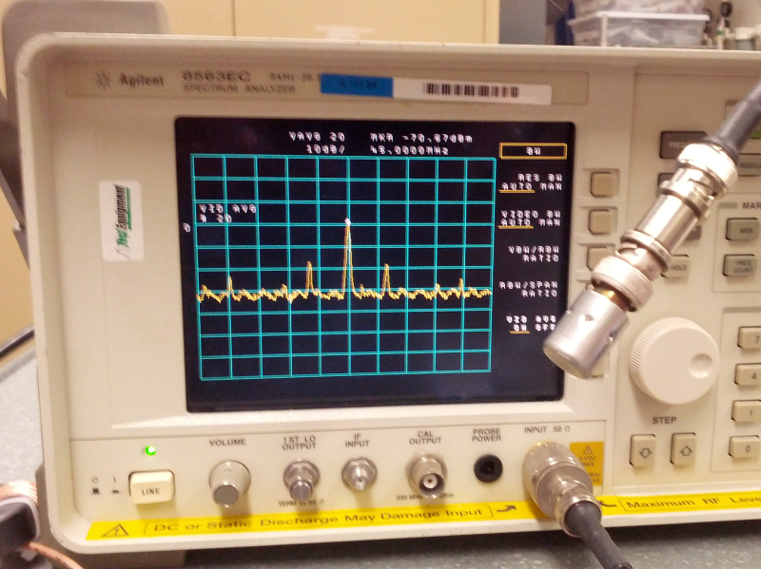

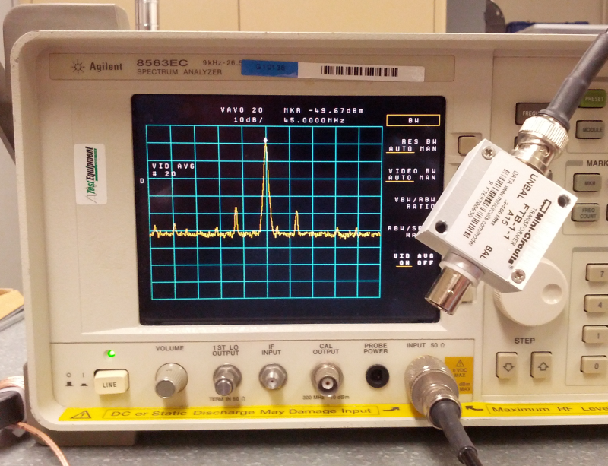

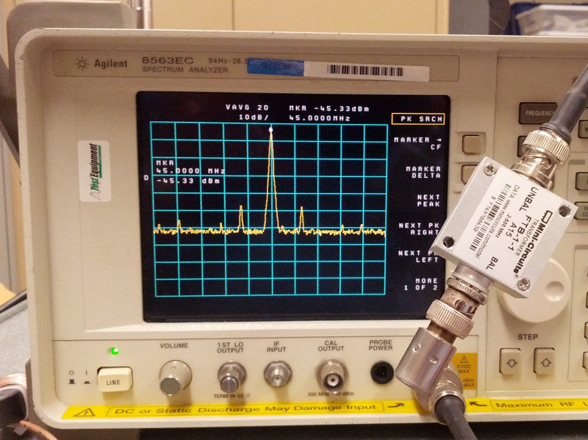

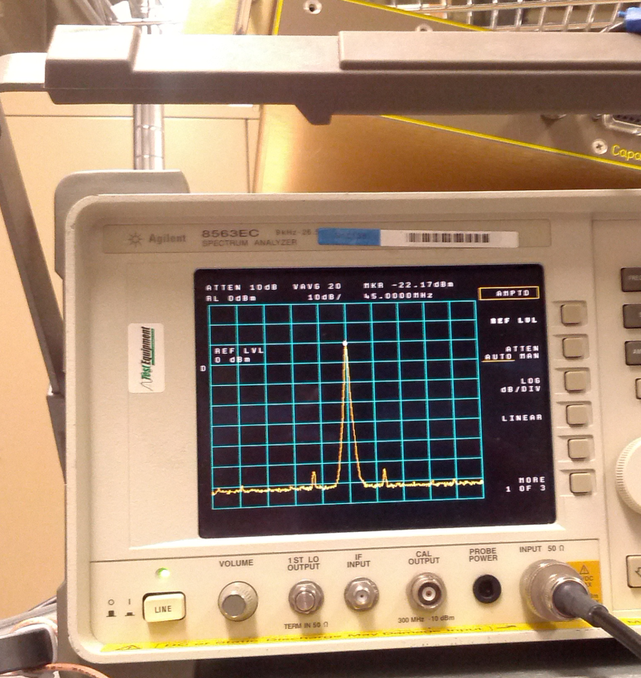

Conclusion
It would appear that our standard practices ought to be analyzed further as they don’t yield a minimum radiated power. The impact of power line harmonics may well be worse if these standard tools are not used, but the tradeoff study still ought to be done.

