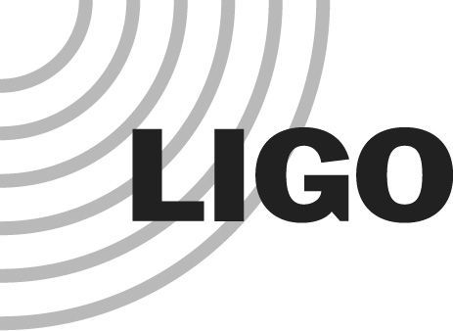
LIGO LABORATORY
MS 100-36
PASADENA CA 91125

TEL: 626.395.2129
FAX: 626.304.9834

MEMORANDUM

DATE: March 30, 2015

TO: | 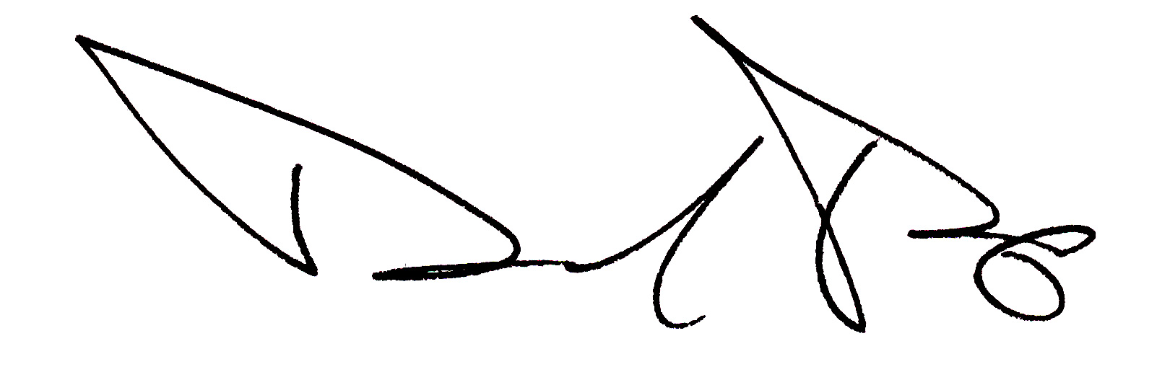  LIGO Laboratory, LIGO Scientific Collaboration
FROM: | David Reitze  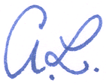  Albert Lazzarini
SUBJECT: | Completion of Advanced LIGO Construction Project
Refer to: | LIGO-L1500053-v1

This memo serves as the formal Directorate determination of the successful completion of the Advanced LIGO Construction Project (excluding the procurement of data analysis computers and associated Data and Computing Subsystem activities). The Directorate accepts in entirety the recommendations presented in the Advanced LIGO Project Closeout Acceptance (LIGO-M1500035), the aLIGO System Acceptance Document Review (LIGO-L1500032), and the aLIGO L1 and H1 Subsystem Meta-reviews (LIGO-L1500033).

We find that the requirements needed for Project Acceptance as defined in the Advanced LIGO Project Execution Plan (LIGO-M050303) and Advanced LIGO Project Closeout Acceptance (LIGO-M1500035) document have been fulfilled. Effective April 1, 2015, the H1, L1, and 3IFO interferometers revert fully to LIGO Laboratory Operations. Activities identified by the Advanced LIGO Project System Review as needed to achieve Advanced LIGO performance and design goals are hereby transferred to Operations.

The H1 and L1 interferometers have performed remarkably to date. We commend and congratulate the Advanced LIGO Project Management Team and Advanced LIGO team members from the LIGO Laboratory and the LIGO Scientific Collaboration on this tremendous accomplishment.

