TMDS Test Bench at LLO
Scott McCormick
6-Jan-2015

Cooling Bath
See the cooling bath guidance here:
http://www.ncsu.edu/ehs/www99/right/handsMan/factsheet/coolbath.html
(also included as a figure below).
Rai Weiss has used Methanol rather than isopropyl alcohol or glycol ethers.

We want a bath that is well above the condensation temperature for liquid oxygen (90K), but low enough to condense out organic contaminants. The lowest temperature dry ice bath mixture is 14% by volume H2O in MeOH, which produces a bath at -128 C (145 K).

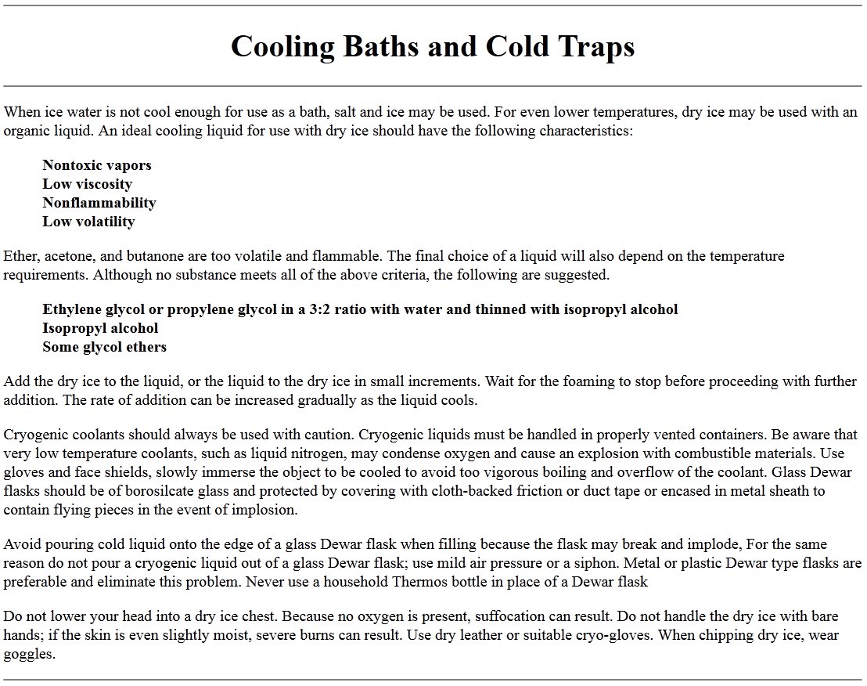

Photo #1
Regulator attached to the 1” dry air supply line. Note: The SS ball valve is there for a 24 hr. purge of the system prior to connecting the regulator, etc. We check the particle count and dew point at that point and if it’s OK we go ahead with installing the TMDS components. This was to verify our installation was clean enough and prevent contaminating anything down stream of our new supply line.
The regulator has 3/8” compression fittings and the flexible line from the regulator to the flow meter is a SS braided PFTE hose Harry had brand new in the bag (scrounging for parts).

Photo # 2
Flow meter Rai Weiss provided. Note: We disassembled the meter, cleaned and reassembled. I believe this is also another source of pipe threads we had to adapt to compression. I will provide more info on the flow meter in a separate email.

Photo # 3
PALL filter data sheet housing LINK and filter link
Part number IDL11GN12J7
Note: Pipe thread on the filter housing is a potential particle contamination. This is obvious for all pipe threads and should try to avoid if possible.

Photo # 4
Cold trap/bath. At the time we had dry ice, glycol and methanol in the SS can and insulated the can.

Photo # 5
Note: down stream of the bath we wrapped the 3/8” SS line with a 110V heat tape and controller set to ~ 70F (room temp) to prevent freezing at the ionizer. Based on final dimensions will determine the size heat tape required. Note: Copper line used for flexibility when connecting to the ionizer and allowed for any thermal expansion and contraction.

Photo # 6
Complete set up on bench with the electronics Rai Weiss provided. Note: We added a Bourdon needle gauge Link at the scroll pump for reference down stream of the TMDS vacuum gauge for reference at the scroll pump inlet.
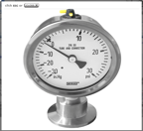

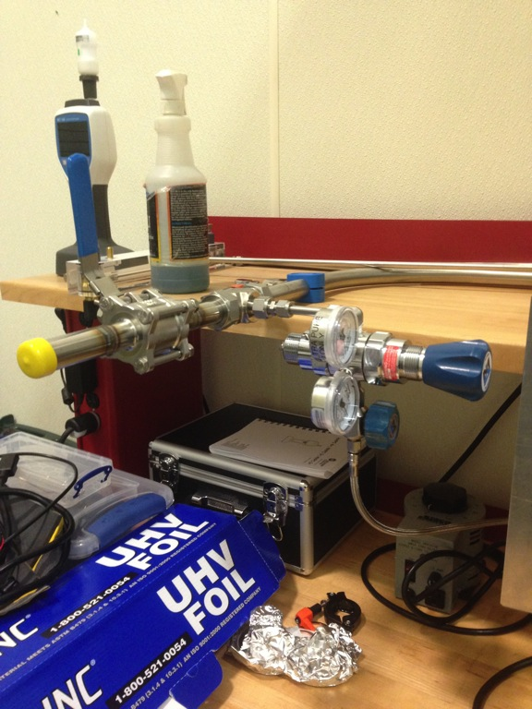
Photo 1
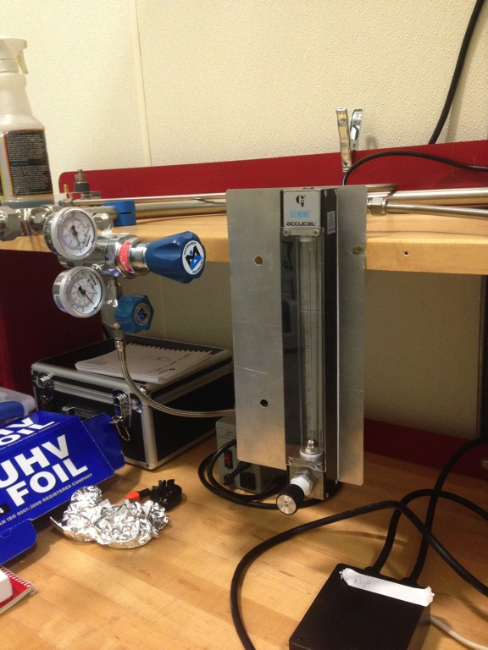
Photo 2
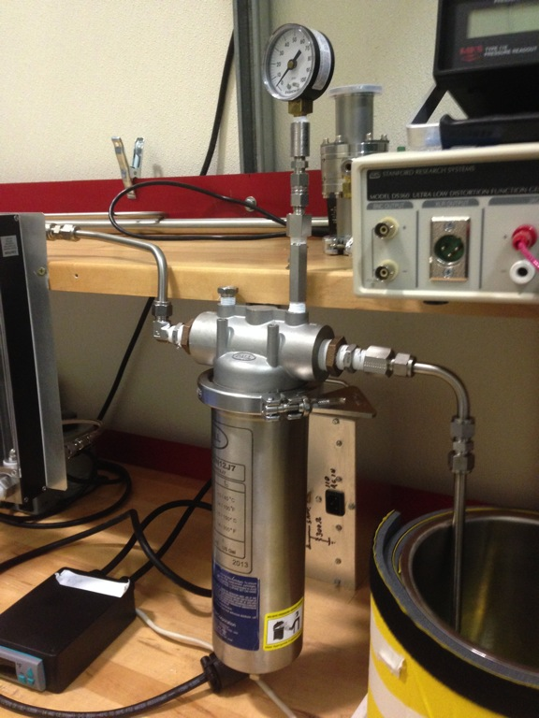
Photo 3
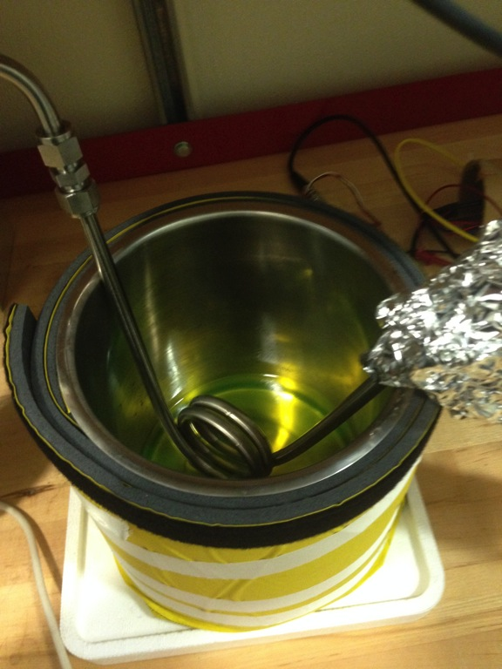
Photo 4
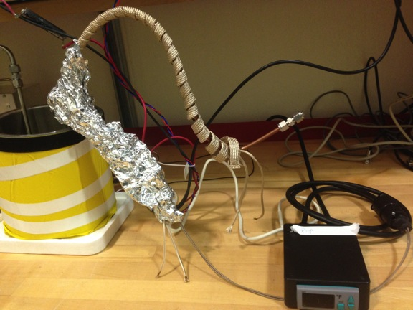
Photo 5
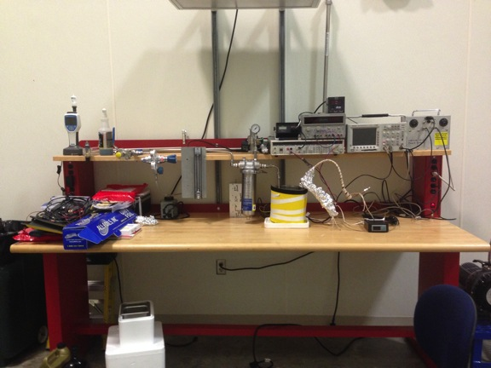
Photo 6

