T1400750 - aLIGO Mechanical design considerations for a larger Beamsplitter optic

Table of Contents
2 Introduction 3
2.1 Background: 3
2.2 Design philosophy: 3
3 Top stage conceptual modifications: 4
3.1 Existing design features: 4
3.2 Design intent for design modifications 4
3.3 Top stage proposed changes: 5
4 Top mass conceptual modifications: 7
4.1 Existing design features 7
4.2 Design intent for modifications 7
4.3 Top mass proposed changes 8
4.4 Comparison of top mass dynamics (existing vs new) 9
5 Round masses: 10
5.1 Existing design features (lower tablecloth omitted for clarity) 10
6 Intermediate mass conceptual design modifications 11
6.1 Design intent for modifications: 11
6.2 Intermediate mass proposed changes 11
7 Test mass dummy 13
7.1 Design intent for modifications: 13
8 LS Tooling 15
8.1 Issues with modified lower structure in existing LS tooling. 15
8.2 Recommendations for modifications to LS tooling: 16
9 Wire jig 17
9.1 Proposed wire jig modifications: 17
10 Summary of proposed changes 18
10.1 Modification of existing parts 18
10.2 Re-make parts 18
10.3 New parts 19

Introduction

Background:
Norna Robertson outlines first thoughts for a larger Beamsplitter suspension in T1400296, and this includes a proposed set of updated parameters which were discussed between Norna and Joe O’Dell at Rutherford Appleton Laboratory on 15th September.
For full conclusion to this discussion, see afore mentioned document.
This document outlines mechanical considerations and recommendations for an updated Beamsplitter design. Here the intention is to outline a conceptual design for the updated parameter set, to identify the following:
- Nature and scale of the modifications including a detailed summary of;
  - Parts that require modification
  - Parts that need to be re-made
  - Parts that are new
- Identification of key features and components where modification should be avoided
Summary of relevant parameters (altered parameters marked in red):
 | Current | New
M1 | 1.2630e+001 | 1.2630e+001
M2 | 1.3575e+001 | 1.3575e+001
M3 | 1.4168e+001 | 2.0983e+001
N0 | 7.7000e-002 | 7.7000e-002
N1 | 1.3000e-001 | 1.3000e-001
N2 | 6.0000e-002 | 4.0000e-002
N3 | 1.9150e-001 | 1.9150e-001 (check)
N4 | 1.8650e-001 | 2.3750e-001
N5 | 1.8650e-001 | 2.3750e-001
ir | 1.8500e-001 | 1.8500e-001
tr | 1.8500e-001 | 2.2500e-001

Design philosophy:

- Attempt to modify the parameters outlined in T1400296, whilst avoiding altering others
- Re-use as many of the original components as possible
- Increase MOI numbers for suspended masses as little as possible
- Take the opportunity to make design improvements to existing parts, where it can be done economically

Top stage conceptual modifications:

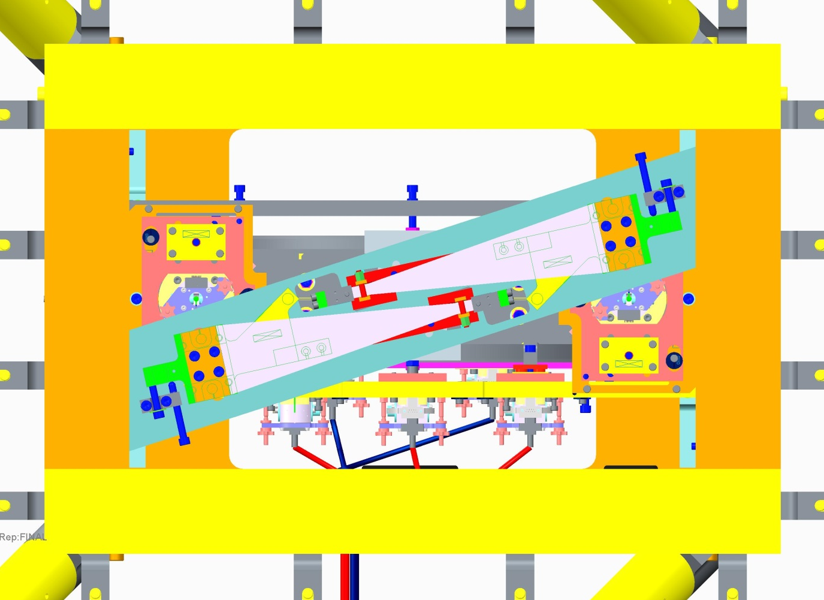
Existing design features:
Suspension Centre Line
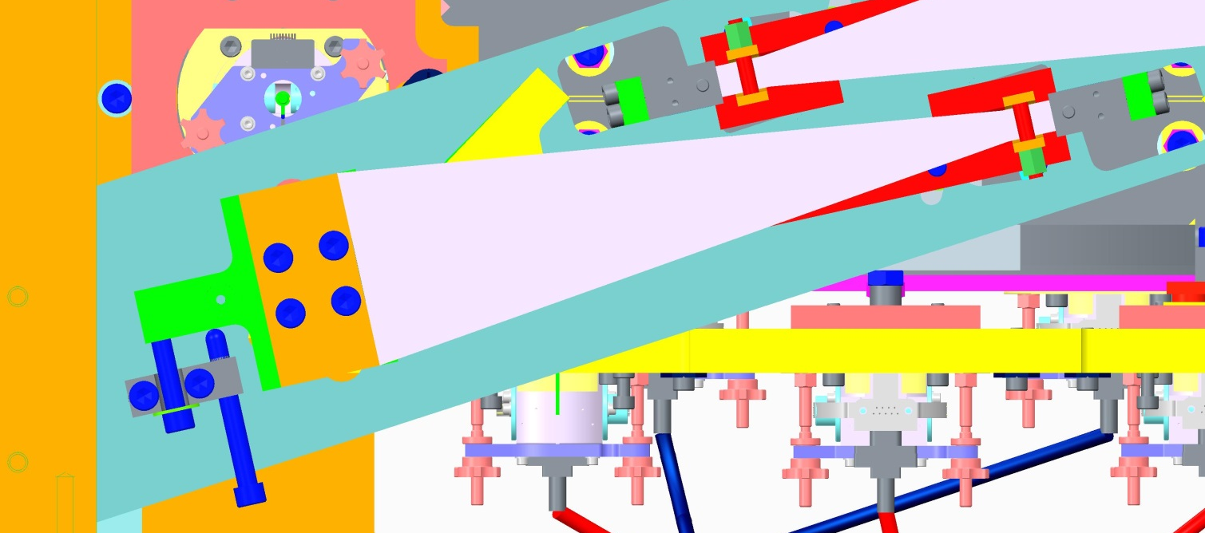
Remove rotational adjuster from back of the “blade clamp base” (D080085) and re-locate. Remove material from “US cross member” (D080505) to allow blade clamp to be retracted
…
Blade rotational adjuster pivot (on BS suspension CL)
Blade rotation starts perpendicular to suspension CL in both directions
75mm

Design intent for design modifications
- Increase length of blades by 75mm
- Maintain position of rotational adjuster pivot on optic centre line (this minimises coupling of yaw adjustment with lateral shift, and also maximises linearity of adjustment)
- Maintain existing value of n0 without changing the blade angle by pushing blade roots away from suspension Centre line
- Relocate all adjustment screws to below the base of the top stage to ease adjustment

Top stage proposed changes:
View from above – top stage in upper structure.
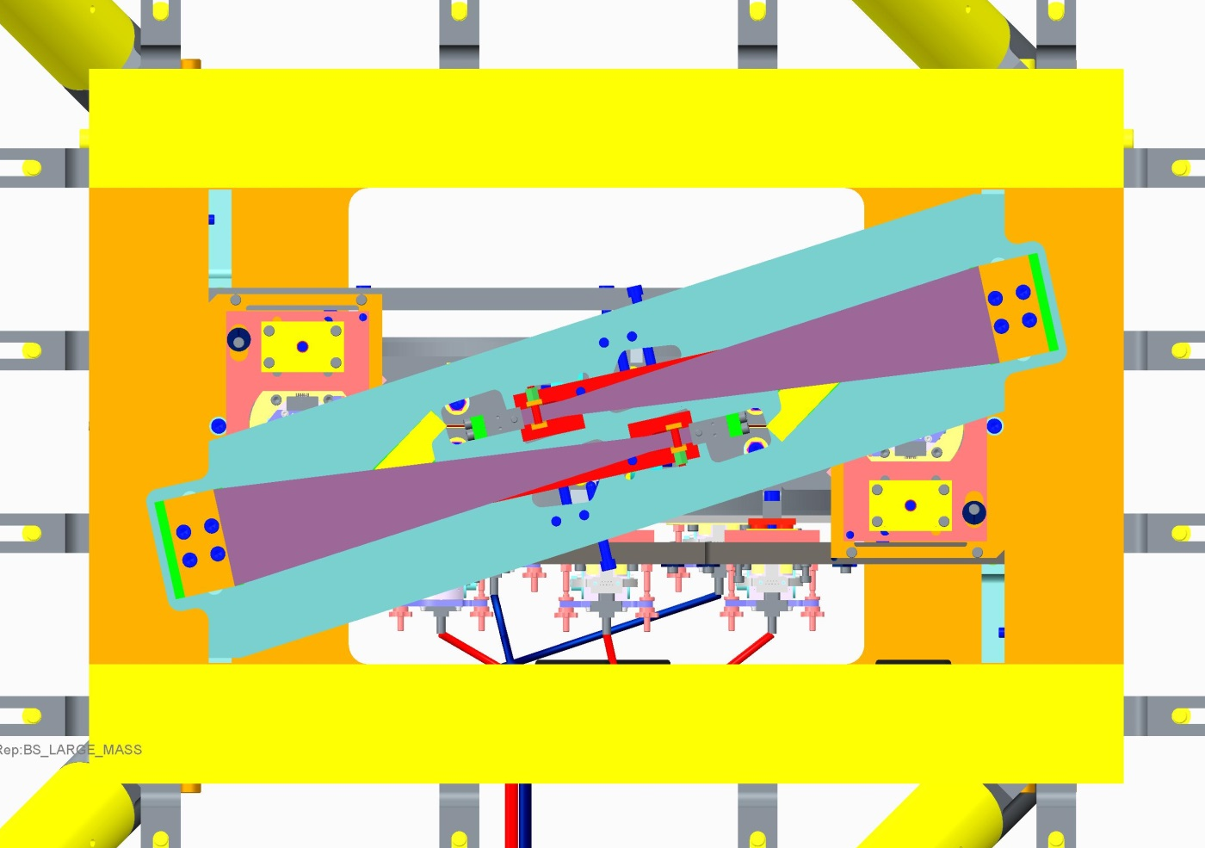
…
Blade tip/wire break-off position (n0) unchanged from original
Rotational adjuster pivots remain on suspension CL
Material cut away from the upper structure top plate to allow blades clamps to be retracted
…
Rotational adjusters removed from the back of the blade clamp
3D view – upper structure omitted for clarity
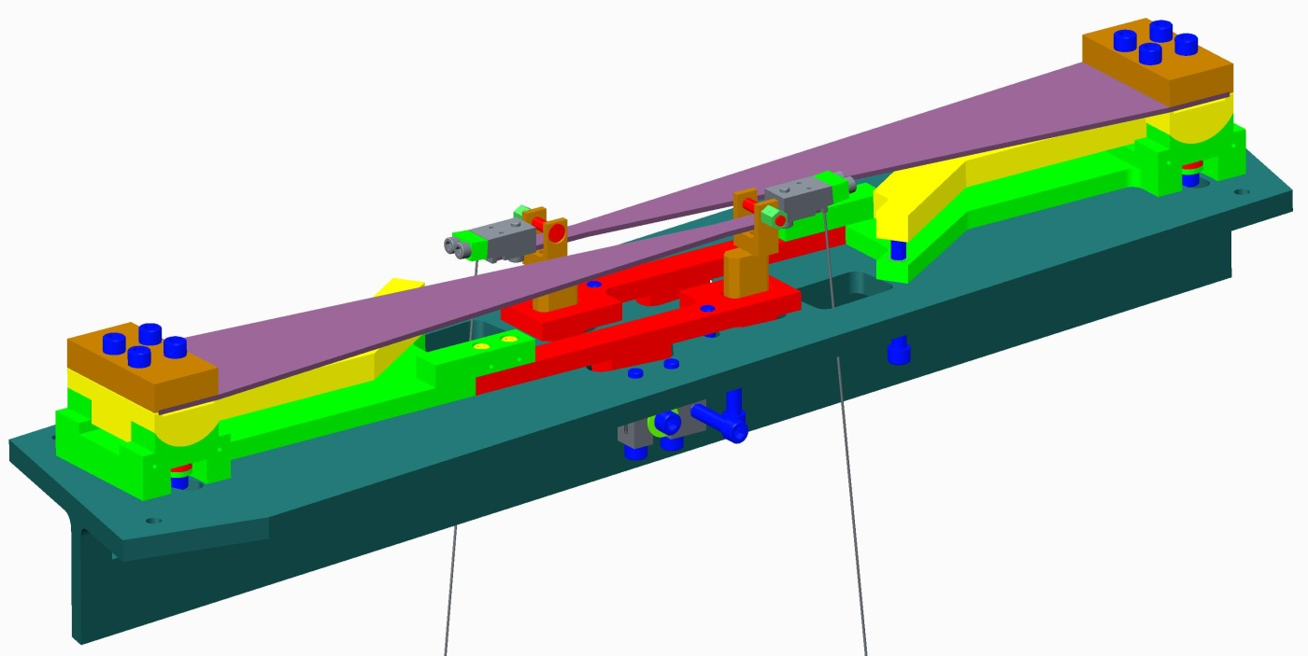
“Blade clamp base” (D080085) and “blade clamp bottom” (D080083) are extended to retract the root of the blade, and maintain the position of the rotational adjustment pivot
Top stage – view from below

“Rotational adjusters” (D060325) re-located toward the tip of the blades, and “adjuster arm” (D080086) projected through the “top stage stiff back” (D080081)
*New part - “Tab” to project “rotational adjuster” through the “top stage stiff back” and make accessible from below

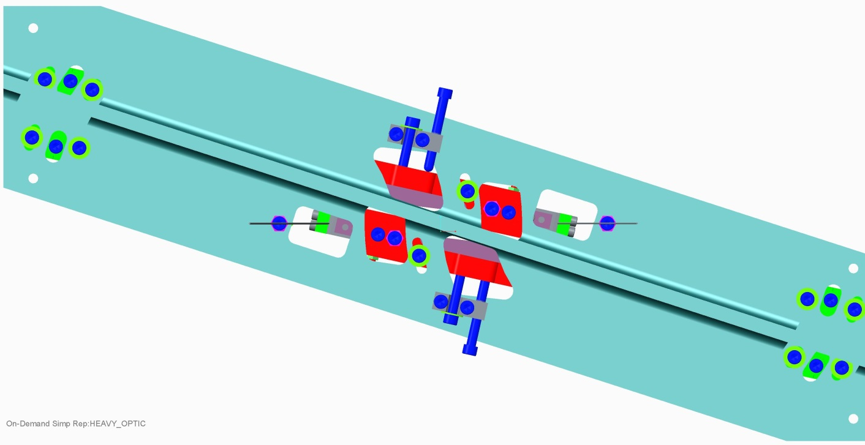
“Top stage stiff back” re-made from wider T section to allow it to be mounted in-line with retracted clamps. Clamp mounting holes and rotational adjustment features re-located to new blade root positions. Clearance slots added for projection of rotational adjustment tabs through it.

Top stage – side view
“Rotational adjusters” (D060325) located below the “stiff back” for ease of access.

Top mass conceptual modifications:

Existing design features

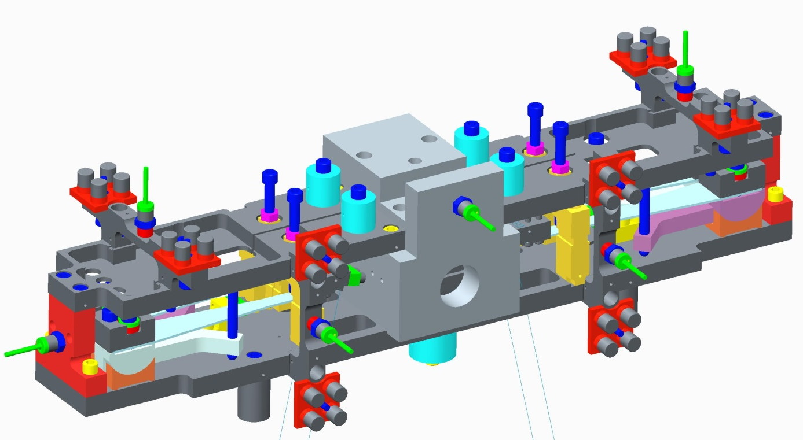
“Addable/removable mass” – 400g nominal. Range 0 – 800g
Weight concentrated at the centre of the mass in order to reduce moments of inertia for the mass. Large stainless block houses pitch flag and pitch adjuster

Design intent for modifications

- Increase length of top blades by 20mm
- Keep moments of inertia as low as possible – double that of the existing design has been identified by Norna as a limit.
- Increase adjustment range for mass by incorporating more “addable/removable mass”
- Maintain line of sight onto blade tips for ease of measurements and trouble shooting.
- Maintain all other functionality including flag positions and blade height adjustment

Top mass proposed changes
Heavy upper mass block added to compensate for mass removed from central block

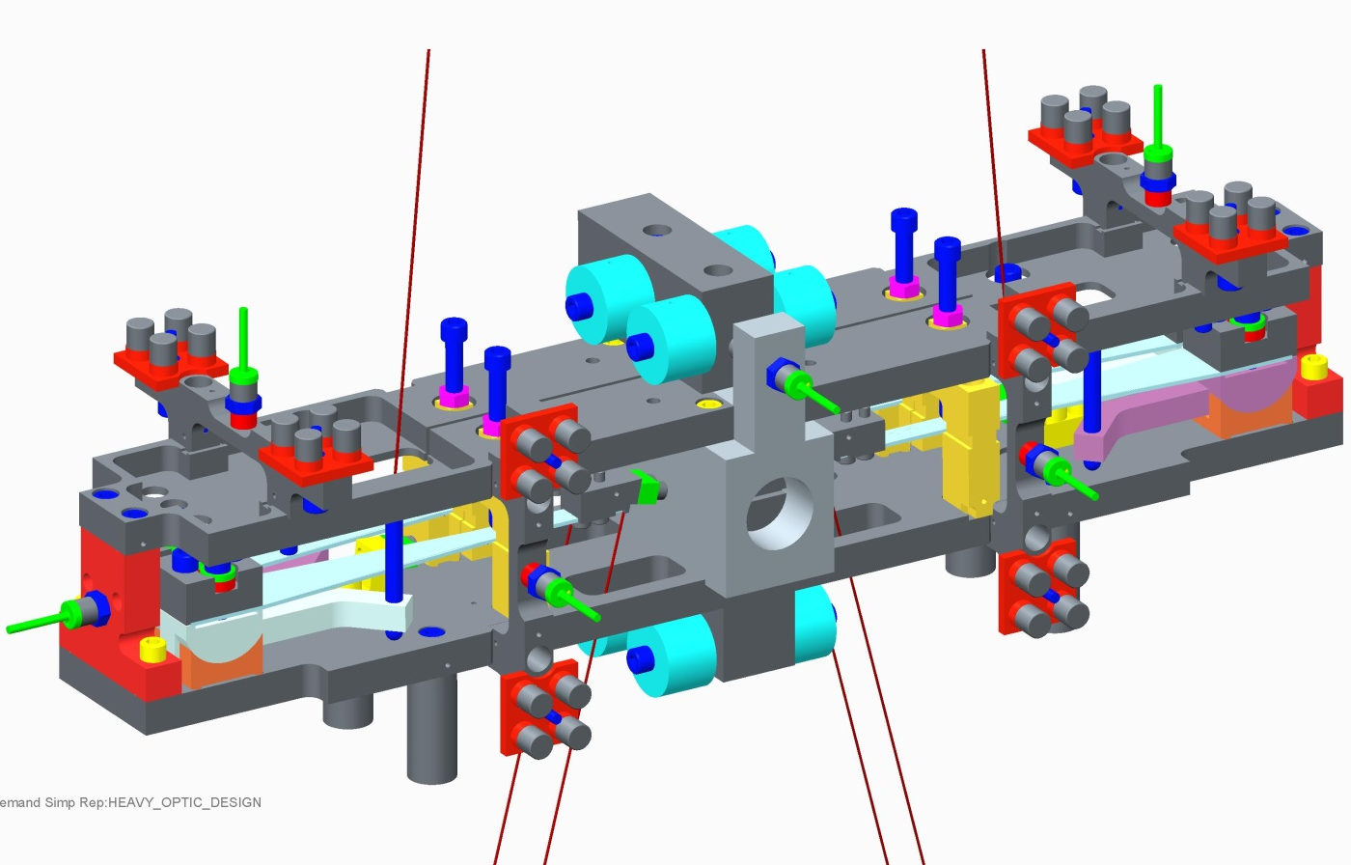
Nominal “Addable/removable mass” increased from 400g to 800g to give an increased range of 0 – 1600g
Heavy lower mass block added to compensate for mass removed from central block

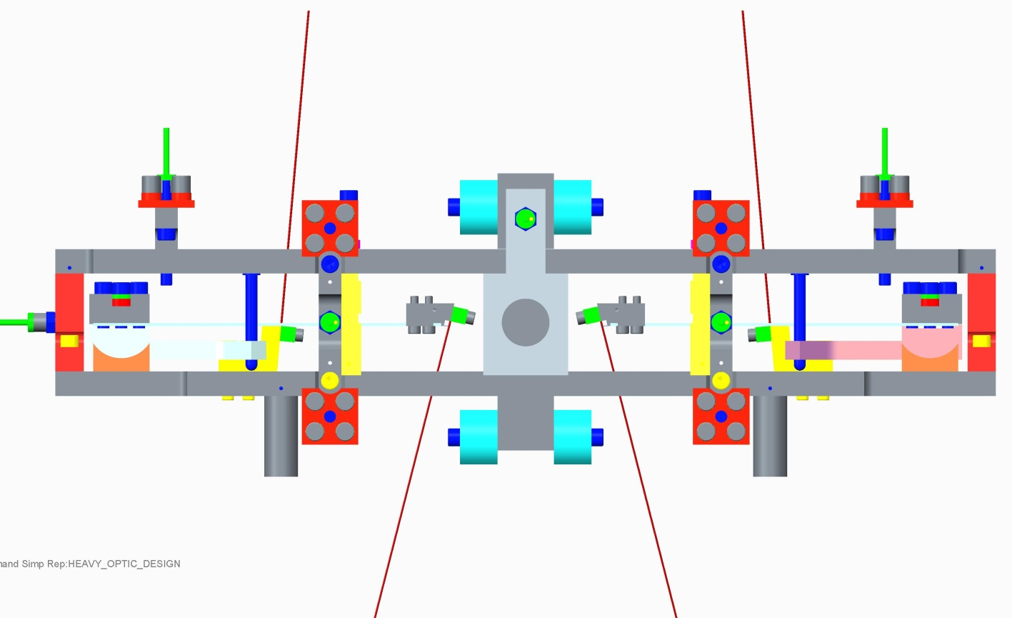
Mass feet lengthened to ensure that they extend beyond additional block below bottom plate. Diameter also reduced
Top plates lengthened and material changed from Al alloy to Stainless.
Central mass reduced in width to allow blade tips to be extended toward the centre of the mass

Comparison of top mass dynamics (existing vs new)

 | Existing | New conceptual | % increase
I1x | 1.6593E-01 | 1.8934E-01 | 14.11%
I1y | 2.4732E-02 | 2.7037E-02 | 9.32%
I1z | 1.6432E-01 | 1.8123E-01 | 10.29%

Note: Mass C of G and overall weight remain unchanged.

Round masses:

Existing design features (lower tablecloth omitted for clarity)
Extra mass (D080484) to increase weight of bottom mass, whilst using same main mass body
Interface bracket (D080011) between upper and lower structure
Bottom wires are vertical/parallel
Main masses are identical with provision to bolt on mass to generate two different variations – intermediate and test

Intermediate mass conceptual design modifications

Design intent for modifications:

- Maintain existing weight of middle mass
- Maintain vertical/parallel orientation of bottom wires
- Use existing structure parts where possible i.e. wires exit lower structure from existing holes

Intermediate mass proposed changes

Intermediate mass with structures omitted:
Mass (D080369) radius/flat transitions rounded off to give clearance to middle wires (this could also be done by modifying n3 on the wire clamp
Wire clamps (D080007) extended outward to allow vertical wires to the larger mass below

Note:
Changes to mass dynamics are thought to be negligible
Intermediate mass shown with upper/lower structures
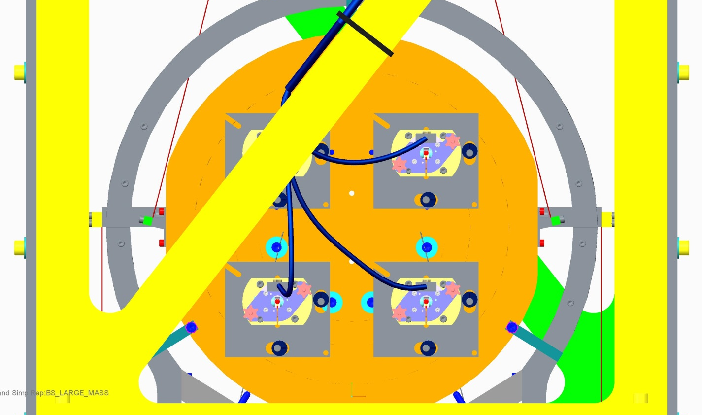
Clamps extend beyond existing lower structure top half

Intermediate mass shown with upper/lower structures – section view through CL
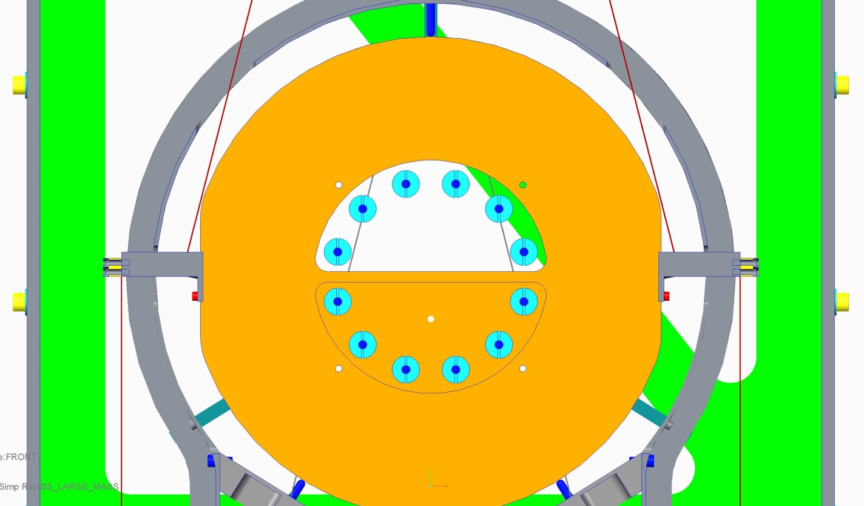
Middle wires exit lower structure through existing cut-outs in lower structure, meaning no modifications are required
Existing cut-outs in lower structure are probably sufficient to allow the extended clamps clearance to pass through – however a minor modification could increase the clearance further if necessary

Test mass dummy

Design intent for modifications:
- It is clear that changes to the lower half of the lower structure are unavoidable, but it is the intention to maintain the original interfaces to all mating parts.
- Avoid modification to the Upper structure
- Use same EQ stops and support pads
Mass enlarged from diameter 370mm to diameter 450mm
Lower structure bottom half enlarged to fit larger mass with the same clearance as for the previous design
It looks as though it may be possible to incorporate the new lower structure bottom half (D080006) with the existing brace design with minor modifications, but this requires verification
Re-designed interface bracket between the upper and lower structures allows modified lower structure to be bolted on without modifications to the upper structure
Bottom mass dummy – section view through CL

Altered geometry at the top interface of the bottom half of the lower structure (D080006). This allows connection to both top half of the lower structure, and bottom of the upper structure without the need for modification or replacement to those parts.
Bottom wires clear upper structure easily without modification to the bottom plate
Current EQ stop mounts and pads can be re-used without modification
Current EQ stop mounts and pads can be re-used without modification

LS Tooling

Issues with modified lower structure in existing LS tooling.
Cut out in “LS tooling top plate” (D080643) too narrow to allow larger lower structure clearance

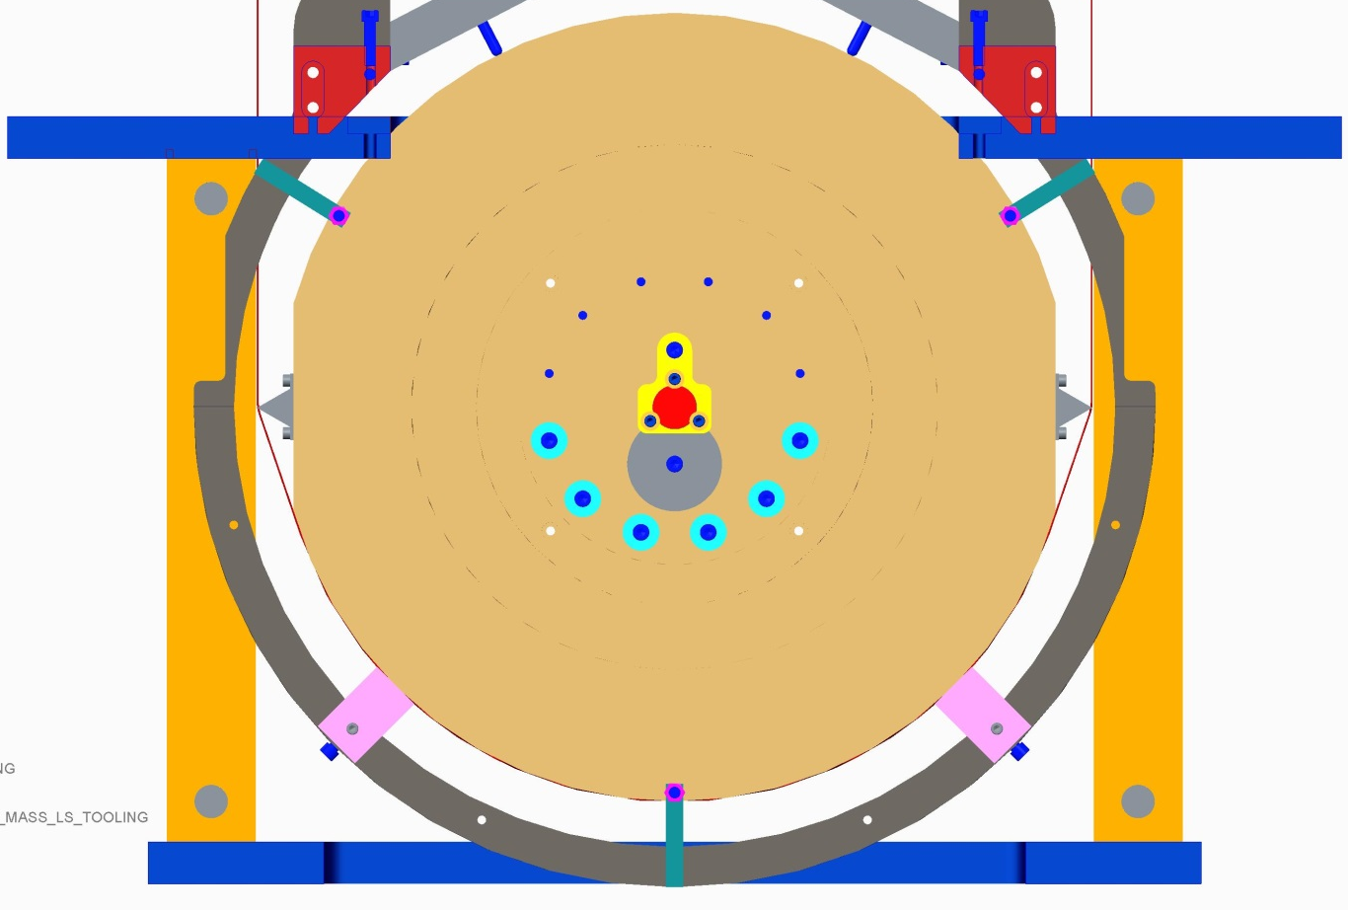
New US – LS bracket position moved outward from existing cut-out and clashes with LS top plate
Enlarged LS extends marginally below the bottom of the LS tooling

Recommendations for modifications to LS tooling:
Modify the “LS tooling top plate” (D080643) with the following alterations:
- Widen the cut-out to allow the LS bottom half to slide through it without interference
- Machine new recesses for the location of the “US – LS brackets”
- Reduce the depth of the new recesses in order to raise the “US – LS bracket” so that the LS bottom half does not protrude below the base of the LS tooling.

Note – these modifications can be made to the existing plate without the need to re-make. It is believed that the modifications described to the existing plate above are the only modifications required to the LS tooling.

Wire jig
Here the wire lengths for the conceptual design for the larger mass are considered relative to the existing wire jig tooling pictured below:
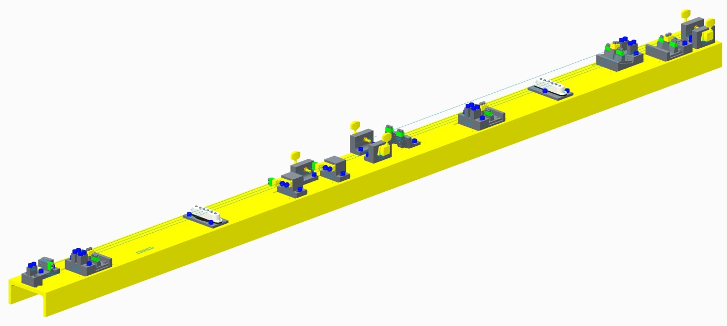

The table below shows the new wire lengths in comparison to the nominal wire lengths on the wire jig. The wire jig is capable of making wires of length “nominal” +/- 20mm.
 | Wire length |  | Wire jig settings |  | Notes
 | Wire jig nominal | New conceptual | Offset | Spacer total (range 0 - 40mm)
Top wire | 612 | 612 | 0 | 20 | Within range of wire jig
Middle wire | 600 | 604.5 | 4.5 | 24.5 | Within range of wire jig
Bottom wire | 1586.9 | 1711.9 | 125 | 145 | Out of range of wire jig

Proposed wire jig modifications:
The top wire is unchanged, and can therefore be made with the existing wire jig and spacers per assembly drawings D080133. The Middle wire changes slightly in length, but is still well within the range that the wire jig is capable of. The new bottom wires for the larger mass design are increased in length by approximately 145mm. This takes them well outside of the range that the existing wire jig is capable of, and this means that the wire jig base plate (D080147) requires re-make with an increased length.

Summary of proposed changes

All of the conceptual design changes discussed previously have been summarised below in terms of three categories:
- Modifications of existing parts
Parts could be kept and modifications made by machining new features into them
- Re-make parts
Parts that have been changed significantly and require remake
- New parts
New parts that have been identified that are additional to the existing parts

Modification of existing parts

Upper structure:
- D080505 - Upper structure cross member
Lower structure:
- LS stiffening brace (part number not known)
Top stage:
- D080086 - Top stage adjuster arm
Intermediate mass:
- D080369 - BS round mass body

Re-make parts

Top Stage
- D080081 - Top stage stiff back
- D080083 - Top stage blade clamp bottom
- D080085 - Top stage blade clamp base
- D080513 - Top blade spring
Top mass
- D070417 - Bottom blade spring
- D070422 - Top mass baseplate
- D070430 - Top mass top plate
- D070423 - Top mass pitch adjuster and mass
- D070434 - Top mass stability leg
Intermediate mass
- D080560 - D clamp body
Lower structure
- D080006 - Lower structure bottom half
- D080011 - Lower structure – upper structure interface bracket
Lower structure tooling
- D080643 - LS tooling top plate
Wire jig
- D080147 - wire jig base plate

New parts

Top stage
- Rotational adjustment extension tab
Top mass
- Heavy upper mass block
- Heavy lower mass block
Test mass dummy
- Test mass dummy body

  - Appendix A - Alternative top mass modification

The following is a study that was carried out previously to consider whether the BS top mass could be modified for the longer blades, without increasing the MOIs, and with only modifications to existing parts without the need to re-make parts.
This approach is not recommended, but has been included for reference as a possible option for reducing the work required to make these modifications. It could also be referred to in the future if requirements on MOIs became more stringent than currently supposed.
The current central mass has been modified to include further machining that will allow it to be reused with the proposed larger blade springs. This now includes new holes for mounting it to the main chassis, as the position of the bolts in the current position would clash with the blade tips. There are large sections taken out for the blade tips to be located in their extended positions, with the assembly order being accounted for. There is also a slot machined out just below the central hole to reduce the moments of inertia to the same order as that of the previous design. Figures 1 and 2 show the new central mass from two opposite angles.

The centre of mass and the moments of inertia of the previous and new designs are shown below:

Previous Design
COG | X | Y | Z
 | 3.69E-01 | -2.77E-01 | 2.29E-01
I Tensor | 1.62E+05 | 0 | 5.76E+00
 | 0 | 2.39E+04 | 2.32E-01
 | 5.76E+00 | 2.32E-01 | 1.61E+05
New Design
COG | X | Y | Z
 | 8.01E-04 | -2.85E-01 | 1.31E-01
I Tensor | 1.63E+05 | -2.48E-01 | -5.17E-01
 | -2.48E-01 | 2.40E+04 | 2.32E-01
 | -5.17E-01 | 2.32E-01 | 1.61E+05

These numbers show that the centre of mass has been maintained. The most significant moments of inertia (Ixx, Iyy and Izz) are of the same order of magnitude and value as that of the previous design, whilst the other inertias also stay close to their former values. With further work it may be possible to bring these down to smaller numbers if necessary, but for the purpose of providing a conceptual design is to show that the larger blades can be introduced to the suspension system with modifications to the central mass, and also the addition of more balancing masses. Figures 3 and 4 show the middle suspension system from above and below respectively.

Figure 4. Middle suspension system below

The main advantage of this concept is that the mass dynamics are maintained, and there is a minimum of modification work involved.

The main disadvantage of this concept is that the blade tips are hidden by the pitch adjuster/mass block, which will make diagnosis work on the BS more difficult.

