|  |  |
| --- | --- |
| *Title* | *ESD Feedthrough Retrofit* |
| *Author* | *R. Abbott, Caltech* |
| *Date* | *27 October 2014* |

# Overview

An analysis of the parts and process associated with changing out the ESD feedthroughs at the ITM and ETM chambers. The basic process consists of venting the applicable chamber and removing the existing 4.5 inch flange serving the vacuum feedthrough for the ESD actuator chain. There is no obvious reason that the main chamber door need be taken off provided that the residual slack in the in-vacuum ESD cables is sufficient.

# Preparatory Work Prior to Chamber Vent (one chamber)

* 1. Class-A clean the new vacuum feedthrough Accuglass part number 100520
  2. Class-A clean 5 of the Accuglass coaxial contacts part number 100909 with RG316 PEEK inserts drilled to 0.098 inches (see Figure 2)
  3. Class-A clean 1 UHV 5-way coaxial female connector Accuglass part number 100930 (see Figure 1)
  4. Class-B clean 1 OK Industries ST-550 (18-28 AWG) Adjustable Wire Stripper (see Figure 7)
  5. Class-B clean 1 pair of nice diagonal cutting pliers for trimming small wire (see Figure 9)
  6. Class-B clean 1 pair of nice fine tipped needle nose pliers for seating pins (see Figure 10)
  7. Class-B clean one large DMC crimper with Daniels Y204P jaw inserts (see Figure 6)
  8. Class-B clean one DMC 4-jaw crimper for center pin crimping (see Figure 5, Rich has this already)
  9. Class-B clean one L-COMM RG-316 coaxial cable stripper pre-adjusted for RG-316 (see Figure 4)

# Step-by-step Process

* 1. De-energize ESD system and unplug the airside connections at the vacuum feedthrough flange
  2. Clean area around the vacuum feedthrough that is to be removed
  3. Put up temporary covers around feedthrough to help prevent contamination while working
  4. Vent chamber
  5. Turn on purge air
  6. Be careful here that there isn’t a blast of air upon removing the vacuum feedthrough. Using garb suitable for Class-A vacuum work (full bunny), unbolt and remove the existing vacuum feedthrough. Pull the wires out into the air (assuming they are long enough) and disconnect the existing in-vacuum feedthrough from the old flange.
  7. Take careful note of the order of the in-vacuum wiring working one connection at a time to avoid confusion (see Figure 11). Take apart the existing 5-way coaxial connector and up near the end of the RG-316 cable, just prior to the part that’s soldered onto the gold terminal, cut off the gold terminal leaving a clean end cut flush on the RG-316 (see Figure 12). Start with pin 1 such that a sequence can be made to reduce confusion.
  8. Pass the cut coaxial cable through the new PEEK 5-way coaxial connector using a one-to-one pin numbering (pin 1 to pin 1, pin 2 to pin 2, etc.) and crimp on the new coaxial termination following the numerous pictures in this note. Repeat until all 5 coaxial connections have been retrofitted.
  9. Complete assembly of the new 5-way coaxial connector and affix it to the vacuum side of the new 4.5 inch flange by lightly tightening the strain relief screws (3/32 inch Allen key). Don’t forget to pass a clean copper O-ring on before attaching the connector.
  10. Attach new flange and bolt it back onto the chamber feedthrough
  11. Pump down chamber and detect gravity waves

Figure 1, Accuglass 100909 UHV connector. Pin 1 is shown on the right slightly offset in spacing from the other connections. Coaxial cable must pass through the back of this connector PRIOR to crimping the gold contacts on or else you can’t assemble it.

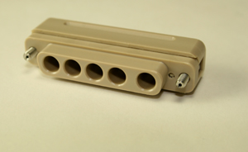

Figure 2, Accuglass 100909 contact assembly with RG-316 collet prior to final crimp. Accuglass 100909 better be to the left of the wire at this point or else you are in trouble

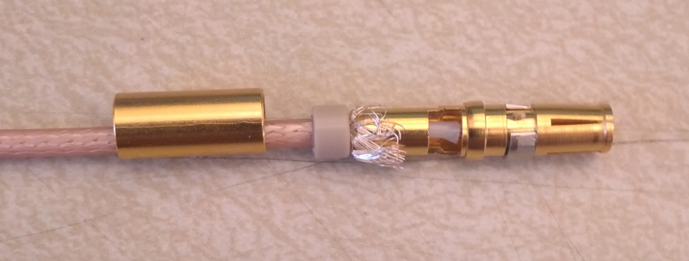

Figure 3, Accuglass 100909 contact assembly with RG-316 collet after final crimping

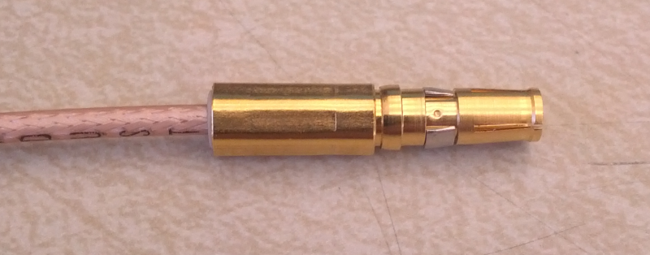

Figure 4, L-Comm RG-316 stripping tool. Note that the RG-316 protrudes flush with the right hand extreme of the stripper

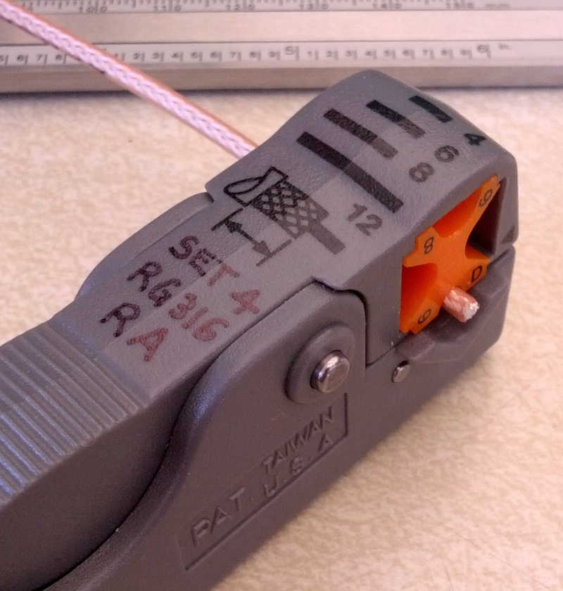

Figure 5, DMC 4-jaw crimper

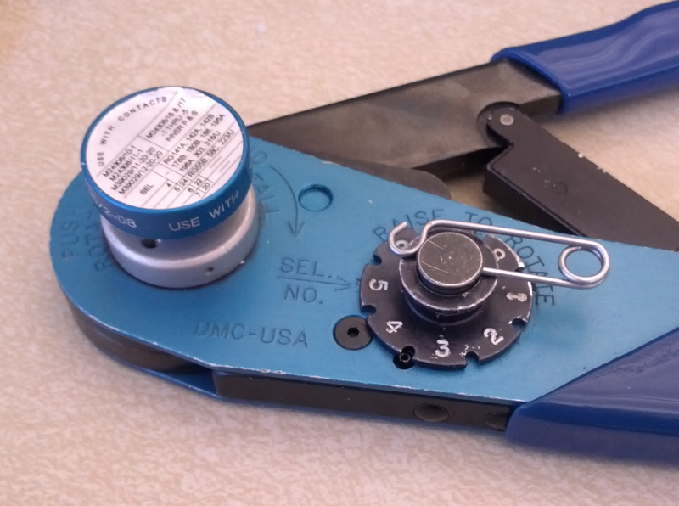

Figure 6, large DMC crimper with Daniels Y204P jaw inserts

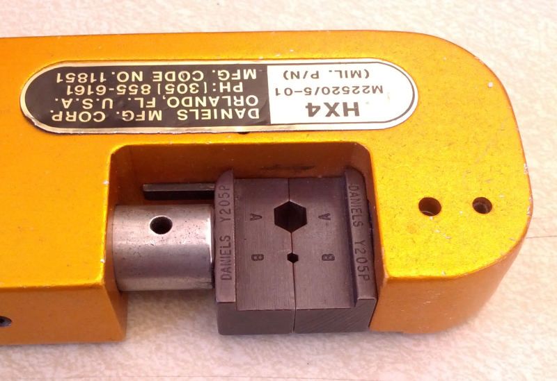

Figure 7, OK Industries ST-550 Stripper

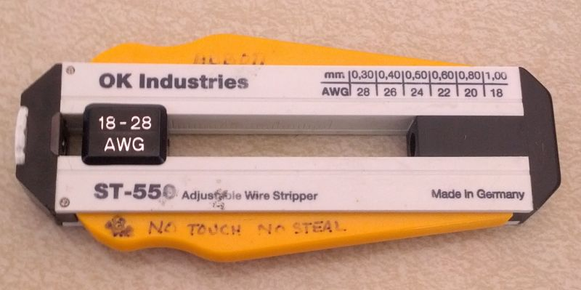

Figure 8, new vacuum feedthrough Accuglass part number 100520

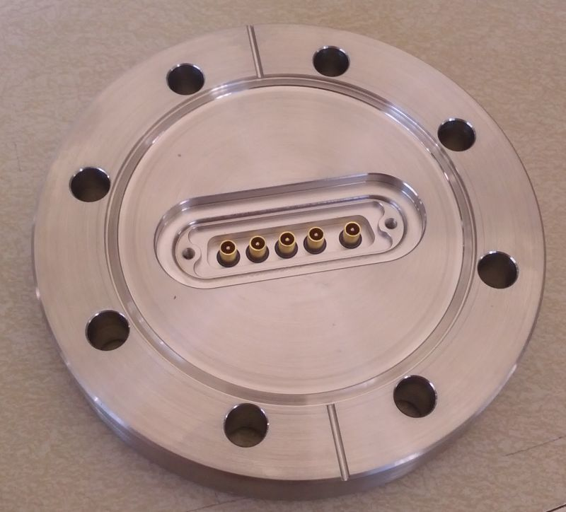

Figure 9, nice cutters

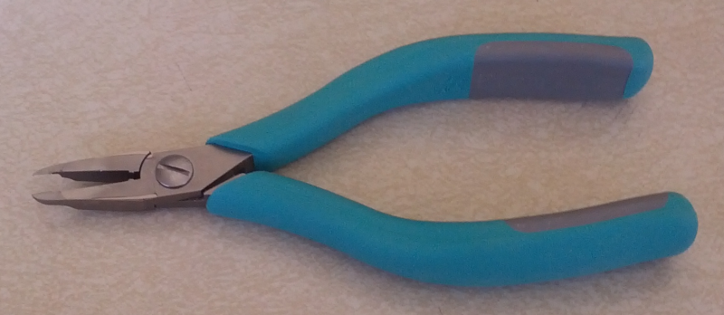

Figure 10, nice (rusty) pliers to grab and seat the socket inside the connector if needed

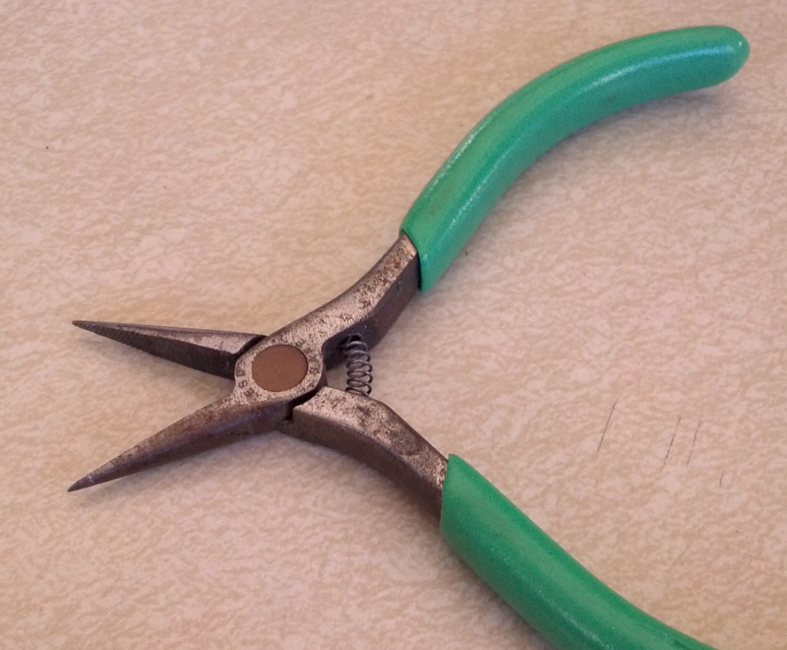

Figure 11, existing 5-way coaxial feedthrough. Note pin numbers.

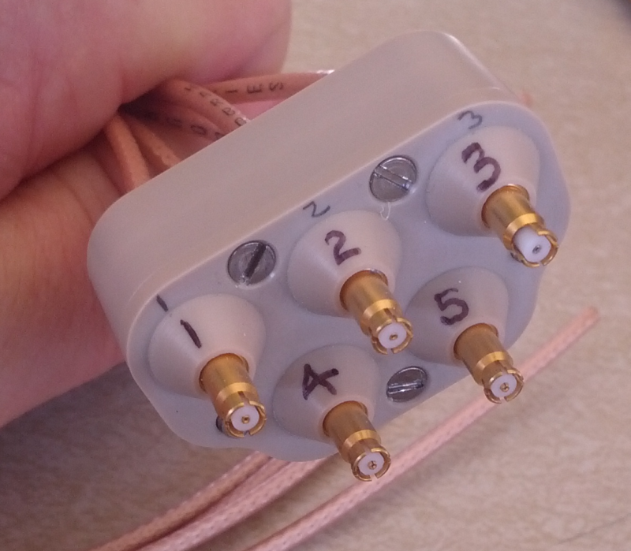

Figure 12, feedthrough taken apart, see little black band for indication of where to cut to maximize the remaining length

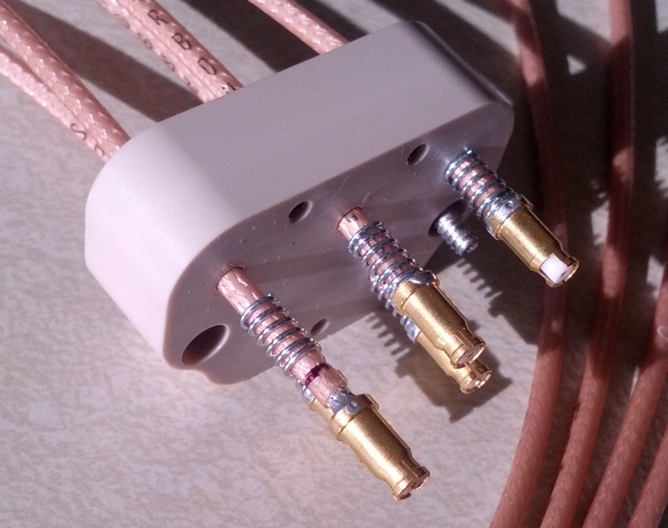

Figure 13, stripping dimensions for RG-316 cable termination into new Accuglass coaxial contacts



Figure 14, Accuglass coaxial contact



Figure 15, Accuglass 100909 assembly sequence. First put body sleeve and PEEK sleeve onto cable. Then crimp on the socket. Push the socket into the body socket, and slide the PEEK sleeve up. Fold the shield wires around the body socket and crimp the whole thing in place with the body sleeve. For God’s sake, don’t forget to pass the RG-316 through the new 5-way coaxial PEEK connector before crimping this thing on or else you are in a world of trouble as it’s captive on the new connector.

