LIGO Laboratory / LIGO Scientific Collaboration

LIGO-T400593-v1 Advanced LIGO Date: 22-Dec-14

Optical Lever Fermion II Internal Optimization Procedure

Authors: Suresh Doravari, Douglas Cook, Christopher Guido, Michael Vargas

Distribution of this document:
LIGO Scientific Collaboration

This is an internal working note
of the LIGO Laboratory.

California Institute of Technology  LIGO Project – MS 18-34  1200 E. California Blvd.  Pasadena, CA 91125  Phone (626) 395-2129  Fax (626) 304-9834  E-mail: info@ligo.caltech.edu | Massachusetts Institute of Technology  LIGO Project – NW22-295  185 Albany St  Cambridge, MA 02139  Phone (617) 253-4824  Fax (617) 253-7014  E-mail: info@ligo.mit.edu
LIGO Hanford Observatory  P.O. Box 159  Richland WA 99352  Phone 509-372-8106  Fax 509-372-8137 | LIGO Livingston Observatory  P.O. Box 940  Livingston, LA 70754  Phone 225-686-3100  Fax 225-686-7189
http://www.ligo.caltech.edu/

Table of Contents
1 Introduction 3
2 Test setup 3
2.1 Understanding the Problem 3
2.2 Procedure to stabilize the laser output 5
2.2.1 Adjusting the laser Power 5
2.2.2 Adjusting the coupling into the fiber 5
2.2.3 Adjusting the temperature control setpoint 6
2.2.4 Thermal stabilization with an enclosure 6
2.2.5 Reducing the acoustic vibrations within the laser enclosure 6
2.2.6 Long term observations using the CDS data acquision 7
2.3 Equipment Needed for Testing/Optimization 10
3 Detailed instructions for optimization 10
3.1 Fiber Misalignment 10
3.2 Temperature setpoint adjustment 12
3.2.1 Thermal Electric Cooler - Smaller Chassis 12
3.2.2 Thermal Electric Cooler – Larger Chassis 13
4 Appendix 13
4.30.1 4.1 ThorLabs FiberPort Collimator 13

Introduction
This document describes a test-setup for evaluating the performance of diode lasers used in Optical Levers and outline a procedure for improving their performance.
In aLIGO, the Optical Lever subsystem utilizes Micro Laser’s FI2 Fermion II fiber coupled lasers. The laser comprises of a laser diode encased in a temperature-controlled oven, with the output of the laser coupled to an FC/APC fiber using a Thorlabs FiberPort. This fiber is connected to a bulkhead fiber coupler on the chassis through which we couple light to an external single mode fiber. The chassis contains two circuit boards one of which controls the current supplied to the laser diode and the other is a temperature controller servo board. The external single mode fibers (typically yellow in color) is used to carry the laser light to the optical lever telescopes (See figure 1).
Note: There are actually 2 different types of laser chassis even though they have the same model number. Internally, they are basically the same. One allows for external Temperature control whereas the other does not
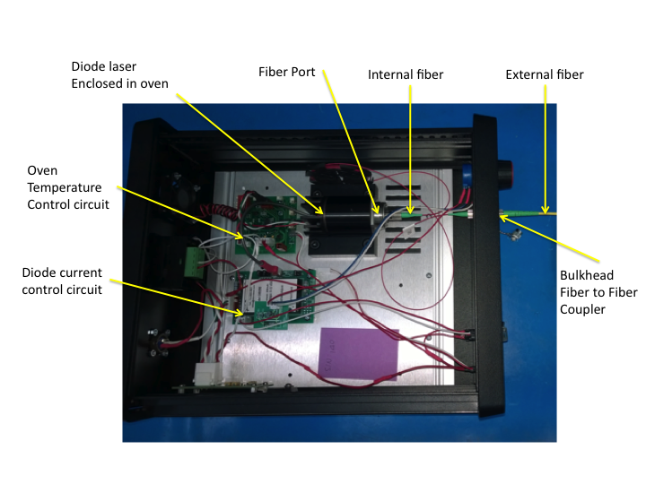
Fig 1. Layout of Fermion II fiber coupled laser

Test setup

Understanding the Problem
Many of the fiber coupled diode laser sources have a high RIN and glitches in output power leading to broadband noise. The observed power fluctuations are generally within the 1% of total power output as claimed by the manufacturers. These fluctuations occur due to mode hops within the Fabry-Perot Cavity of the diode laser. The mode hops are due to mode competition between coupled optical cavities, which are formed by laser light being reflected from downstream interfaces (“feed-back”) outside the diode laser. One such interface is the window on the diode laser package and the other is the input face of the internal fiber (thin red fiber from the laser to the chassis). To minimize these reflections the window on the laser is antireflection coated and the FC/APC fiber connector has the fiber tip polished at an 8 deg angle with respect to its optic axis. However even a reflection of a few ppm is sufficient to cause mode hops and therefore it is essential to make sure there is no feedback from any down stream interface. Fig 2. Shows the typical output of a diode laser when it arrives from the manufacturer.

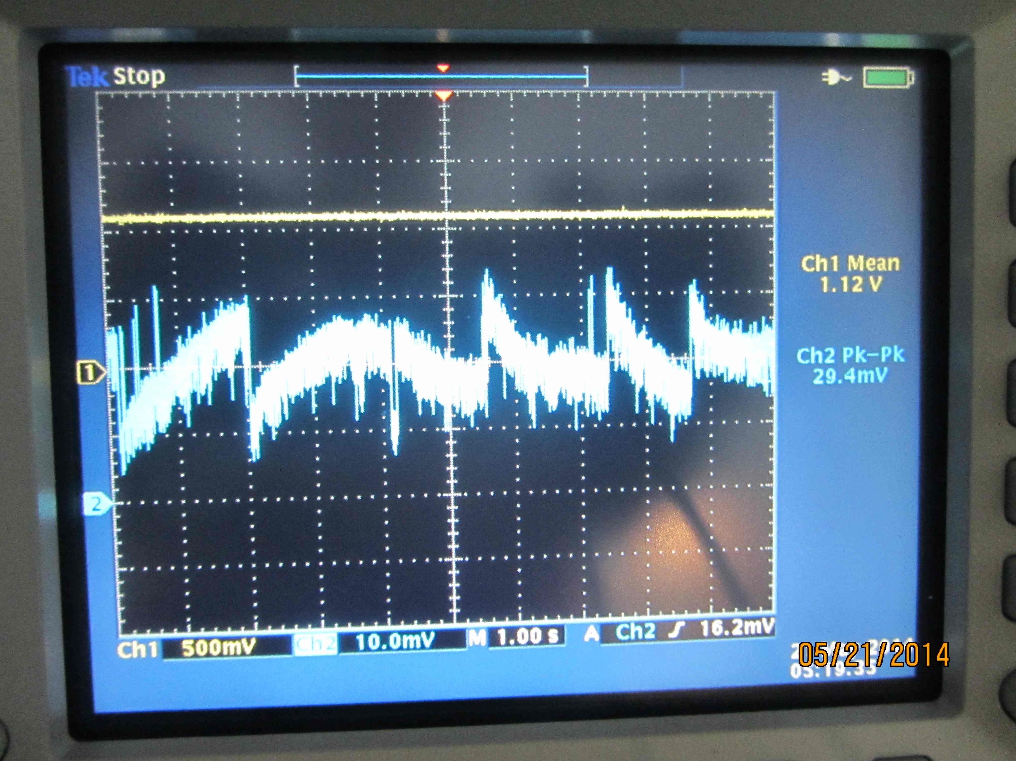

Fig 2. Power fluctuations of a typical diode laser received from the factory

The test setup in which the laser is tested is shown below in Fig.3. On a test bench a Thorlabs PDA36A variable gain photodiode is used to sense the power output from a laser diode. A part of the signal is bandpass filtered with an SR560 preamp and both the unfiltered and filtered signals are displayed on an oscilloscope screen.

Figure 3. Diode laser test setup.
The yellow trace on the oscilloscope shows the power output from the laser and the blue trace shows only the high frequency part of this signal. Note the sharp steps in the blue trace each of which indicates a mode hop within the laser.

Procedure to stabilize the laser output
The complete solution to stabilize the laser has four steps. The first is to adjust the laser power and thus the operating temperature of the laser, to minimize cross-talk between the internal FP cavity of the laser and the external cavity with the laser window. The second is to adjust the coupling between the laser and the internal single mode fiber using the fiber port alignment controls. Third is to choose a set-point in the temperature controller such that we get stable operation at about 75% of maximium power. The fourth step is to stabilize the thermal environment of the laser so that the air-conditioning in VEA does not cause temperature changes within the laser. An ancillary step is to reduce the acoustic vibrations in the chassis is to reduce the cooling fan speed.

Adjusting the laser Power
When current to the laser diode is increased, light output increases and so also does the heat generated within the semiconductor chip. In response, the temperature stabilization circuit will source more current to the Thermo Electric Cooler (TEC) within the oven and thus try to transport away the extra heat generated. However the temperature sensor of the servo is not co-located at the source of heat (diode chip) so the thermal gradients previously present will change and restabilise into a different pattern within the oven. This causes an effective change in the operating temperature at the location of the laser diode. The result is a shift of the gain-profile of the lasing medium (the peak shifts to a different wavelength) and thermal expansion of the FP cavity. The length between the diode chip and the window also changes, causing a change in the resonant frequency of the external cavity. It is possible to choose an operating power such that, at the lasing wavelength, the external cavity is anti-resonant and thus does not feedback to internal cavity. The signature of this is a reduction in the frequency of mode hops.

Adjusting the coupling into the fiber
In order to reduce the feed-back from the fiber tip we move the lens which mode-matches the laser light into the single mode fiber. The objective is to increase the angle of incidence such that the uncoupled light, which is already directed away by the 8 deg angle of the fiber face, is further away from the laser. This involves moving the lens horizontally using the Fiber Port translation screws.
It should be noted, that even if fiber misalignment reduces the peak to peak voltage such that it is less than 0.1% of the DC voltage, if the output looks like that of figure 4, then it is still not optimal. The sudden changes in the AC power are caused by output power instability. The TEC settings should be adjusted so that it provides enough range for the temperature to vary, from daily temperature fluctuations, while producing no instability or glitches. This correction will require some long duration observations.

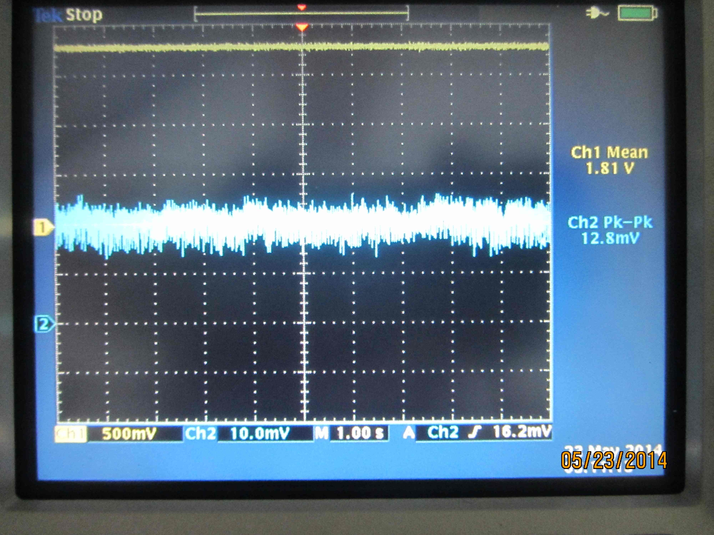
Fig 4. Output of a laser after minimizing optical feedback. The blue trace we see is typically limited by the noise in the test setup indicating a RIN <0.1%.

Note: Acoustic vibrations can also appear as a noise source and can be mistaken for fiber feedback when the chassis is open during testing. It is good to replace the chassis cover during testing every once in a while to ensure that observed noise is not dominated by acoustic noise.

Adjusting the temperature control setpoint
After the above two adjustments if we scan the power output range of the laser we will notice that at certain power ranges the laser is stable and stays on a single mode. These “islands” of stability are interlaced with islands of instability where the laser will hop between two or more modes continuously. Our aim is to obtain an island of stability in the upper 25% of the power range of the laser. We can achieve this by adjusting the temperature set-point. Also the width of the island will depend on the choice of the temperature setpoint. Typically the temperature adjustment is to drop the unscaled temperature indicator voltage from 1.25V to about 1.1V. But some searching in the T space is needed for optimization.

Thermal stabilization with an enclosure
Despite these adjustments the laser is sensitive to external temperature varations of more than half a degree centigrade. A variation of 1 deg C is typical during the course of a day in the LVEA. Therefore we need to place the laser in a thermally insulating enclosure and add some material with high heat capacity to increase the thermal time constant of the laser. We have thus far used a simple ice cooler with chiller packs to achieve this stabilization.

Reducing the acoustic vibrations within the laser enclosure
The chassis cooling fan is typically the largest source of vibrations within the chassis. We can reduce the speed of the fan by adding a pair of diodes in series with the fan so as to reduce the voltage across the fan coils without dissipating heat within the chassis. The voltage drop across a typical diode being 0.7V, two of them in series will drop the voltage from 5V to 3.6 V across the fan.

Long term observations using the CDS data acquision

After the laser has been tested in the lab we install the laser into HAM3 optical lever. There are two objectives in doing so. One is to observe the long term trends of the data. The other is to let the laser reach thermal equilibrium with the LVEA as the operating temperature could be quite different between the EE shop and the LVEA. If the laser is found to be glitchy in the LVEA after the adustments described above the most likely reason is the change in the environment and this can be adjusted away choosing a different operating power. Typically if the laser has been stable in the upper 25% of its power range then no adjustment is needed in the LVEA.

The figures below show the improvement in laser performance from before to after the stabilization procedure described above. These observations are logged into LHO alog 15637. Figs 5,6,7,8 and 9 below show this improvement in the LHO BS suspension.

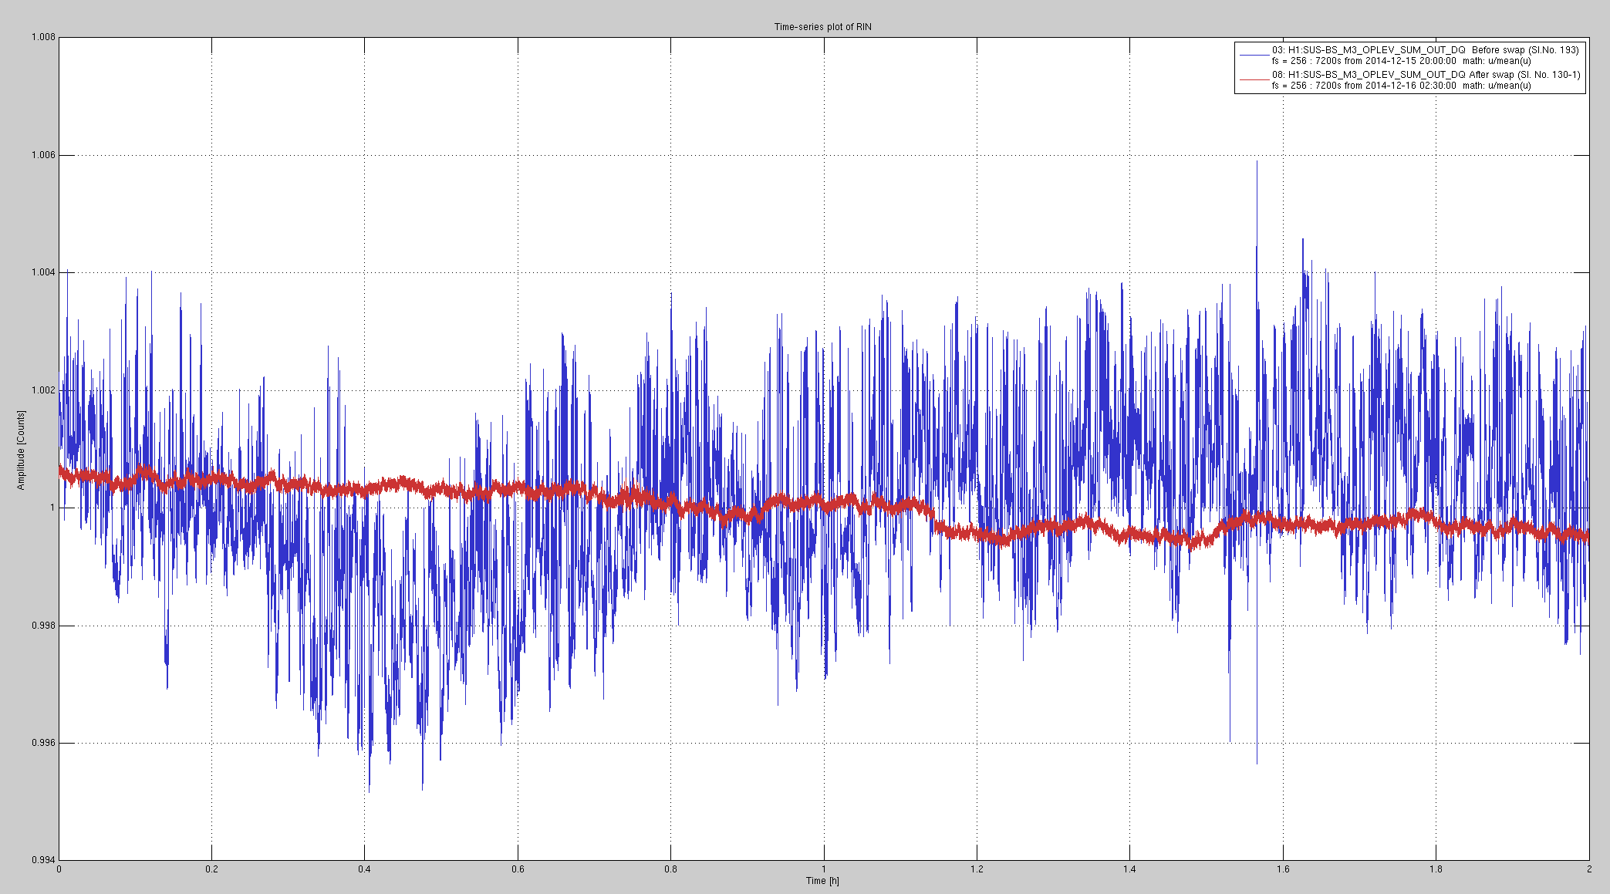
Figure 5. The time trace of the laser power output. The blue trace is from before the stabilisation procedure and the red trace is from after. The time interval of observation is two hours. The behaviour is typical of longer durations as well.

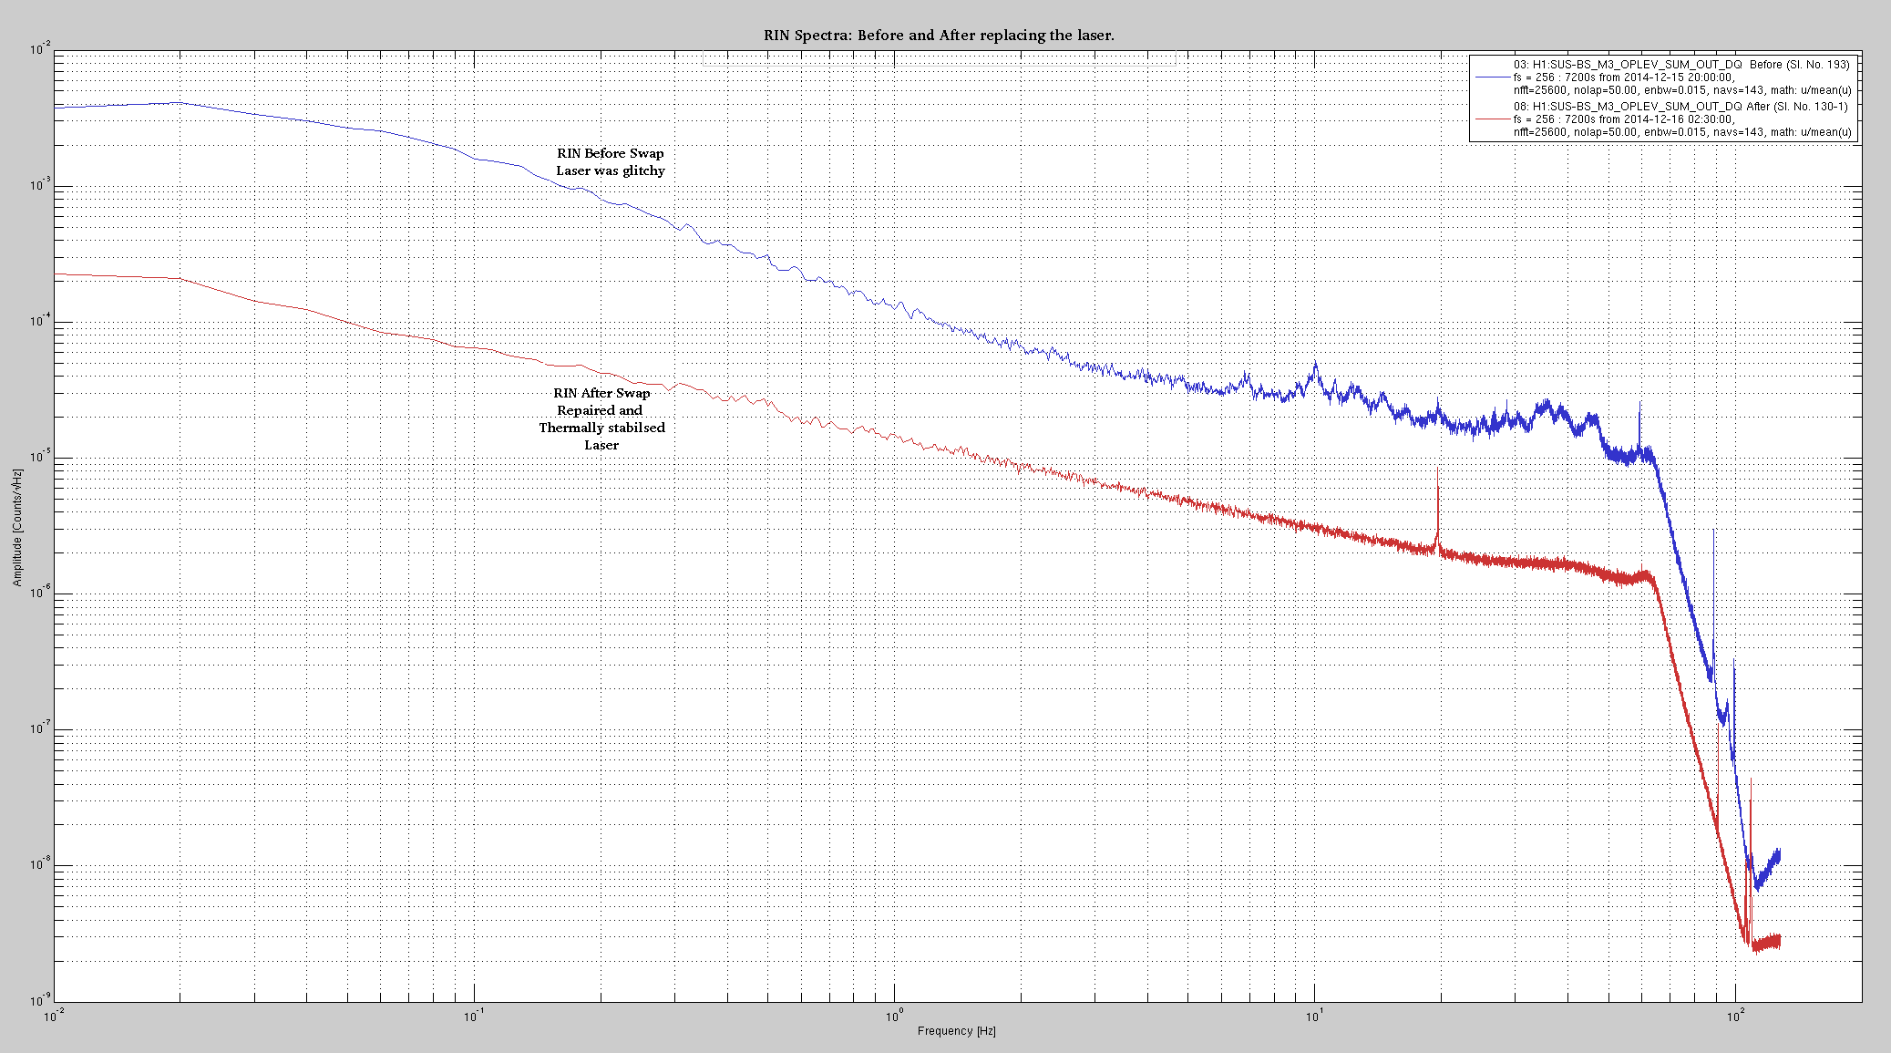
Figure 6. The reduction in RIN across the entire spectrum is about an order or magnitude.

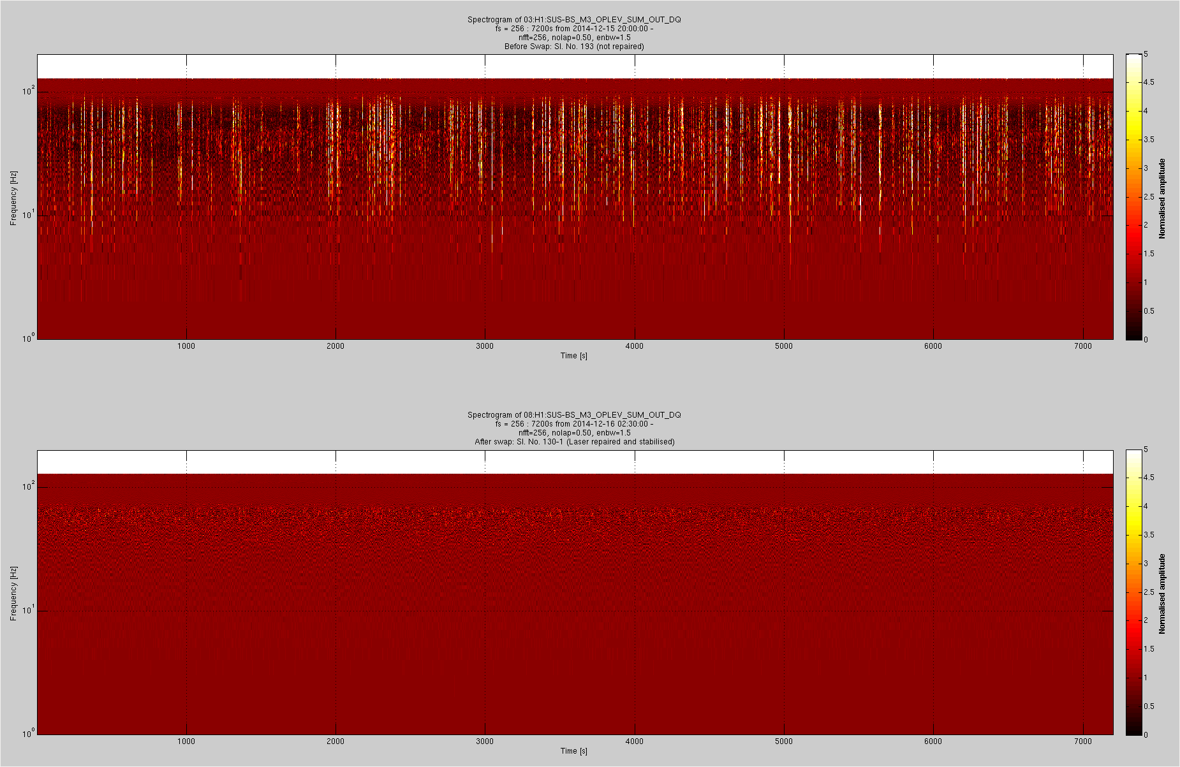
Figure 7. These spectrograms show that the injection of bradband noise due to the glitches has disappeared after the laser stabilisation procedure. The upper panel is before the procedure and the one below is after fixing the laser.

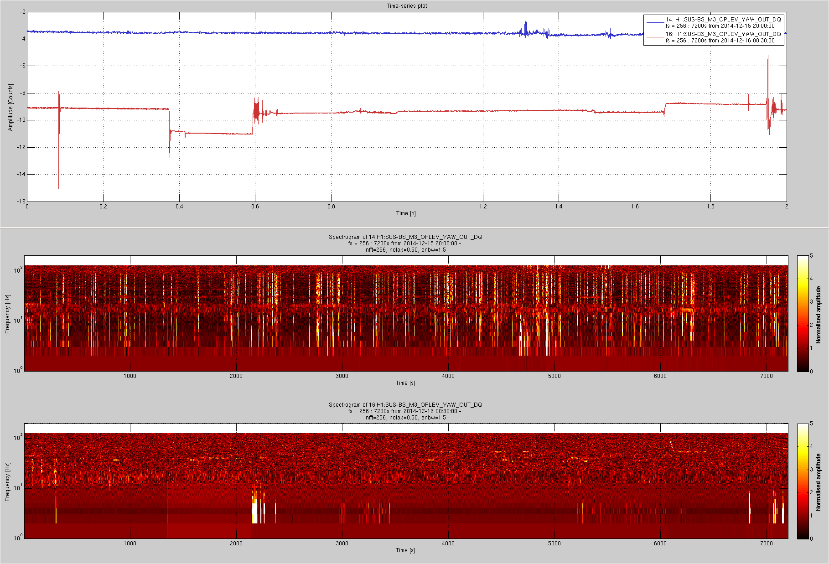
Figure 8. As the laser is used in local damping of the BS suspension the glitches were injecting broadband noise into the pitch and yaw motions of the optic. The spectrogram above shows the noise injected into the yaw motion. The spectrogram of the blue trace is the middle panel and the lower panel corresponds to the red trace after fixing the laser. The steps in the red trace are because of operators moving the optic during the initial alignment procedure. They cause low frequency motion of the optic as shown the lower panel, where as the glitches seen in the middle panel cause broadband noise.

Equipment Needed for Testing/Optimization

Photodiode | Thorlabs PDA36A- used to measure laser power
Oscilloscope | At least four channels, one to record DC power, AC power, Temp set point, Temp readout
SR560 Preamplifier | Receive AC signal and applies a band pass filter and gain, then outputs to Oscilloscope
+5V Power Supply | Used to power the Fermion II laser
BNC cords and BNC T splitter | Carries signals from the photodiode to the oscilloscope and the Preamplifier
Tools | 0.05” Allen key, 3/16” Allen key, Phillips screw driver, Flat head screw driver for adjusting the temperature set point

Detailed instructions for optimization
Because the laser is a class 3B laser, with an output power of less than 5mW at 635nm, the testing can occur on an electronics bench where access to other items (as needed) can be easily obtained. No eye protection is required.
Note: The output of the diode head can be greater than 5mW; therefore, if the internal fiber is completely removed from the system exposing the diode, eye protection at 635nm will be required.

Fiber Misalignment
- Begin by removing the top cover and base floor of the Fermion II laser chassis. On the larger chassis, remove the 4 screws on the side of the top and bottom panel to slide the panel out (upwards). On the smaller chassis, remove the two back “legs” and slide the top away from the front panel (See figure 4)

Side screws
Back legs
Fig 9. Two types of laser chassis

- Remove the internal fiber from the front panel of the laser (be careful not to damage the tip of the fiber by handling it roughly)
- Remove the front panel of the laser and slide it through the inside of the chassis and place it on top of the chassis as seen in figure 5. Do not disconnect any electrical wires. This is done so that it is easier to access and adjust the fiber coupler.

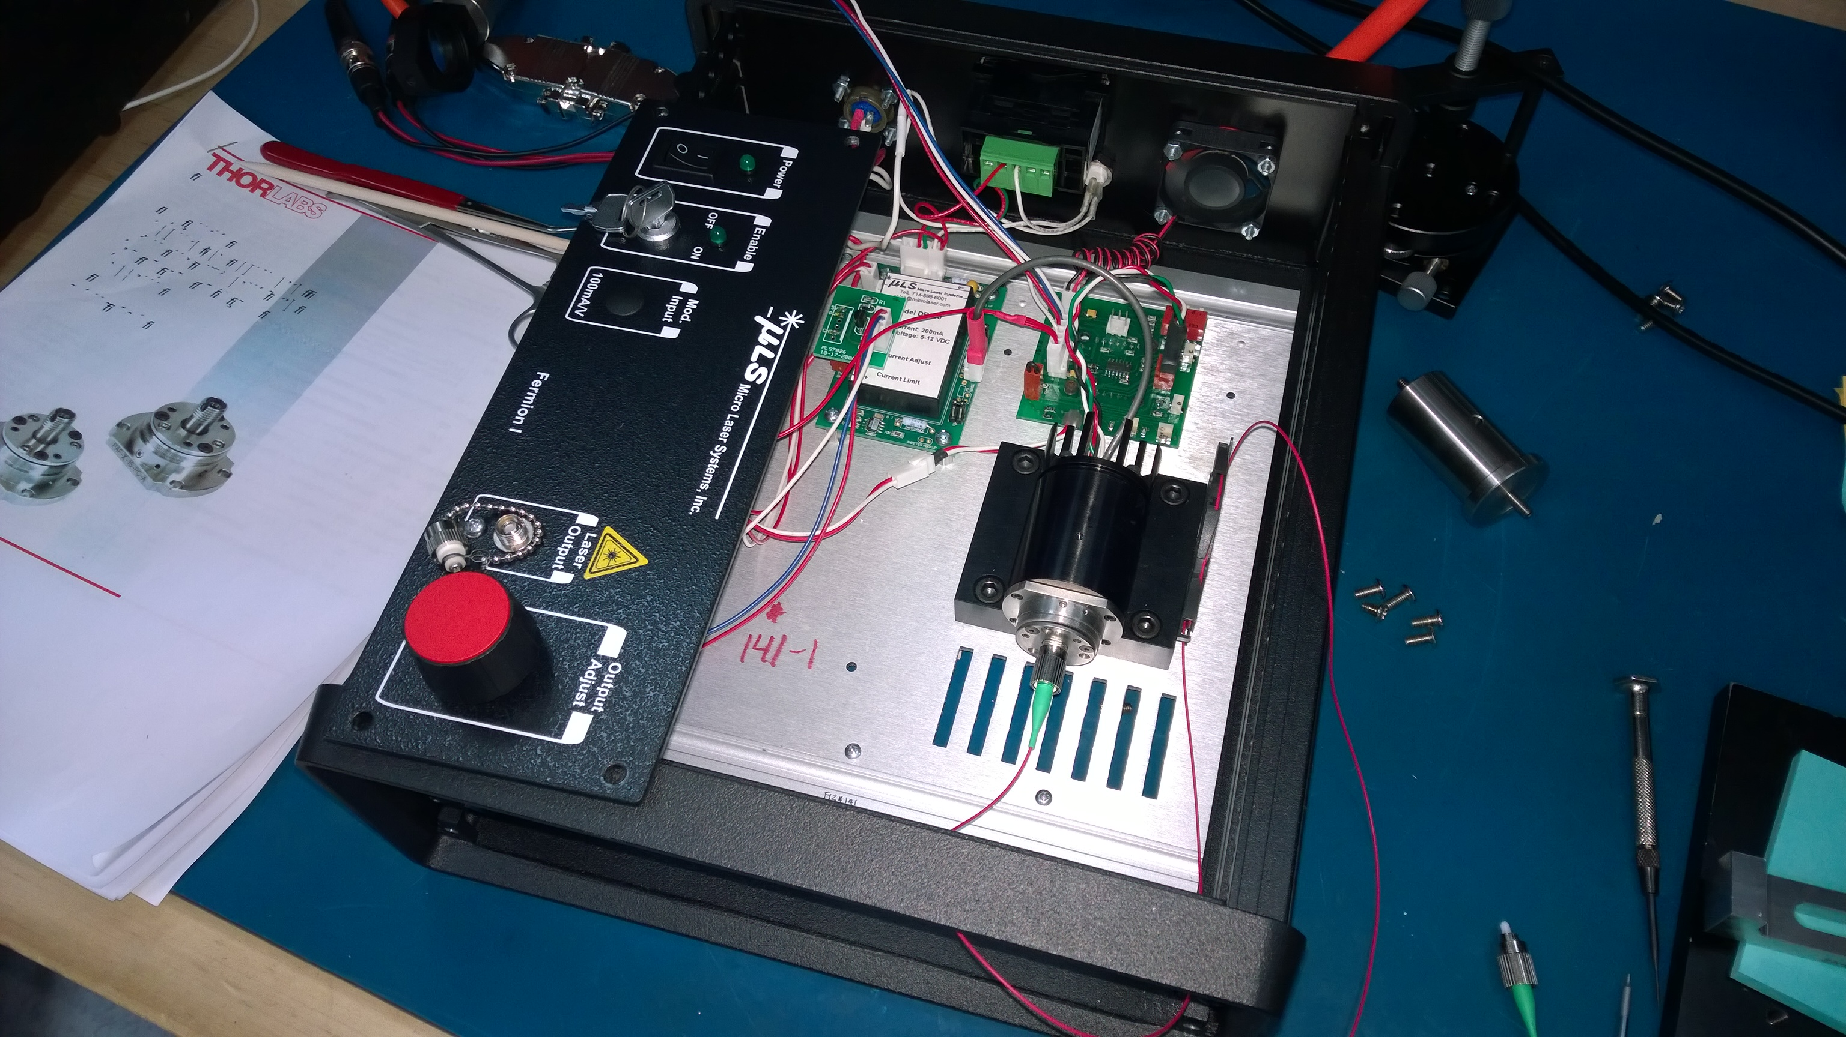
Figure 10) open laser chassis for optimization

- Take the loose end of the fiber (the side originally connected to the front panel of the chassis) and place it into the fiber holder (see figure 6). Turn on the laser and aim the fiber coupler such that such that the back reflection from the photodiode is not clipping (is circular) and is away from the fiber.

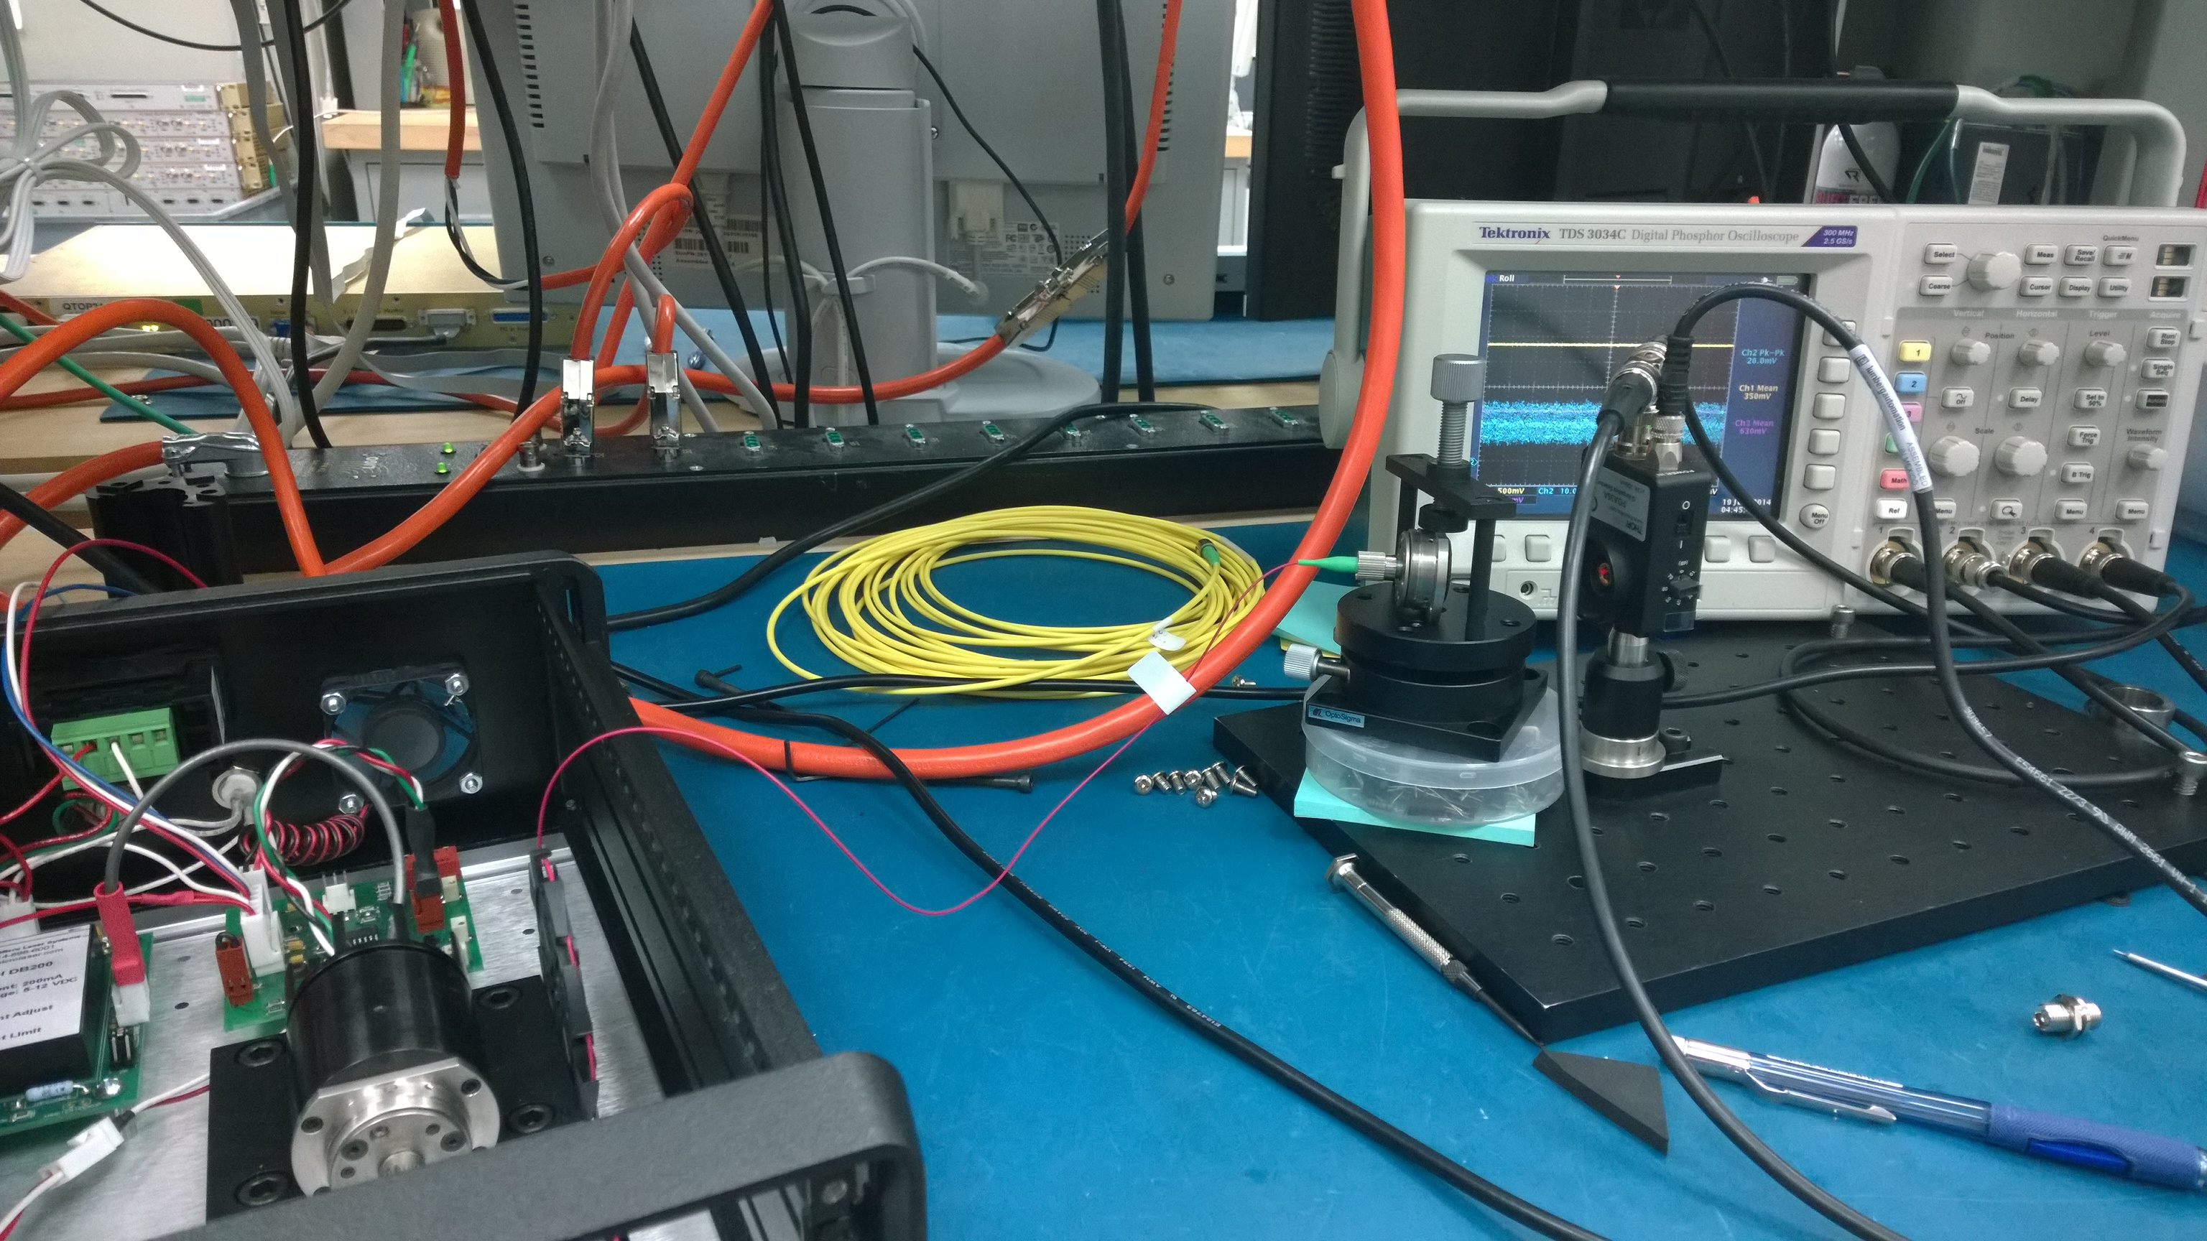
Figure 11) internal fiber connected to Thorlabs Fiber Coupler

- Connect the photodiode to both the preamplifier (DC coupling) and the oscilloscope using a BNC T-adapter and two BNC cables. Verify that the photodiode has a gain setting of 1.
- Set the preamplifier to have a bandpass filter with cutoffs at 10 Hz and 10 kHz at 6 dB/oct. The output gain should be set to 5 or 10. Connect the output of the Preamplifier to the oscilloscope.
- The BNC from the PD to the oscilloscope is the DC signal and the BNC from the preamplifier to the oscilloscope is the AC signal. Measure the DC voltage and the AC peak to peak voltage to determine the AC fluctuation relative to the DC power (AC rms peak to peak voltage/ DC mean voltage). This value needs to be less than 0.1%.

Note: Be sure to divide the measured AC peak to peak value by the gain set on the preamplifier. This is the true AC value used to calculate RIN.

- Adjust the angle of the Thorlabs FiberPort Collimator (seen in Figure 12), which is attached to the thermal cavity and fiber, such that the AC rms peak to peak voltage reduces. Note, this will reduce to the DC voltage as well. To adjust the angle of the collimator, use the three socket head cap screws on the front of the collimator. If all three are equally turned in the same direction, this will create an axial (z) translation of the fiber.
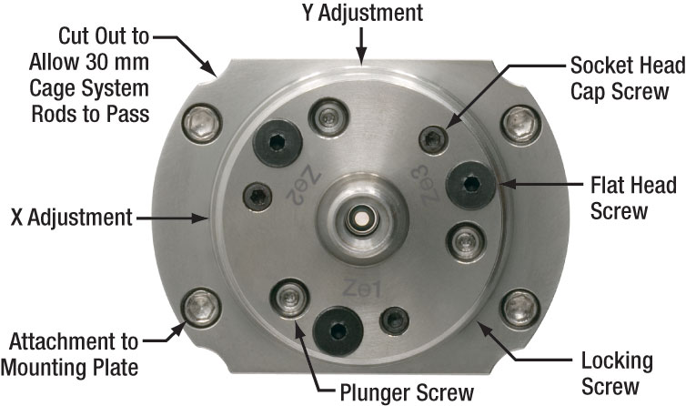
Figure 12) Thorlabs FiberPort collimator

As the DC voltage begins to decrease, the X and Y translation of the FiberPort will needed to be adjusted. To do so, the locking screw must also be loosened; however, some amount of pressure is still needed to have the FiberPort translate smoothly. To loosen the locking screw on the larger chassis, slide the allen key through the base grooves (this is why the bottom panel was removed). On the smaller chassis, the thermal chamber will have to be removed from the support floor. The thermal chamber is bonded to a base which is held onto the support floor by four ¼-20 screws. Be sure to bolt this back onto the chassis when measuring the AC noise as it will be greatly affected by acoustic vibrations.

- Repeat step 8 until the DC voltage is relatively high compared to its maximum yet the AC fluctuation is less than 0.1% of the DC voltage.

Temperature setpoint adjustment
The temperature setpoint adjustment is done differently for the two types of chassis.

Thermal Electric Cooler - Smaller Chassis
For the smaller chassis, the TEC can be adjusted and monitored externally from the laser chassis. Using a flat head screw driver, adjust the temperature so that instability glitches disappear. Note, this will also affect the DC power of the laser; however, you shouldn’t have to adjust the fiber misalignment except for minor tweaking. Figure 13 shows the back of the two chasses with the smaller chassis being on top.
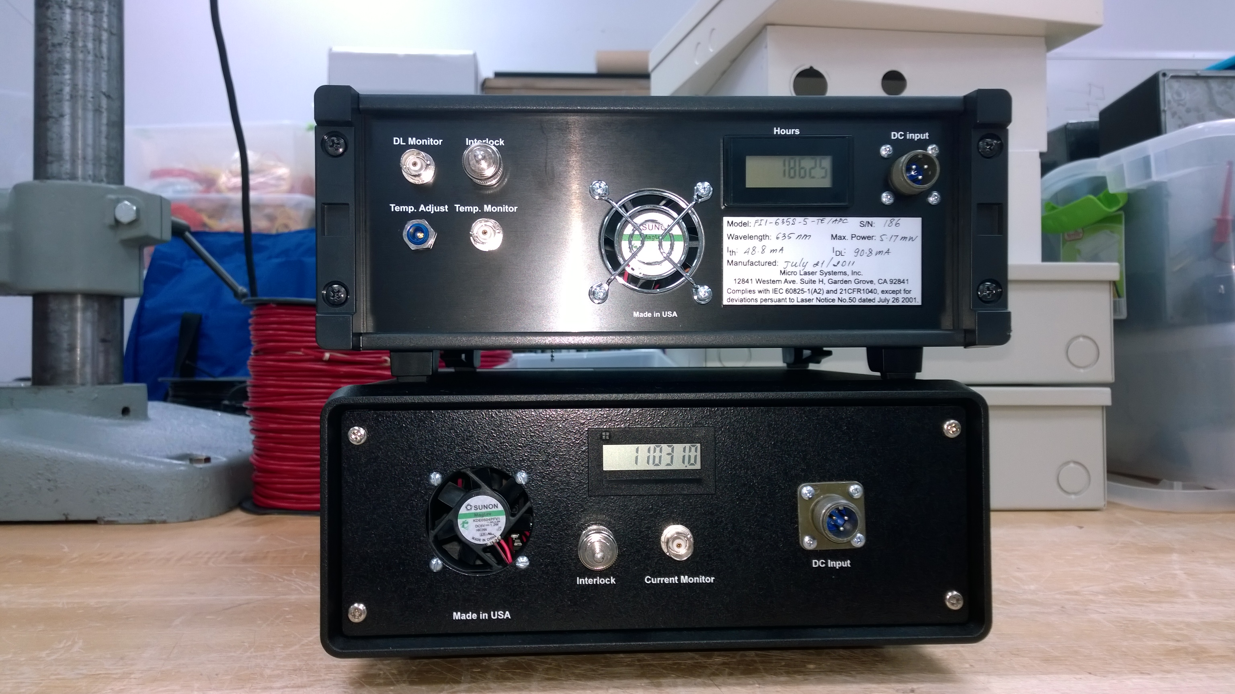
Figure 13) the back of the laser chasses. The smaller chassis is on top and has external TEC controls

Thermal Electric Cooler – Larger Chassis
For the larger Chassis, connect a voltmeter to the connector shown in Figure 14. This reads out the temperature controller board set point. The set point is adjusted as in 3.2.1.
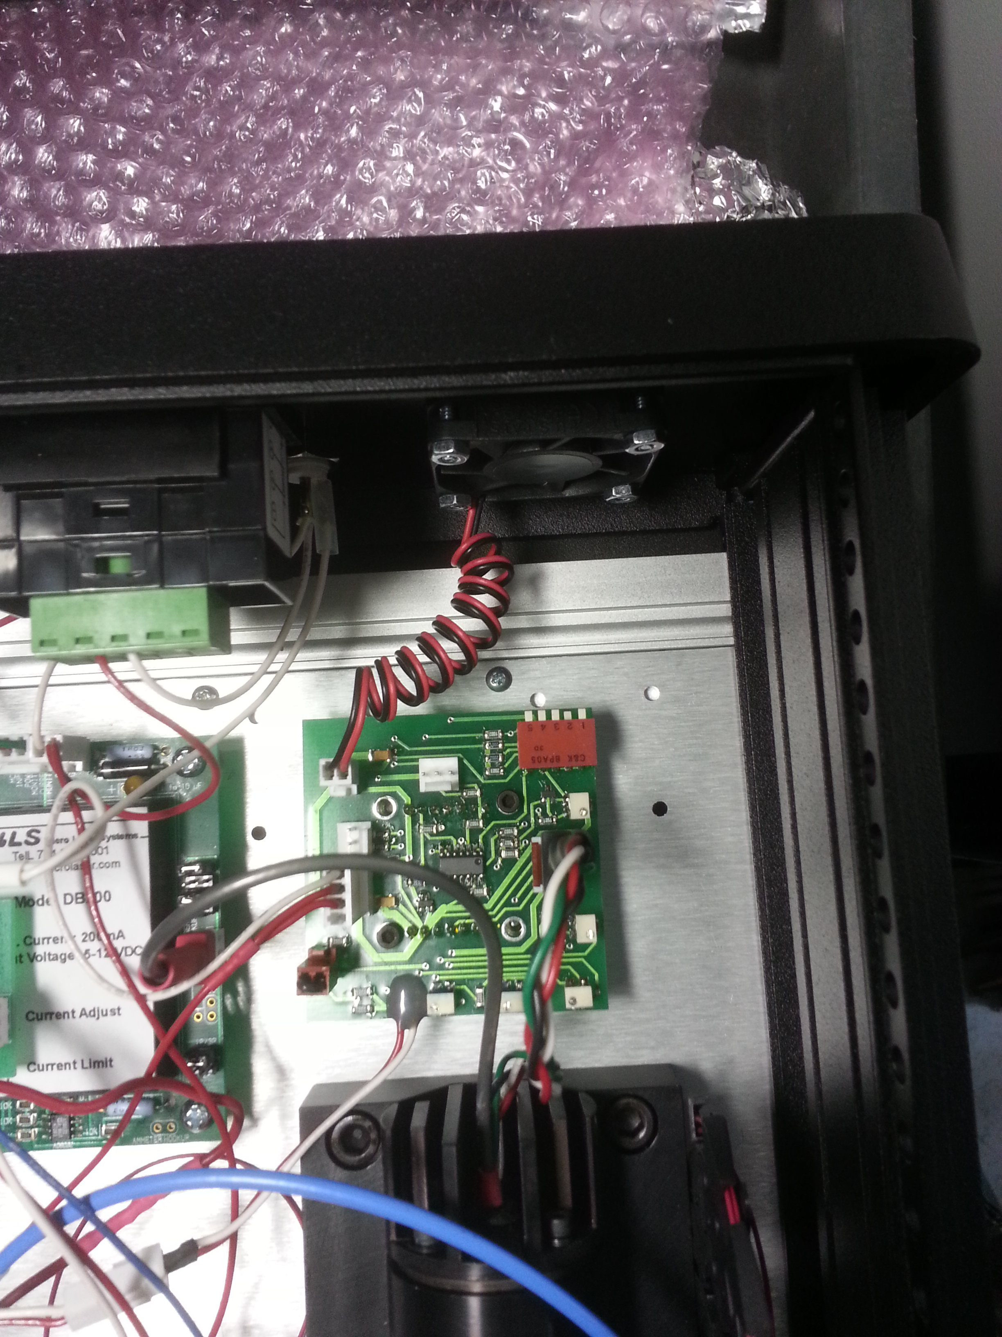
Temperature indicators
Set-point adjustment.
Figure 14) Top view of temperature controller board. Temperature probe should be attached to the highlighted indicators. Temperature set point is adjusted on the potentiometer shown above.

Appendix

4.1 ThorLabs FiberPort Collimator
The FiberPort is a six-degree-of-freedom fiber collimator and coupler (5 axes, plus rotation). It uses a movable lens as the alignment mechanism while holding the fiber stationary. This provides an extremely stable and repeatable platform for coupling and collimating. All adjustments are coupled.
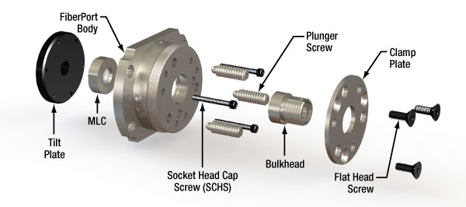
Exploded View of FiberPort

The FiberPort consists of a body, a Magnetic Lens Cell (MLC) adhered to a tilt plate, and a bulkhead with fiber connector. The bulkhead is locked onto the FiberPort body by three flat head screws and the clamp plate. By loosening the flat head screws, the fiber bulkhead can be rotated freely.
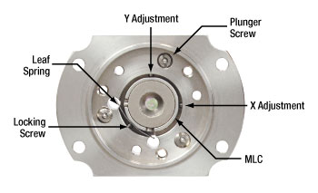
FiberPort MLC as Viewed from the Lens Side (with Tilt Plate Removed)

Z/q/j Adjustment
The MLC adheres to the tilt plate, which can be adjusted in Z/q/j (axial, tip, and tilt, respectively) using the three socket head cap screws (SCHS). The plunger screws provide counterforce against the SCHS. The q/j (tip/tilt) and Z (optical axis) translation range is ±4° and ±0.4 mm, respectively, for a given position of the plunger screws. The tip/tilt and Z-axis resolution is 1.32° (23 mrad) and 0.012" (0.32 mm) per revolution, respectively. The plunger screws can translate the positive extreme of the travel range in the Z direction over a distance of 2 mm.

X-Y Adjustment
Additionally, the MLC can be translated in X-Y using the socket head cap screws in the side of the FiberPort body. The MLC rests on a leaf spring, and the X-Y screws push the cell against the leaf spring. A third socket head cap screw behind the leaf spring can be used for locking. The travel range of the aspheric lens in the X and Y directions is ±0.7 mm, with a resolution of 0.012" (0.32 mm) per revolution, but when the FiberPort is used in a standard collimation/coupling application only a small portion of this translation range is used.

Location of Screws on the FiberPort
The X-Y lens adjustment screws are located on the outer diameter of the FiberPort body at the 9 o'clock and the 12 o'clock positions (shown in the photos to the right). The three plunger screws provide counterforce for the tilt plate. The three socket head cap screws (SHCS) provide the Z/q/j adjustments for the FiberPort. The three SHCS and the X-Y screws are the only screws that are normally used in the alignment of the FiberPort, but the plunger screws can be used to adjust the tension on the tilt plate if needed. Also, the three flat head screws on the face of the FiberPort hold the clamp plate and bulkhead in place. By loosening these screws, the bulkhead can be rotated through a full 360° and secured at any angle for PM applications. This is a coarse adjustment, however.
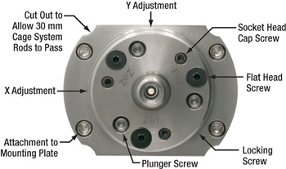
Location of Adjustment and Mounting Screws as Viewed from the Fiber Bulkhead Side

The locking screw is located on the outer diameter of the FiberPort body at the 4:30 o'clock position. The locking screw is not installed when the FiberPort is shipped, but it is included in the package. The locking screw is only used after the FiberPort is aligned. NOTE: Locking is not necessary in most applications and tightening the locking screw may affect the coupling.
Part | Screw Size | Head Size (Hex)
Mounting Plate Attachment Screws | 2-56 | 5/64" (2 mm)
X, Y, Z, Tip & Tilt  Socket Head Screws | 0-80 | 0.050"ª
Flat Head Screws | 2-56 | 0.050"ª
Plunger Screws | 6-32 | 0.035"ª

