Classroom Activities

Energy, Vibrations and Waves

Kindergarten and First Grade

A Collaboration of the Pasco (WA) School District and the Laser Interferometer Gravitational-wave Observatory (LIGO)

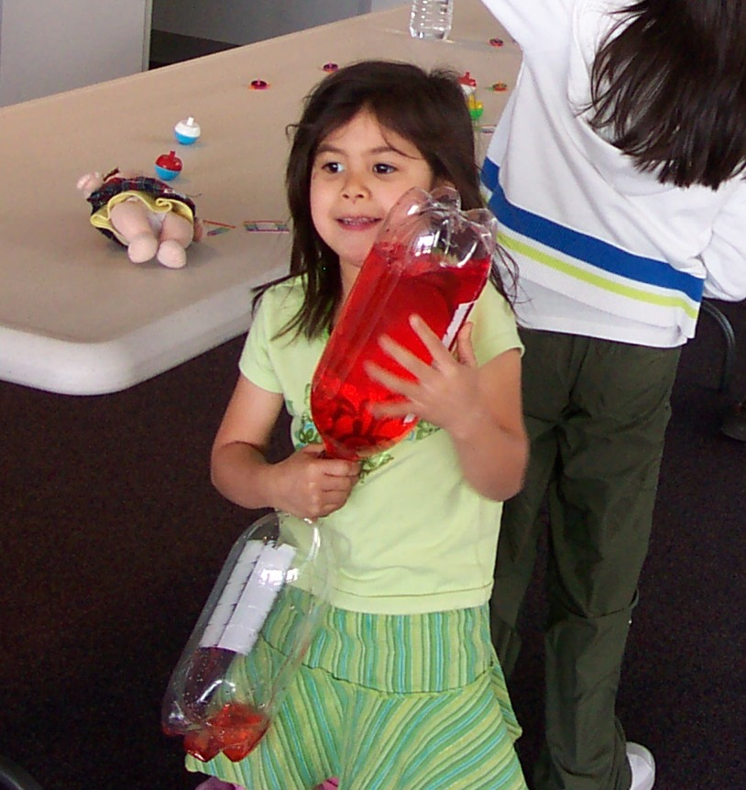
Version 3
August 2015

This version of the kindergarten-first grade packet may not be the most up-to-date version that exists. Please check the following url to download the most current version:

https://dcc.ligo.org/LIGO-T1400520/public

For additional information, including teacher professional development related to the packet materials, contact

Dale Ingram
Education and Outreach Coordinator
LIGO Hanford Observatory
PO Box 159 Richland, WA 99352
509-372-8248
ingram_d@ligo-wa.caltech.edu

LIGO is operated by the California Institute of Technology and the Massachusetts Institute of Technology and is funded by the National Science Foundation

Table of Contents

Introduction ………………………………………………………………….. page 3

NGSS-Kindergarten ………………………………………………………… page 4

NGSS-1st grade ………………………………………………………………. page 5

Overview ……………… ………………………………………………………. page 6

Sample 5E Mini-Unit Plan …………………………………………………… page 7

Conceptual Background for Teachers …………………………………… page 9

Science Kit Stations ………………………………………………………… page 13

Materials List ………………………………………………………………….. page 21

Scenario Assessment ………………………………………………………. page 22

Student Scientists’ Survey ………………………………………………… page 23

Tabletop Signs for the Activities …………………………………………. Page 24

Introduction

This packet contains classroom activities and materials designed to address most of the Disciplinary Core Ideas (DCI’s) for standard 1-PS4 in the Next Generation Science Standards (NGSS). The packet also addresses some of K-PS2 standard and could be used to supplement learning about energy and engineering. Middle and elementary teachers in the Pasco School District (PSD) along with personnel at LIGO Hanford Observatory have developed the activities.

Similar packets exist for 4th grade and middle school. These contain a greater number of activities and more in-depth practices. Hopefully this packet will give students a foundation for future learning about energy, waves, light and sound.

Some comments about implementation and safety:
- Use adequate space for the sound tubes so students do not hit each other or items in the classroom.
- If two students stretch the Slinky and one student suddenly lets go, the rapid compression of the Slinky could cause injury. Ask students to avoid letting go of the stretched Slinky.
- If the end caps come off of the Slinky, sharp edges could be exposed.
- When using the optical materials, please beware that they provide no protection from the Sun. Remind students not to look directly at the Sun.
- Use caution when handling magnifying glasses. Under the right conditions, magnifying lenses could cause a burn.

LIGO and PSD welcome feedback regarding the use of this packet and the related standards. Direct feedback to outreach@ligo-wa.caltech.edu .

LIGO provides training on the classroom use of these materials. We strongly encourage teachers to request a workshop for this training. Contact LIGO at 509-372-8248 or at outreach@ligo-wa.caltech.edu to discuss possibilities for a wave workshop at your school or at LIGO Hanford Observatory.

LIGO welcomes students of any age to visit the Observatory on field trips. At LIGO students can see wave science and scientists in action as LIGO personnel continue their quest to uncover new information about the universe by measuring gravitational waves. LIGO offers enjoyable age-appropriate hands-on experiences for students along with opportunities to rub shoulders with STEM professionals in work locations such as LIGO’s control room. Check the LIGO Hanford Web site at www.ligo-wa.caltech.edu/field_trips.html for more information on field trips.

Kindergarten standard, Next Generation Science Standards



Next Generation Science Standards, Volume 1. 2013. The National Academies Press. ISBN 13: 978-0-309-27227-8

First grade standard, Next Generation Science Standards

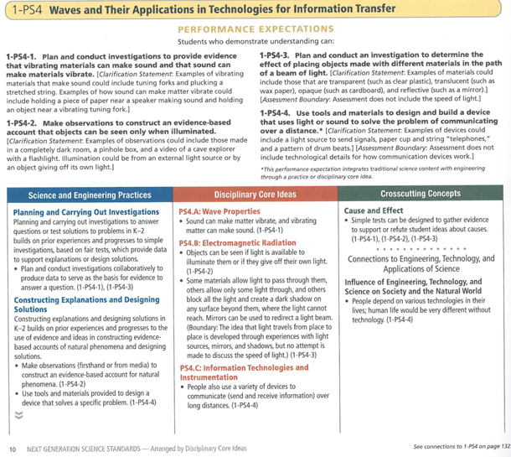
Next Generation Science Standards, Volume 1. 2013. The National Academies Press. ISBN 13: 978-0-309-27227-8

Overview

Through the use of this packet students and teachers will begin to explore the science of vibrations, waves, sound, light and similar expressions of energy. The packet activities support exploration and inquiry. The packet encourages students and teachers to make meaning of the activities, to connect their ideas to prior learning and to begin to interrogate the universe around them. Additionally, teachers can use the packet activities to introduce kindergarteners and first graders to several of the NGSS science and engineering practices. Asking questions, constructing explanations and engaging in argument from evidence represent the NGSS Science and Engineering Practices that most closely connect to the explorations in this kit.

Teachers can use the packet to involve students in pure exploration or in a more structured mini-unit. To use this packet in an exploratory manner, introduce the activities and ask students to move through the activity stations. Teachers who already possess a plan for wave instruction but who need a high engagement component to supplement their plan will find the packet helpful. As an alternative, the packet and the stations could be used as a mini-unit to address relevant NGSS and Common Core standards as well as the language development needs of students. Specific teacher implementations of the packet will depend on time and other logistics constraints and the teacher’s goals for student learning.

This packet does not fully address the information transfer component of the NGSS standard. To more fully meet this component, teachers might add an activity in which students use walkie-talkies for communication (perhaps if such items can be borrowed from the school’s office or administration).

The 5E model that appears in this packet relates to the stages of the 5E learning cycle: Engage, explore, explain, elaborate and evaluate. This model encourages and promotes inquiry-based learning and allows students to build personal meaning from the activities. Check the Midwestern State University (MSU) or NASA links below for more 5E information.

- http://faculty.mwsu.edu/west/maryann.coe/coe/inquire/inquiry.htm

- http://www.nasa.gov/audience/foreducators/nasaeclips/5eteachingmodels/

The packet includes some ideas for informal assessments. Teachers should use best practices for assessing student progress against the learning goals for the content that the packet supports.

5E Mini-Unit Sample

Engage (Day 1: 30 minutes): Background knowledge and classroom demonstration
- Create KWL chart about energy, waves, sounds and light
- Demonstrate “Tornado Tube” and “Bottle Fountain” activities
- Classroom discussion about the demonstration
  - Why does the water form a whirlpool?
  - What causes this reaction?
  - What is happening to the water?
  - How are the “Tornado Tube” and the “Bottle Fountain” different?
- Statement of purpose for the remainder of the unit

Explore (Day 2: 45 minutes): Activity station rotations
- Expectations for activities
- Set up the following activities:
  - Sound Tube
  - Groaning Tube
  - Regular Top
  - Top with Arms
  - Upside-Down Top
  - Gyroscope
- Group the students by 3 or 4
- Rotate groups every 5 minutes for 6 rotations
- Classroom discussion: What did you see/learn/experience today?
Explore (Day 3: 30 minutes): Activity station rotations
- Review expectations
- Set up the following activities:
  - Slinky
  - Poppers
  - Kaleidoscopes
  - Rattlebacks
- Group students and rotate every 5 minutes for 4 rotations
- Classroom discussions: What did you see/learn/experience today? Did it relate to any activities we did yesterday? How?

Explore (Day 3: 30 minutes): Activity station rotations
- Review expectations
- Set up the following activities:
  - Colored acetate sheets
  - Polarizing film
  - Prisms
  - Ultraviolet beads
- Group students and rotate every 5 minutes for 4 rotations
- Classroom discussion: What did you see/learn/experience today? Did it relate to any activities we have done the last two days? How?

Explain (Day 4: 30 minutes)
- Showcase each station as a whole group
- Ask the students what they discovered, share scientific principles found in this packet under the “science kit” section

Elaborate (Day 5: 30 minutes)
- Watch Bill Nye the Science Guy video Sound** (this will connect and cement the understanding they gained during the “Explain” day).

Evaluate (Day 6: 45 minutes): Build a device to communicate over a distance
- Complete KWL chart
- Read the scenario (at the end of the packet)
- Place students in teams of 3 or 4
- Give them access to a variety of materials such as tin cups. Light sources, paper clips, string, musical instruments, paper towel tubes or anything found in the LIGO kit
- Students work for 30 minutes then present their idea to the their classmates
- Unit checklist assessment (whole class)

** Bill Nye Sound video: http://www.dep-store.com/product-p/77a34vl00.htm

Conceptual Background for Teachers

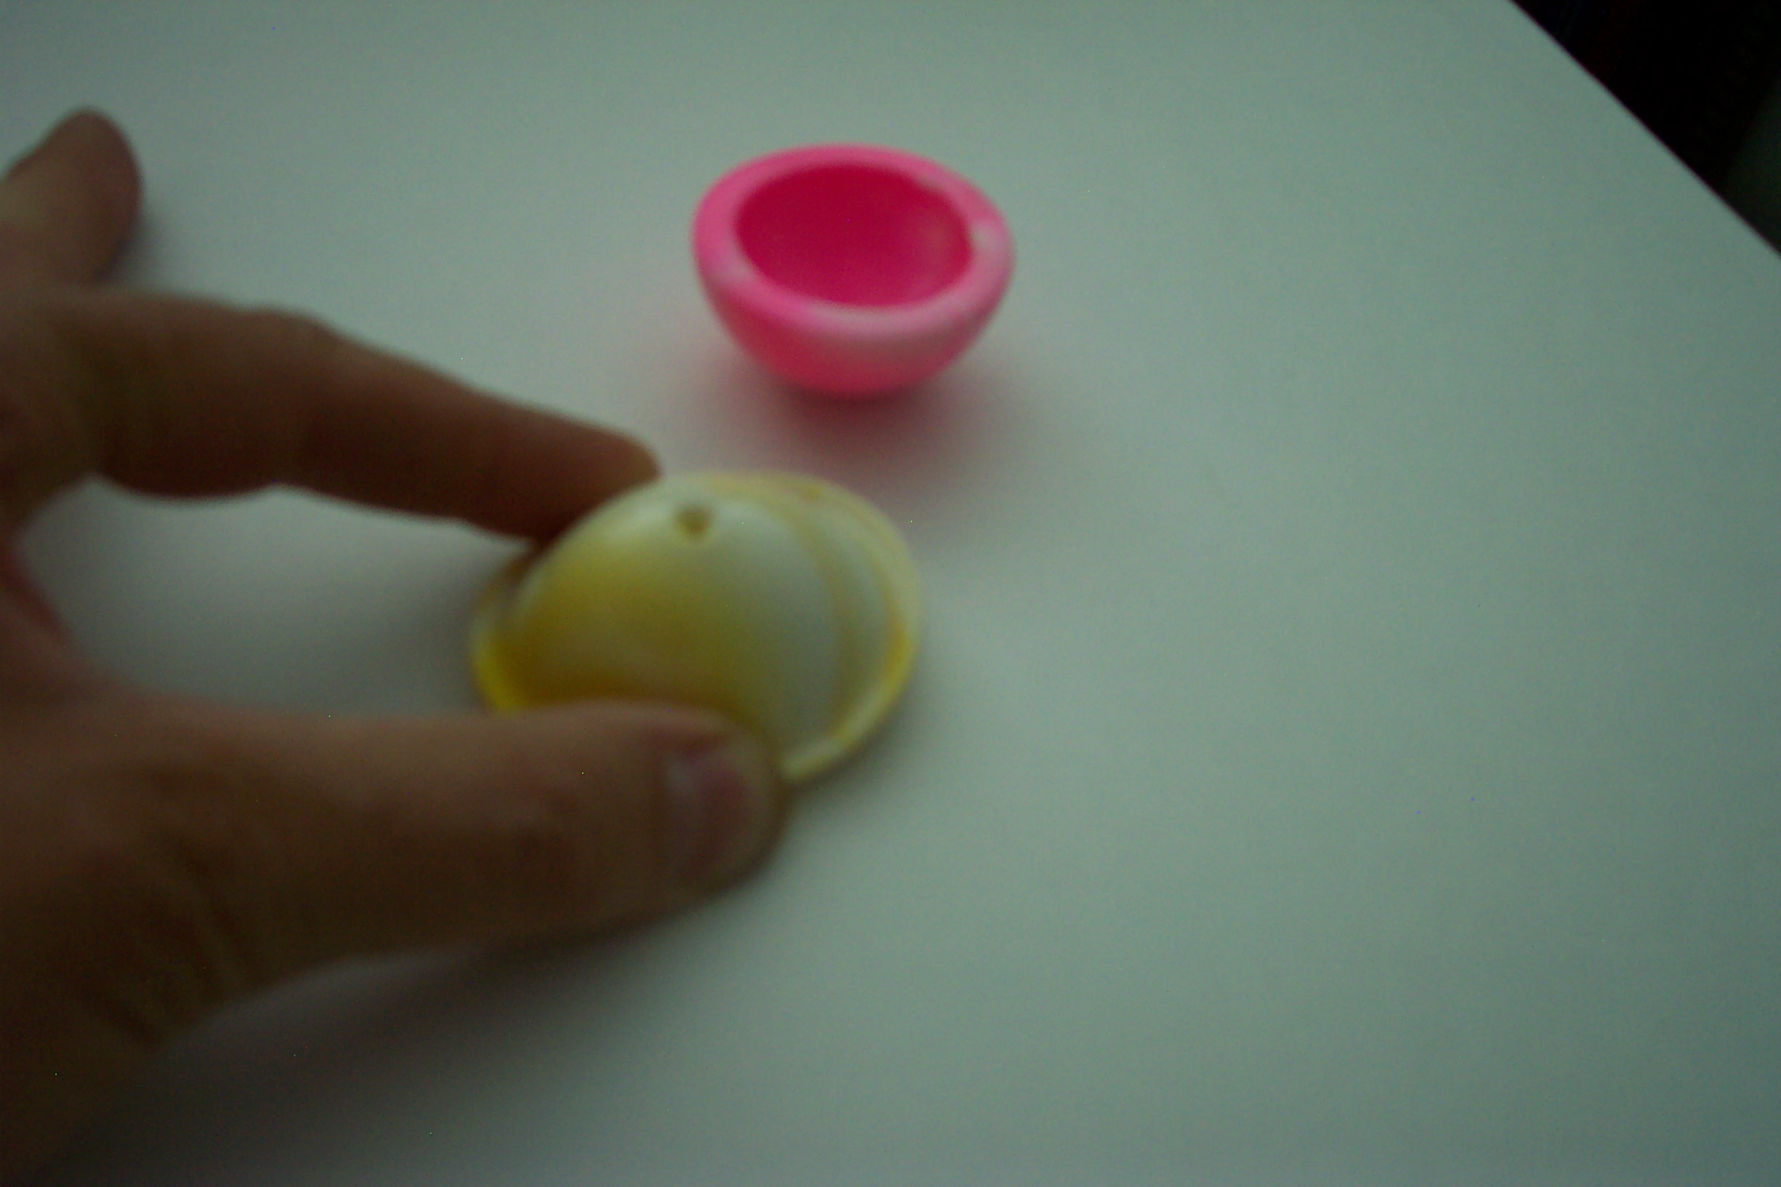
The poppers station represents perhaps the simplest activity in the kit. Students fold the popper inside out and set it on the table (this can be a challenge for kindergarten hands). The popper sits still for a moment – students might notice that the plastic starts bending on its own – and then the popper propels itself into the air. This scenario offers connections to several basic concepts of motion.
A stationary object needs a push or a pull to move. The fancy word for push or pull is force. Notice that the popper pushes itself.
The popper flies upward into the air, but then the motion changes. The popper stops moving up and starts moving down. Our observation tells us that a second force must be present, a force that pulls the popper down after the popper pushes itself up. We call the second force gravity. Gravity belongs to a class of forces that can cause objects to move without being touched.
After students turn the popper inside out but before the popper pushes itself off the table, the object rests in a somewhat funny or special state. If I merely set a popper on a table, the self-push won’t occur. I must turn the device inside out. After doing so, I notice that the popper now possesses “something” that causes it to jump. We call the “something” energy.
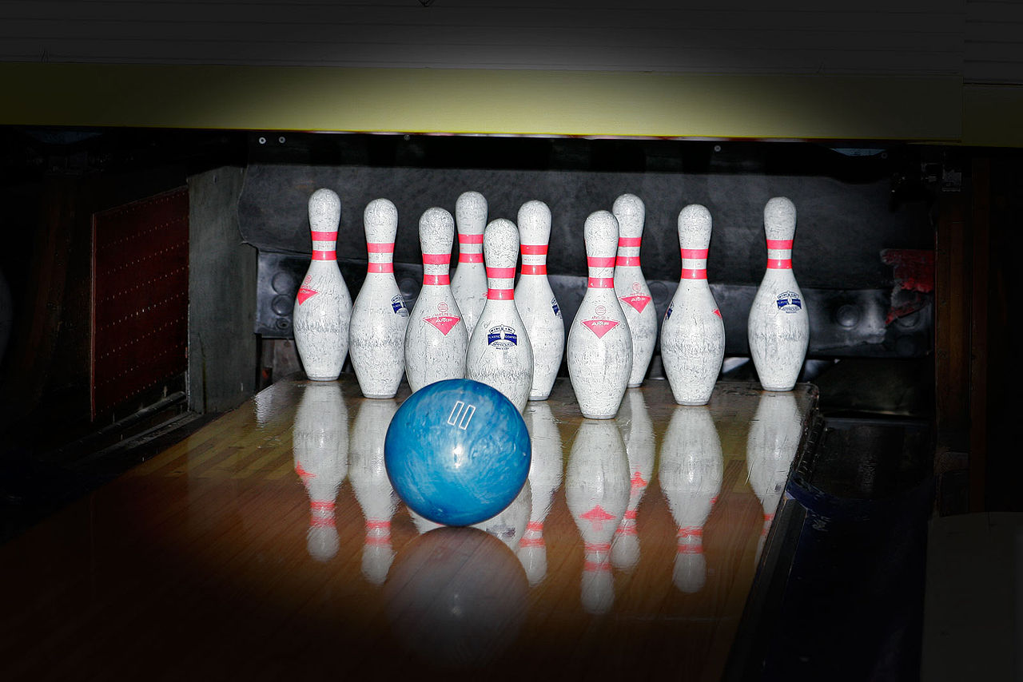
We can define energy by what it accomplishes. Energy can cause things to move. Imagine a bowling pin that’s sitting still. If I hit the pin by rolling a bowling ball at it, the pin will receive a force (a push) from the ball and the pin will fall over. The fact that the pin moved means that the bowling ball possessed energy. As it falls, the pin might hit another pin and knock over the second pin. This means that the first pin possessed energy. Where did this energy come from? The ball. The ball transferred some of its energy to the first pin; the first pin transferred some of this energy to the second pin. Whenever I see a stationary object begin to move, I know that the object must have received energy.
(Bowling photo: Wikipedia)
The popper differs from the bowling pin. The bowling pin was struck by another object (the ball) – this is how the energy transfer occurred. But once we turn the popper inside out, the popper doesn’t need energy from a different object to move. Apparently the energy comes from within the folded popper. We conclude that once we turn the popper inside out, the popper contains stored energy. We name stored energy potential energy. A stationary bowling pin doesn’t knock itself over – it doesn’t contain potential energy. The pin receives its energy from a moving object, the bowling ball. The energy that objects possess because they’re moving is named kinetic energy.
Now imagine that I don’t fold the popper but that I merely hold it (or any other object) in the air with my hand. When I let go, the object will begin moving downward. This means that the object received energy. But I didn’t fold the popper to give it “inside out” potential energy. What’s the source of the energy for a falling object? Gravity. When I hold an object, gravity gives the object potential energy. When I let go (without pushing or pulling – just dropping), the potential energy from gravity causes the popper to move. Now that it’s moving, the popper possesses kinetic energy. If the popper falls into a pan of water, the water will move. I’ll see a splash and some waves. The popper transferred some of its kinetic energy to the water. Energy is energy; we recognize energy because it can cause stationary objects to move (or, more generally, it can change the motion of objects). Energy finds expression as potential energy (stored energy) or kinetic energy (the energy associated with motion).
To summarize, let’s describe the popper experiment using vocabulary. When I turn a popper inside out, I transfer energy to the popper. This energy exists as potential energy as the popper sits on the table. Finally the popper puts a force on itself and moves upward; the popper’s potential energy turns into kinetic energy. Gravity puts an opposite force on the popper (but not through a touch – gravity doesn’t require a touch). Eventually the force of gravity changes the direction of the popper’s motion and the popper starts to fall. At the top of its jump, the popper sits still for a tiny fraction of a second. At this point the popper has no more kinetic energy, but it has potential energy from gravity. Gravity’s potential energy now turns into the popper’s kinetic energy as the popper falls back to the table.
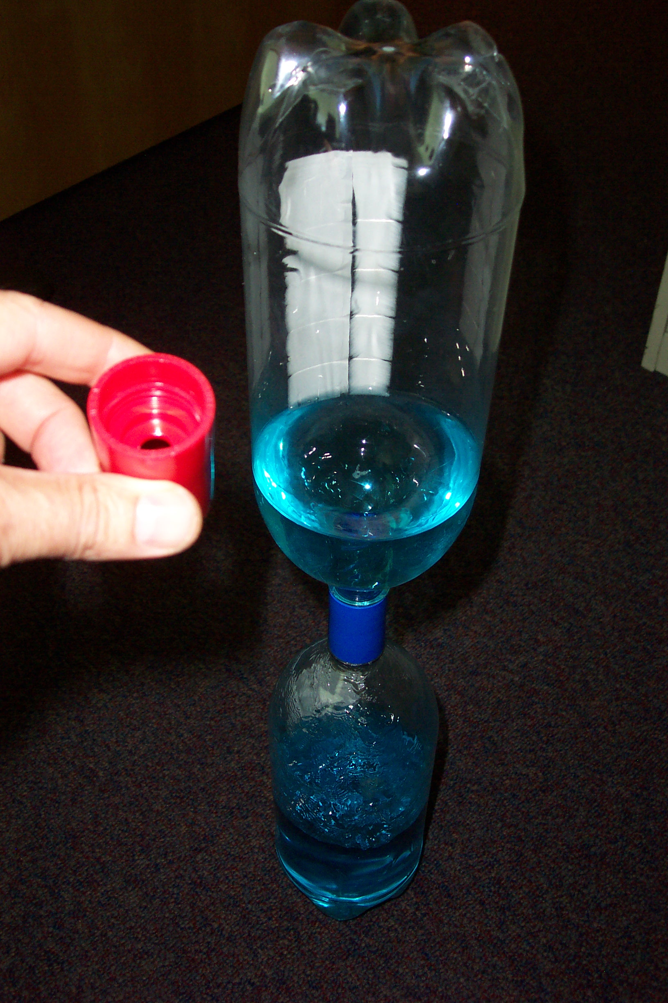
Now think about the kit’s tornado tube experiment. Just like the popper, the water in the tornado tube might be sitting still. I invert the tornado tube and transfer energy to the water by swirling the device with my hands rapidly. I watch the tornado form inside the bottle. Unlike the popper, which quickly lost its energy and sat still again, the water in the tornado tube just keeps going around and around until all of the water in the top bottle drains into the bottom bottle. Of course gravity supplies the force that makes the water go down. We imagine that if we carried a tornado tube into outer space to a location where gravity was very weak, and we shook the tube in a circle, the water might go around and around for a very long time because it wouldn’t fall into the lower bottle. We name the movement of the water in the tornado tube periodic motion. Periodic motion occurs over and over again the same way. The popper experiment doesn’t illustrate periodic motion. The popper moves up, falls down and then stops. The water in the tornado tube, in contrast, continues moving around and around over and over again. Tornado tubes, tops and gyroscopes all illustrate periodic motion.
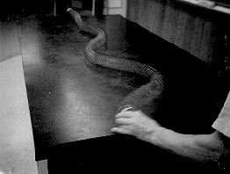
If I stretch my arm in front of me and swing my arm back and forth (left to right) I’m doing periodic motion. We could call this type of back-and-forth periodic motion an oscillation. Now imagine that someone places the end of a Slinky in my hand. Then the person grabs the other end of the Slinky and backs away from me, so the Slinky stretches out between us as we face each other. This person holds her end still, but my end constantly moves because I’m moving my hand back and forth. The Slinky follows the movement of my hand, and this movement travels down the Slinky. I see sideways hills and valleys traveling down the Slinky. These are waves. When the waves reach the end of the Slinky held by the other person, the waves bounce back – they reflect – and travel back toward me. Waves occur when something vibrates or oscillates and the energy of the vibration transfers into a medium. In the Slinky experiment, my hand acts as the oscillator and the metal coils of the Slinky act as the medium.
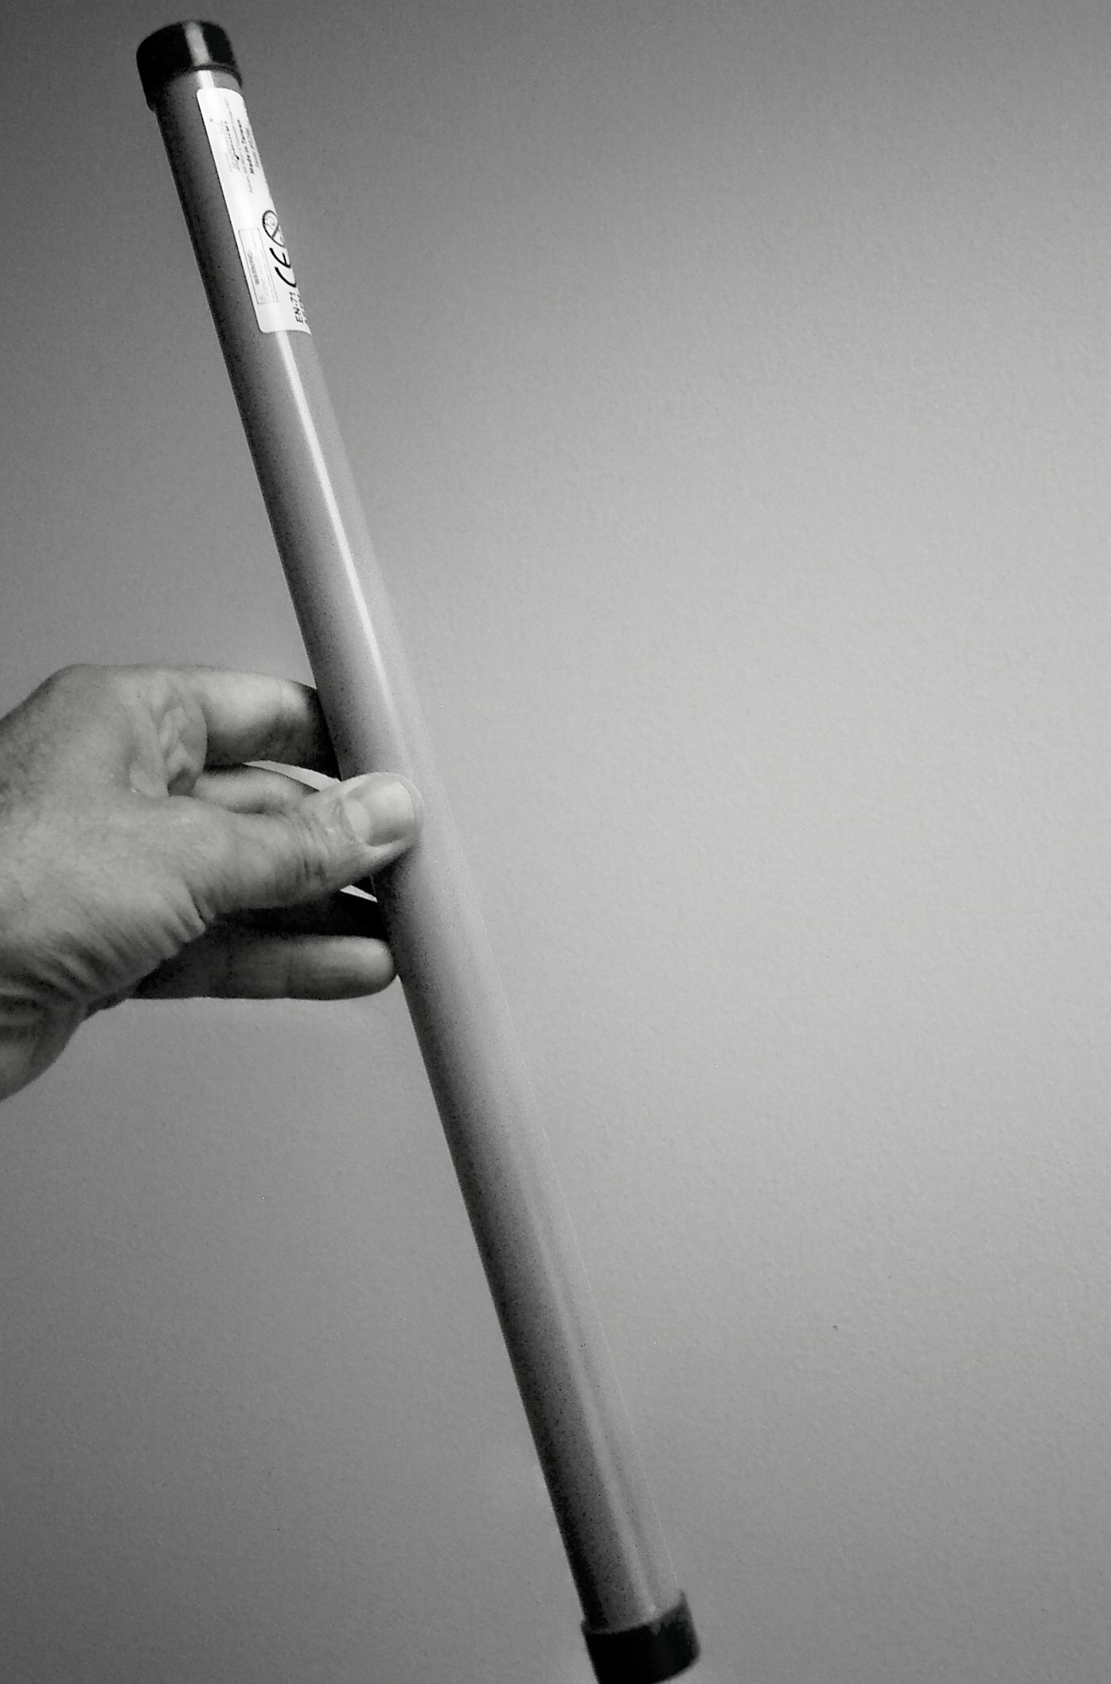
Now imagine the groaning tube experiment. When I hold the tube upright, the little kazoo inside falls through the tube. As the air moves through it, the kazoo vibrates. These vibrations transfer energy into the surrounding air. The energy vibrates as it travels through the air in the same manner that the kazoo was vibrating in the tube. These “traveling vibrations” in the air are sound waves. When the sound waves reach our ears, they make our eardrums vibrate and our brain recognizes this pattern of vibrations as the sound of the kazoo. The whirly tube also makes sound waves.
All waves can be characterized be certain measureable properties.
- Amplitude describes the height of waves.
- Frequency represents the rate at which the medium vibrates.
- Wavelength represents the distance between two successive peaks (crests) or two successive valleys (troughs) in a series of waves.
In several respects light waves don’t differ significantly from sound waves. Sound waves are produced when objects vibrate (musical instruments, human vocal cords, audio speakers, etc.). Light waves are produced when subatomic particles vibrate (usually electrons). A system must receive energy to vibrate. In the case of sound waves, the energy might come from the expulsion of air from my lungs or from the tap that I give to a piece of metal like a wind chime. In the case of light, electrons can receive energy from several possible sources, such as heat (incandescent lights), electrical voltage (fluorescent lights) or chemicals (glow sticks). Both with sound and light, energy causes vibrations and these vibrations produce waves.
Frequency constitutes one big difference between sound waves and light waves. Sound waves represent hundreds or thousands of vibrations per second. Light waves that cause color arise from trillions of vibrations per second. Electrons have very little mass and can vibrate at very high frequencies.
Because light waves travel with such high frequencies, we don’t really experience light as wave behavior; we experience light as color. Several experiments in the kit involve processes that relate to the wave nature of light, even though we don’t see the light “waving.”

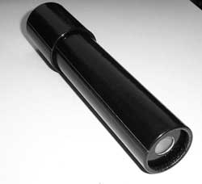
- Kaleidoscopes: Reflection of light to make the nice patterns in the scope

- Look-through kit: Absorption (colored filters), diffraction (rainbows), polarization (polarizing filters)
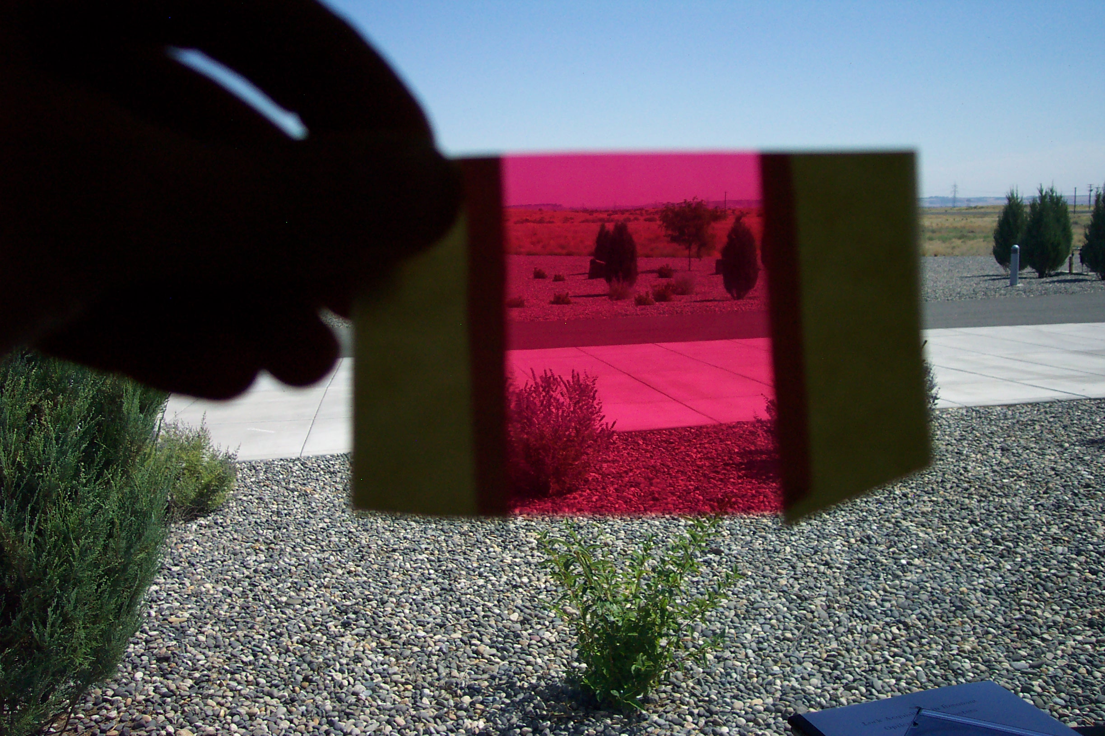
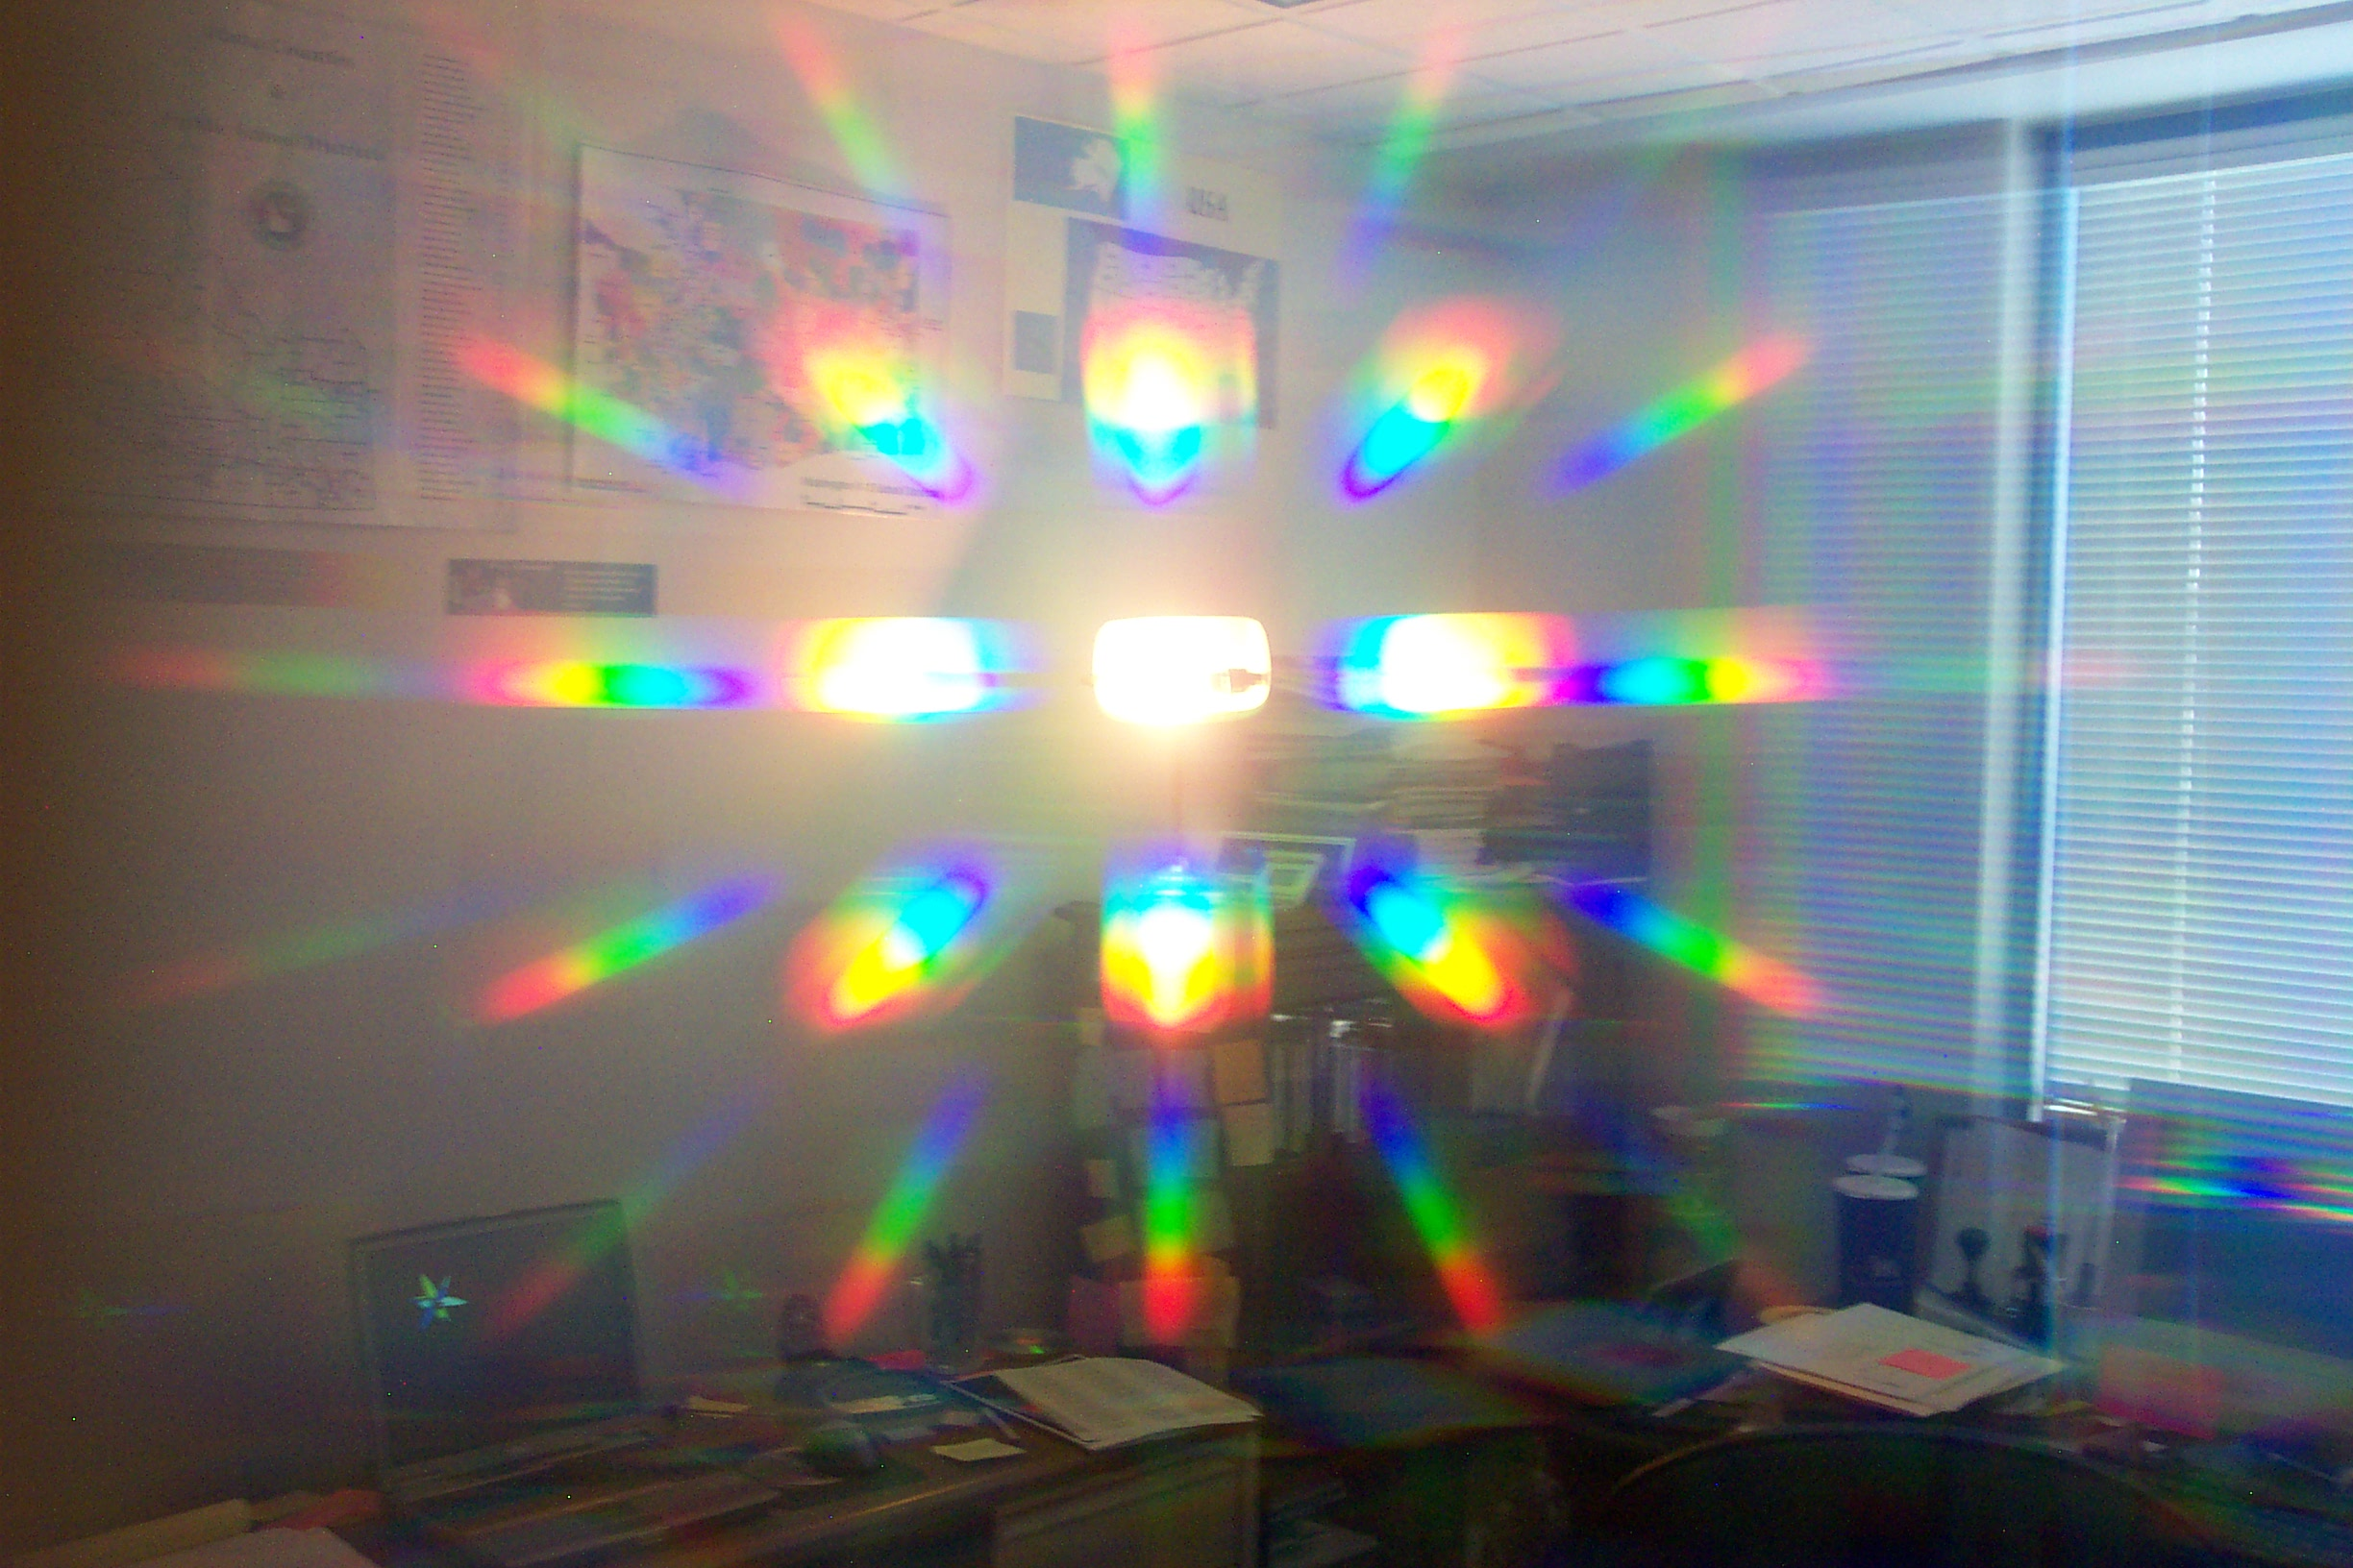
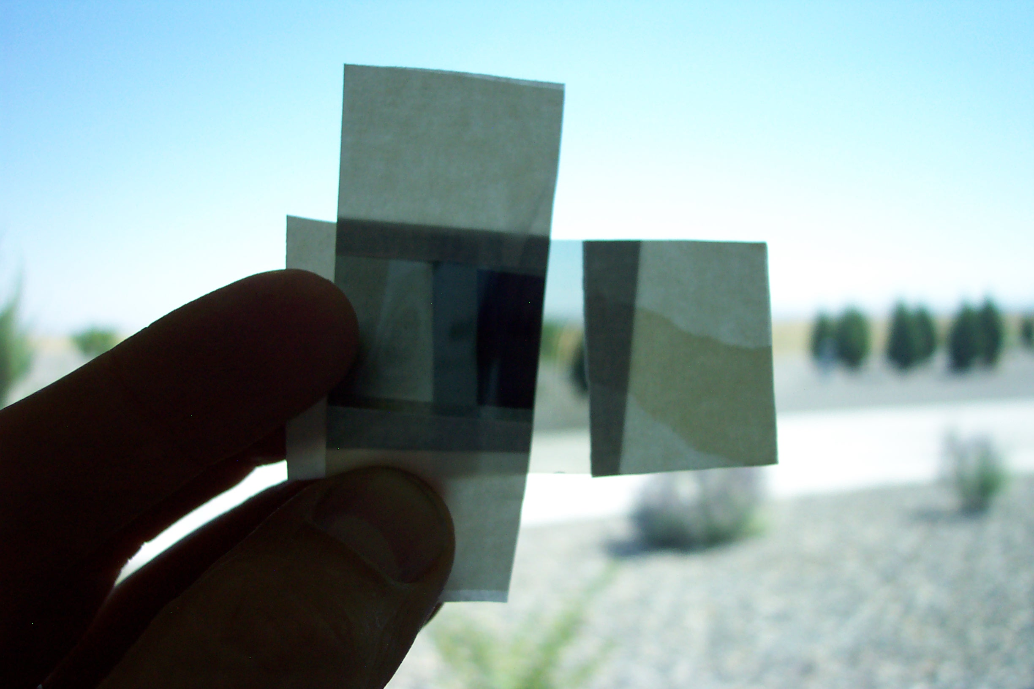

- Magnifying glass, prisms: Refraction
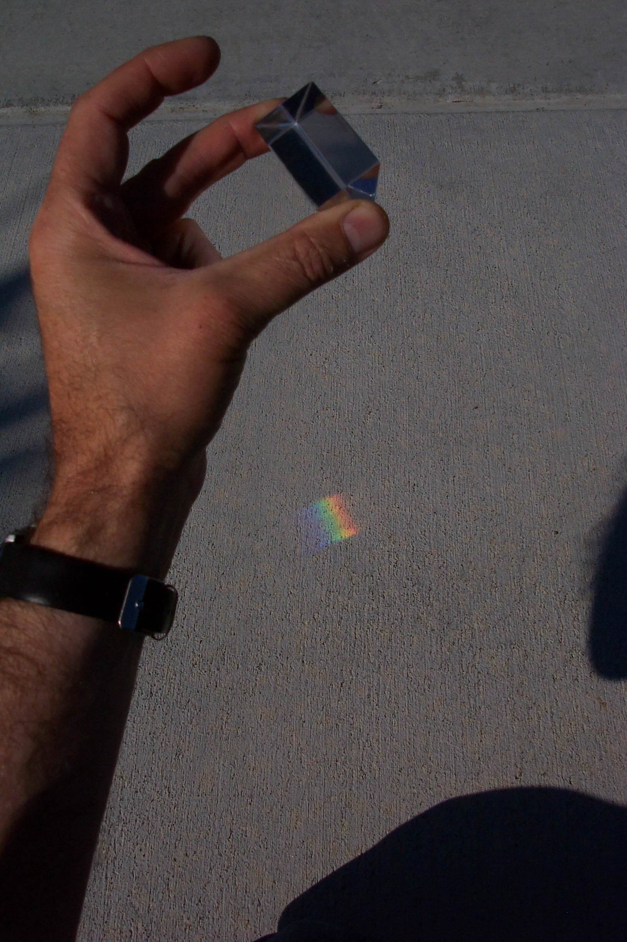
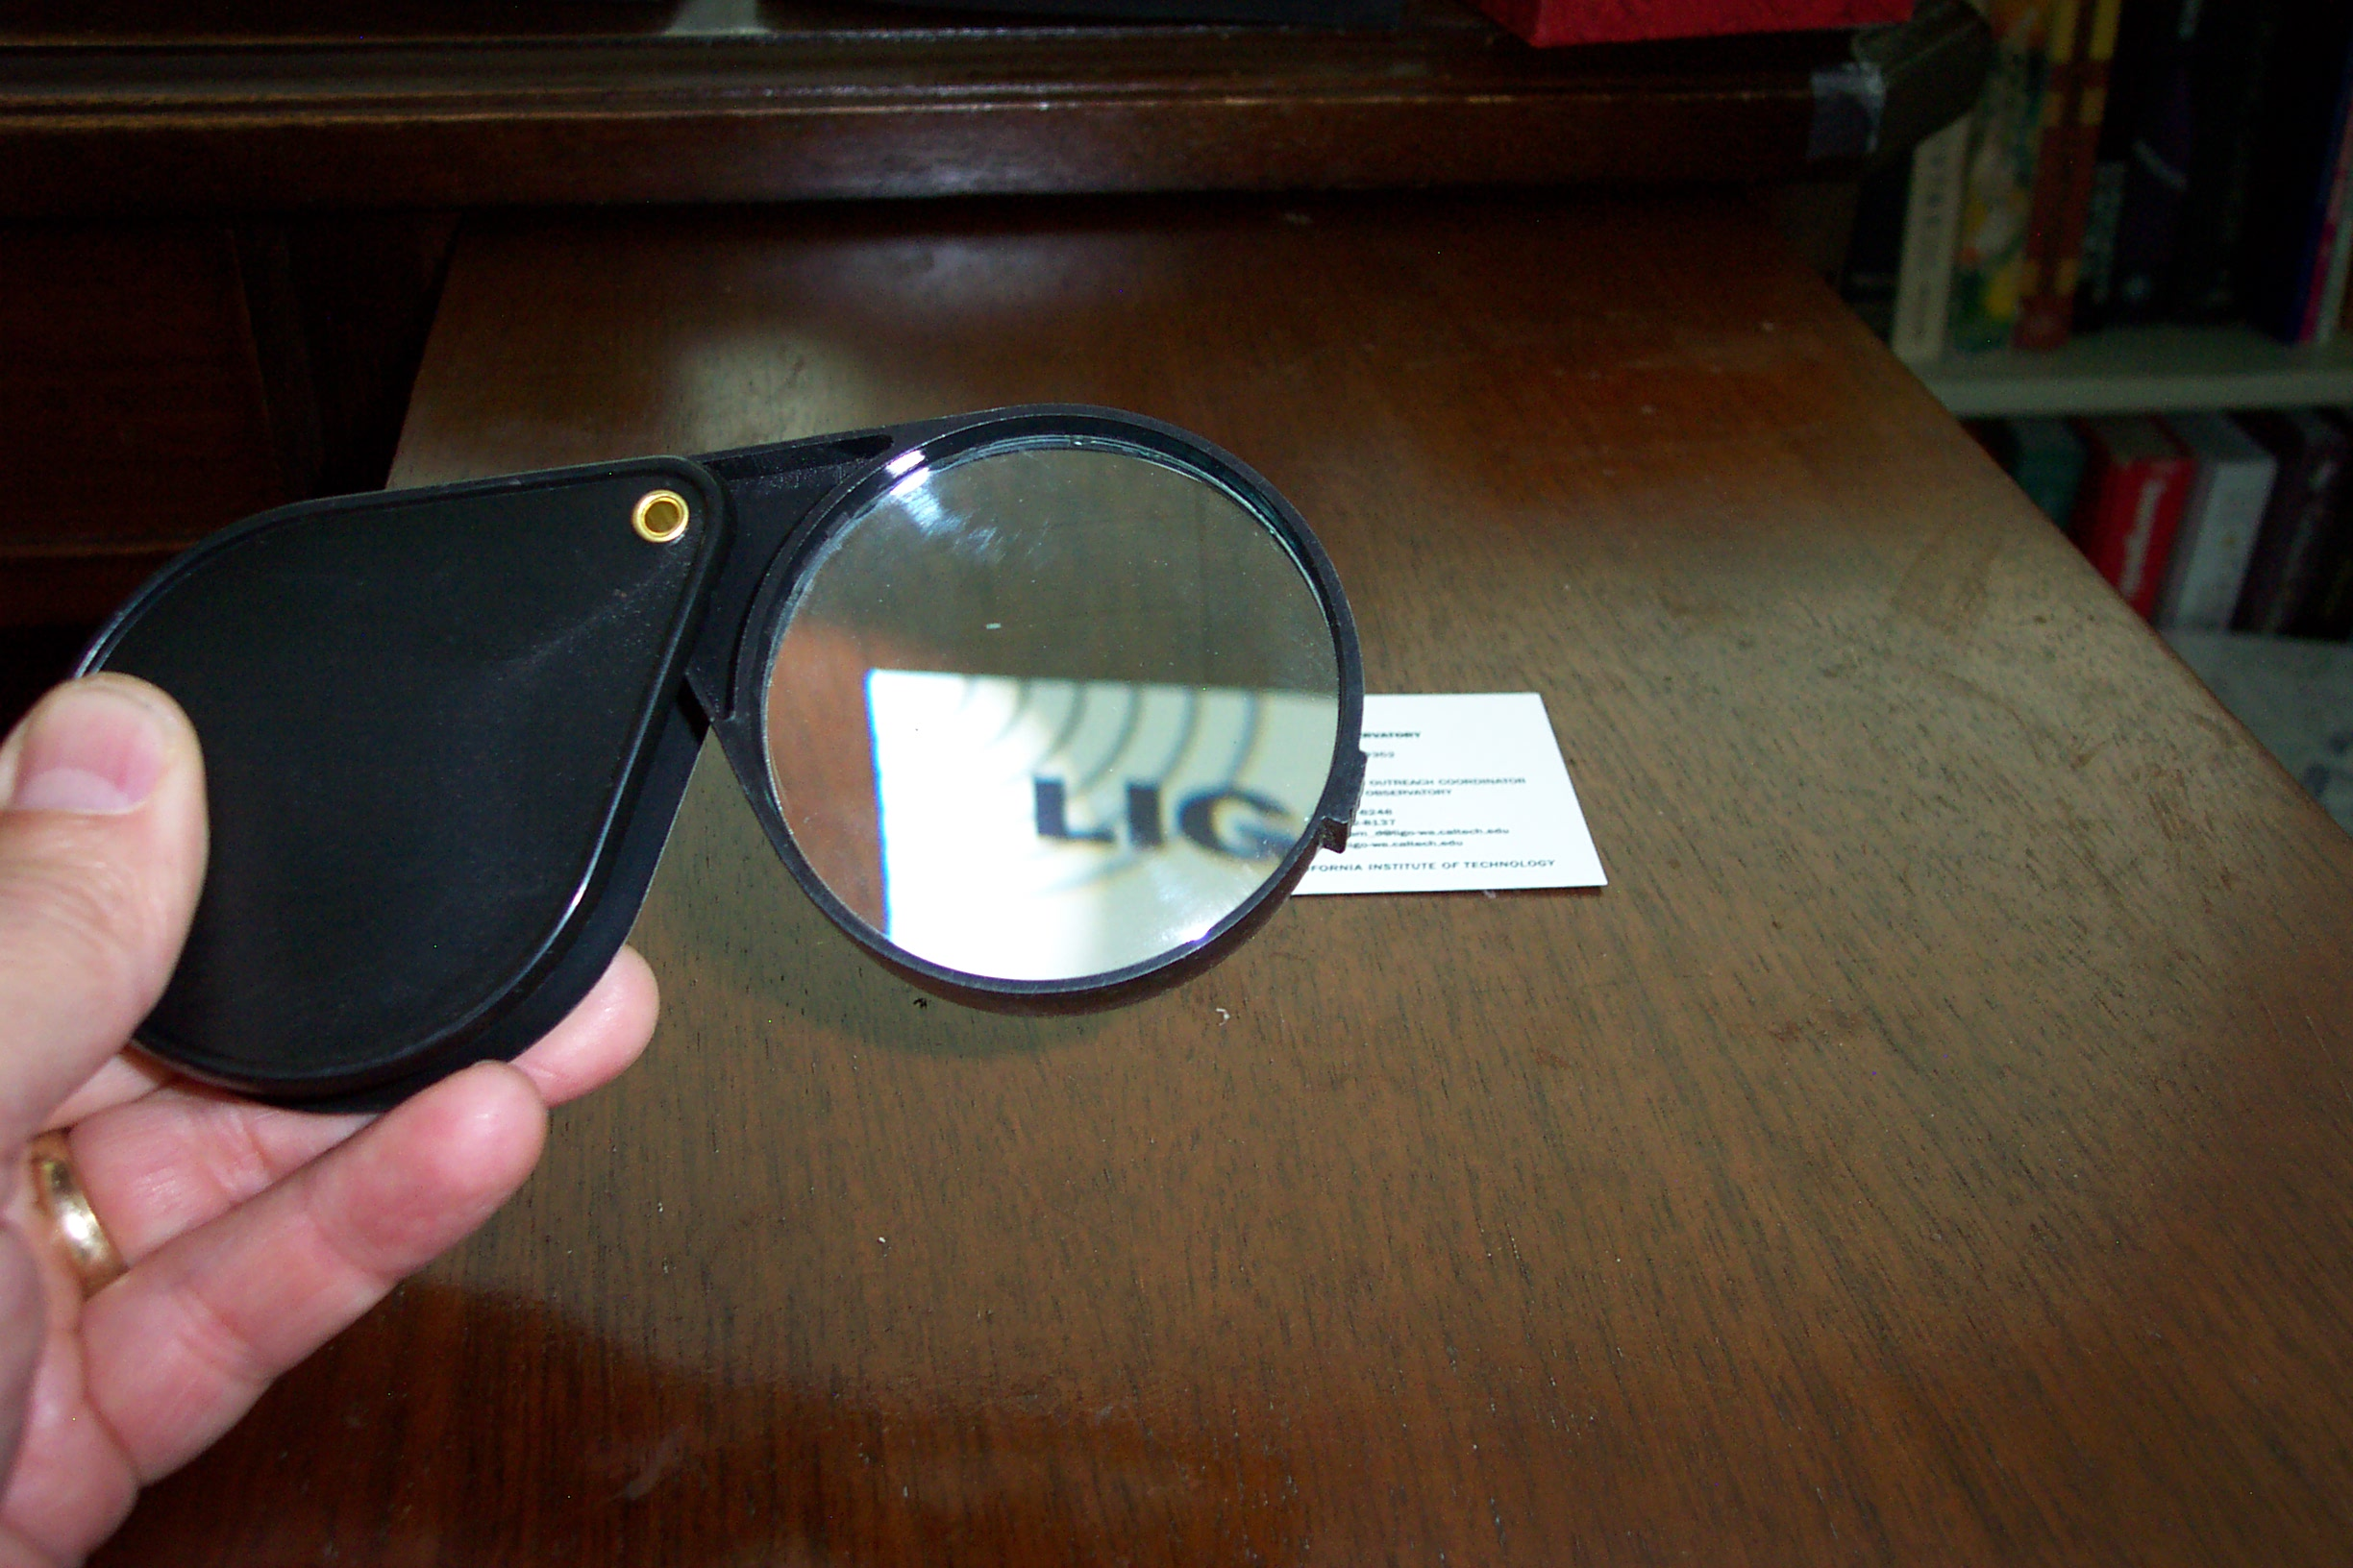

- UV Beads: Absorption (of non-visible UV light from the Sun).
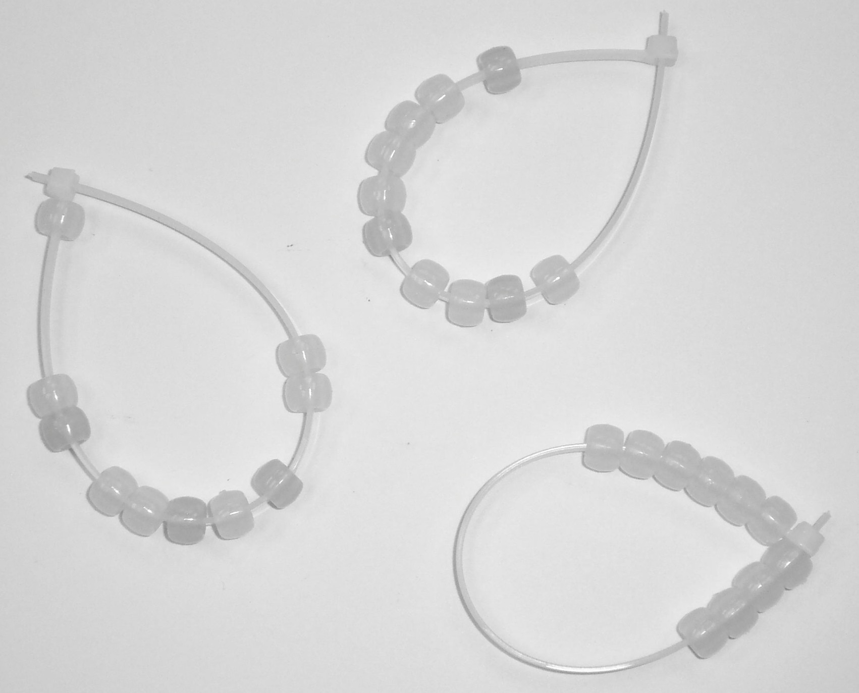

Kit Stations

Use the items in this kit to explore various aspects of physical science. Instructions with photographs are given below. Some of the items are small and should not be used by younger preschoolers or toddlers.

Sound Tube

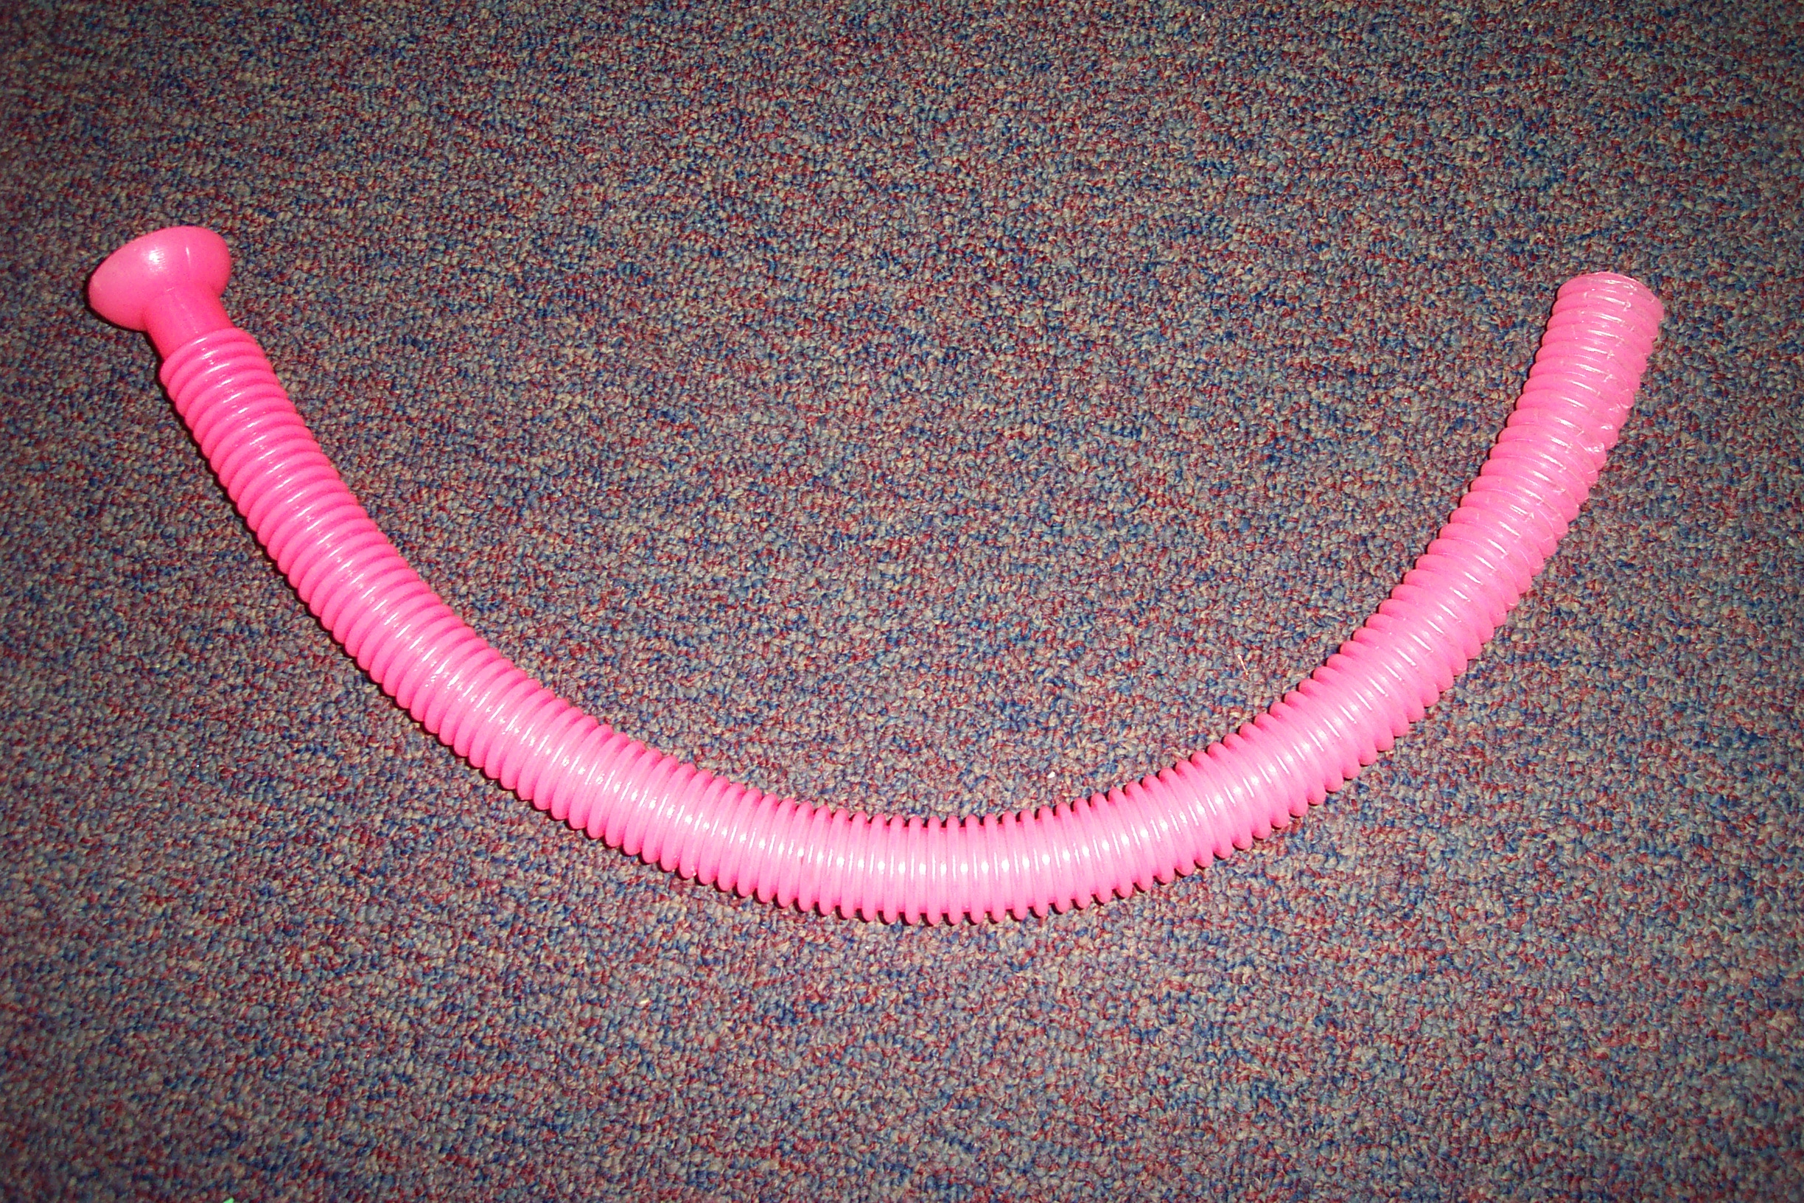
Description: Long flexible plastic tube

Instructions: Hold the tube by the small end
and whirl the tube around quickly. Listen for
the notes that the tube produces.

Science principles: As you whirl the tube, air is forced through the tube. The ripples in the tube create small whirlwinds in the tube as the air passes through. The vibration of the whirlwinds produces sound waves. The more rapidly you whirl the tube, the higher the frequency (pitch) of the sound waves.

Groaning Tube
Description: Rigid plastic tube

Instructions: Hold the tube upright and quickly turn it over. Listen for the sound.

Science principles: There is a small unit that slides back and forth inside the tube. This is the sound emitter. The length of the air column changes as the emitter slides down the tube. The air column vibrates because of the sound waves produced by the emitter. As the length of the air column changes, the pitch of the sound changes slightly.

Regular Top

Description: Disk-shaped top with a stem for spinning.

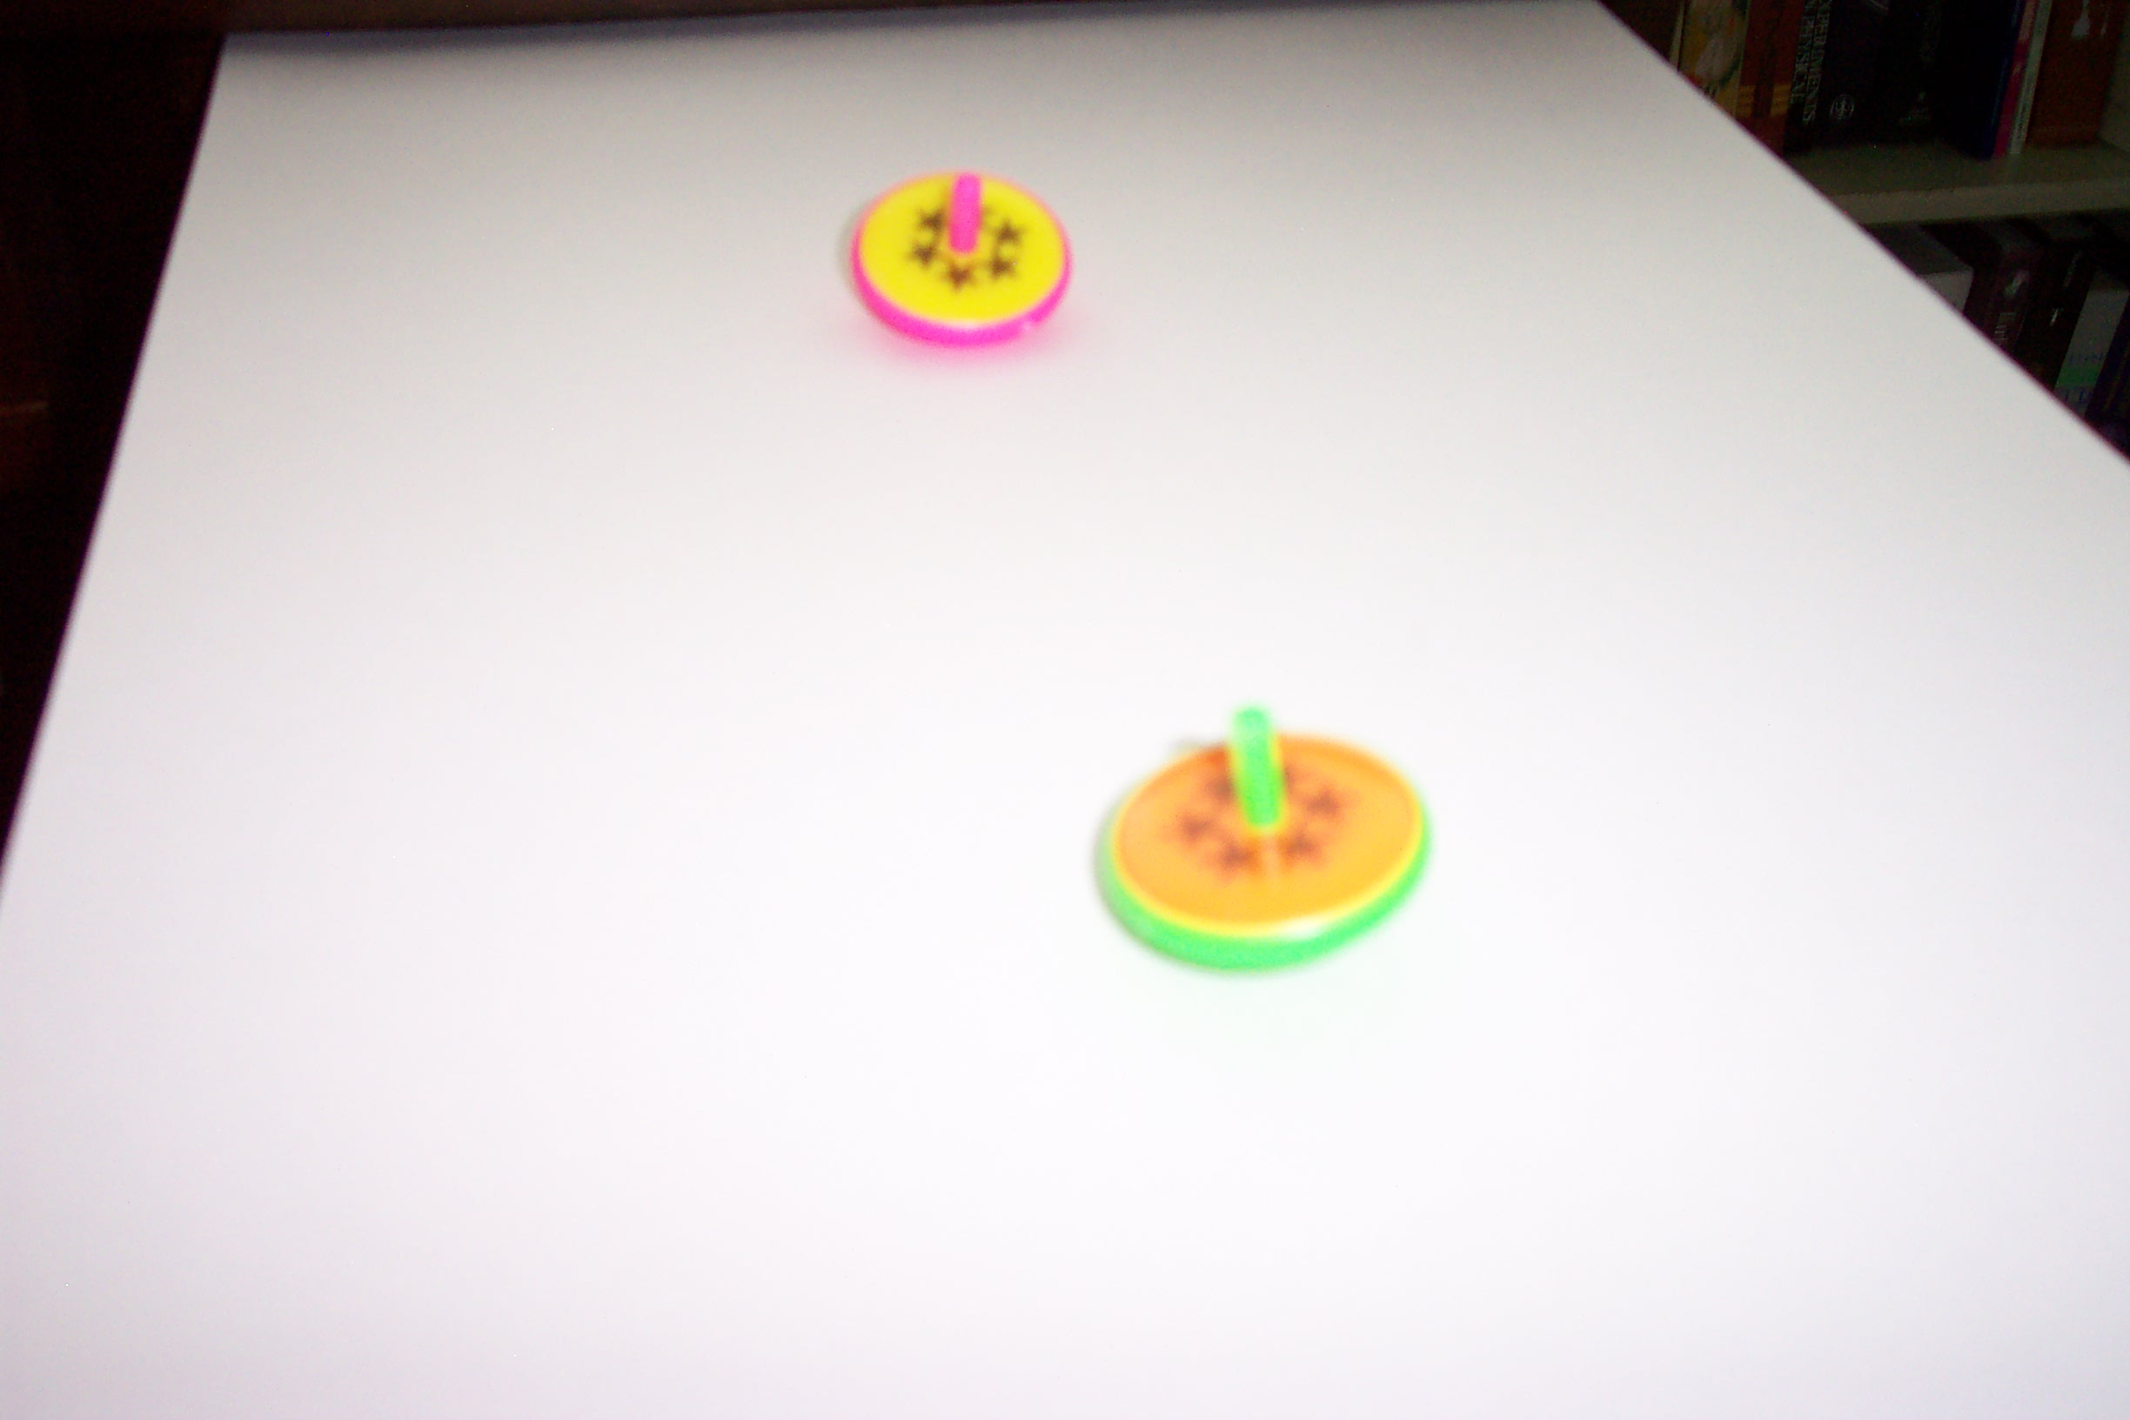
Instructions: Grab the top by the stem and spin it on a hard surface.

Science principles: When an object starts moving in a certain direction, it will continue to move in that direction unless something applies a push or pull (a force) to the object. The same is true of spinning objects. Once they start spinning, they will continue to spin unless another force, such as friction, reduces the spin. Tops and gyroscopes also wobble as they spin. The wobbling motion is “precession” and comes from the fact that a spinning object produces torques that can oppose the effect of gravity.

Top with Arms

CAUTION: SMALL PIECES
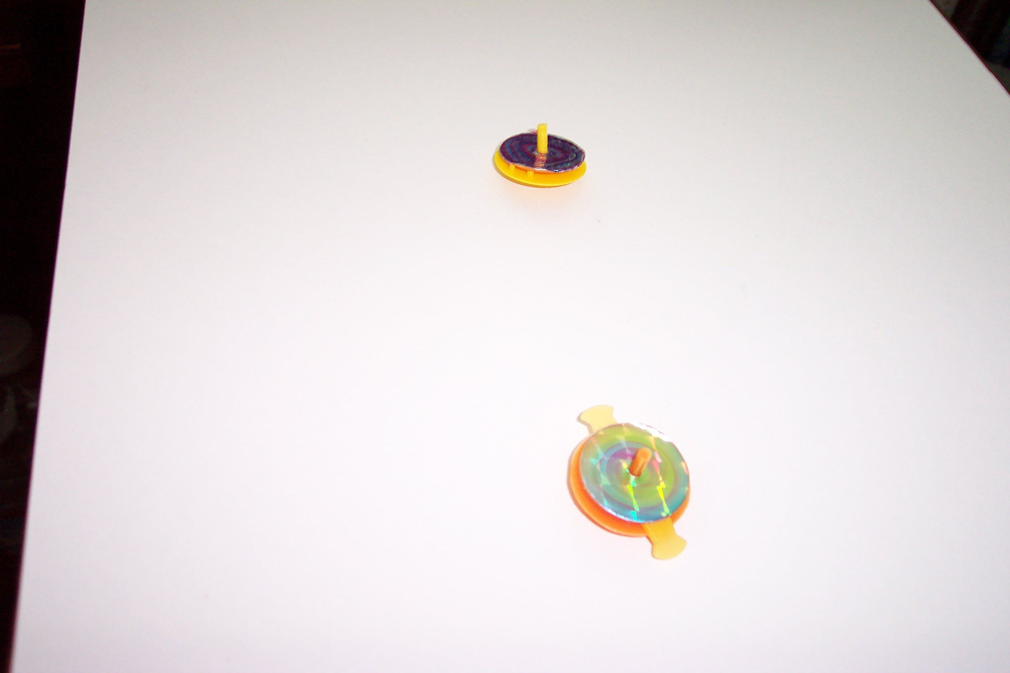
Description: Similar in appearance to the regular top but smaller. Two plastic extensions lie between the two layers of the top.

Instructions: Grab the top by the stem and spin it on a hard surface.

Scientific Principles: Same as the regular top. When the tops spins, the two extension arms are flung outwards and the arms spin at the same rate as the top. The top spins rapidly enough that your eyes can’t resolve the motion of the arms. You see a blurred image as the arms spin.

Upside-down Top

Description: Nearly a sphere. One portion of the top is flat. The stem protrudes from the flat portion.
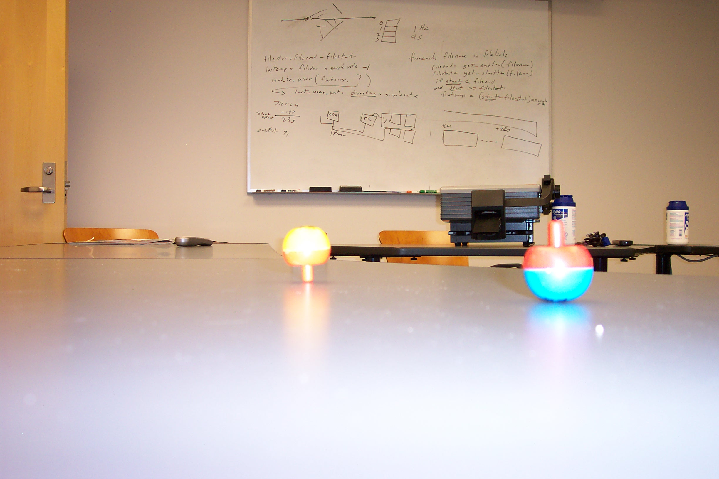
Instructions: Grab the top by the stem and spin it on a hard surface. Watch the top turn upside down as it spins. It should turn all the way over and spin on the stem.

Scientific Principles: The upside-down behavior of the top requires a good bit of mathematics to explain. The behavior basically arises from the top’s odd shape.

Gyroscope

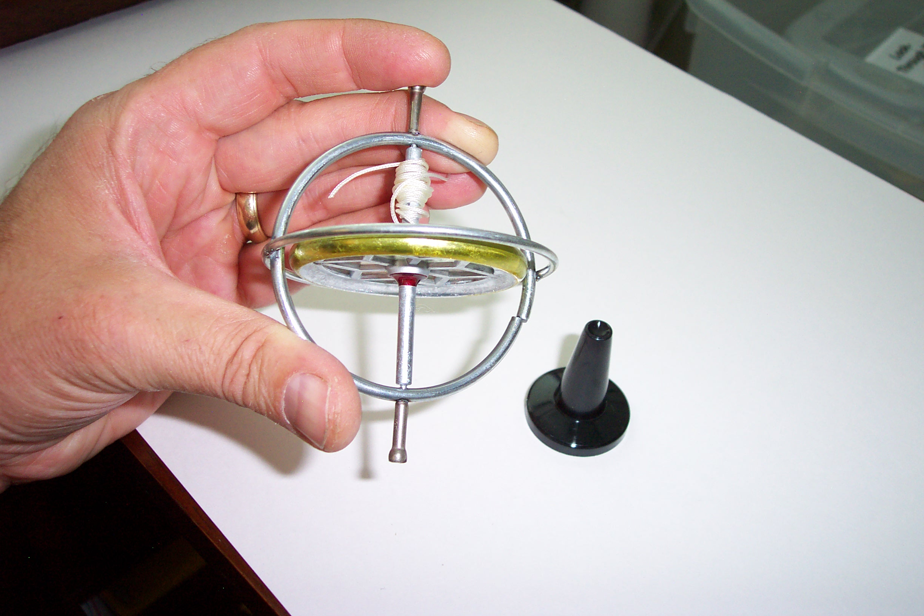
Description: A metal wheel that spins on an axle inside a round metal cage. A piece of string is required. The gyroscope may have a plastic base on which you can place it when it is spinning.

Instructions: The gyroscope is tricky to use. You must feed one end of the string through the tiny hole in the axle. Then you must wind the string onto the axle by turning the wheel without tangling the string. Once the string is wound, pull the free end of the string to make the axle spin. You’ll need to be holding the gyroscope by the metal cage so your fingers don’t slow the spinning of the wheel. A strong, smooth pull will unwind the string and make the axle spin at a high rate. Then you can set the gyroscope on the plastic base, on the floor or on the palm of your hand to watch it spin.

Scientific Principles: The gyroscope is basically another type of top. If you spin the gyroscope at a high rate then tap the top, you’ll see the precession, or wobble, of the device.

Slinky

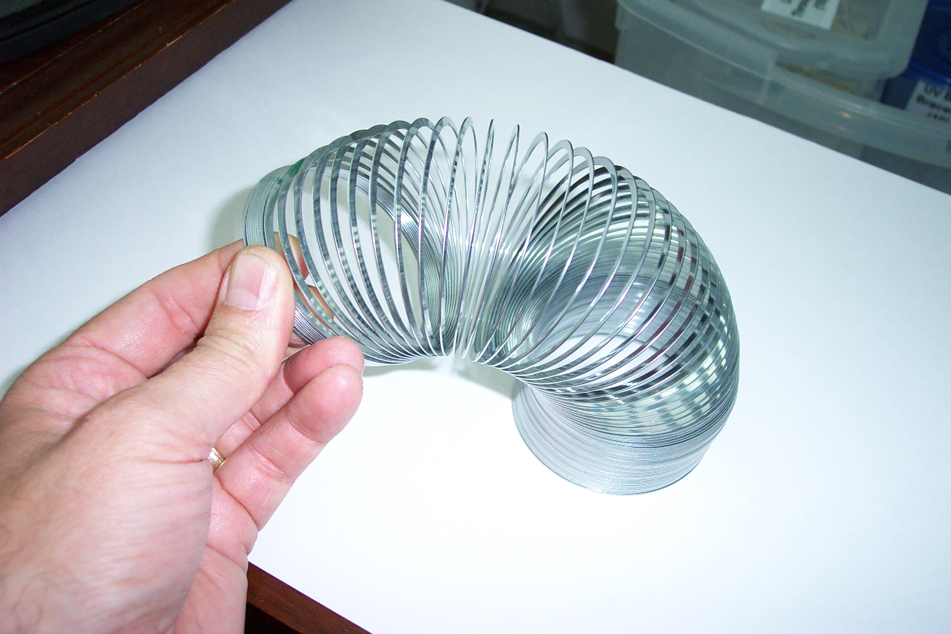
Description: A loosely coiled spring

Instructions: There are many interesting things to do with a Slinky. Two people can stretch the ends and shake one end, making waves travel up and down the spring. Slinkies can also walk down stairs if given a start down the first step.

Scientific Principles: Slinkies are excellent devices for showing that waves are movements of energy. When shaking the end of a stretched spring, you can see that the wave moves down the length of the Slinky while the coils vibrate back and forth.

Tornado Tube

Description: The Tornado Tube is a short plastic pipe with threads on each end and a reduced-diameter opening through the middle. You will need two empty 2-liter plastic bottles. Fill one of the bottles about 2/3 full of water.
Then screw the neck of each bottle into the threads on
each end of the Tornado Tube.

Instructions: With the two bottles screwed into the
ends of the tube, and with one bottle partially full of
water, turn the device upright so that the partially full
bottle is on top. Now swirl the device in a circular
motion. You should see a whirlpool form in the top
bottle as the water falls to the bottom.

Scientific Principles: Gravity causes the water in the
top chamber to move to the bottom, but the air in the
bottom chamber must leave if the water is to enter
from the top. Swirling the device creates a whirlpool with a hole in the center. The air in the bottom chamber will be pushed to the top through the hole as the water falls down to the bottom along the sides.

Bottle Fountain

Description: Nearly identical to the Tornado Tube. There are two long thin tubes that protrude from the connector, one up and one down. Invert the device just like the Tornado Tube. The upward movement of air from the lower bottle to the upper forces a fountain of water to the top of the upper bottle.

Poppers

CAUTION: SMALL PIECES

Description: Small rubbery bowl-shaped objects

Instructions: The poppers are a challenge to operate. Hold a popper by the rim and turn the center portion inside-out by pushing on it with your thumbs. Set it on a flat hard surface, keeping it inside-out. Now let go. If you are quick enough, the popper will throw itself into the air as it turns right-side-out.

Scientific Principles: The popper material is elastic. When you change its shape, it wants to snap back to its original shape. When you turn the popper inside-out it acquires a lot of potential energy through stretching. When you let go, the potential energy of the stretching turns into kinetic energy as the popper flies into the air.

Kaleidoscopes

Description: Black tube with an eye hole at one end

Instructions: The kaleidoscope works best in well-lit conditions. Do not point a kaleidoscope at the sun. Look through the eye hole and turn the rotating piece at the opposite end of the tube. You should see a pattern inside the kaleidoscope that changes as you rotate the end.

Scientific Principles: The kaleidoscope contains a group of small colored pieces that randomly arrange themselves at the end of the tube. The arrangement of the pieces changes as you rotate the end of the tube. The nice pattern that you see on the inside of the tube is produced by a set of mirrors that reflect the incoming light back and forth, causing the arrangement of the pieces to become multiplied in your view. The inside of the kaleidoscope is like a tiny house of mirrors, causing the image of the randomly arranged pieces to be reflected several times,

Rattlebacks

Description: Small colored plastic items that are long and thin and shaped like little boats

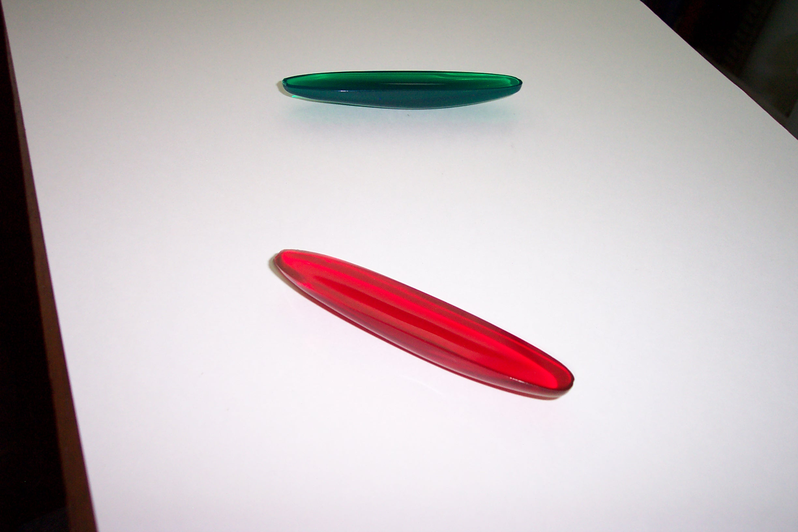
Instructions: Set the rattleback on a hard smooth surface so that it rests on the surface like a little boat. Hit the end of the rattleback with your finger to make it spin horizontally. Try spinning it in the clockwise direction first. You should see it spin clockwise. Then it will stop spinning and bob up and down with a rocking motion. It will then spin in the opposite direction – counterclockwise. Note that if you spin it counterclockwise at the start, it will continue to spin and will not reverse the direction of its spin.

Scientific Principles: Look carefully at the rattleback and you will see that its shape is not symmetric. There is an imbalance in its mass that produces a transfer of energy from the spinning motion to the rocking motion. Once the rattleback starts the rocking motion, the resulting spin will only occur in the counterclockwise direction due to its shape. Try tapping it from the top on one of the ends to make it rock – you should then see it start to spin counterclockwise.

Look-Through Kit

The Look-Through Kit is a small Zip-lock bag that contains six pieces of plastic. The sheet sections are three different activities. Do not use any of these items to look directly at the sun. Make sure that you hold the pieces of plastic by the tape on the edges instead of touching the plastic itself.

Colored Acetate Sheets
Description: These are the pieces of red, green and blue plastic.

Instructions: Hold the sheets in front of your eyes and the world will appear to change color. You can also combine the colors by holding more than one sheet in front of your eye.

Scientific Principles: The colored sheets act as filters, removing certain colors by absorbing those colors from sunlight or room lights. Other colors are allowed to pass through. When you combine sheets, you see an even smaller slice of color that is allowed to pass through. This slice is a color that is between the two colors of the filters that you are using.

Polarizing Film

Description: These are the two small pieces of dark plastic film.

Instructions: Hold one piece in front of the other in line with your eye and look at a light or a cloud in the sky (do not look directly at the sun). Now rotate one of the pieces while you hold the other still. What you are looking at will almost disappear when you’re holding the two pieces at a right angle.

Scientific Principles: Polarizing film absorbs all of the light waves from a light source except those waves that are wiggling along one particular direction. When you hold one sheet in front of the other at a right angle, you are blocking nearly all of the possible orientations of light waves that are coming from your light source, so the source looks very dark. Polarizing sunglasses have lenses that contain polarizing material.

Diffraction Gratings

Description: This is the piece of nearly colorless, nearly transparent plastic film.

Instructions: Hold the diffraction grating (by
the taped edge) and look at a light source
(not the sun). The gratings work best in a
dark room. You should see rainbow patterns
as you look at lights with the diffraction grating film.

Scientific Principles: The diffraction grating film has thousands of lines etched on its surface, lines that are so thin that your eye cannot distinguish them. The sets of lines acts as a picket fence when light hits it, blocking the light that hits the lines but letting the light pass between the lines. As the broken-up light makes its way through the grating, it undergoes a process called diffraction in which certain wavelengths of light reinforce each other at particular angles. The result is that the original white light sample is split into its component colors. Fluorescent and incandescent lights (household lights) will yield a diffraction pattern that contains nearly all the colors of the rainbow

Prisms

Description: These are solid triangular shaped pieces of colorless transparent plastic.

Instructions: The prisms only work effectively when you pass sunlight through them and look for the resulting rainbow pattern on a nearby smooth surface such as concrete or asphalt. Stand in sunlight and hold a prism by the ends so that the sunlight can pass through it. Rotate the prism around to change the angle at which the sun strikes it. At the correct angle, you should see a rainbow pattern appear on the ground in front of you.

Scientific Principles: When light goes through a prism, the light undergoes refraction, which is the bending of light that is cause by changing the speed of the light as it passes out of one materials and enters another material. Different wavelengths (colors) of light are refracted by different amounts, causing the colors of white light to separate into a rainbow pattern.

Magnifying Glass

Description: These are oval-shaped plastic
units. The magnifying glass sits inside its plastic cover.

Instructions: You must swivel the lens out of
the cover. It only swivels out in one direction.
Use the raised edges on the top of the lens to
push it out of the cover.

Scientific Principles: The magnifying glass has curved surfaces. Light rays change speed as they enter the glass from the air. Because the glass is curved, the change in speed results in a change in direction. The path of the light is bent by the lens as the light moves from the object through the lens and to your eye. This makes objects appear larger than their actual size.

Ultraviolet Bead Rings

CAUTION: SMALL PIECES

Description: Small beads that are strung on loops of plastic

Instructions: The beads change color in sunlight. Take them from a room that has reduced lighting into the sunshine and you will see the changes.

Scientific Principles: The sun delivers some ultraviolet light to us in addition to visible light and infrared light (heat). Ultraviolet light is more energetic than visible light and carries enough energy to change the chemical bonds in certain molecules. This type of change in pigment molecules in your skin is what gives you a sun tan (or burn). The beads contain a UV-sensitive chemical. Sunlight stimulates a change the structure of the chemical, changing its color while the sunlight strikes it. Darkness turns off the change.

Materials List
Activity | Item | Source | Part Number | Cost
Sound Tube | Sound tube (whirly) | Educational Innovations** | SS-600 | 3.50
Groaning Tube | Ridged plastic tube | Arbor Scientific** | P7-7160 | 1.75
Regular Top | Standard top | Oriental Trading Co** | IN-13602699 | 5.99 (12)
Top with Arms | Plastic top with extenders | Toy store |  | 1.29
Upside-down Top | Spherical top | Amazon.com** |  | 6.65 (4)
Gyroscope | Gyroscope | Arbor Scientific** | P3-3501 | 6.50
 | Fishing line | Sporting goods** |  | 2.49
Slinky | Metal slinky | Fred Meyer |  | 3.50
Tornado Tube | Tornado tube | Educational Innovations** | SS-1 | 1.95
Bottle Fountain | Fountain Connection | purefunsupply** | YEP10112 | 5.36
Poppers | Poppers | Oriental Trading Co** | IN-16/454 | 4.25 (12)
Kaleidoscope | Basic kaleidoscope | Yoyo.com** | Schylling Classic | 7.99
Rattlebacks | Plastic rattlebacks | Educational Innovations** | SS-310 | 7.95 (5)
Colored Acetate | Red, green, and blue plastic | Craft store |  | 5.99
Polarizing Film | Dark, plastic film | American Science & Surplus** | 37640P1 | 17.50
Diffraction Gratings | Diffraction grating slides | Rainbowsymphony.com** | 01602 | 0.40
Prisms | plastic prisms | stevespanglerscience** | WPSM-700 | 8.99
Magnifying Glass | Small hand-held magnifying glasses | Toy store |  | 3.99
UV Beads | UV beads | Educational Innovations** | UV-AST | 6.95
Storage | Zip-ties | Hardware store |  | 3.99

** Online source

Name: __________________________________________

Group Scenario

Pretend that you find a room that’s the size of your classroom but the room is completely empty. There’s nothing in it at all. On the floor in the middle of the room there’s a water bottle standing upright on the floor. Your job is to knock the bottle over. You’re not allowed to touch the bottle with your hands. You’ll need to figure out another way to knock it over.

See if your group can think of six different ways to knock over the bottle without touching it with your hands.

1.
2.
3.
4.
5.
6.

Which one of your six ideas do you think would work the best? Explain why.

Draw a picture of what your idea would look like if you actually did it.

Student Scientists’ Survey

Scientist Score Sheet

Check how well each of these activities helped you learn about energy, vibrations and waves.

 | My favorite | I liked this | I did not like this
Watching demonstrations
Hands-on stations
Working with a partner
Working in small groups
Presenting your ideas to the class
Watching “Bill Nye the Science Guy”
Asking questions in class
Class discussions
Engineering (the Scenario)

Table Signs for the Activities

Cut out these labels and instructions and tape them to the tables on which you’ve placed the activities.

Sound Tube

Instructions: Hold the tube by the small end and whirl the tube around quickly. Listen for the notes that the tube produces.

Groaning Tube

Instructions: Hold the tube upright and quickly turn it over. Listen for the sound.

Regular Top

Instructions: Grab the top by the stem and spin it on a hard surface.

Top with Arms

CAUTION: SMALL PIECES

Instructions: Grab the top by the stem and spin it on a hard surface.

Upside-down Top
Instructions: Grab the top by the stem and spin it on a hard surface. Watch the top turn upside down as it spins. It should turn all the way over and spin on the stem.

Gyroscope

Instructions: The gyroscope is tricky to use. You must feed one end of the string through the tiny hole in the axle. Then you must wind the string onto the axle by turning the wheel without tangling the string. Once the string is wound, pull the free end of the string to make the axle spin. You’ll need to be holding the gyroscope by the metal cage so your fingers don’t slow the spinning of the wheel. A strong, smooth pull will unwind the string and make the axle spin at a high rate. Then you can set the gyroscope on the plastic base, on the floor or on the palm of your hand to watch it spin.

Slinky

Instructions: There are many interesting things to do with a Slinky. Two people can stretch the ends and shake one end, making waves travel up and down the spring. Slinkies can also walk down stairs if given a start down the first step.

Tornado Tube

Instructions: With the two bottles screwed into the nds of the tube, and with one bottle partially full of water, turn the device upright so that the partially full bottle is on top. Now swirl the device in a circular motion. You should see a whirlpool form in the top bottle as the water falls to the bottom.

Bottle Fountain

Instructions: Invert the device just like the Tornado Tube.

Poppers

CAUTION: SMALL PIECES

Instructions: The poppers are a challenge to operate. Hold a popper by the rim and turn the center portion inside-out by pushing on it with your thumbs. Set it on a flat hard surface, keeping it inside-out. Now let go. If you are quick enough, the popper will throw itself into the air as it turns right-side-out.

Kaleidoscopes

Instructions: The kaleidoscope works best in well-lit conditions. Do not point a kaleidoscope at the sun. Look through the eye hole and turn the rotating piece at the opposite end of the tube. You should see a pattern inside the kaleidoscope that changes as you rotate the end.

Rattlebacks

Instructions: Set the rattleback on a hard smooth surface so that it rests on the surface like a little boat. Tap the end of the rattleback sideways with your finger to make it spin horizontally. Try spinning it in the clockwise direction first.

Look-Through Kit

Instructions: Colored pieces -- hold the sheets in front of your eyes and the world will appear to change color. You can also combine the colors by holding more than one sheet in front of your eye. Gray pieces -- Hold one piece in front of the other in line with your eye and look at a light or a cloud in the sky (do not look directly at the sun). Now rotate one of the pieces while you hold the other still. Colorless piece -- Hold the diffraction grating (by the taped edge) and look at a light source (not the sun).

Prisms

Instructions: Stand in sunlight and hold a prism by the ends so that the sunlight can pass through it. Rotate the prism around to change the angle at which the sun strikes it.

Magnifying Glass

Instructions: You must swivel the lens out of the cover. It only swivels out in one direction. Use the raised edges on the top of the lens to push it out of the cover.

Ultraviolet Bead Rings

CAUTION: SMALL PIECES

Instructions: Take them from a room that has reduced lighting into the sunshine.

