Document Change Notice (DCN) Title:
Document No.  Doc-Rev |  | New Rev
D1200614-v1 | TCS SLED Driver Change Notice | V2
REASON FOR CHANGE: To protect the 15V Voltage Regulator from shorting to the chassis.
ACTION: Incorporate Change Attach DCN to Drawings Other Action (specify):

DISPOSITION OF HARDWARE
(IDENTIFY SERIAL NUMBERS)
No hardware was affected (record change only):
List S/Ns to be retested per this change:
DCN DISTRIBUTION
Required:
excomm (Lab Grp Leads, LSC Spokesperson)
Michael Landry (LHO AdL Liaison)
Brian O'Reilly (LLO AdL Liaison)
Bill Tyler (Lab Safety & QA)
Recommended (AdL Area/Subsys Leads & Cog. Sci./Eng., subsystem email distribution lists): [please delete if/as appropriate for this DCN]
Aidan Brooks | Carl Adams | Richard McCarthy
Alastair Heptonstall | Filiberto Clara
Additional Distribution List for this DCN:

APPROVALS: | DATE | OTHER APPROVALS (SPECIFY) | DATE
ORIGINATOR: Ben Abbott | 8/7/2014
TASK LEADER: Aidan Brooks
GROUP LEADER:
DCC RELEASE:
CHANGE DESCRIPTION (FROM/TO) – Continue on next sheet if needed:
Rev v1 has been changed to v2 by adding an isolated heatsink to U3 which helps shield the tab from being touched by the lid, and shorting out. The lip of the lid should also be notched to avoid the tab and heatsink, at this time.

SAFETY, COST, SCHEDULE, REQUIREMENTS IMPACT? NO YES
(If YES, enter CR (CCB) or TCP (TRB) #)
Other disposition/instructions or additional comments:
List S/Ns to be reworked/scrapped: All
List S/N’s to be built with this change: all future Chassis.
(Continue on sheet 2 if needed)
List S/Ns which comply already: None

CHANGE DESCRIPTION (FROM/TO) -- continued:

Parts needed for this change:

Digikey P/Ns

Qty.1) A10762-ND (Heatsink)

Qty.1) 345-1002-ND (Insulating pad)

Qty. 1) HS418-ND (Shoulder Washer)

McMaster P/N

Qty. 1/50) 91735A101 (Screw)

Heatsink: Insulating Pad:

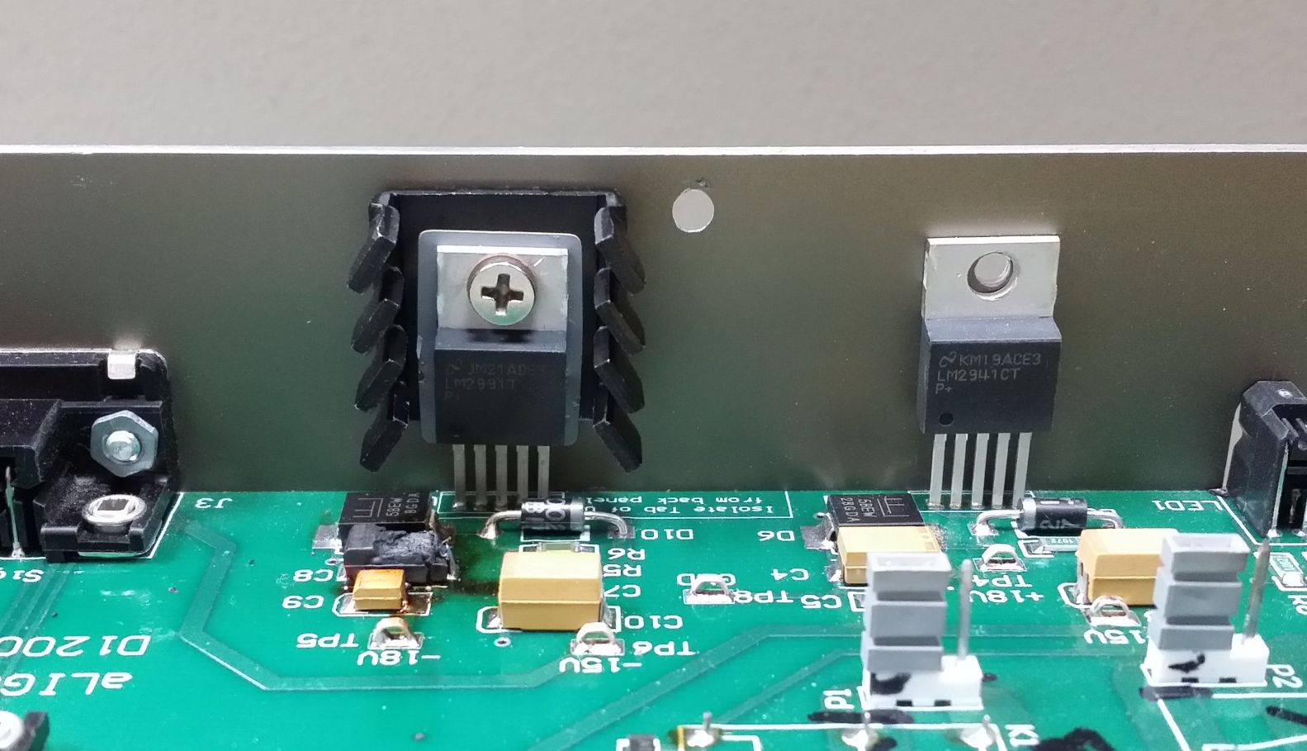

Shoulder Washer: Screw:

