LIGO Laboratory / LIGO Scientific Collaboration

LIGO- T1400367-v2 LIGO 30th May 2014

Some Notes on Assembly of Modified UIM Magnet/Flag Unit

Norna Robertson and Jeff Lewis

Distribution of this document:
LIGO Scientific Collaboration

This is an internal working note
of the LIGO Laboratory.

California Institute of Technology  LIGO Project | Massachusetts Institute of Technology  LIGO Project
LIGO Hanford Observatory | LIGO Livingston Observatory
http://www.ligo.caltech.edu/

Introduction
The purpose of this document is to capture some tips on assembly of the proposed modified magnet/flag unit for the upper intermediate (UIM) stage of the quad suspensions. The information given is taken from email exchange between Jeff Lewis, who did the design and assembly of the prototypes of this unit, and Norna Robertson.

Background
Magnetic coupling to the quad suspensions has been measured to be higher than expected and could possibly be a limitation to sensitivity in aLIGO. See for example bugzilla report 21 and references and links therein. One way to mitigate magnetic coupling is to reduce the size of the magnets used for global actuation at the UIM stage, while increasing the available current to maintain the level of actuation. This is discussed in T1300503. To investigate this further, a revised design of magnet/flag assembly for the UIM has been prototyped. See the part D1300760, which replaces the part D060394 within the whole assembly D1100937 (see figure 1). The current magnets in that assembly (10 mm diameter x 10 mm long) would be replaced by ones approximately 3/16" diameter x 3/8" long (4.76 mm diam. x 9.525 mm long).
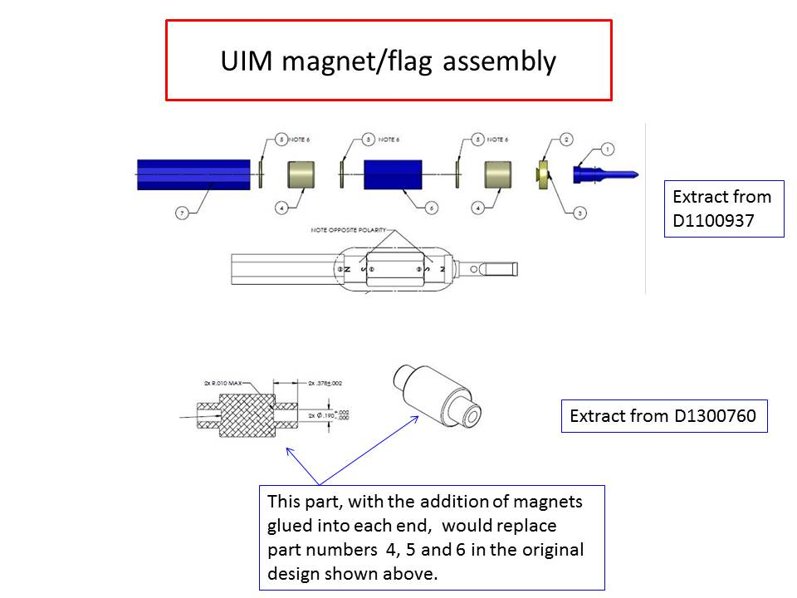
Figure 1. UIM magnet/flag assembly, showing the current assembly, and the replacement parts.

Magnet/Flag Assembly
Since the two magnets are aligned with like poles facing each other (so that there is a cancellation effect for the magnetic fields from the two magnets at a sufficient distance away) the magnets want to repel each other and pop out of the D1300760 part. From Jeff’s experience, that only happened on one of his (several) prototype assemblies. He had used a temporary fixture to hold them in place while the glue was drying. For making production assemblies Jeff thinks that a simple fixture to keep the magnets in place would be warranted. It will be important the fixture doesn’t get glued to the magnets or aluminum body so maybe a point contact on the magnets would be best.
With regard to gluing in the magnets, the trick to gluing was to get the epoxy to the bottom of the blind holes. Jeff used a wire (unfolded paper clip) to dab a couple of drops to the bottom. Then he dropped the magnet in and forced it down till it bottomed out. The epoxy is extruded up through the gaps and seems to distribute well.
There were no vent holes. Jeff recalls Dennis agreed this would be fine (to be confirmed). Dennis was concerned about the strength of the epoxy holding the magnets in place. It is worth a little due diligence to try to pull out the magnets on the prototypes as a test. Jeff is confident that they are well glued in.

Conclusions
The prototypes which Jeff Lewis assembled have been tried out by Betsy for a fit check and she reported that they fitted OK. In addition Robert Schofield agrees that if increasing the current to make up for the reduced size of magnets can be carried out, this flag design with the small magnets looks fine to him.
We note that these prototype assemblies were not class A cleaned and that they were assembled using off-the-shelf Ni-plated NdFeB magnets. For production items we will need to use Ni-plated SmCo magnets (see RODA M0900034) which are not an off-the-shelf item. Thus these assemblies are not suitable as production items and should be quarantined or suitably marked.
With regard to the magnets, it might be useful to have them marked in such a way as to identify the N or S pole. This would make the assembly process more straightforward. For our current production Ni-plated SmCo magnets we had a dimple added to them, to make identification of the material SmCo easier (since we also use same-size NdFeB magnets). For these new magnets we could request that the dimple is used to mark (say) the N pole when we get these magnets made. We note that SmCo magnets are not typically plated, so they could take a long lead time (many weeks) to procure.
In conclusion, we have a working design to go forward with if the decision is taken to carry out this work. Some fixturing will be needed for assembly, and a rigorous test of the glue joints after assembly will be required as part of the procedure.

