LIGO Laboratory / LIGO Scientific Collaboration

LIGO- E1400313-v1 07/08/2014

Realignment plan for H1 TMSX IR QPD sled, July 2014
Keita Kawabe

Distribution of this document:
LIGO Scientific Collaboration

This is an internal working note
of the LIGO Laboratory.

California Institute of Technology  LIGO Project – MS 18-34  1200 E. California Blvd.  Pasadena, CA 91125  Phone (626) 395-2129  Fax (626) 304-9834  E-mail: info@ligo.caltech.edu | Massachusetts Institute of Technology  LIGO Project – NW22-295  185 Albany St  Cambridge, MA 02139  Phone (617) 253-4824  Fax (617) 253-7014  E-mail: info@ligo.mit.edu
LIGO Hanford Observatory  P.O. Box 159  Richland WA 99352  Phone 509-372-8106  Fax 509-372-8137 | LIGO Livingston Observatory  P.O. Box 940  Livingston, LA 70754  Phone 225-686-3100  Fax 225-686-7189
http://www.ligo.caltech.edu/

Table of Contents
1 References 3
2 Scope 3
3 Tools etc. 3
3.1 Dirty equipments for ISCTEX 3
3.2 Clean parts and tools 3
4 Ground loop check 3
5 Realignment procedure 3
5.1 Prerequisite 3
5.2 First contact 4
5.3 Setting up ISCTEX IR injection 4
5.4 IR QPD sled alignment 6
5.5 High power beam dump path 6
5.6 Final alignment check 7
6 Inserting kapton washers to picomotors 7
7 Ground loop fix 7

References
- R. Abbott, “Grounding and Shielding at LIGO”, LIGO-T 1200131.
- B. Slagmolen, “ISCTEX Optical Layout”, LIGO-D1201448.
- L. Barsotti, “TRANSMON ISC EX: component specifications and beam routing”, LIGO-D1201457.

Scope
The primary purpose of this incursion is to realign the EX TransMon IR QPD sled path.
We will also install kapton washers between all in-vac picomotor collars and Siskiyou mount surface to prevent the picomotors from getting stuck when overdriven.
If the ground loop is found before the incursion, fix will be attempted.

Tools etc.

Dirty equipments for ISCTEX
- One set of OzOptics IR laser and beam expansion telescope.
- Two adjustable irises each mounted on an adjustable pole.
- Two sets of 2” IR high reflector assy. Beam height is 4”.
- IR viewer cards.
- IR viewer.

Clean parts and tools
- 8 Class-A kapton washers.
- Assortment of Class-B Allen keys.
- IR viewer cards (wiped clean).
- IR viewer (wiped clean and wrapped with gloves/wipes).

Ground loop check
Ground loop check should be performed prior to this incursion.
Refer to LIGO-T 1200131.

Realignment procedure

Prerequisite
The following should be checked before any incursion activities including SEI and SUS.
- HEPI and ISI are not out of whack.
- ETM, ERM and TMS are all damped.
- TMSX beam diverter is open.
- Green ALS beam is retro-reflected by the ETMX and hits the PDH diode.

First contact
Ask SUS if they need to apply first contact to EX.
If this needs to be done, the procedure should be:
- Record the ETMX bias slider values.
- Turn on the QPD centering servo for ALS beam.
- Turn off the QPD centering servo.
- Apply the first contact to the ETMX.
- Damp ETMX and adjust the bias slider until the ALS beam hits the PDH diode.
- Record the ETMX bias slider values as well as their difference from the previously recorded numbers.

Setting up ISCTEX IR injection
Two persons stay outside and one person works in chamber.
Turn off the QPD centering servo.
In-chamber person checks the green leakage beam on M12 and M14 (Fig. 1). Without changing the position of M12 and M14, steer M4 such that the leakage beam is roughly centered on the aperture formed by two faces of M12 (HR and AR).
There are two visible beams impinging M12. The correct one is the closest to the high power beam dump and the furthest from ISCTEX.
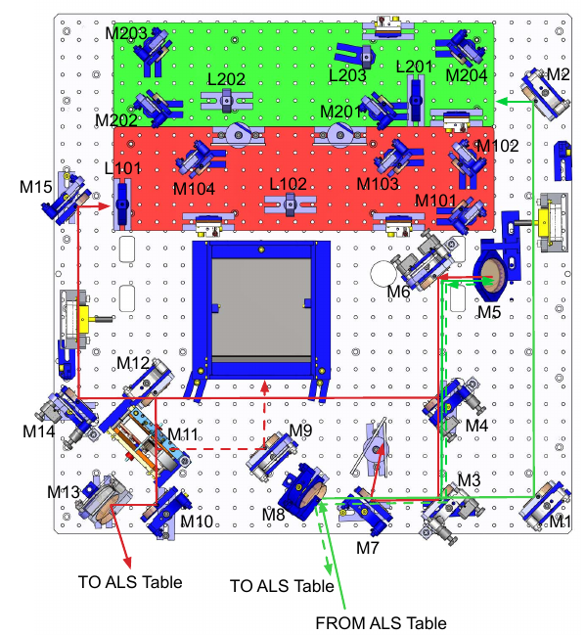
Figure 1. Never touch any mirror except M4 and Mn (100>n>=9).

Locate the leakage beams reflected by M13 that goes to the TR viewport on the chamber. There are many ghost beams, but the correct one is the one farthest from ETMX and closest to the primary mirror. Steer M13 such that the beam is centered on the aperture formed by the chamber, the viewport and the opening on the ISCTEX enclosure.
At this point, two persons outside of the chamber adjust the TR periscope such that the correct beam is roughly centered on two periscope mirrors. The correct beam is the one closest to the green periscope and the highest at the bottom periscope mirror.
Set up two irises on ISCTEX to mark the beam position of the correct green leakage beam. This is just for convenience, exact location of irises is not important at this stage.
Set up the OzOptics laser assy and inject the IR beam back into chamber through the irises. The beam should already hit ETMX. Remove one of the ISCTEX irises.
From here, the three workers make the IR beam co-linear with the green beam. The criterias we use for this are:
- The green beam and the IR beam are on top of each other in the injection hole on the TMS ISC table under M5. This is checked by the in-chamber worker using an IR viewer card and/or IR viewer.
- The green beam is retro-reflected by the ETMX (i.e. the green beam is on PDH diode). This is checked by the outside workers.
- The IR beam should be retro-reflected by the ETMX (i.e. the IR beam reflection is centered on the iris on ISCTEX). This is checked by the outside workers.
In reality, the procedure would be something like this:
- The outside worker opens the iris and moves the steering mirror on the ISCTEX that is farther away from the chamber until the IR beam goes on top of the green beam under M5.
- The outside worker moves the steering mirror on the ISCTEX that is closer to the chamber until the IR beam retro-reflects.
- Repeat.
- Once the alignment becomes roughly good, the IR retro-reflection condition is checked by moving the iris and checking the centering on the iris (both injection and reflection) using an IR viewer.
- Turn on and off the green QPD centering servo. Check the green retro reflection, move TMS bias if necessary.
- Repeat.
After the IR injection path is set up, the in-chamber worker checks the beam position on M12 and M14. The beam should be roughly centered on these mirrors. Since the centering on these mirrors is not critical, DO NOT move M4 to center M12 and M14 unless the centering is off by more than 3mm (or 1/8 inch). If you move M4, you need to go back to ISCTEX and redo the IR injection path.

IR QPD sled alignment
In-chamber worker moves M14 and M15 repeatedly until the beam is centered on both of the QPDs. It should be possible to check the beam position on these QPDs using MEDM screen.

High power beam dump path
Close the beam diverter.
Fold an aluminum foil that is to be used as a beam block.
Put the aluminum foil beam block between M12 and M11 such that everything except the one closest to the primary mirror and farthest from the ETMX is blocked.
Steer M9 so the correct beam is directed to the center of high power beam dump aperture. If it’s still difficult to find the correct beam, put another aluminum foil beam block between M11 and M9 such that the beam closest to the beam dump is selected.
Remove the foil(s).
Open the beam diverter.

Final alignment check
Turn on and off the green QPD centering servo.
Check that the green and the IR beam are both retro-reflected.
Check that the green and the IR beam are on top of each other under M5.
Check that the IR beam is centered on IR QPDs.
Check the IR beam position between ISCTEX and the TMS. There is plenty of room horizontally, but vertically the beam might be close to one of the edges, as the aperture formed by the chamber, the viewport and the ISCTEX opening is (American) football-shaped, the long dimension being horizontal.
If the beam is found to be close to one of the edges, note the position difference between the correct green leakage beam and the IR beam on the viewport (they should be very close to each other). Block the IR beam on ISCTEX and steer M13 in chamber such that the correct IR path is far enough from any of the edges. Use green leakage beam as a reference, dead-reckoning the IR and the green position difference.
At this stage, the IR injection is not a good reference any more, but the in-chamber alignment is done, and we can still use the green leakage beam as the reference.

Inserting kapton washers to picomotors
Kapton washers are made out of thin sheet material, and have cuts such that they could be slipped on the shaft of the picomotor between the collar and the Siskiyou mounts without removing the picomotor.
Slip kapton washers on all picomotors (there are 8 total, 2 each for M3, M4, M6 and M14). Take extra care not to move picomotors at all.

Ground loop fix
If there is any know ground loop, we will attempt to fix it.

