LIGO Laboratory / LIGO Scientific Collaboration

LIGO- T1400296-v10 LIGO 8th April 2019

Conceptual Design of a Larger Beamsplitter Suspension

Norna A Robertson, Mark Barton

Distribution of this document:
LIGO Scientific Collaboration

This is an internal working note
of the LIGO Laboratory.

California Institute of Technology  LIGO Project | Massachusetts Institute of Technology  LIGO Project
LIGO Hanford Observatory | LIGO Livingston Observatory
http://www.ligo.caltech.edu/

Introduction
As noted in the LIGO operations request M1300529, section 3.1.9.3, the size of the beamsplitter (BS) was frozen early on to allow time to design its suspension. The current BS aperture compromises the optical performance more than previously appreciated, and while it is expected to be tolerable, we may wish to retrofit a larger BS in the future. A larger beamsplitter will require a redesigned suspension and support structure. How much redesign work is needed will depend on the new size (from consideration of both the larger footprint and the larger mass).
In this document I explore some of the ramifications of a larger beamsplitter in terms of the design of the triple pendulum supporting the optic, with MATLAB modeling of various possible options.
8th April 2019. Note added in v10. A larger beamsplitter is now part of the design for A+. This document now serves as a starting place for the A+ design. As such it has been renamed “Conceptual Design…”

Size of New Beamsplitter
The current beamsplitter has a diameter of 370 mm. The current design of beamsplitter triple suspension within its support structure is shown in figure 1.
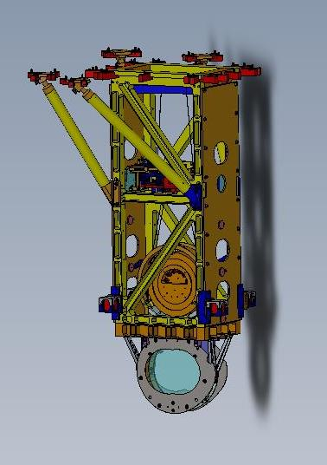

Figure 1: current design of beamsplitter suspension within its support structure.
When we were considering options for the design of the BS upper structure, D080501, (i.e. the box-like part in gold in figure 1) for an increased size of optic, the upper range in size which was proposed was 600 mm. See for example the work discussed in the poster G1300956. For an optic of diameter 600 mm the upper structure would indeed need to be increased. A more modest increase in size of optic could make use of the existing upper structure. For example an optic of diameter 450 mm with a middle mass of the same diameter could fit into the existing upper structure, although the “figure of eight” lower structure (D080005), in which the middle and lowest masses nestle, would need to be enlarged.
A BS diameter of 450 mm has been considered by Hiro Yamamoto as a potential new value which reduces geometrical limitations – see his recent talk (G1400198). Thus we have taken this value as a working number to use in a new suspension design.

Parameter space to explore
3.1 Beamsplitter optic size and mass
Currently the beamsplitter is 370 mm diam. x 60 mm thick (ignoring wedge for now) which with silica density = 2201 kg/m^3 gives mass = 14.2 kg.
Investigate two options:
a) Diameter = 450 mm, thickness = 60 mm (unchanged). This gives mass = 21.0 kg
b) Diameter = 450 mm, thickness = 60*450/370 = 73.0 mm (aspect ratio same as current optic). This gives mass = 25.6 kg.
Note that according to T040232 “Beamsplitter First Elastic Mode Frequency versus Dimensions (Advanced LIGO)” these sizes are acceptable as both have first elastic mode frequency > 1 kHz. Using Figure 2 in that document, we note that option a) has its lowest frequency at ~1.75 kHz and option b) at ~ 2 kHz. The current design has its first mode at ~ 2.5 kHz.
Obviously moments of inertia for the optic will also change.
3.2 Other masses in the triple suspension
Historically (from GEO experience) we have aimed for approximately the same mass at each stage in a multiple suspension. This is currently the case for the beamsplitter. However in the development of the quad suspension we departed from this model to keep overall weight down. The masses in the quad are 22, 22, 40, 40 kg from top to bottom. Thus we can start by exploring what happens for the beamsplitter suspension if we leave the top two masses unchanged (at 12.6 and 13.6 kg respectively). However we may want to at least widen the middle mass if we wish to keep the bottom set of wires oriented vertically.
3.3 Other parameters impacted.
Clearly with the larger mass, all the blades will need to be changed. This could be achieved by making thicker blades with new curvature and keeping other dimensions unchanged. For running the MATLAB model we will assume for now that the blade dimensions are changed such that the uncoupled frequencies (i.e. the frequencies of a stage calculated from the blades at that stage suspending the mass immediately below) remain unchanged.
Wire separations will change at a minimum for the face-on value at the bottom mass (the n5 value). Depending on whether the diameter of the middle mass is changed, the n4 and n3 values may also change. We will assume that separations in the direction normal to the face of the optic remain unchanged.
We take as baseline for the BS parameter set the file bsfmopt_metal (rev 6436) in the SUS SVN.

Initial Results and Observations from MATLAB: Optic as in 3.1 a).
4.1 Change optic to diameter = 450 mm, thickness = 60 mm (mass and MOIs change). Change n5 to match new radius. No other changes.
Two major changes to transfer functions are seen.
a) The first pitch frequency goes down from 0.47 to 0.34 Hz, see figure 2. This is likely to be unacceptable. See for example RODA M080134 “E/ITM and BS/FM pitch frequencies” where the choice of values of first pitch frequencies for quads and BS are discussed.
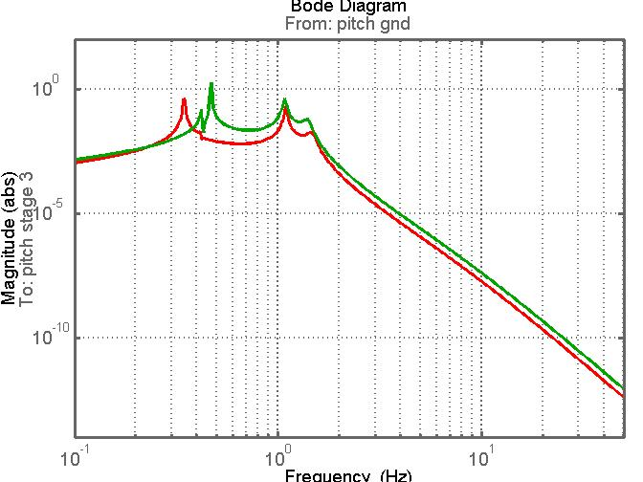

Figure 2. Pitch transfer function for larger bottom mass as the only change, see text. Green is original, red is new.
b) The highest roll mode (at 23 Hz) is now strongly coupled into the transverse transfer function, see figure 3. This arises due to the fact that the lowest wires are not vertical, since we have not changed the middle mass diameter, (i.e. n4≠n5).
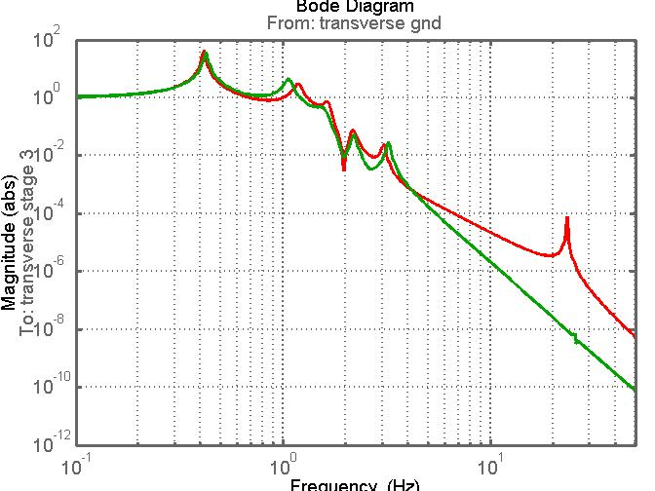

Figure 3. Pitch transfer function for larger bottom mass as the only change, see text. Green is original, red is new.
This coupling also means that the transverse isolation is not as good. It is not clear if this is acceptable. It is probably better to aim to avoid this strong coupling.
4.2 Increase the “d” value at the new bottom mass (d4) by 9 mm to raise the first pitch frequency. (This is not the only way to achieve a higher mode).
This change raises the first pitch frequency to 0.54 Hz which would be quite acceptable. See figure 4.
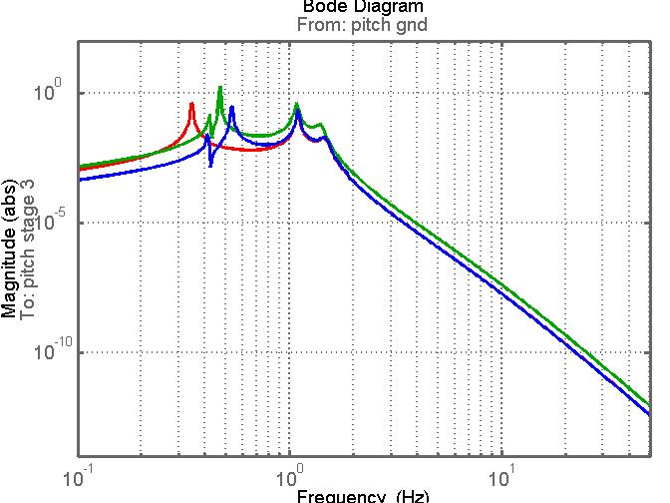

Figure 4. Pitch transfer functions. Green and red as in figure 3. Blue curve is with addition of change in d4 value.
The pitch transfer functions in figures 3 and 4 have been produced with lower damping gains than we would normally run with, to allow the three peaks to be clearly seen. If we return to a gain setting closer to what we would use in practice and compare the level of damping on the first mode, we find that the Q of the damped first mode is ~ factor of 2.5 higher in the modified (blue) version compared to the original (green). See figure 5. This suggests that coupling of this mode to the top mass where damping is applied is reduced. This is not unexpected given that the bottom mass is now significantly heavier than the top two.
4.3 Change the mass, size and MOIs of the middle mass to match the bottom mass, keeping the changes already made.
This change now implies that the bottom wires will be vertical, n4 = n5. We also need to change n3 at the middle mass. We do this by keeping the difference between n3 and n4 the same as in the original design (i.e. the compound clamp design at the middle mass remains unchanged). The wires from the top mass to middle mass will change in slope due to the change in n4.
The main change is seen in the transverse transfer function, see figure 6, where the strong coupling of the highest roll mode, now at ~ 21 Hz, is much reduced as expected with the final set of wires being vertical.
The first pitch frequency is slightly better coupled than the case 4.2 above. Its Q is ~ 2 times the Q of the original first pitch mode for the same damping function, suggesting somewhat better coupling than in case 4.2.
This model appears to be worth taking further, including looking at redesign of blades.
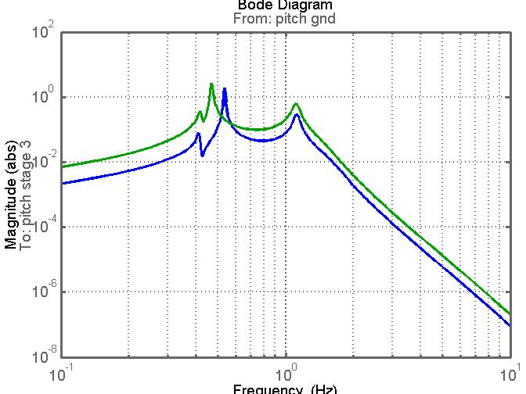

Figure 5. Comparison of pitch transfer function for the original (current) design (green) and the design as in section 4.2 (blue), showing higher Q first mode.
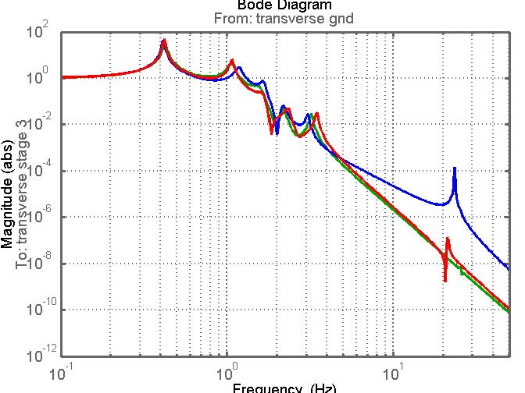

Figure 6. Transverse transfer function for original (green), design as section 4.2 (blue) and design as in section 4.3 (red).

Initial Results and Observations from MATLAB: Optic as in 3.1 b).
Building on our findings in the previous section we go straight to a model with the following changes (similar to 4.3 above):
Optic and middle mass: diameter = 450 mm, thickness = 73 mm (mass and MOIs change). Change n4 and n5 to match new radius. Change n3 such that we keep the difference between n3 and n4 the same as in the original design. Increase d4 by 9 mm from original design to raise pitch frequency.
The general shapes of the transfer functions are very similar to those obtained with parameters as in 4.3. The first pitch mode is slightly shifted down (at 0.51 Hz) and slightly less well damped compared to the model in 4.3. See figure 7 for comparison of pitch TFs. Note that the damping is such that the third pitch frequency (~1.4 to 1.8 Hz depending on the model) is well damped.
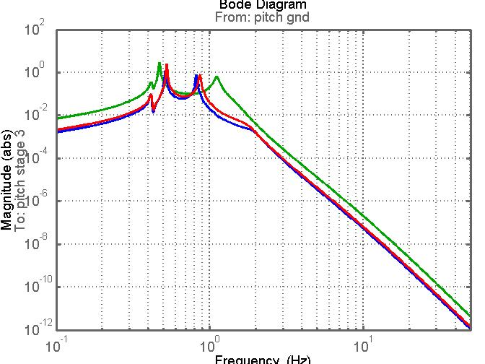

Figure 7. Comparison of pitch transfer functions: green = original design, red = 60mm thick optic (parameters as in section 4.3), blue = 73 mm thick optic (parameters as in section 5).

We note for completeness that in our new models we also need to change length of wires between top and middle masses to get the overall length correct (since those wires are now angled differently), and we need to increase radii of all wires for the larger masses to get same safety margin over the breaking stress. However these are minor changes in terms of the behaviour of the suspension.
Given that we have a couple of possible suspension models, we should now consider the physical layout implications for thinner or thicker optic of diameter 450 mm, as well as looking into revised blade parameters.

Blade Redesign
The starting condition for a redesign is to try to keep the uncoupled frequencies involving the blades unchanged so that the overall vertical isolation will be essentially the same (noting that final wire radius would also need to change to keep the uncoupled vertical frequency of lowest stage the same, return to this later). We carry this out for parameter changes as in section 4.3 i.e. a beamsplitter mass of 450 mm diameter x 60 mm thick.
The key equations (see for example T1000351) are
(1) $f=\frac{1}{2π}\sqrt{\frac{Eah^{3}}{4ml^{3}α}}$
where f = uncoupled frequency, a, h and l are blade parameters width, thickness and length respectively, E = Young’s modulus for blade material, m = mass immediately supported by that blade, α = shape factor (typically around 1.4)
(2) $σ=\frac{6Pl}{ah^{2}}$
Where σ = stress in blade (assuming perfect triangle) and P = m_{tot}g where m_{tot} is total mass supported by that blade.
6.1 Redesign of top (upper) blades (optic thickness = 60 mm)
If we keep the top mass in the suspension unchanged, then for these blades we would achieve the same uncoupled frequency with unchanged blade parameters (apart from initial curvature). However since m_{tot} is increased, the stress will be increased. We have already pushed the stress level in the BS blades as far as we are willing to go in the original design, i.e. less than 1000 MPa (see T080267). Thus we cannot keep the same blade parameters. If instead we increase the blade thickness to keep the stress the same, the uncoupled frequency goes up. So we cannot simply change the blade thickness if we wish to keep the frequency constant. We need to change more than one parameter of the blades, which will have implications for the design of the structure holding these blades.
From equations (1) and (2) we can derive different combinations of a, h, and l to achieve an unchanged frequency and unchanged stress. As a working example we can set a constant and only change h and l. They can be increased proportionately to keep f constant until the increase in h²/l balances the increase in P from the original design to keep the stress constant. Using an EXCEL spreadsheet blade calculator (loaded under “other files” on this DCC filecard) we find the following values give a possible solution:
Original values:
m1, m2, m3 = 12.62, 13.575, 14.175 kg
a = 6.25 cm, h = 2.2 mm, l = 25 cm
f = 2.42 Hz, stress = 982 MPa
New Values:
m1, m2, m3 = 12.62, 20.98, 20.98 kg
a = 6.25 cm, h = 2.9 mm, l = 32.5 cm
f = 2.47 Hz, stress = 993 MPa
The major change which we have to deal with in such a redesign is the increase in length of 7.5 cm for each blade. We can use the CAD model to assess how realistic this increase is within the current support structure.
6.2 Redesign of lower blades (optic thickness = 60 mm)
For this blade, both the immediate mass and the total mass suspended from the blade will change. Immediate mass changes from 13.575 kg to 20.98 kg – factor of ~1.5. Total mass changes from 13.575+14.175 to 2 x 20.98, again a factor of ~1.5. Again keep a constant. The following values give a possible solution:
Original values:
m2, m3 = 13.575, 14.175 kg
a = 2.578 cm, h = 1.5 mm, l = 14 cm
f = 2.84 Hz, stress = 986 MPa
New Values:
m2, m3 = 20.98, 20.98 kg
a = 2.578 cm, h = 2.0 mm, l = 16 cm
f = 2.88 Hz, stress = 958 MPa
Again the key change which we need to see if it can be easily accommodated is the increase in length of the blades, in this case by 2 cm.
We stress here that the above are working examples which can be explored further, but they are by no means the only solutions for revised blades.
For completeness we now change all the wire radii to keep the same factor of safety using the heavier masses. This takes r1 from 312.5e-6 to 362.5 m, r2 from 200e-6 to 246e-6 m, and r3 from 125e-6 to 152.5e-6 m. We compare the resulting vertical transfer functions in figure 8.
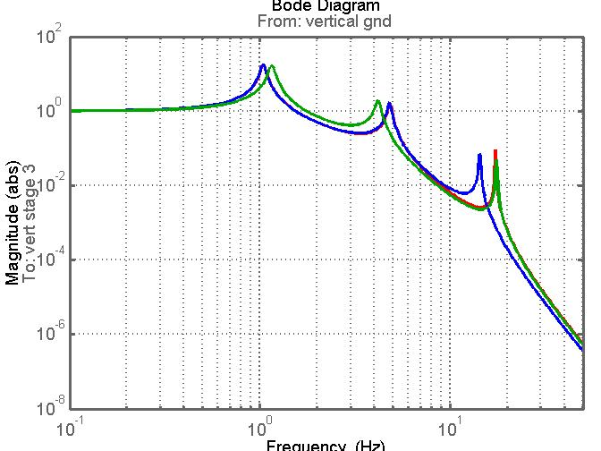
Figure 8. Comparison of vertical transfer function: green is original (current) design of beamsplitter suspension, blue is new design of suspension as in 4.3 above, with new blades as in this section, red is as blue with addition of revised wire radii.
We note that at 10 Hz and above the transmissibility curves for green (original) and red (new design with new blades and new wires) are virtually the same.
6.3 Redesign of blades (optic thickness = 73 mm)
We repeat the above exercise for the larger thickness optic (450 mm diam. x 73 mm thick, mass 25.6kg). A working set of upper and lower blades are:
Upper blades
m1, m2, m3 = 12.62, 25.6, 25.6 kg
a = 6.25 cm, h = 3.4 mm, l = 38 cm
f = 2.48 Hz, stress = 988 MPa
Lower blades
m2, m3 = 25.6, 25.6 kg
a = 2.578 cm, h = 2.25 mm, l = 17 cm
f = 2.84 Hz, stress = 981 MPa
We now turn our attention to the practicalities of fitting new blade lengths into the existing design of top stage and top mass.
6.4 Fitting in new blades
The revised length of the top blades presents the more challenging design change. These blades are currently mounted to an assembly (D080080 BS top stage) in which they are angled at around 20 degrees to the transverse axis of the suspension structure. See figures 9 and 10.

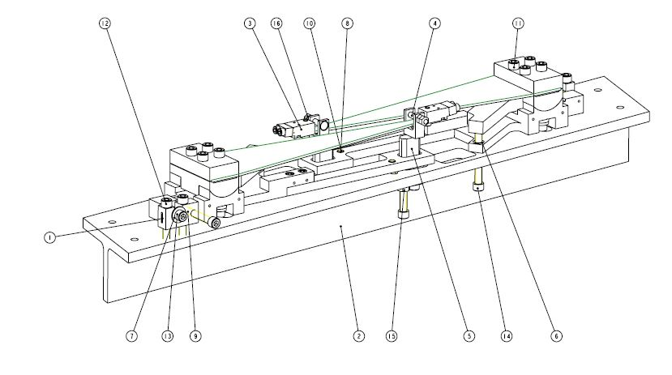
Figure 9. Extract from D080080, BS TOP STAGE, showing the top blades mounted to their support structure. See also figure 10.

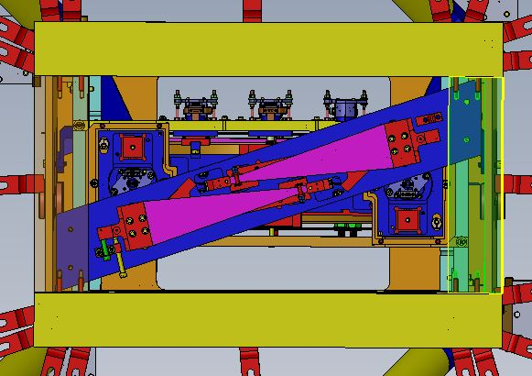
Figure 10. Snapshot from CAD drawing looking from above at the beamsplitter suspension. The two blades (magenta) on the top stage (blue) can be seen. This stage is attached from below to the two side sections of the top of the support structure – these pieces have been made transparent in this view. For scale the length of the magenta blades is 25 cm, and their clamping area (in red with 4 fasteners) is 3 cm long.
From figure 10 we can see that there is not a lot of room to extend the blades in length at their current angle before the red clamp units will hit the side sections of the support structure. There is certainly not 7.5 cm as would be needed for the blades in section 6.1. There is also not a lot of room to swing the blades to a larger angle before they would interfere with the front and back top sections of the support structure.
Another possibility to explore is to increase the blade tip separation (the parameter 2 x n0) by moving the blades inwards toward the centre, possibly also angling them more to fit in. It is useful to return to the MATLAB model to see what effect changing n0 has.
6.5 Moving top blades to fit
We have tried increasing the n0 value from its current value of 0.077 m to approximately double at 0.15 m. That means the tips of the blades are separated by 0.30 m and are significantly more crossed than as seen in figure 10. The main difference in behaviour is seen in the yaw transfer function, with smaller changes in transverse and roll. See figure 11 for the yaw transfer function. Here blue is before changing n0, red is after. As expected, the larger value of n0 has stiffened up the yaw modes, and the first mode is less damped. However the new family of modes looks quite acceptable. A detailed layout needs to be done with the new size of blades to see if there are any potential problems with increasing the crossover of the blades, but at first look this could be a solution to fitting them in. It should be noted that in the quad suspension design we fit in long blades in a similar overall footprint by significantly crossing them, so we have experience of getting this to work.
We consider the lower blades in the next section.

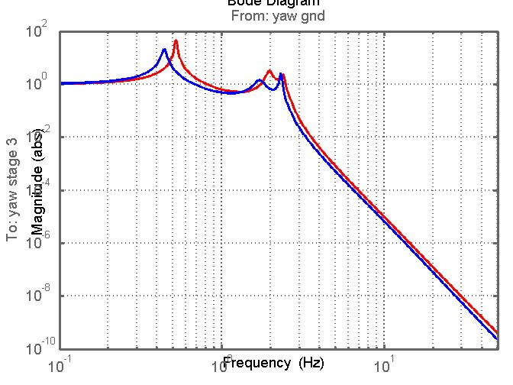
Figure 11. Comparison of yaw transfer function with change of value of n0 (half-separation of tips of top blades). Blue : n0 = 0.077 m (current design), red: n0 = 0.15 m (potential revised design).
6.6 Fitting in new lower blades
From section 6.2 we have a potential design for new lower blades where the key change with regard to fitting it into a new suspension is the length increase of 2 cm. Figure 12 shows a partially assembled top mass, where the mass is shown upside down, where the current blades can be seen ( taken from D070435). One way to fit longer blades could be to keep the mounting positions at their bases unchanged and let them extend inwards towards the central axis of the mass, thus decreasing the parameter n2 (where two times n2 is the separation of the blade tips). There is a central piece which gets added to the top mass between the blade tips (not shown in figure 12) but its size could be changed if the new position of blade tips interfered (to be checked). The current value of n2 is 6 cm. Thus we would be decreasing n2 to 4cm. We have tried this out in the MATLAB model. The main difference in behaviour is seen in the yaw transfer function, with smaller changes in transverse and roll. See figure 13 for the yaw transfer function. Here blue is before changing n0 or n2, red is after changing n0 only as in section 6.1 to accommodate the larger top blades, and green is changing n0 and n2 to accommodate both new sets of blades. The smaller value of n2 has softened up the yaw modes compared to the case of changing n0 only, and the first mode is less damped than either of the two previous cases. However the new family of modes still looks quite acceptable.
We have possible solutions to fitting in both sets of new blades for the case of a 450 mm diameter x 60 mm thick optic. A more detailed look at the layout can now be pursued to see if these solutions are indeed workable.

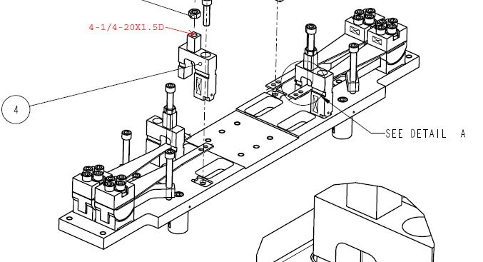

Figure 12. Extract from D070435 showing a partially built top mass with blades in place.

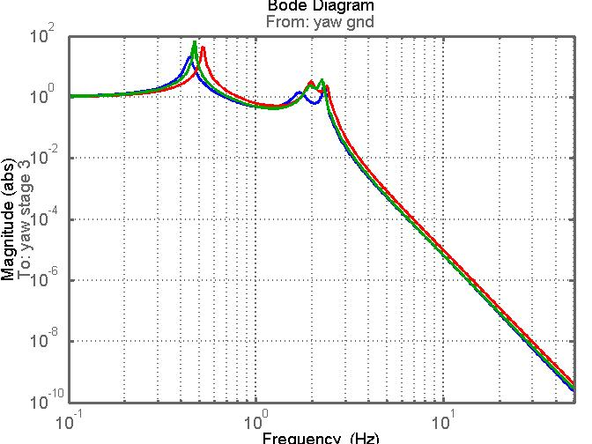

Figure 13. Comparison of yaw transfer function with changes of value of n0 and n2 (half-separation of tips of top blades and bottom blades respectively). Blue : n0 = 0.077 m, n2 = 0.06 m (current design), red: n0 = 0.15 m, n2 = 0.06m (changing top blades) , green: n0 = 0.15 m, n2 = 0.04m (changing top and bottom blades).

Suspension Thermal Noise
To check that the changes to the suspension parameters have not adversely affected the thermal noise performance, Mark Barton has run his suspension thermal noise model with a parameter set corresponding to the 450 mm diameter x 60 mm thick case as in section 4.3 with blades as in section 6.2. The parameter set is given in Appendix A. Note that the parameter set does NOT include the changes to n0 and n2 considered in section 6. However these changes have no significant effect on longitudinal or vertical transfer functions and therefore should not significantly change the thermal noise estimates.
Mark’s model is saved as 20140529bsNWlarge, where NW corresponds to No Wedge. Further details can be found on the wiki page at
https://awiki.ligo-wa.caltech.edu/aLIGO/Suspensions/OpsManual/BSFM/Models
and the files will be added to the SVN.
The modeled thermal noise is shown in figure 14. It can be seen that the expected performance meets the noise requirements except at the highest vertical mode around 17 Hz. It is very similar to the predicted performance of the current beamsplitter suspension, see for example figure 1 in T040027. Thus we conclude that this parameter set is acceptable as regards thermal noise performance.

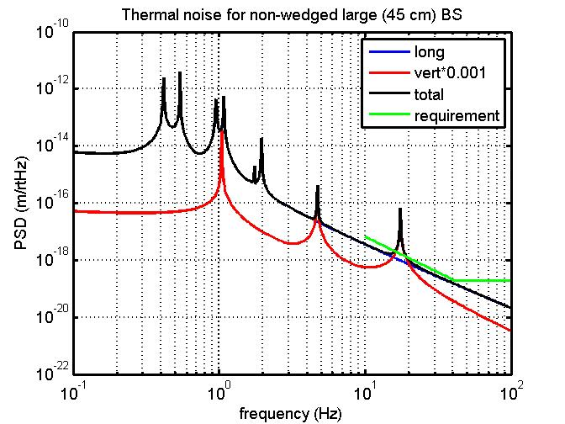

Figure 14. Suspension thermal noise for large beamsplitter suspension, parameters as in appendix A.

Further Development of Conceptual Design
Norna visited Joe O’Dell at Rutherford Appleton Laboratory on 15th September 2014. We discussed ideas for reworking the top stage and top mass to take longer blades and also looked at needed reworks for the figure of eight support structure to accommodate the larger optic. Joe and his junior engineer Charles Evans will write up their findings and post to the DCC in due course. Here I summarise some of the key issues which we discussed, and capture a revised set of parameters and MATLAB model as an outcome of these discussions.
8.1. Fitting in blades
We continued to work on the assumption that the optic is 450 mm diameter x 60 mm thick. Joe and Charles have considered how to fit in top blades which are 75 mm longer than the original blades and bottom blades which are 20 mm longer – thus corresponding to sections 6.1 and 6.2 above.
Regarding the top blades, it looks feasible to keep the tip separation (the n0 value) the same as the current design rather than crossing the blades more as discussed in section 6.5. To fit them in requires cut-outs to the cross-struts at the top of the structure (made transparent in figure 10), and a new backbone for holding the blades. The rotational adjusters (part of which are shown in red on the wide end of the blades) need to be modified to allow the blades to extend outwards. The changes all look feasible.
Regarding the bottom blades within the top mass, their wide ends would stay in the same position and so their tips would extend inwards, reducing the n2 value by 20 mm. This requires modification/reduction of the central “turret” and reallocation of mass elsewhere in the top mass, with consequent increases to moments of inertia (MOI). Another possibility is to move the wide ends of the blades partially outwards, maybe by 10 mm, so that the tips are not so close. The second idea is probably more favourable in terms of being able to sight the tips to check for interferences when the mass is assembled. There was concern that the necessary repositioning of mass, which would increase the MOIs, might have adverse effect on transfer functions, but a quick check with the MATLAB model has shown that a 100% increase in pitch or roll MOI at the top mass is not a problem.
8.2 Masses in the suspension.
As discussed in section 4.3, I have been considering increasing the mass and size of the middle mass to match the new bottom mass, to allow the lowest wires to remain vertical. As Jim Hough pointed out to me, we only need to extend the middle mass at the attachment points to get vertical wires. Joe and I looked at the implications of attaching a revised compound clamp to the sides of the current design of middle mass to allow the bottom wires to remain vertical. This looks quite feasible. I have rerun the MATLAB model with the original middle mass and MOIs, with acceptable results. Note that with the smaller mass, the blades would not need to be increased by as much as discussed above. However it is useful to keep some mass in reserve in case i) a thicker optic is called for, or ii) a larger diameter than 450 mm is proposed.
8.3 Modifications to “Figure of Eight”.
The figure of eight is the part of the support structure which nestles around the middle and bottom masses, supporting the earthquake stops and the BOSEMs at the middle mass. Clearly the lower half of this structure needs to be changed to accommodate the larger optic. This has implications for the attachment of the new piece to the existing upper part and outer box. The RAL team has looked into this and come up with a potential solution. With an unchanged middle mass, the top part of the figure of eight can remain essentially unchanged. We also looked at how wires and clamps would sit with respect to the modified figure of eight and could see no show-stoppers. RAL has also considered how to modify the lower structure tooling.
8.4 Revised MATLAB model.
As a consequence of the above considerations I have generated a revised MATLAB model as work in progress. The basic parameter changes from the current (original) design are as follows:
a) bottom mass is silica cylinder of diameter 450 mm x 60 mm thick.
b) top and middle masses are unchanged
c) radii of wires have been increased to take larger masses.
d) n2 value is reduced from 0.06 m to 0.04 mm, corresponding to longer bottom blades with tips closer together.
e) uncoupled vertical frequencies are as in the “new “ designs in sections 6.1 and 6.2. Note that the blade sizes and frequencies were derived there assuming a heavier middle mass, but can be considered conservative values.
f) The d4 value has been increased by 4 mm from the original value. Note that this is less than the increase discussed in section 4.2 above. It was found not necessary to increase by so much with the return to the original middle mass
g) the value of n4 was set to equal the new n5 so that the bottom wires are vertical. The value of n3 was changed so that the difference between n3 and n4 remains the same.
The transfer functions from suspension point to optic for the 6 degrees of freedom, comparing the original design with the design using this new parameter set, are given in figures 15 to 20 inclusive.
A full listing of the new parameter set is given in appendix B.

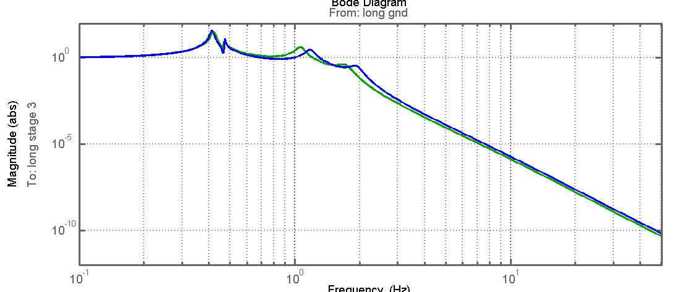
Figure 15. Longitudinal transfer function: green = original design, blue = new design as discussed in section 8.
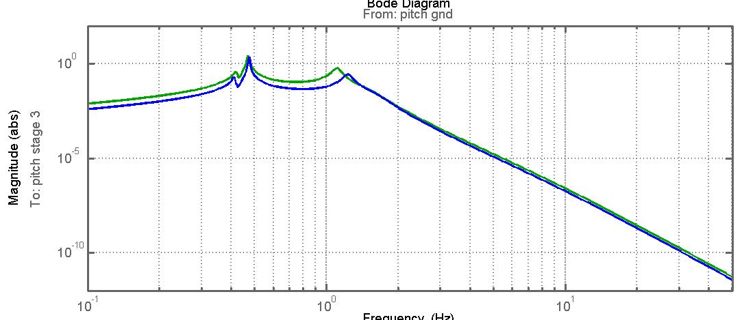
Figure 16. Pitch transfer function: green = original design, blue = new design as discussed in section 8.
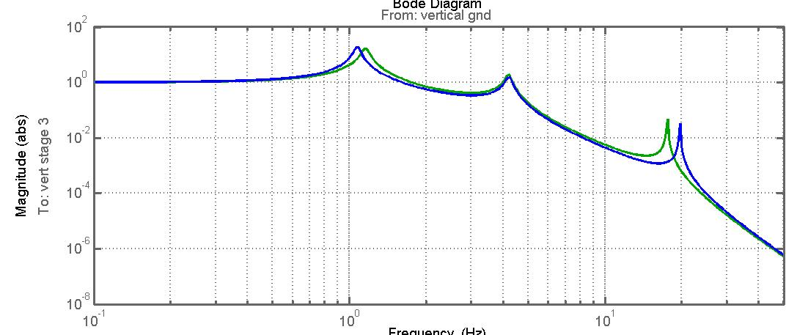
Figure 17. Vertical transfer function: green = original design, blue = new design as discussed in section 8.
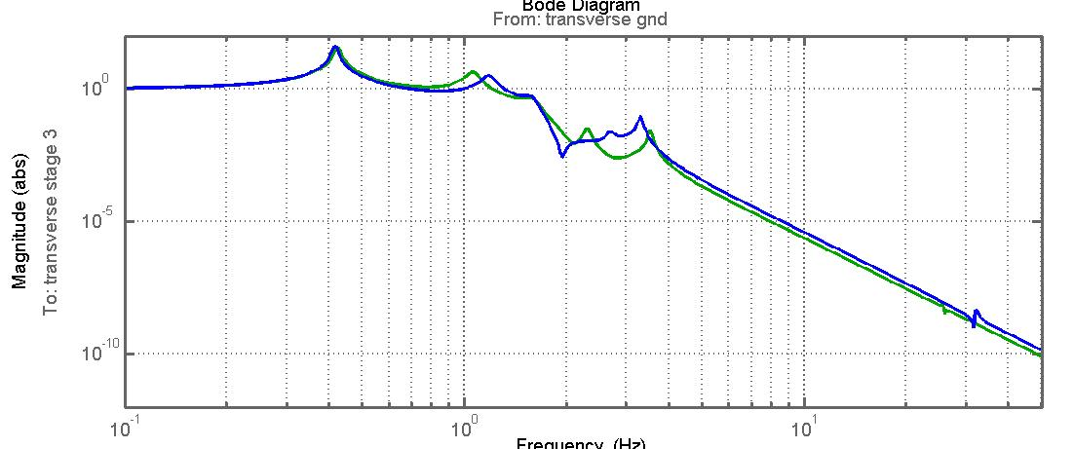
Figure 18. Transverse transfer function: green = original design, blue = new design as discussed in section 8.

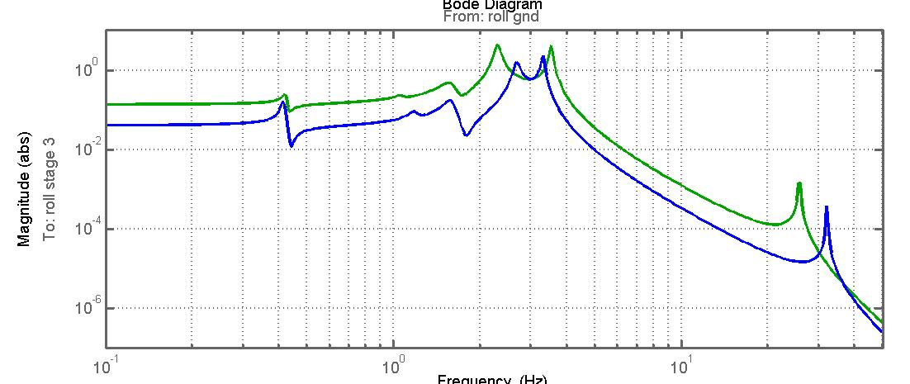
Figure 19. Roll transfer function: green = original design, blue = new design as discussed in section 8.
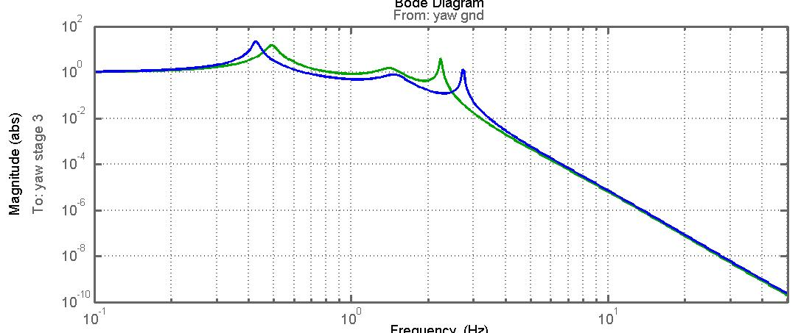 Figure 20. Yaw transfer function: green = original design, blue = new design as discussed in section 8.

Appendix A.
Suspension parameters used to generate thermal noise graphs as in figure 14.
The parameters highlighted in red are the ones which have been changed from those recorded in the SVN for the current beamsplitter as revision 6436. The family of mode frequencies is included at the end.
>> pend_ref
Using Stage 2 fudges
Using matrix elements with no blade lateral compliance
Using matrix elements with quad blades at top mass

pend =

m1: 1.2630e+001
I1x: 1.6590e-001
I1y: 2.4730e-002
I1z: 1.6430e-001
m2: 2.0983e+001
ix: 6.0000e-002
ir: 2.2500e-001
ifs: 4.5000e-001
I2x: 5.3113e-001
I2y: 2.7186e-001
I2z: 2.7186e-001
m3: 2.0983e+001
tx: 6.0000e-002
tr: 2.2500e-001
tfs: 4.5000e-001
I3x: 5.3113e-001
I3y: 2.7186e-001
I3z: 2.7186e-001
nw1: 2
nw2: 4
nw3: 4
l1: 6.1200e-001
l2: 5.9600e-001
l3: 5.0000e-001
r1: 3.6250e-004
r2: 2.4600e-004
r3: 1.5250e-004
Y1: 2.1190e+011
Y2: 2.1190e+011
Y3: 2.1190e+011
l1b: 2.5000e-001
a1b: 6.2500e-002
h1b: 2.2000e-003
ufc1: 2.4700e+000
l2b: 1.4000e-001
a2b: 2.5780e-002
h2b: 1.5000e-003
ufc2: 2.8800e+000
stage2: 1
su: 0
si: 1.5000e-002
sl: 5.0000e-003
n0: 7.7000e-002
n1: 1.3000e-001
n2: 6.0000e-002
n3: 2.3110e-001
n4: 2.3750e-001
n5: 2.3750e-001
d0: -2.2574e-003
d1: -2.8145e-004
d2: 7.7185e-003
d3: -3.2255e-004
d4: 7.6775e-003* (added 9mm)
flex1: 3.2574e-003
flex2: 2.2815e-003
flex3: 1.3225e-003
bd: 0
ribbon: 0
db: 0
g: 9.8100e+000
kc1: 1.5210e+003
kc2: 3.4354e+003
tl1: 6.0744e-001
tl2: 5.7835e-001
tl3: 5.0735e-001
l_suspoint_to_centreofoptic: 1.6931e+000
l_suspoint_to_bottomofoptic: 1.9181e+000
flex3tr: 1.3225e-003
longpitch1: [4.1701e-001 5.3913e-001 9.5148e-001]
longpitch2: [1.0758e+000 1.7420e+000 1.9475e+000]
yaw: [4.4269e-001 1.6709e+000 2.3083e+000]
transroll1: [4.1959e-001 1.0688e+000 1.6634e+000]
transroll2: [2.4253e+000 3.8715e+000 2.5974e+001]
vertical: [1.0413e+000 4.7059e+000 1.7416e+001]

Appendix B
MATLAB parameter set for model as discussed in section 8, and used to generate figures 15 to 20. Parameters which have been changed from the original design are shown in red. Some other derived parameters (flexure lengths etc) have also changed as a result. The mode frequencies are shown at the end.
Parameters from bsfmopt_metal_r6436_mod_60mm_thickv2.m
17 Sept 2014
pend =

m1: 1.2630e+001
I1x: 1.6590e-001
I1y: 2.4730e-002
I1z: 1.6430e-001
m2: 1.3575e+001
ix: 5.7090e-002
ir: 1.8500e-001
ifs: 3.5000e-001
I2x: 2.5920e-001
I2y: 1.2976e-001
I2z: 1.3587e-001
m3: 2.0983e+001
tx: 6.0000e-002
tr: 2.2500e-001
tfs: 4.5000e-001
I3x: 5.3113e-001
I3y: 2.7186e-001
I3z: 2.7186e-001
nw1: 2
nw2: 4
nw3: 4
l1: 6.1200e-001
l2: 5.9600e-001
l3: 5.0000e-001
r1: 3.6250e-004
r2: 2.4600e-004
r3: 1.5250e-004
Y1: 2.1190e+011
Y2: 2.1190e+011
Y3: 2.1190e+011
l1b: 3.2500e-001
a1b: 6.2500e-002
h1b: 2.9000e-003
ufc1: 2.4700e+000
l2b: 1.6000e-001
a2b: 2.5780e-002
h2b: 2.0000e-003
ufc2: 2.8800e+000
stage2: 1
su: 0
si: 1.5000e-002
sl: 5.0000e-003
n0: 7.7000e-002
n1: 1.3000e-001
n2: 4.0000e-002
n3: 2.3110e-001
n4: 2.3750e-001
n5: 2.3750e-001
d0: -2.5038e-003
d1: -4.7210e-004
d2: 7.5279e-003
d3: -3.2255e-004
d4: 2.6775e-003 *( added 4 mm)
flex1: 3.5038e-003
flex2: 2.4721e-003
flex3: 1.3225e-003
bd: 0
ribbon: 0
db: 0
g: 9.8100e+000
kc1: 1.5210e+003
kc2: 2.2226e+003
tl1: 6.0720e-001
tl2: 5.7159e-001
tl3: 5.0235e-001
l_suspoint_to_centreofoptic: 1.6811e+000
l_suspoint_to_bottomofoptic: 1.9061e+000
flex3tr: 1.3225e-003

longpitch1: [4.1251e-001 4.7383e-001 1.1646e+000]
longpitch2: [1.1922e+000 1.5519e+000 1.9055e+000]
yaw: [4.2698e-001 1.4537e+000 2.7299e+000]
transroll1: [4.1625e-001 1.1659e+000 1.5760e+000]
transroll2: [2.6381e+000 3.2799e+000 3.2097e+001]
vertical: [1.0686e+000 4.0851e+000 1.9640e+001]

