LASER INTERFEROMETER GRAVITATIONAL WAVE OBSERVATORY
CALIFORNIA INSTITUTE OF TECHNOLOGY
MASSACHUSETTS INSTITUTE OF TECHNOLOGY
Laser SOP LIGO-M1300574-v1 16 December 2013
Temporary SOP for LLO Photon Calibrator alignment

Submitted By:
Christopher Guido, Richard Savage

LIGO Hanford Observatory LIGO Livingston Observatory
P.O. Box 159 19100 LIGO Lane
Richland, WA 99352 Livingston, LA 70754
Phone (509) 372-8106 Phone (225) 686-3100
Fax (509) 372-8137 Fax (225) 686-7189
E-mail: info@ligo.caltech.edu E-mail: info@ligo.caltech.edu

California Institute of Technology Massachusetts Institute of Technology
LIGO Project – MS 18-34 LIGO Project – NW22-295
Pasadena, CA 91125 185 Albany St. Cambridge, MA 01239
Phone (626) 395-2129 Phone (617) 253-4824
Fax (626) 304-9834 Fax (617) 253-7014
E-mail: info@ligo.caltech.edu E-mail: info@ligo.mit.edu

APPROVAL SIGNATURES

Christopher Guido, Author Date

David Kinzel, LLO Laser Safety Officer, Author Date

Richard Oram, Operations Manager Date

Joe Giaime, LLO Head Date

Peter King, LIGO Laser Safety Officer Date

David Nolting, LIGO Safety Coordinator Date

Contents
PREFACE 2
1. INTRODUCTION 2
2 HAZARDS 7
2.1 Nominal Hazard Zone 7
3. CONTROLS 8
3.1 Access and Administrative Controls 8
3.2 Physical Controls: Exposure Control 9
3.3 Physical Controls: Electrical Controls 9
3.4 Eye Protection 10
4. OPERATING PROCEDURES 11
4.1 Responsible Laser Operator 11
4.2 Start-up procedures 11
4.3 Shutdown procedures 11
5. TRAINING 12
6. RESPONSIBILITIES 12
7. References 13

PREFACE
Table of Documentation Hierarchy

Tier 1 = M950046 (LIGO Laboratory System Safety Plan)
Tier 2 = M960001 (LIGO Laser Safety Program)
Tier 3 = M1000228 (LLO Laser Safety Plan) (Site-specific)
Tier 4 = Site-specific, laser-specific SOPs, FMEAs, and special procedures
Tier 5 = Operating, user, or other technical manuals from the manufacturer
Tier 6 = Wiki entries instructing operators "how-to".

This document is for individuals who require basic knowledge about this laser equipment. It is not a substitute for operating manuals or for one-on-one training. Standard operating procedures (SOPs) are site-specific and equipment-specific documents that fall under the jurisdiction of the site laser safety officer. Candidate laser operators must read and understand all site-specific laser safety plans as well as laser-specific SOPs. Candidate laser operators must understand that reading this documentation is necessary, but does not automatically qualify personnel to work on this laser equipment. Neither does it clear anyone to operate identical hardware at any other LIGO location.

Table of Documentation Hierarchy

Tier 1 = M950046 (LIGO Safety Plan)
Tier 2 = M960001 (LIGO Laser Safety Plan)
Tier 3 = Site-specific (LLO) Safety Plans: M040112 and M1000228
Tier 4 = Site-specific, laser-specific SOPs, FMEAs, and special procedures
Tier 5 = Operating, user, or other technical manuals from the manufacturer
Tier 6 = Wiki entries instructing operators "how-to".

This document is for individuals who require basic knowledge about this laser equipment. It is not a substitute for operating manuals or for one-on-one training. Standard operating procedures (SOPs) are site-specific and equipment-specific documents that fall under the jurisdiction of the site laser safety officer. Candidate laser operators must read and understand all site-specific laser safety plans as well as laser-specific SOPs. Candidate laser operators must understand that reading this documentation is necessary, but does not automatically qualify personnel to work on this laser equipment. Neither does it clear anyone to operate identical hardware at any other LIGO location.

1. INTRODUCTION
This document is the Standard Operating Procedure governing the operation of the Photon Calibrator (PCal) laser at LLO during the initial setup in the X-end VEA. This SOP is designed to ensure the safety of all personnel and equipment in and around the experiment while it is operating. Its role falls within the overall laser safety plan is described in LIGO-M960001, LIGO Laser Safety Plan.

The Photon Calibrator can be found in the X-End Station (EX) and Y-End Station (EY) Vacuum Equipment Area (VEA) nominal hazard zone (see Figure 1). It is a class 3B infrared laser product based on a laser head manufactured by CrystaLaser Corporation’s model IRCL-500-1047. This laser product is capable of delivering 500 mW of 1047 nm radiation to its emission port, the PCal vacuum viewport on the EX and EY end spool. Each CrystaLaser laser head is matched to a particular power supply (model CL-2000).
Each PCal injects two light beams to the EX or EY optic (ETM) inducing radiation pressure on the ETM. This pressure moves the ETM minutely and can therefore be used to calibrate displacement sensitivity of a fully operational LIGO Livingston interferometer.
This 1047 nm infrared radiation is not visible without infrared viewing equipment such as IR cards or IR viewers.
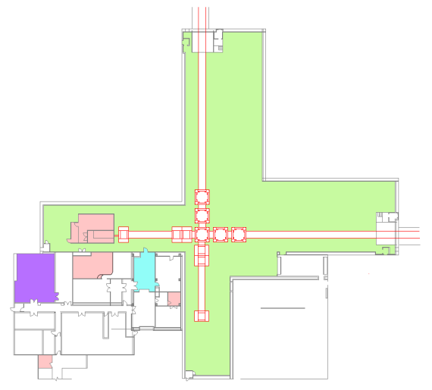
Control Room
Large Vacuum Equipment Area (LVEA)
Laser Safety Officer (LSO)

X-End Station
4 km
Nominal Hazard Zone

Figure 1: EX’s floor plan and relative position with respect to the LVEA. Not to scale. The X-End Station sits 4 km west of the LVEA. Red outlines indicate the vacuum system.

For this initial setup, the PCal will be comprised of only a few of its final components. The PCal laser will be placed on top of an optical breadboard which is then mounted to the PCal pylon so that a beam can be injected into the transmission port to verify the alignment of the in vacuum components. Figure 2 depicts the intended setup
Figure 2: A conceptual picture of the Photon Calibrator transmitter at EX (left) and its projected beam path. The EMTX optical lever leaner pier is shown as well in this picture (right). Note that for the initial setup, the pylon will be in place; however, there will not be an enclosed volume on top. Just an optical breadboard with the laser and its power supply.
A closer view of the CrystaLaser’s power supply is shown in Figure 3. This box supplies the laser head with electrical power and monitors basic performance details. A rocker switch on the back panel activates the CrystaLaser power supply. A key switch on the control box front panel controls laser light discharge. Three LEDs on the front panel of the power supply indicate power supply on/off status, laser emission, and the laser head’s over heat status.
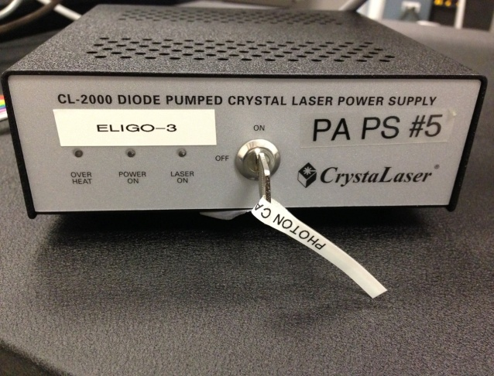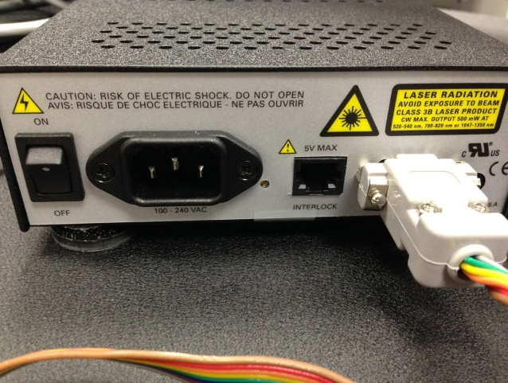
Figure 3: Crystal Laser Power Supply (front and back)
The parameters for the primary output of the PCal are listed in Table 1.
Table 1: Laser parameters
Description | Value/Designation
Laser Type | Diode Pumped Nd:YLF laser product
Class | 3B
Emission center wavelength | 1047 nm
Emission repetition rate | Continuous Wave
Emission waist (minimum radius) | 0.057 mm
Waist location | Inside Laser Head
Beam divergence | N/A
Output polarization | Horizontal
Maximum power output | 500 mW
Interlocked | Jumper on power supply
Authorized locations | VEAX, VEAY

2 HAZARDS
- This laser is a class 3B laser product. Its (near) infrared radiation is considered hazardous to the eyes (retina) and skin. Unprotected eye exposure to the direct beam or specular radiation can lead to instant blindness.
- Unprotected to concentrated 500 mW radiation can lead to skin burns.
- A 110 VAC shock hazard exists if the power supplies are opened for repairs, modification, or diagnostics.
- A fire hazard is present when direct focused laser light falls onto non-fire resistant articles in the beamline.

2.1 Nominal Hazard Zone
The nominal hazard zone (NHZ) for the PCal is the EX VEA (see Figure 4).
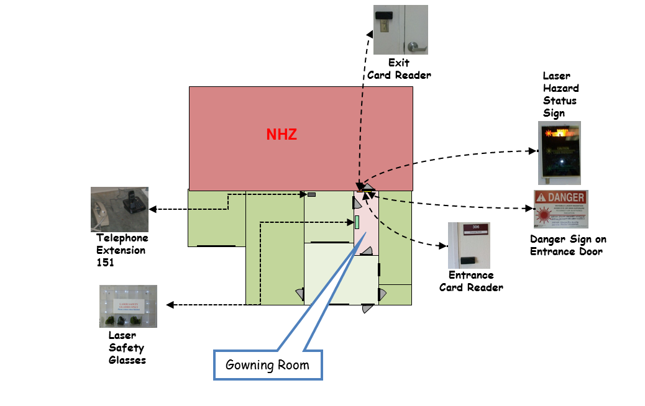
Figure 4: End station X’s floor plan including the NHZ, the VEA. Various safety features of the EX station are shown.

3. CONTROLS

3.1 Access and Administrative Controls
Access to the PCal in the EX VEA is controlled to ensure site personnel safety. Access to the EX VEA is restricted to qualified laser operators only. These individuals gain access to these NHZs by individualized key cards and key card readers found at the entrance of VEAX (see Figure 4).
Unauthorized visitors must be escorted by qualified laser operator. Also, all operations in the VEAX must follow LIGO work permit procedures.
A lighted warning sign is located at EX’s NHZ entrance and indicates either a “Laser Hazard” or “Laser Safe” condition (see Figure 4).

3.2 Physical Controls: Exposure Control

A manual shutter exists at the aperture of the laser head. This shutter can be closed at any power without risk to hardware or personnel.
Beam dumps are provided in the optics lab and may be installed around the laser as required. These beam dumps vary from razor blade based beam dumps to larger conical units (see Figure 5). Lab provided clean smocks and gloves provide a limited degree of skin protection to the CrystaLaser’s radiation.
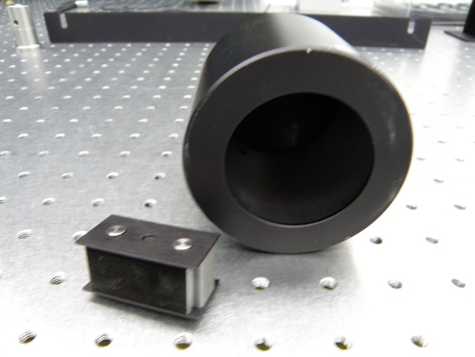
Figure 5: Beam dumps examples are shown, a razor blade dump for low power (lower left) and a larger conical unit for moderate powers (right).

3.3 Physical Controls: Electrical Controls

A hardware activation key on the power supply controls can turn on the device and arm the laser head. In all circumstances, this hardware activation key can shut down the laser. There is also a jumper on the back of the power supply that can be used for the interlock

3.4 Eye Protection
All personnel working in EX’s and EY’s NHZ while the laser is capable of being or is energized will wear protective laser safety eyewear whose optical density is specified in Table 2. Laser safety goggles may be found in the gowning room racks.
Table 2: Laser safety eyewear minimum optical density (OD) for the Photon Calibrator light source
Wavelength (nm) | Minimum O.D. | Beam parameters (estimate)
1047 | 3.0 | 500 mW

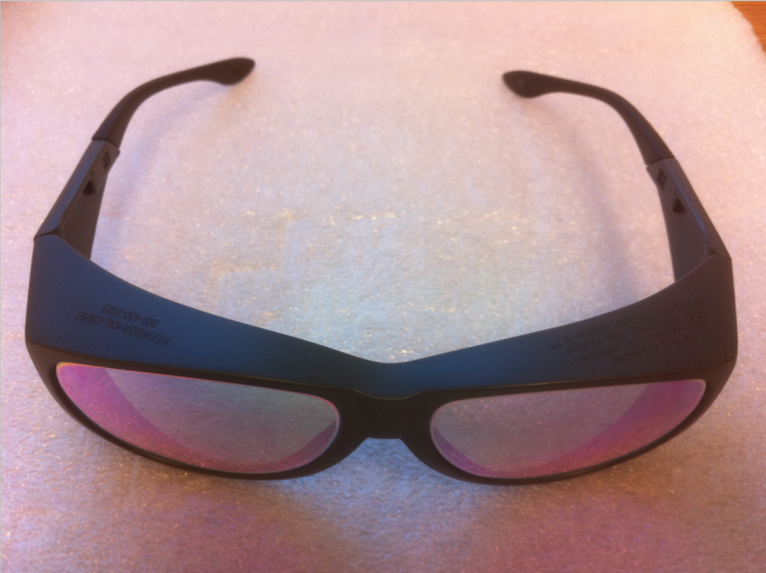
Figure 6: Laser goggles are found in the gowning room rack.

4. OPERATING PROCEDURES

4.1 Responsible Laser Operator
The Responsible Laser Operator (RLO) coordinates tasks and informs the on-duty control room operator when work is started and completed for the Photon Calibrator. When a work permit is required, it must be filed before any work begins.
Notice that the individual who files the work permit is the RLO for the Photon Calibrator unless specified by the work permit. Access to the EX NHZ is handled by key card access and monitored by the status panels that are located in the control room. These panels show whether or not the NHZs are occupied and the current laser state. Others wanting access to the EX’s NHZ must gain permission from the on-duty control room operator and contact the RLO before they enter the area.

4.2 Start-up procedures
Only qualified laser operators are permitted to activate the PCal.
The PCal may be activated by qualified laser personnel only. Access cards must be used to enter the NHZ. General lab rules for the EX VEA follow those for the LVEA. In other words, the VEAX must be in laser hazard before a laser may be activated.
- File a work permit as required.
- Turn on the CrystaLaser power supply using the rocker switch on the back panel of the power supply.
- Wait 30 seconds for the power supply and laser head to warm up.
- Turn the CrystaLaser power supply activation key switch to the “ON” position.
- Open the shutter for light as needed.
- Make an ilog entry indicating the status of the PCal.
NOTE: If a laser beam with power in excess of 2 mW is found (reported by any observer), leaving the light source in an unauthorized trajectory, the PCal will be shut down by the LSO and will remain off until start-up authorization is received.
It is the responsibility of each person working within the NHZ to ensure that LIGO and ANSI Z136.1 standards for safe laser operation are being followed at all times

4.3 Shutdown procedures
- Close the shutter.
- Turn the key switch to the “OFF” position to turn off the laser light.
- Turn off the CrystaLaser power supply using the rocker switch on the back panel.

5. TRAINING
LIGO basic laser safety training must be completed before any individual can work around any class 3B and/or class 4 laser emission.
Access to the Photon Calibrator is only on an “as needed” basis for qualified laser operators. To become a qualified laser operator, an individual must complete the following requirements.
- Received LIGO basic laser safety training
- Have a full understanding of this SOP and its associated FMEA
- Understand emergency and safety procedures
- Received authorization from the LIGO Livingston laser safety officer
NOTE: Training on any specific laser system does not automatically qualify individuals for other lasers at the LIGO facilities and associated university labs.

6. RESPONSIBILITIES
- Each person working with the EX NHZ is responsible for ensuring that safe laser practices are being followed at all times.
- The responsible laser operator is responsible for the conducting tasks on a specific laser system in accordance with the prescribed control measures and in compliance with this SOP.
- The responsible laser operator is responsible for informing any and all assisting personnel regarding the control measures and SOP for the specific laser system.
- The responsible laser operator shall be responsible for any communications with other site personnel regarding changes in the operational status of the specific laser system.
- In case of safety incidents, contact the immediate personnel and (if necessary) emergency medical services as soon as possible.
- Any identified flaws in procedures or potential improvements that could enhance safety should be brought to the attention of the LLO Laser Safety Officer or cognizant laser personnel.

7. References
- American National Standard for Safe Use of Lasers, ANSI Z136.1-2007
Laser Institute of America, ISBN 0-912035-65-X
- LIGO-M950046 (LIGO Laboratory System Safety Plan)
- LIGO-M960001 (LIGO Laser Safety Program)
- LIGO-M1000228 (LLO Laser Safety Plan)
- LIGO-M0900241 (Laser Safety Training for Certification and Recertification of LIGO Personnel)
- LIGO-M080368 (LLO NHZ Transition Procedures)
- LIGO-G0901007 (LIGO Basic Laser Safety Training Presentation)
- LIGO-G1000017 (LLO Addendum to Basic Laser Safety Training)

