LIGO Laboratory / LIGO Scientific Collaboration

LIGO-E1300939-v3 LIGO 1/31/14

Procedure For Attachment Of The Pcal Periscope Alignment Target To ETM Quad Frame
C. Conley, R. Savage

Distribution of this document:
LIGO Scientific Collaboration

This is an internal working note
of the LIGO Laboratory.

California Institute of Technology  LIGO Project – MS 18-34  1200 E. California Blvd.  Pasadena, CA 91125  Phone (626) 395-2129  Fax (626) 304-9834  E-mail: info@ligo.caltech.edu | Massachusetts Institute of Technology  LIGO Project – NW22-295  185 Albany St  Cambridge, MA 02139  Phone (617) 253-4824  Fax (617) 253-7014  E-mail: info@ligo.mit.edu
LIGO Hanford Observatory  P.O. Box 159  Richland WA 99352  Phone 509-372-8106  Fax 509-372-8137 | LIGO Livingston Observatory  P.O. Box 940  Livingston, LA 70754  Phone 225-686-3100  Fax 225-686-7189
http://www.ligo.caltech.edu/

Introduction
The D1301016 Pcal Periscope Alignment Target (Target Assembly) attaches to the ETM Quad Frame as shown in Figures 1 and 2.

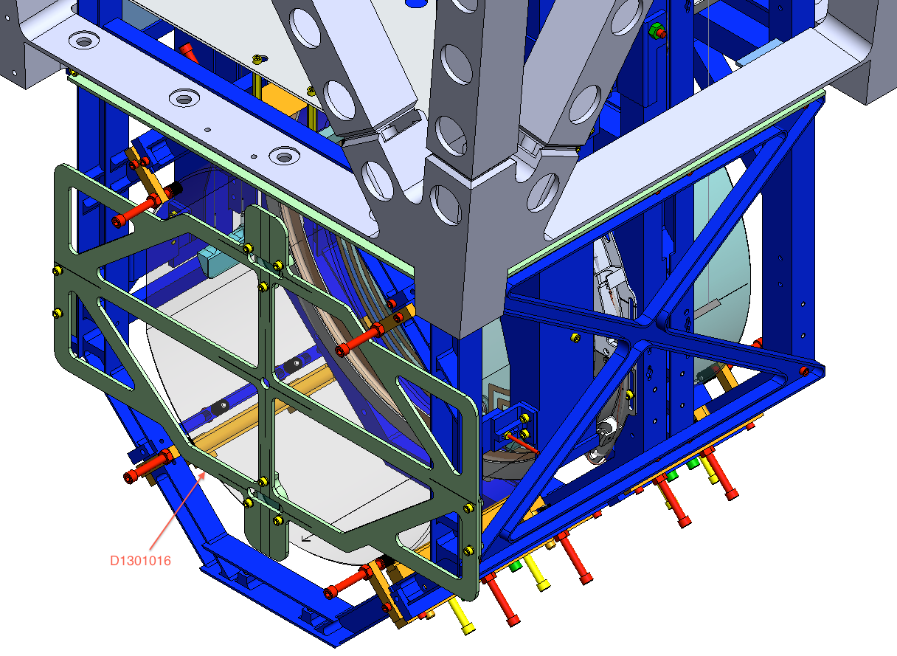
D1301016
Figure 1 D1301016 Pcal Periscope Alignment Target Assembly (Target Assembly) attached to the ETM Quad Frame.

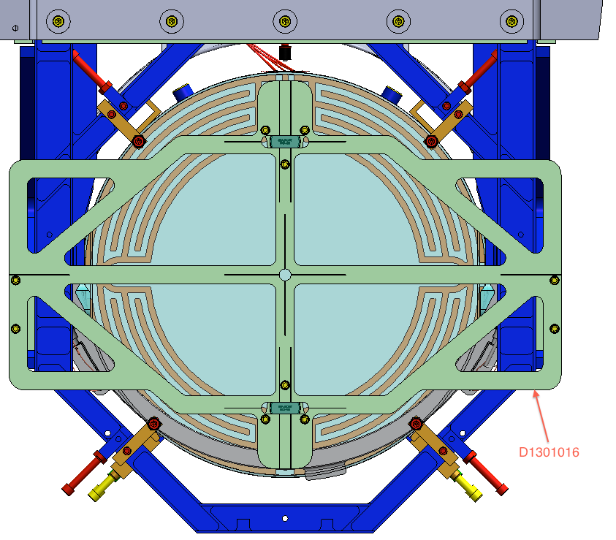
D1301016
Figure 2 D1301016 Pcal Periscope Alignment Target Assembly (Target Assembly) attached to the ETM Quad Frame.

Attaching the Target Assembly to the Quad Frame
- At time of mounting Target Assembly to the quad frame, the ETM may have First Contact on its reflective surface. No other reflective surface protection should be on the ETM. The two 1” mirrors (see figure 3) are to be included on the Target Assembly only if First Contact is present and left fully intact on the ETM reflective surface.
- Also at time of mounting Target Assembly to the quad frame, the screws of the right side mounting bracket of the Target Assembly should be slightly loose to allow travel in the clearance slots (see LIGO drawing D1301014 for slots, also see figure 3).
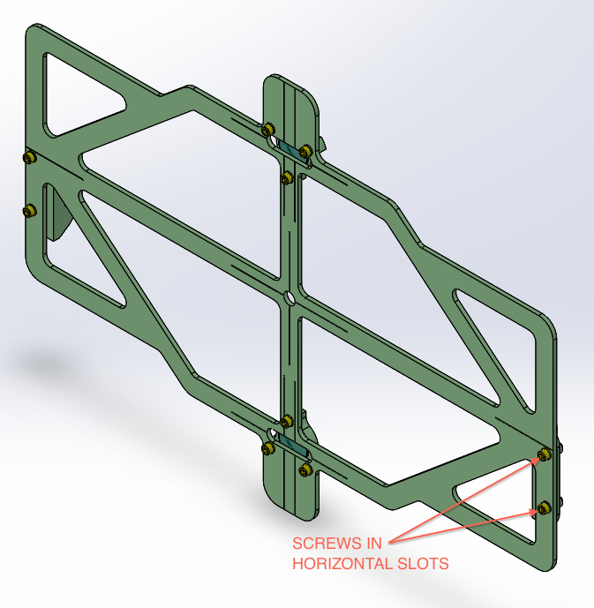
1” MIRRORS &
MIRROR CLAMPS
(8-32 X 1/2L) 10 PLACES
(HERE ONLY)
Figure 3 Target Assembly

- Mount the Target Assembly onto the left side of the Quad frame (as facing the ETM reflective surface) as shown in figure 4, using two 8-32 X 3/8L SHCS screws. Ensure that these class-B screws are inspected and have good threads before attempting attachment inside the vacuum envelope. Tighten the 2 said screws on the left side of the Quad frame snugly, while carefully registering the target sheet against the front of the Quad frame. Make sure the mounting bracket is fully driven against the Quad frame by the two 8-32 X 3/8L SHCS screws.
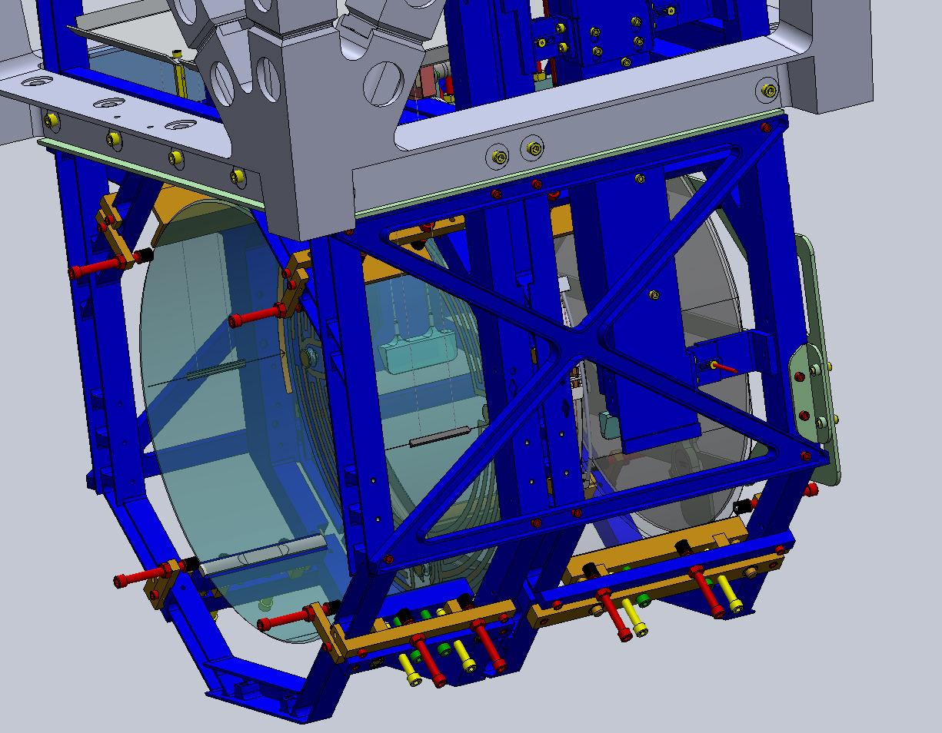
8-32 X 3/8L SHCS, HERE AND FAR END
D1301016

Figure 4 Showing the left bracket of the Target Assembly mounted to the Quad Frame.

- Repeat step 3 on the right side of the Quad frame, then snug the two loose screws on the right side of the Target Assembly. If First Contact is not present and left intact on the ETM reflective surface, the Target Assembly attachment is now complete. Otherwise go to next section.

Aligning 1” Target Mirrors to IFO Beam Axis
- With assistance from IAS, shim the Alignment Target as necessary to achieve 141 µrad maximum IFO Beam Axis parallelism errors in both pitch and yaw, for both 1” mirrors.

