LIGO Laboratory / LIGO Scientific Collaboration

LIGO- E1300928 LIGO January, 30th 2014

aLIGO HEPI L1 ITMX (BSC3) Assembly Validation Report
E1300928

Joe Hanson, Jeremy Birch, Michael Vargas, Rich Mittleman, Ryan DeRosa, Céline Ramet for the SEI Team

Distribution of this document:
Advanced LIGO Project

This is an internal working note
of the LIGO Laboratory

California Institute of Technology  LIGO Project – MS 18-34  1200 E. California Blvd.  Pasadena, CA 91125  Phone (626) 395-2129  Fax (626) 304-9834  E-mail: info@ligo.caltech.edu | Massachusetts Institute of Technology  LIGO Project – NW22-295  185 Albany St  Cambridge, MA 02139  Phone (617) 253-4824  Fax (617) 253-7014  E-mail: info@ligo.mit.edu
LIGO Hanford Observatory  P.O. Box 1970  Mail Stop S9-02  Richland WA 99352  Phone 509-372-8106  Fax 509-372-8137 | LIGO Livingston Observatory  P.O. Box 940  Livingston, LA 70754  Phone 225-686-3100  Fax 225-686-7189

Contents
Contents 2
Introduction 3
Sub-Components Testing 4
Assembly Validation 4
1.1 Load Cells assembly 4
1.2 Bellows 5
1.3 Boot Location 5
1.4 Check Stops Gaps 5
1.5 Gaps check 5
1.6 IPS Centering 6
1.7 Sensors ASD 6
1.8 SUS-watchdogs interaction test 9
1.9 Static Test local drive 9
1.10 Linearity Test/Range of motion in the local basis 11
1.11 Actuator Plate to Shields gap 12
1.12 Valve Check 12
1.13 Local-to-local measurements 13
1.14 Alignment offsets: 16
Conclusion 17

\

Introduction

This document summarizes the tests done to validate the HEPI L1 ITMX (BSC3) assembly and installation. As all L1 HEPI BSC, it had been installed since 2004 at Livingston. However, it had been grounded for the 2 to 3 years of aLIGO install. All electronics has been updated since, and more importantly, the position of the ITMX support tubes (i.e. the position of the 4 HEPI ITMX boots), but not the one of the housings, was adjusted to accommodate for Initial Alignment needs. All tests were completed by June 2013.

Sub-Components Testing
- Kaman Inductive Position Sensors: calibration, linearity, factory data, noise measurements
The IPS sensors on this chamber haven’t been changed since their original installation in 2004. No specific individual testing had been done then or since.
- HEPI actuator linearity test (E1100338 – aLIGO HEPI Actuators Test Results)
The HEPI actuators on this chamber haven’t been changed since their original installation in 2004. No specific individual testing had been done then or since.
- L4C test
The L4C sensors on this chamber haven’t been changed since their original installation in 2004. No specific individual testing had been done at the time or since on the “old units”.

Assembly Validation

Load Cells assembly
- Spring attachment
For the BSC HEPI springs, check the assembly per D030320-v4. See LLO aLOG 7162 for more details.
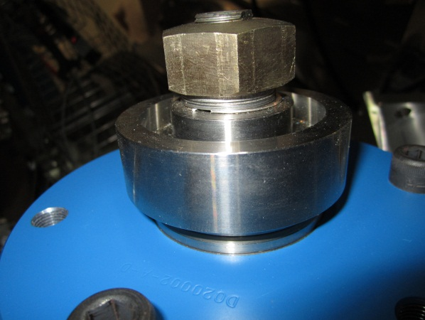
- Load cell values
BSC HEPI load cell capacity → 3000 lbs

 | Spring | Left Spring (lbs)
Pier 1 | 1
 | 2
Pier 2 | 3
 | 4
Pier 3 | 5
 | 6
Pier 4 | 7
 | 8

Acceptance criteria:
- The values must not exceed 80% of the load cell capacity (2400lbs for BSC and 1600lbs for HAM).

Test result: Passed: X Failed: .

Bellows

The bellows are hard to access and tests are hard to proceed. After several discussions and brainstorming sessions, it has been decided not to measure the gaps on HEPI-HAM and HEPI-BSC.

Test result: Passed: Failed: Waived: _ X_

Boot Location

Test result: Passed: Failed: Waived: _ X_

Check Stops Gaps
The stops must not touch the boot.
If the valve check test is a success, we are sure there is no touching against the boot.
Test result: Passed: X Failed:

Gaps check
If the valve check test is a success, we are sure there is no touching against the boot.

Test result: Passed: Failed: Waived: _ X_

IPS Centering
Scripts files for processing and plotting in SVN at:
/SeiSVN/seismic/HEPI/Common/Testing_Functions_HEPI/Offset_STD_IPS_HEPI.m

All the loops must be turned off during this test.

 | H1 | H2 | H3 | H4 | V1 | V2 | V3 | V4
Mean (counts)
Acceptance | +/- 15000 | +/- 15000 | +/- 15000 | +/- 15000 | +/- 15000 | +/- 15000 | +/- 15000 | +/- 15000

Test result: Passed: X Failed:

Sensors ASD
Scripts files for processing and plotting in SVN at:
/SeiSVN/seismic/HEPI/L1/ITMX/Scripts/Perf_Analysis/

Data in SVN at:
SeiSVN/seismic/HEPI/L1/ITMX/Data/Figures/Perf_Analysis/2013-06-21-Level1/
L1_HPI_ITMX_Test_1_2013-06-21-Level1.mat

Figures in SVN at:
/SeiSVN/seismic/HEPI/L1/ITMX/Data/Figures/Perf_Analysis/2013-06-21-Level1/
- HEPI_L1_ITMX_Test_1_Fig_a_HPI_L4C_Hor_2013-06-21-Level1.fig
- HEPI_L1_ITMX_Test_1_Fig_b_HPI_L4C_Vert_2013-06-21-Level1.fig
- HEPI_L1_ITMX_Test_1_Fig_c_HPI_IPS_Hor_2013-06-21-Level1.fig
- HEPI_L1_ITMX_Test_1_Fig_d_HPI_IPS_Vert_2013-06-21-Leve12.fig

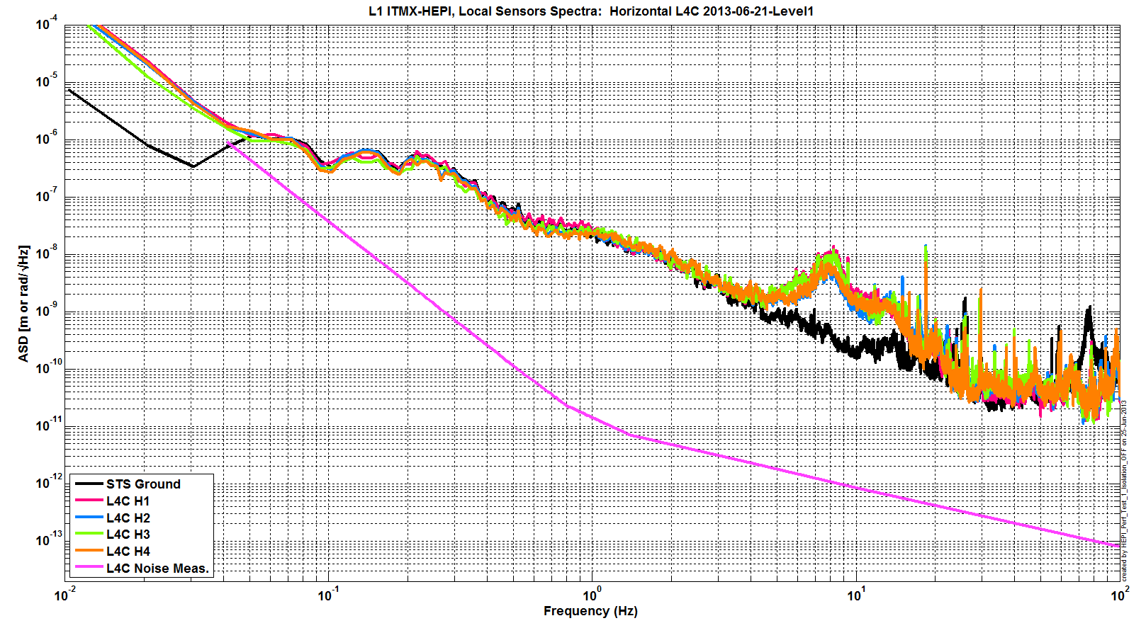

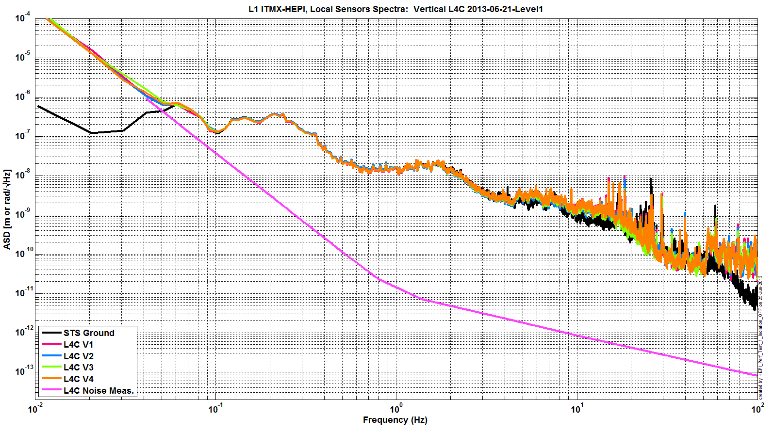

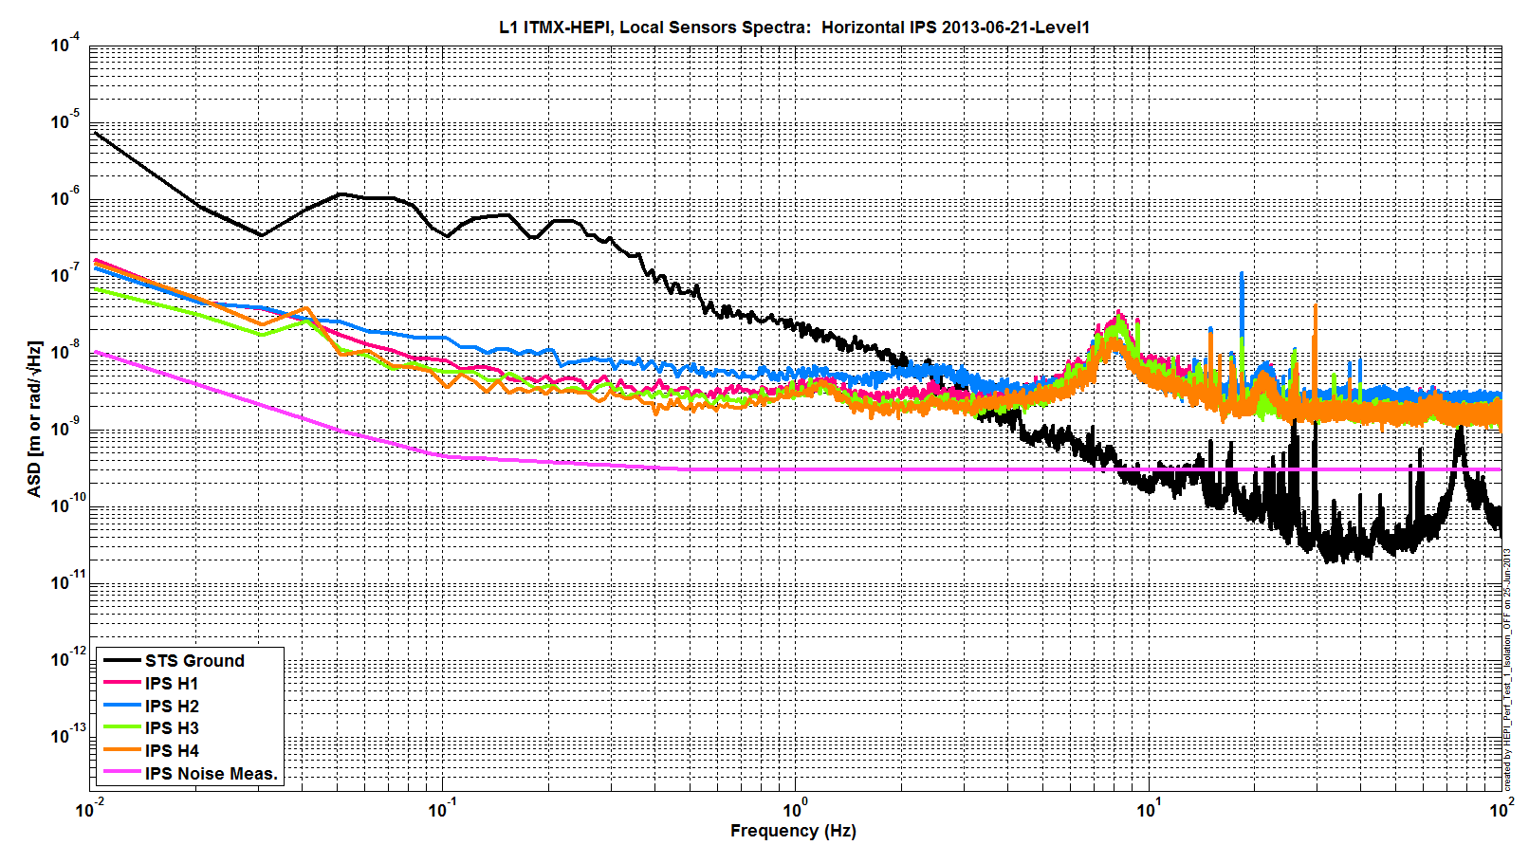
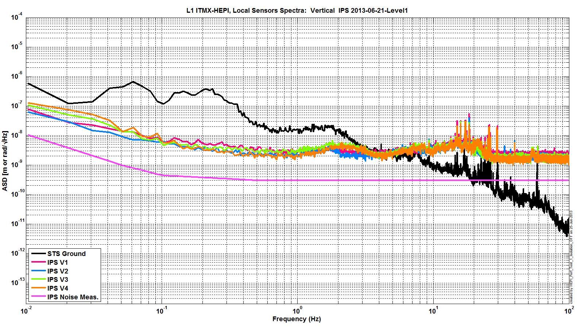
Issues/difficulties/comments regarding this test:
Calibration of IPS on those plots is slightly off I believe. However, those are enough to ensure proper functioning of all sensors.

Test result: Passed: X Failed: .

SUS-watchdogs interaction test
This test will be obsolete very soon, as the payload-HEPI WD connection is planned for removal.

. Set up a zero value on the payload watchogs.
. Check that the payload watchdog screen of HEPI tripped.
. In the payload watchdog screen, click on the OVERRIDE button and reset the watchdog.
. Do the same process for all the payloads
Acceptance criteria:
- The HEPI must trip when the payload watchdogs are tripped
- The HEPI watchdogs could be reset when the OVERRIDE button is ON
Test result: Passed: X Failed: .
When this test is done, reset everything (OVERRIDE button OFF, put back the value on the payload watchdog).

Static Test local drive
Scripts files for processing in SVN at:
/SeiSVN/seismic/HEPI/Common/Testing_Functions_HEPI/Static_Test_Local_Basis_HEPI.m

Data files in SVN at:
/SeiSVN/seismic/HEPI/L1/ITMX/Data/Static_Tests/

Drive of 5000 counts (Nominal value handled by testing script)
 | H1 | H2 | H3 | H4 | V1 | V2 | V3 | V4
H1 | -10347.8 | 4054.0 | 1032.3 | 3696.3 | -14.1 | -52.3 | -86.2 | 235.3
H2 | 2213.6 | -8271.2 | 2921.5 | 864.8 | -150.3 | 56.7 | 227.5 | -90.3
H3 | 410.9 | 3475.1 | -10313.7 | 3685.4 | -122.6 | 282.6 | -73.4 | -228.5
H4 | 2333.9 | 1018.0 | 2954.0 | -8909.2 | 108.2 | -3.9 | -205.5 | -55.9
V1 | -377.7 | 141.2 | -221.0 | 230.6 | -5924.4 | -863.5 | 1601.3 | -1299.0
V2 | -493.0 | 259.9 | -10.4 | 30.5 | -913.1 | -5415.2 | -1149.8 | 1344.2
V3 | -462.6 | 524.7 | -214.3 | -69.6 | 1342.6 | -2132.2 | -6899.4 | -793.5
V4 | -188.1 | 220.0 | -324.8 | 105.5 | -1461.9 | 777.0 | -1571.8 | -6540.9

. Drive of 100 counts (in progress)
 | H1 | H2 | H3 | H4 | V1 | V2 | V3 | V4
H1 | 8350.9418 | -5056.1049 | -327.0384 | -1879.51872 | -178.9088 | 209.3388 | 192.18836 | -370.0864
H2 | -4104.049 | 8306.5349 | -1822.531974 | -448.11792 | 134.8916 | -100.465 | -301.80668 | 139.7868
H3 | -233.5984 | -2065.5751 | 8170.4572 | -4615.56692 | 178.7694 | -183.7838 | -239.1095 | 118.1154
H4 | -1807.7793 | -701.3897 | -4558.2268 | 9000.50088 | -488.2914 | 367.591 | -1.00976 | -441.0128
V1 | -87.0864 | 1.56718 | 302.0506 | -174.51156 | 7490.8344 | 918.82254 | -1656.35338 | 784.3534
V2 | 182.2748 | -404.56522 | -128.0876 | 486.57564 | 833.8752 | 7402.042 | 675.00182 | -1629.1482
V3 | 309.8688 | -477.33554 | -80.087 | 272.82164 | -1436.731 | 1099.12212 | 7236.42762 | 695.124
V4 | -177.839 | 74.78868 | 291.7698 | -126.46464 | 955.694 | -1414.8926 | 824.44686 | 7487.4108

. Drive of 1000 counts (in progress)
 | H1 | H2 | H3 | H4 | V1 | V2 | V3 | V4
H1 | 8350.9418 | -5056.1049 | -327.0384 | -1879.51872 | -178.9088 | 209.3388 | 192.18836 | -370.0864
H2 | -4104.049 | 8306.5349 | -1822.531974 | -448.11792 | 134.8916 | -100.465 | -301.80668 | 139.7868
H3 | -233.5984 | -2065.5751 | 8170.4572 | -4615.56692 | 178.7694 | -183.7838 | -239.1095 | 118.1154
H4 | -1807.7793 | -701.3897 | -4558.2268 | 9000.50088 | -488.2914 | 367.591 | -1.00976 | -441.0128
V1 | -87.0864 | 1.56718 | 302.0506 | -174.51156 | 7490.8344 | 918.82254 | -1656.35338 | 784.3534
V2 | 182.2748 | -404.56522 | -128.0876 | 486.57564 | 833.8752 | 7402.042 | 675.00182 | -1629.1482
V3 | 309.8688 | -477.33554 | -80.087 | 272.82164 | -1436.731 | 1099.12212 | 7236.42762 | 695.124
V4 | -177.839 | 74.78868 | 291.7698 | -126.46464 | 955.694 | -1414.8926 | 824.44686 | 7487.4108

Table - Main couplings and cross couplings

Issues/difficulties encountered during this test:

Acceptance criteria:
- The results in these three tables must be the same (within xxx%)

Test result: Passed: Failed: .

Linearity Test/Range of motion in the local basis
Scripts files for processing and plotting in SVN at:
/SeiSVN/seismic/HEPI/Common/Testing_Functions_HEPI/Linearity_Test_Awgstream_HEPI.m

Data in SVN at:
SeiSVN/seismic/HEPI/L1/ITMX/Data/Spectra/Undamped/
L1_ISI_ITMX_ASD_m_CPS_T240_L4C_GS13_Locked_vs_Unlocked_2012_02_07.mat

Figures in SVN at:
/SeiSVN/seismic/HEPI/L1/ITMX/Data/Figures/Spectra/Undamped

 | Slopes | Offsets
H1 | 1.63 | 1800.40
H2 | 1.88 | -522.55
H3 | 1.63 | 1959.94
H4 | 1.76 | -177.98
V1 | 1.54 | -4082.29
V2 | 1.54 | -1558.79
V3 | 1.42 | -516.54
V4 | 1.56 | -5144.56

Issues/difficulties encountered during this test:

Acceptance criteria:

Test result: Passed: Failed: .

Actuator Plate to Shields gap

Perform this test ONLY if the range of motion test failed.

Test result: Passed: Failed: Waived: _ X_

Valve Check
Scripts files for processing and plotting in SVN at:
/SeiSVN/seismic//HEPI/L1/ITMX/Scripts/Valve_Check/plot_valve_check.m
/SeiSVN/seismic/HEPI/L1/ITMX/Scripts/Valve_Check/dtt2mlab_Valve_Check.m

Data in SVN at:
/SeiSVN/seismic/HEPI/L1/ITMX/Data/Spectra/Undamped/
/SeiSVN/seismic/HEPI/L1/ITMX/Scripts/Valve_Check/

Figures in SVN at:
/SeiSVN/seismic/HEPI/L1/ITMX/Scripts/Valve_Check/
/SeiSVN/seismic/HEPI/L1/ITMX/Scripts/Evolution/

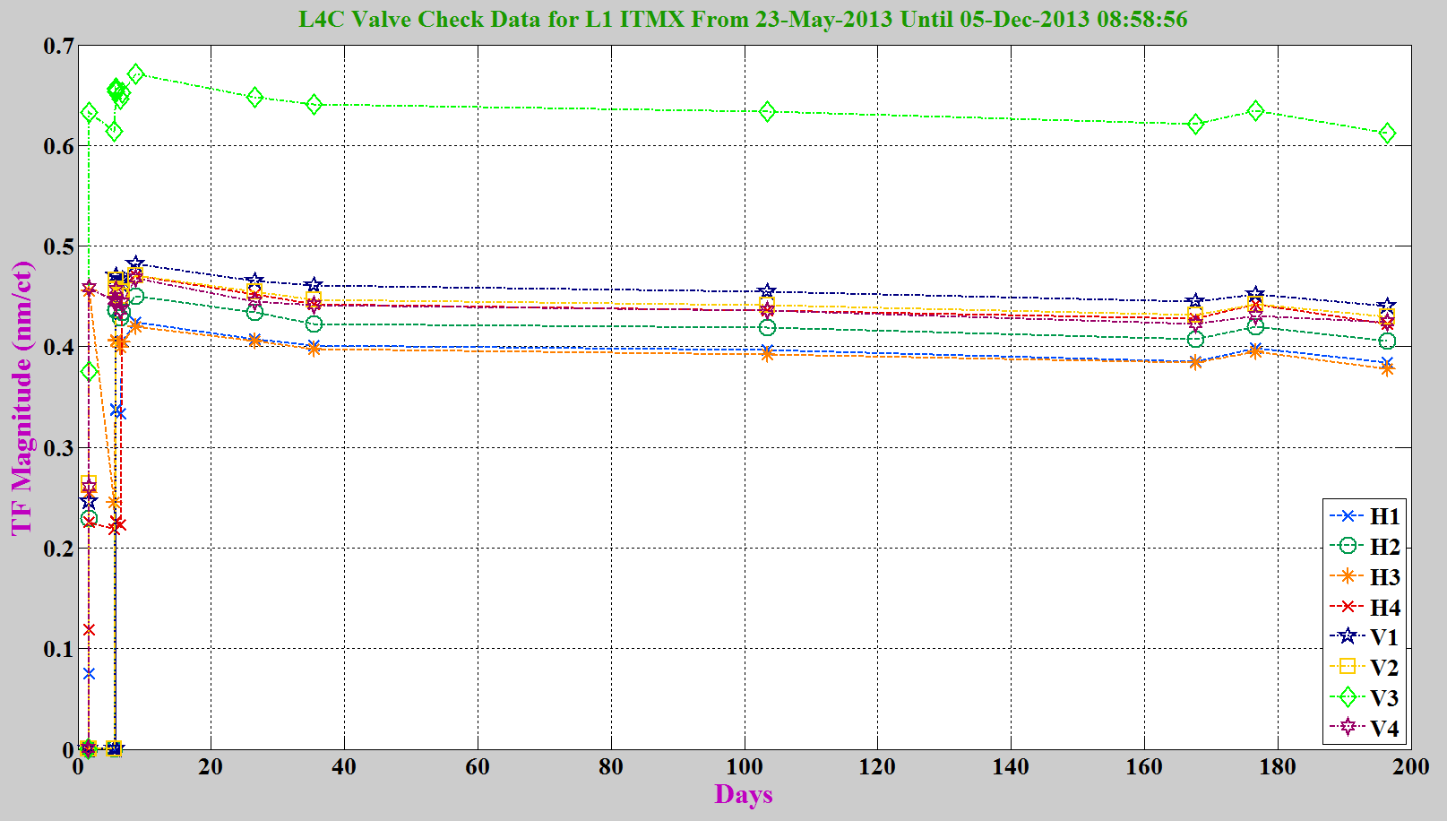

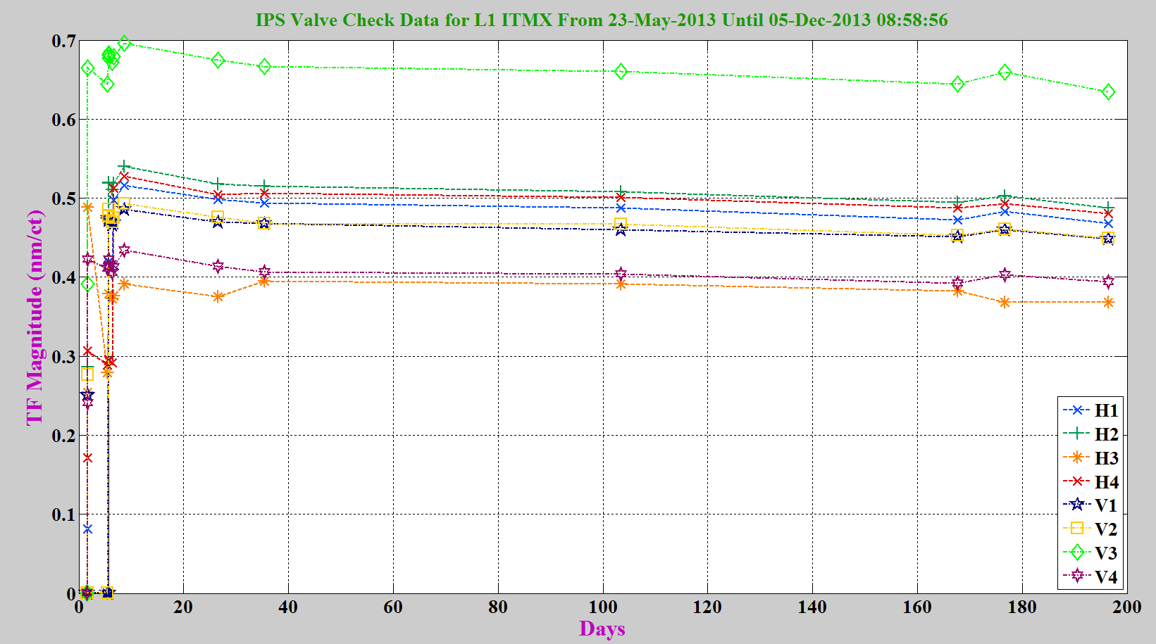

Issues/difficulties/comments regarding this test:
One can see that the V3 actuator/valve is 25% more effective than the others (and the average seen on other chambers). However, this can be taken into account by the symmetrization filters and therefore was deemed not worth changing the actuator control valve.

Acceptance criteria:
- All corners should behave consistently (usually displacement > 0.4 nm/ct)

Test result: Passed: X Failed: .

Local-to-local measurements

Data files in SVN at:
/SeiSVN/seismic/HEPI/L1/ITMX/Data/Transfer_Functions/Measurements/Undamped/
- L1_HEPI_BSC3_100_to_250Hz_20130530-003431.mat
- L1_HEPI_BSC3_20_to_100Hz_20130529-221752.mat
- L1_HEPI_BSC3_2_to_20Hz_20130529-202353mat
- L1_HEPI_BSC3_0p5_to_2Hz_20130529-171514.mat
- L1_HEPI_BSC3_0p05_to_0p5Hz_20130531-182134.mat
Data collection script files:
/SeiSVN/seismic/HEPI/Common//Transfer_Function_Scripts/
- Run_TF_L2L_10mHz_100mHz.m
- Run_TF_L2L_100mHz_500mHz.m
- Run_TF_L2L_500mHz_5Hz.m
- Run_TF_L2L_5Hz_100Hz.m
- Run_TF_L2L_100Hz_1000Hz.m
Scripts files for processing and plotting in SVN at:
/SeiSVN/seismic/HEPI/L1/BS/Scripts/Control_Scripts/release/
- Step_1_TF_Loc_to_Loc_L1_HEPI_ITMX.m
Figures in SVN at:
/SeiSVN/seismic/HEPI/L1/ITMX/Data/Figures/Transfer_Functions/Measurements/Undamped/
- L1_HPI_ITMX_TF_L2L_Raw_from_ACT_to_IPS_2013_05_30.fig
- L1_HPI_ITMX_TF_L2L_Raw_from_ACT_to_L4C_2013_05_30.fig
Storage of measured transfer functions in the SVN at:
/SeiSVN/seismic/HEPI/L1/ITMX/Data/Transfer_functions/Simulations/Undamped/
L1_HPI_ITMX_TF_L2L_Raw_2013_05_30.mat

The local-to-local transfer functions are presented below.

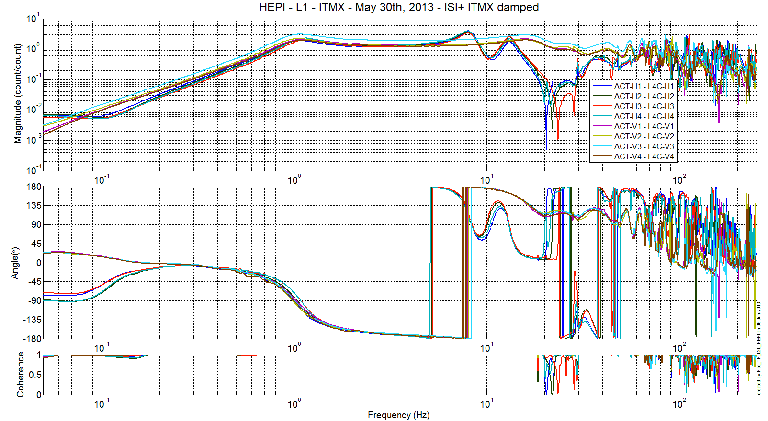
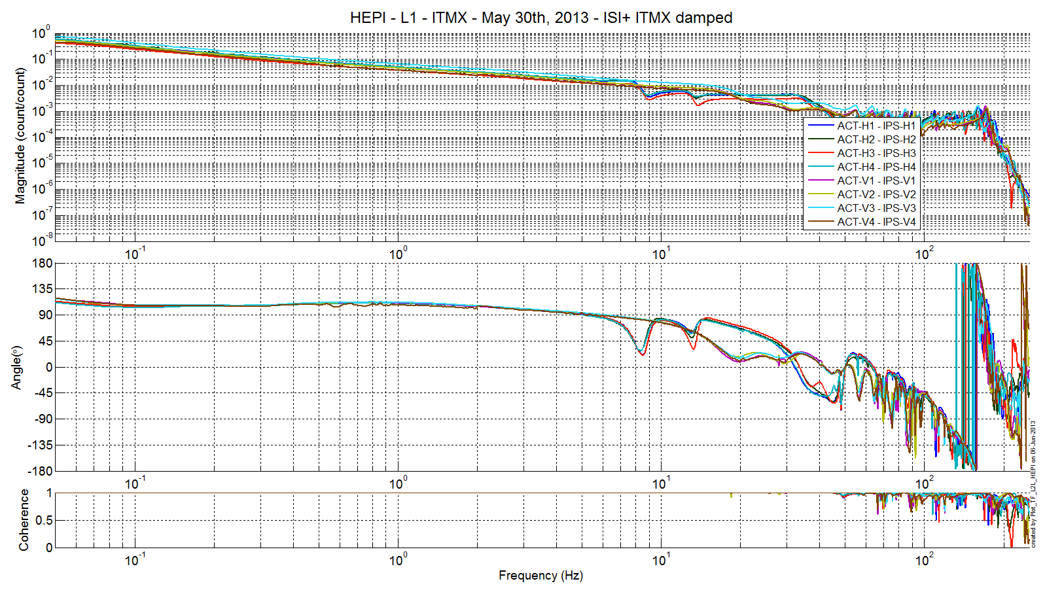
Issues/difficulties/comments regarding this test:
We can still notice the higher actuation of V3 in comparison to the other corners. As stated before this is not an issue.
Note additionally that the L4C sign is opposed to expectations, this is due to the old L4C cables.

Acceptance criteria:
- On IPS, the phase must be 0º at DC
- On geophones, the phase must be 90º at DC
- Identical shape in each corner

Test result: Passed: Waived: X Failed: .

Alignment offsets:
The IPS readouts recorded below are for HEPI unlocked, when on 06/12/13, the commissioning crew made their first attempt at DRMI alignment check (cf LLO alog 7383)

 | IPS Readouts
H1 | -7303
H2 | 11371
H3 | 464
H4 | 140
V1 | 9062
V2 | 5412
V3 | -769
V4 | 1970

Note at the moment, for this chamber, the offsets are re-computed every time HEPI loops are started.

Acceptance criteria:
Offsets were recorded.

Test result: Passed: X Failed: .

Conclusion
The only tests run for initial approval of this systems were the valve checks, the sensors ASDs and the transfer functions. All have looked good since June 2013. Position loops have been used routinely on this chamber.

