LIGO Laboratory / LIGO Scientific Collaboration

LIGO- E1300925-V1 LIGO December 9th, 2013

aLIGO HEPI L1 HAM4 Assembly Validation Report
E1300925-V1

Adrien Le Roux for the SEI Team

Distribution of this document:
Advanced LIGO Project

This is an internal working note
of the LIGO Laboratory

California Institute of Technology  LIGO Project – MS 18-34  1200 E. California Blvd.  Pasadena, CA 91125  Phone (626) 395-2129  Fax (626) 304-9834  E-mail: info@ligo.caltech.edu | Massachusetts Institute of Technology  LIGO Project – NW22-295  185 Albany St  Cambridge, MA 02139  Phone (617) 253-4824  Fax (617) 253-7014  E-mail: info@ligo.mit.edu
LIGO Hanford Observatory  P.O. Box 1970  Mail Stop S9-02  Richland WA 99352  Phone 509-372-8106  Fax 509-372-8137 | LIGO Livingston Observatory  P.O. Box 940  Livingston, LA 70754  Phone 225-686-3100  Fax 225-686-7189

Contents
Contents 2
Sub-Components Testing 4
Assembly Validation 7
1.1 Load Cells assembly 7
1.2 Bellows 8
1.3 Boot Location 8
1.4 Check Stops Gaps 11
1.5 Gaps check 13
1.6 IPS Centering 16
1.7 Sensor ASD 17
1.8 SUS-watchdogs interaction test 21
1.9 Static Test local drive 22
1.10 Linearity Test/Range of motion in the local basis 24
1.11 Actuator Plate to Shields gap 26
1.12 Valve Check 27
1.13 Local-to-local measurements 28
1.14 Alignment offsets: 31
Conclusion 32

Introduction

This document summarizes the different tests which have been done to validate HEPI L1 HAM4. All the HEPI testing reports must be posted under:

LIGO-E1300454: aLIGO HEPI Testing Reports

Sub-Components Testing

- Kaman Inductive Position Sensors: calibration, linearity, factory data, noise measurements (E0900426 – HEPI Kaman Sensor Receiving Analysis - Results posted in the SVN )
Note: these serial numbers have not been recorded at the time of install and are not hidden.
- HEPI actuator linearity test (E1100338 – aLIGO HEPI Actuators Test Results).
Note: these serial numbers have not been recorded at the time of install but are still accessible and will be recorded.

- L4C test (Q0900007)
 | Horizontal | Vertical
Pier 1 | L41684 | L41629
Pier 2 | L41663 | L41611
Pier 3 | L41675 | L41630
Pier 4 | L41653 | L41637

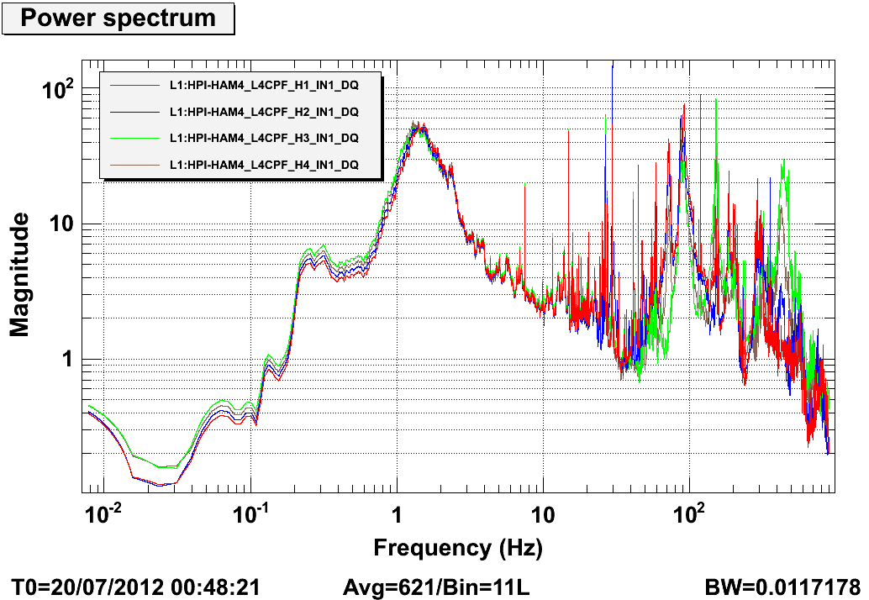
Figure 1: Power spectra of L1 HAM 4 horizontal L4Cs

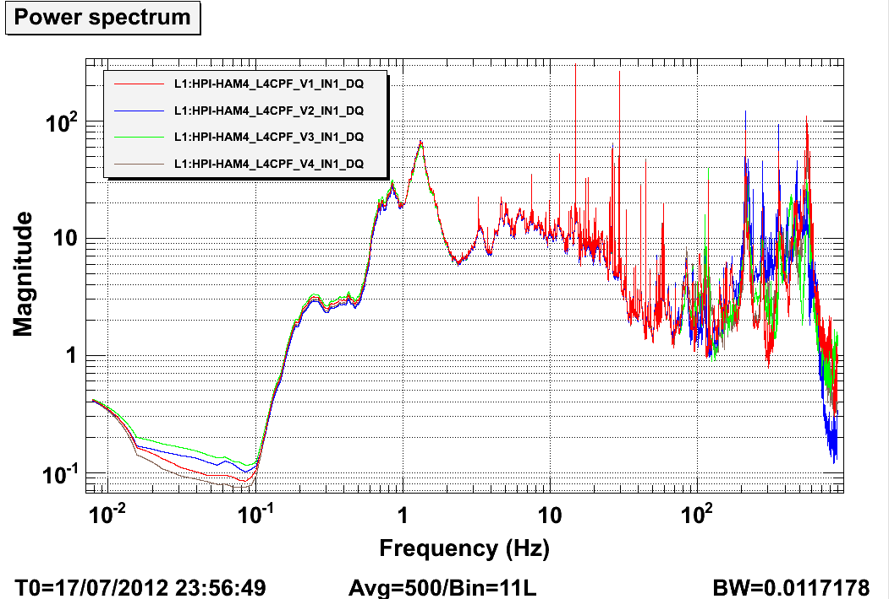
Figure 2: Power spectra of L1 HAM 4 horizontal L4Cs

Assembly Validation

Load Cells assembly
- Spring attachment
For the HAM HEPI springs, check the assembly per D1003359.
- Load cell values
HAM HEPI load cell capacity → 2000 lbs

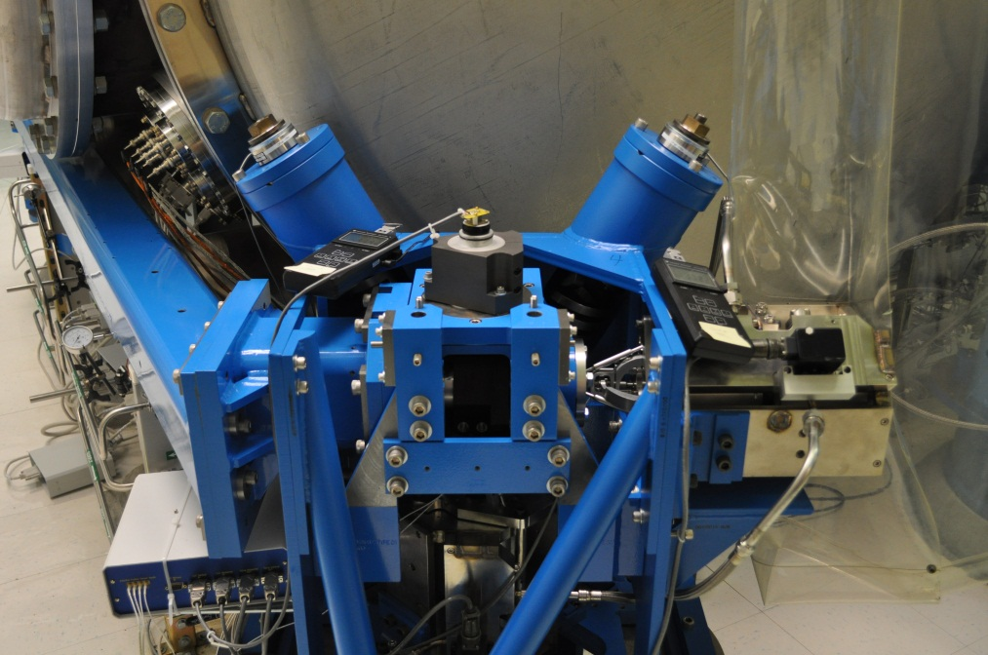
Left Spring
Right Spring
Figure 3: HAM-HEPI example at LASTI

 | Left Spring (lbs) | Right Spring (lbs)
Pier 1
Pier 2
Pier 3
Pier 4

Acceptance criteria:
- The values must not exceed 80% of the load cell capacity (<1600lbs for HAM).

Test result: Passed: Failed: . Waived: . .

Bellows

The bellows are hard to access and tests are hard to proceed. After several discussions and brainstorming sessions, it has been decided not to measure the gaps on HEPI-HAM.

Test result: Passed: Failed: . Waived: . X .

Boot Location

Tangential Left: 5.380”

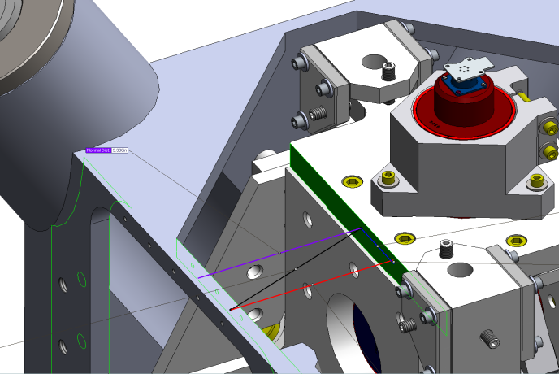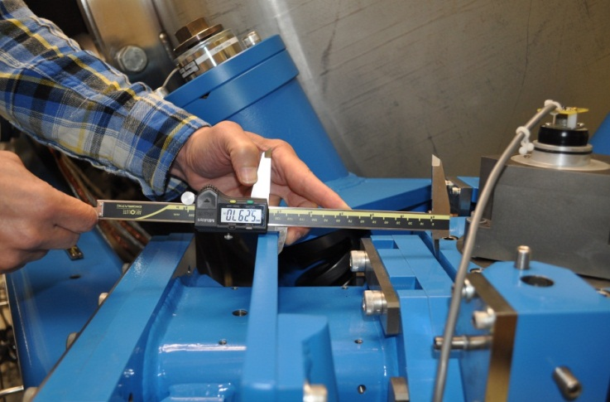
Figure 4: Boot location, tangential left gap measurement

Tangential Right: 5.380”

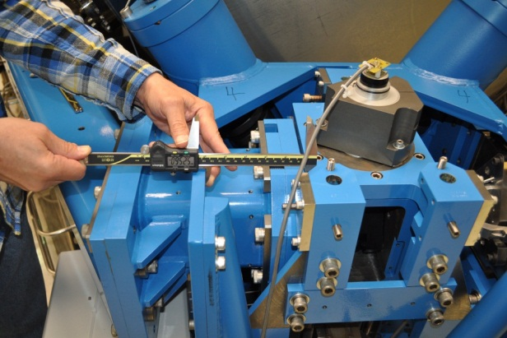
Figure 5: Boot location, tangential right gap measurement

Radial Back: 1.17”

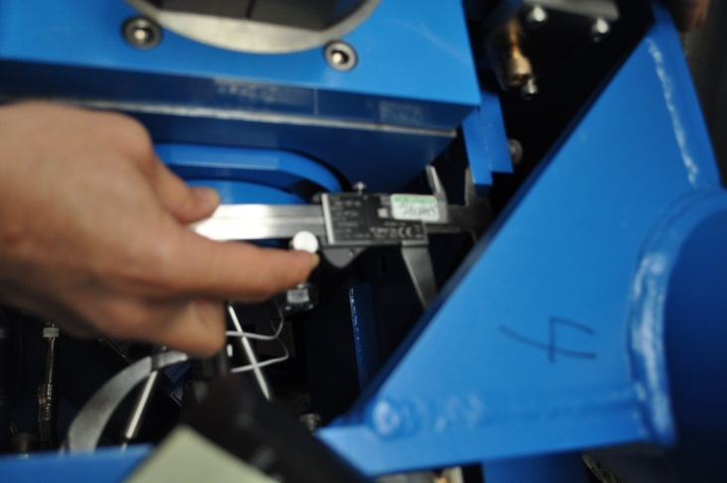
Figure 6: Boot location, radial back gap measurement

Radial Front: 1.42”

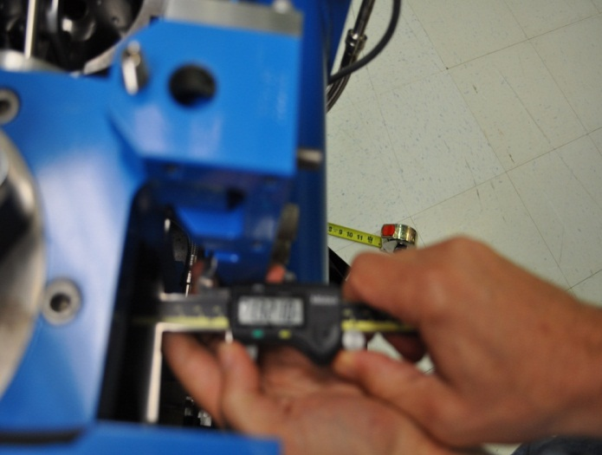
Figure 7: Boot location, radial front gap measurement

Vertical: 0.32”

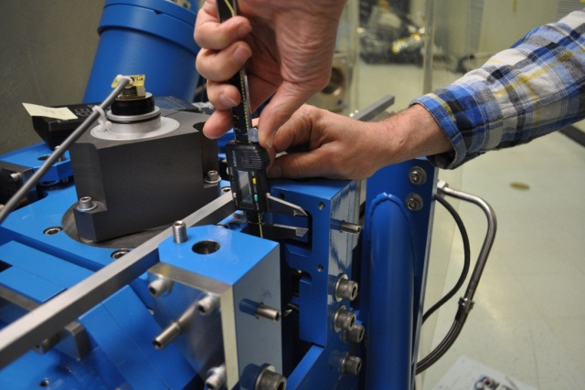
Figure 8: Boot location, vertical gap measurement

 | Pier 1 | Pier 2 | Pier 3 | Pier 4 | Nominal
Tangential Left | 5.061 | 5.021 | 4.884 | 5.215 | 5.38
Tangential Right | 5.631 | 5.654 | 5.785 | 5.485 | 5.38
Radial Back | 1.396 | 1.216 | 1.374 | 1.211 | 1.17
Radial Front | 1.279 | 1.36 | 1.285 | 1.34 | 1.42
Vertical | 0.366 | 0.2 | 0.233 | 0.419 | 0.32

Acceptance criteria:

 | Pier 1 | Pier 2 | Pier 3 | Pier 4 | Requirements
Tangential Left | -0.319 | -0.359 | -0.496 | -0.165 | +/- 0.20
Tangential Right | 0.251 | 0.274 | 0.405 | 0.105 | +/- 0.20
Radial Back | 0.226 | 0.046 | 0.204 | 0.041 | +/- 0.10
Radial Front | -0.141 | -0.06 | -0.135 | -0.08 | +/- 0.15
Vertical | 0.046 | -0.12 | -0.087 | 0.099 | +/- 0.20

Note: usually this test can be waived if step 1.10 Linearity Test/Range of motion in the local basis passes because it means that the system has a full range of motion and is, therefore, free to move.

Test result: Passed: Failed: X . Waived: . .

Check Stops Gaps
The stops must not touch the boot. There are 15 stops per boot, 5 per F bracket.
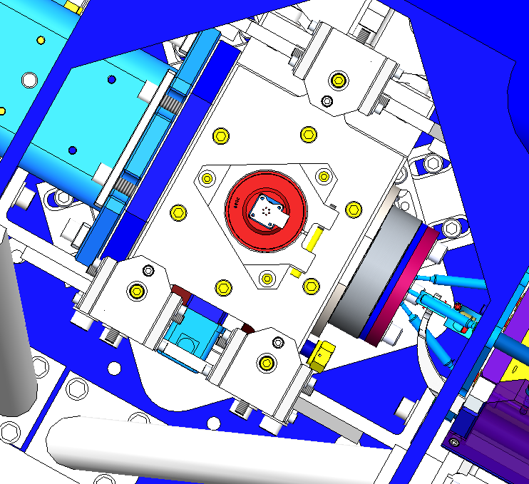
#1
#2
#3
#4
#5
Bracket 1
Bracket 2
Bracket 3
Figure 9: Locations of the boot’s stops

Acceptance criteria:
- A 0.062” shim must fit into the gaps

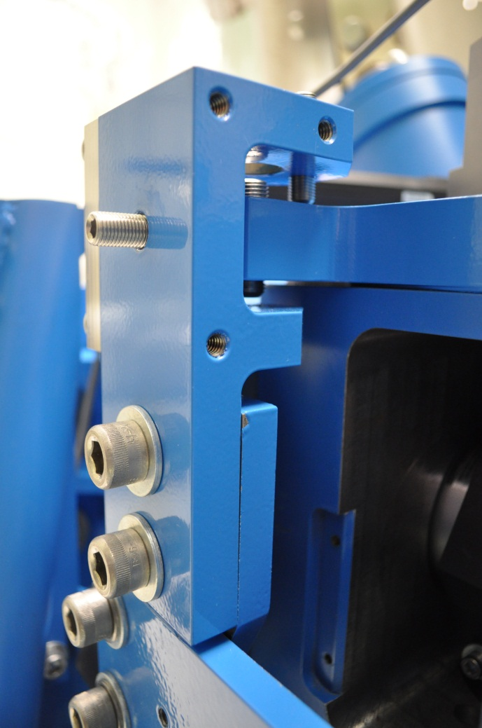
A 0.062” must fit into the gaps

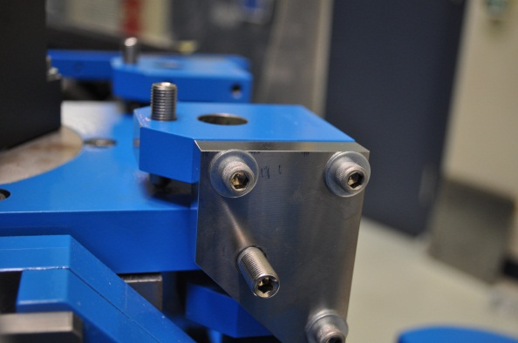

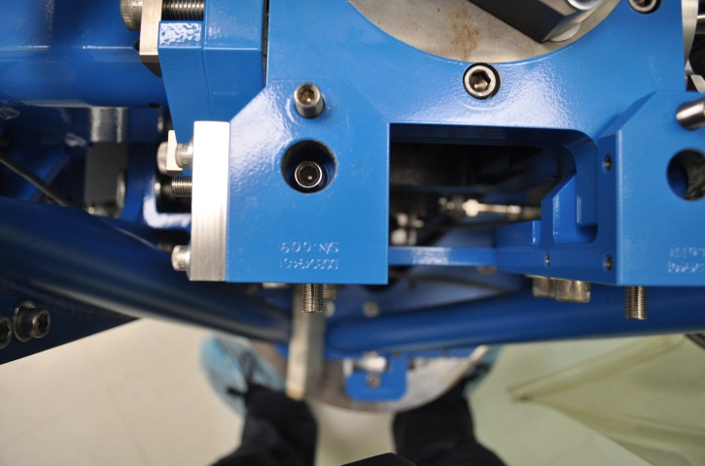
Figure 10: Locations of the boot's gaps to measure
 | Bracket 1 |  |  |  |  |  | Bracket 2 |  |  |  |  |  | Bracket 3
 | Gap1 | Gap2 | Gap3 | Gap4 above | Gap4 under | Gap5 | Gap1 | Gap2 | Gap3 | Gap4 above | Gap4 under | Gap5 | Gap1 | Gap2 | Gap3 | Gap4 above | Gap4 under | Gap5
Pier 1 | Go | Go | Go | Go | Go | Go | Go | Go | Go | Go | Go | Go | Go | Go | Go | Go | Go | Go
Pier 2 | Go | Go | Go | Go | Go | Go | Go | Go | Go | Go | Go | Go | Go | Go | Go | Go | Go | Go
Pier 3 | Go | Go | Go | Go | Go | Go | Go | Go | Go | Go | Go | Go | Go | Go | Go | Go | Go | Go
Pier 4 | Go | Go | Go | Go | Go | Go | Go | Go | Go | Go | Go | Go | Go | Go | Go | Go | Go | Go

Note: HAM 4 is currently in the locked position so the measurement of these gaps is pointless at this time. Measurements will be taken when HEPI will be unlocked on HAM 4.

Test result: Passed: Failed: . Waived: . .

Gaps check
Four particular gaps need to be check.

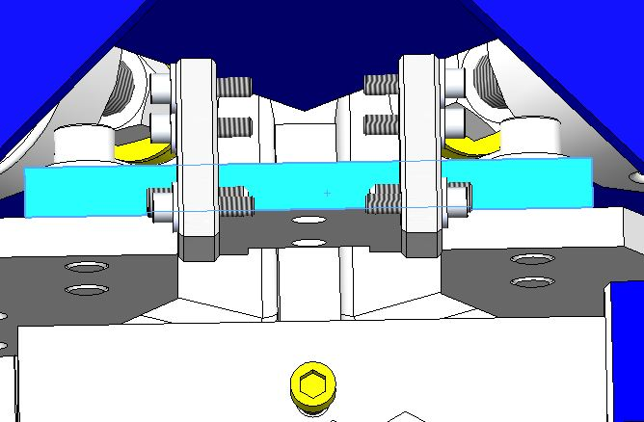
Gap #1
Gap #2
Note: The F bracket has been removed for a better visibility

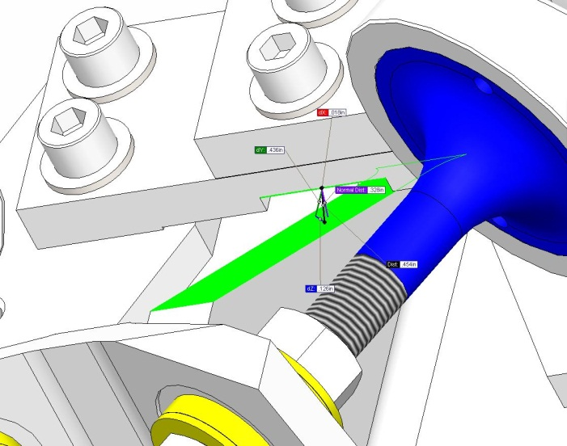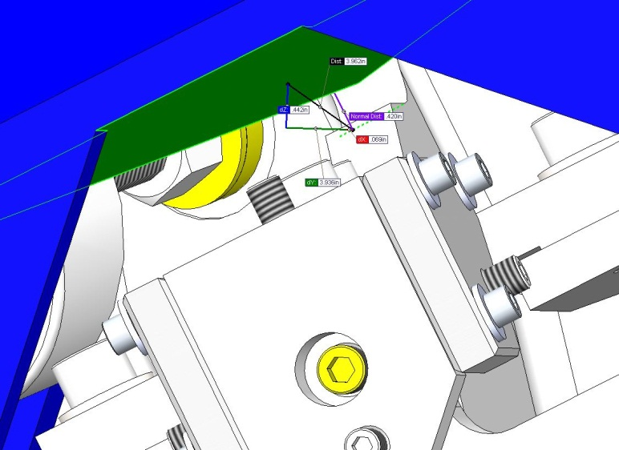

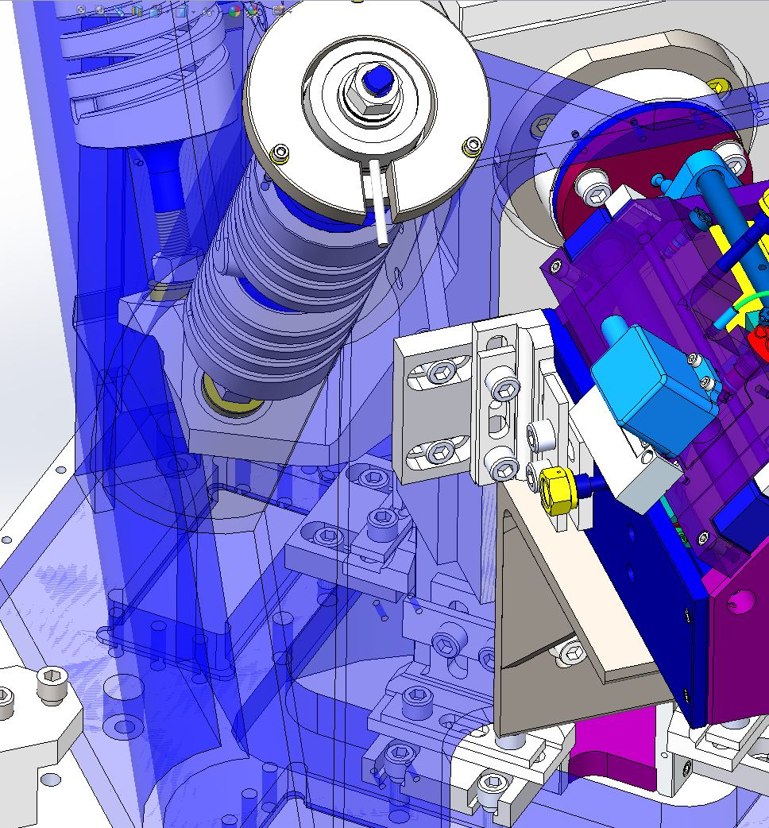
Gap #3
Gap #4
Figure 11: Gaps which need to be checked

Acceptance criteria:
- a 0.08” shim must fit in these two gaps

Issues/difficulties/comments regarding this test: Gap#1 is tricky to reach. At LASTI, the solution found was to tape the shim to an extension (rod, rigid ruler, etc.).
Gap#2 should be reachable by hand.
Gap#3 and 4 are tricky, but should also be doable (no picture)

Gap#1
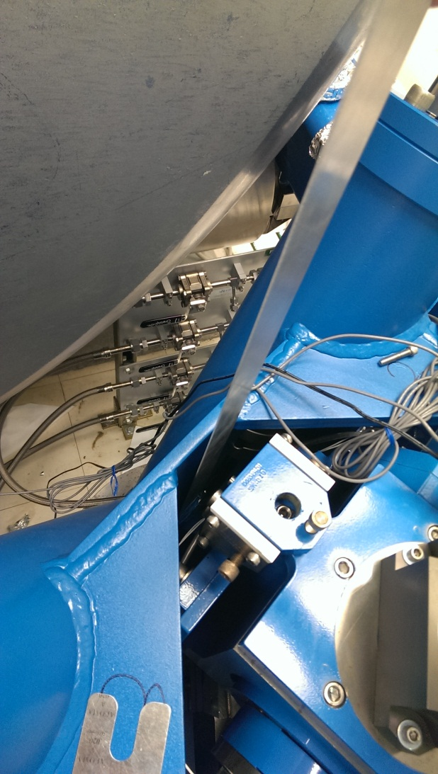
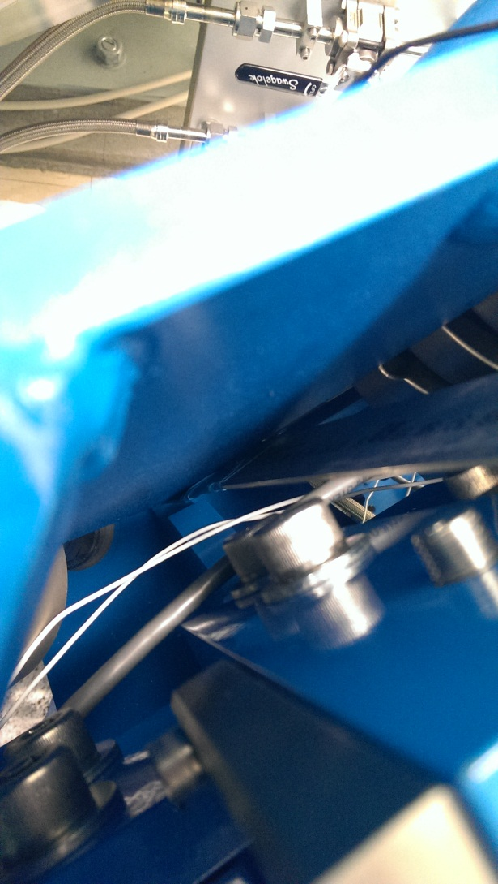
Figure 12: First gap to measure (on the first picture, we can see the tool used to measure that gap)
Gap#2
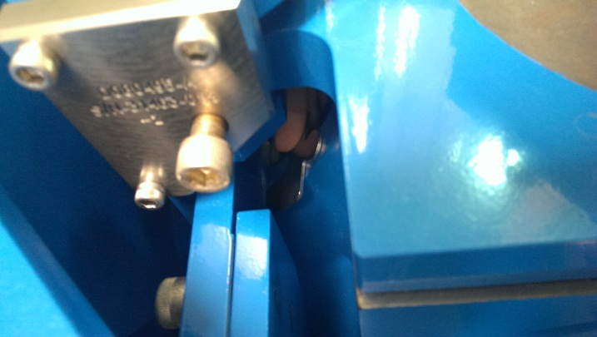
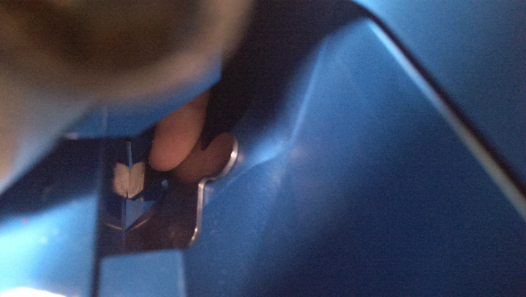
Figure 13: Second gap to measure

 | Gap#1 | Gap#2 | Gap#3 | Gap#4
Pier 1 | Go | Go | Go | Go
Pier 2 | Go | Go | Go | Go
Pier 3 | Go | Go | Go | Go
Pier 4 | Go | Go | Go | Go

Note: usually this test can be waived if step 1.10 Linearity Test/Range of motion in the local basis passes because it means that the system has a full range of motion and is, therefore, free to move.

Test result: Passed: Failed: . Waived: . X .

IPS Centering
Scripts files for processing and plotting in SVN at:
/SeiSVN/seismic/HEPI/Common/Testing_Functions_HEPI/Offset_STD_IPS_HEPI.m

Note: All the loops must be turned off during this test.

 | H1 | H2 | H3 | H4 | V1 | V2 | V3 | V4
Mean (counts)
Acceptance | +/- 15000 | +/- 15000 | +/- 15000 | +/- 15000 | +/- 15000 | +/- 15000 | +/- 15000 | +/- 15000

Test result: Passed: Failed: . Waived: . .

Sensor ASD
Scripts files for processing and plotting in SVN at:
/SeiSVN/seismic/HEPI/Common/Testing_Functions_HEPI/ASD_Measurements_Local_HEPI.m

Data in SVN at:
SeiSVN/seismic/HEPI/L1/HAM4/Data/Perf_Analysis/2013-06-24-HEPI_Level1-ISI_Level2/
- HEPI_L1_HAM4_Perf_Analysis_Parameters_2013-06-24-HEPI_Level1-ISI_Level2.mat
- HEPI_L1_HAM4_Test1_2013-06-24-HEPI_Level1-ISI_Level2.mat
- HEPI_L1_HAM4_Test2_2013-06-24-HEPI_Level1-ISI_Level2.mat

Figures in SVN at:
/SeiSVN/seismic/HEPI/L1/HAM4/Data/ Figures/Perf_Analysis/2013-06-24-HEPI_Level1-ISI_Level2/fig/
- HEPI_L1_HAM4_Test_1_Fig_a_HPI_L4C_Hor_2013-06-24-HEPI_Level1-ISI_Level2.fig
- HEPI_L1_HAM4_Test_1_Fig_b_HPI_L4C_Vert_2013-06-24-HEPI_Level1-ISI_Level2.fig
- HEPI_L1_HAM4_Test_1_Fig_c_IPS_Hor_2013-06-24-HEPI_Level1-ISI_Level2.fig
- HEPI_L1_HAM4_Test_1_Fig_d_IPS_Vert_2013-06-24-HEPI_Level1-ISI_Level2.fig

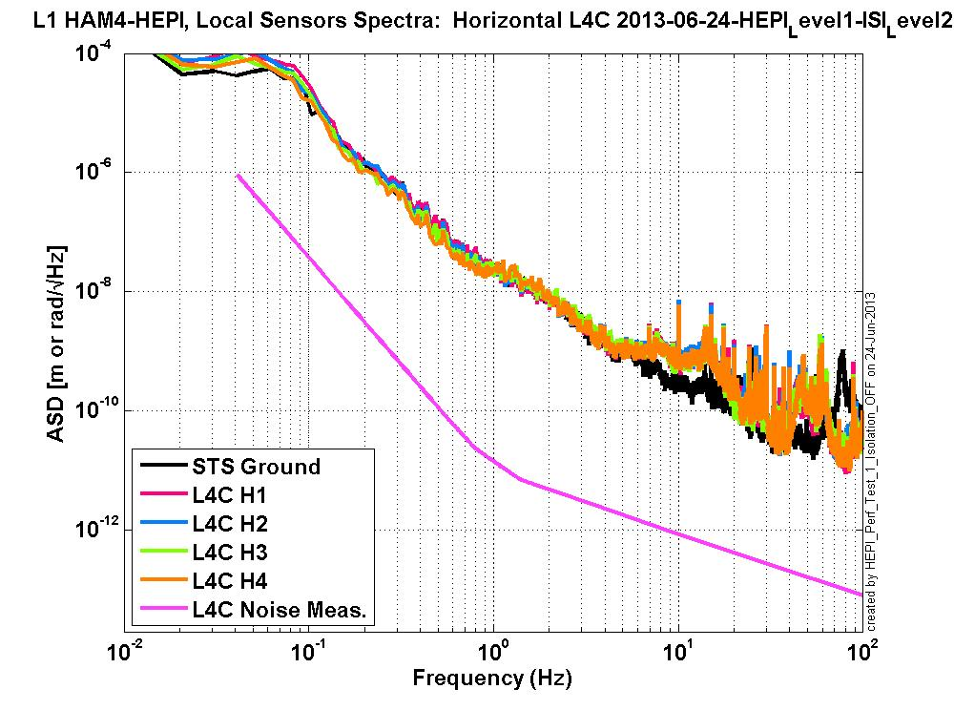
Figure 14: L1 HAM 4 HEPI Sensor spectra Horizontal L4Cs
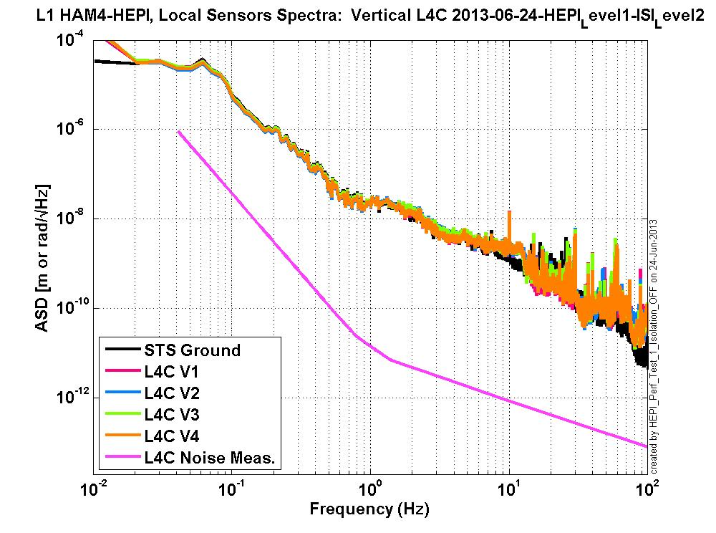
Figure 15: L1 HAM 4 HEPI Sensor spectra Vertical L4Cs

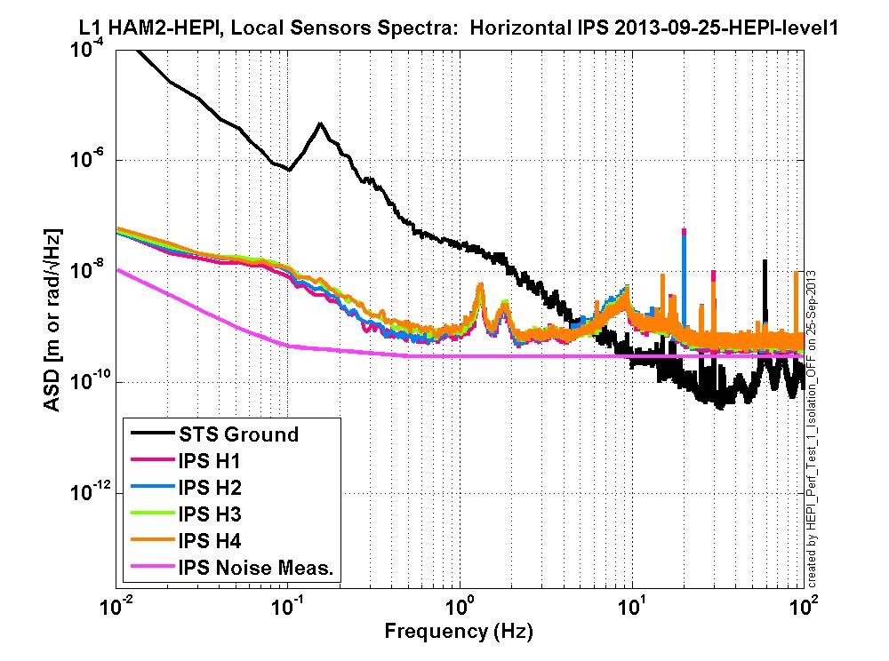
Figure 16: L1 HAM 4 HEPI Sensor spectra Horizontal IPSs

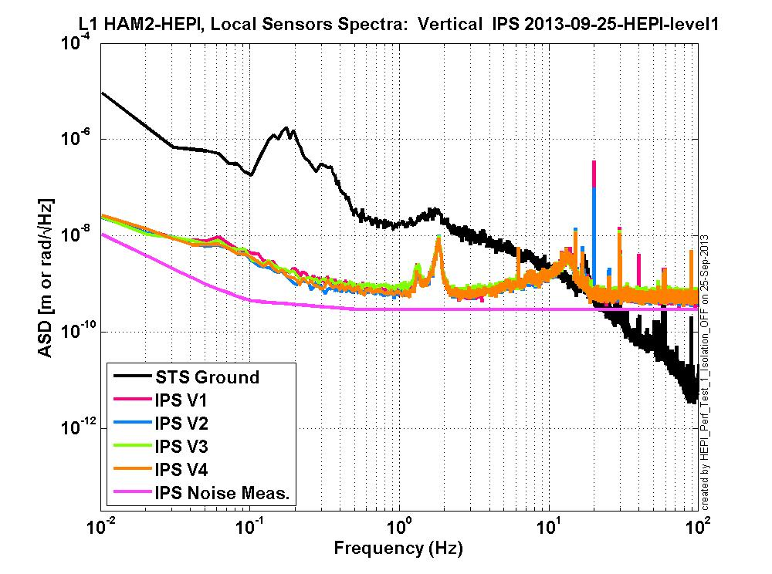
Figure 17: L1 HAM 4 HEPI Sensor spectra Vertical IPSs

Issues/difficulties/comments regarding this test:

Acceptance criteria:

Test result: Passed: X Failed: . Waived: . .

SUS-watchdogs interaction test
Note: This test will be obsolete very soon, as the payload-HEPI WD connection is planned for removal.

. Set up a zero value on the payload watchdogs.
. Check that the payload watchdog screen of HEPI tripped.
. In the payload watchdog screen, click on the OVERRIDE button and reset the watchdog.
. Do the same process for all the payloads

Acceptance criteria:
- The HEPI must trip when the payload watchdogs are tripped
- The HEPI watchdogs could be reset when the OVERRIDE button is ON
- Test result: Passed: X Failed: . Waived: . .
Note: When this test is done, reset everything (OVERRIDE button OFF, put back the value on the payload watchdog).

Static Test local drive
Scripts files for processing in SVN at:
/SeiSVN/seismic/HEPI/Common/Testing_Functions_HEPI/Static_Test_Local_Basis_HEPI.m

Data in SVN at:
SeiSVN/seismic/HEPI/L1/HAM4/Data/Static_Tests/L1_HPI_HAM4_Offset_Local_Drive_20130510.mat

. Drive of 100 counts (in progress)
 | H1 | H2 | H3 | H4 | V1 | V2 | V3 | V4
H1 | 8350.9418 | -5056.1049 | -327.0384 | -1879.51872 | -178.9088 | 209.3388 | 192.18836 | -370.0864
H2 | -4104.049 | 8306.5349 | -1822.531974 | -448.11792 | 134.8916 | -100.465 | -301.80668 | 139.7868
H3 | -233.5984 | -2065.5751 | 8170.4572 | -4615.56692 | 178.7694 | -183.7838 | -239.1095 | 118.1154
H4 | -1807.7793 | -701.3897 | -4558.2268 | 9000.50088 | -488.2914 | 367.591 | -1.00976 | -441.0128
V1 | -87.0864 | 1.56718 | 302.0506 | -174.51156 | 7490.8344 | 918.82254 | -1656.35338 | 784.3534
V2 | 182.2748 | -404.56522 | -128.0876 | 486.57564 | 833.8752 | 7402.042 | 675.00182 | -1629.1482
V3 | 309.8688 | -477.33554 | -80.087 | 272.82164 | -1436.731 | 1099.12212 | 7236.42762 | 695.124
V4 | -177.839 | 74.78868 | 291.7698 | -126.46464 | 955.694 | -1414.8926 | 824.44686 | 7487.4108
Table 1: Main couplings and cross couplings for 100count offset

. Drive of 1000 counts (in progress)
 | H1 | H2 | H3 | H4 | V1 | V2 | V3 | V4
H1 | 8350.9418 | -5056.1049 | -327.0384 | -1879.51872 | -178.9088 | 209.3388 | 192.18836 | -370.0864
H2 | -4104.049 | 8306.5349 | -1822.531974 | -448.11792 | 134.8916 | -100.465 | -301.80668 | 139.7868
H3 | -233.5984 | -2065.5751 | 8170.4572 | -4615.56692 | 178.7694 | -183.7838 | -239.1095 | 118.1154
H4 | -1807.7793 | -701.3897 | -4558.2268 | 9000.50088 | -488.2914 | 367.591 | -1.00976 | -441.0128
V1 | -87.0864 | 1.56718 | 302.0506 | -174.51156 | 7490.8344 | 918.82254 | -1656.35338 | 784.3534
V2 | 182.2748 | -404.56522 | -128.0876 | 486.57564 | 833.8752 | 7402.042 | 675.00182 | -1629.1482
V3 | 309.8688 | -477.33554 | -80.087 | 272.82164 | -1436.731 | 1099.12212 | 7236.42762 | 695.124
V4 | -177.839 | 74.78868 | 291.7698 | -126.46464 | 955.694 | -1414.8926 | 824.44686 | 7487.4108
Table 2: Main couplings and cross couplings for 1000 count offset

. Drive of 5000 counts (Nominal value handled by testing script)
 | H1 | H2 | H3 | H4 | V1 | V2 | V3 | V4
H1
H2
H3
H4
V1
V2
V3
V4
Table 3: Main couplings and cross couplings for 5000 count offset

Issues/difficulties encountered during this test:

Acceptance criteria:
- The results in these three tables must be the same (within xxx%)

Test result: Passed: Failed: . Waived: . .

Linearity Test/Range of motion in the local basis
Scripts files for processing and plotting in SVN at:
/SeiSVN/seismic/HEPI/Common/Testing_Functions_HEPI/Linearity_Test_Awgstream_HEPI.m

Data in SVN at:
SeiSVN/seismic/HEPI/L1/HAM4/Data/Linearity_Test/L1_HPI_HAM4_Linearity_test_20130521T165512.mat

Figures in SVN at:
/SeiSVN/seismic/HEPI/L1/HAM4/Data/Figures/Linearity_Test/L1_HPI_HAM4_Linearity_test_20130521T165512.fig

 | Slopes | Offsets | Average Slope | Difference / Average in %
H1 | -1.95 | 10115.78 | -1.67 | -16.94
H2 | -1.45 | 812.65 |  | 13.04
H3 | -1.7 | -2306.25 |  | -1.95
H4 | -1.57 | -7975.59 |  | 5.85
V1 | -1.44 | 3668.89 | -1.54 | 6.19
V2 | -1.45 | -4205.36 |  | 5.54
V3 | -1.78 | 611.54 |  | -15.96
V4 | -1.47 | 3233.16 |  | 4.23

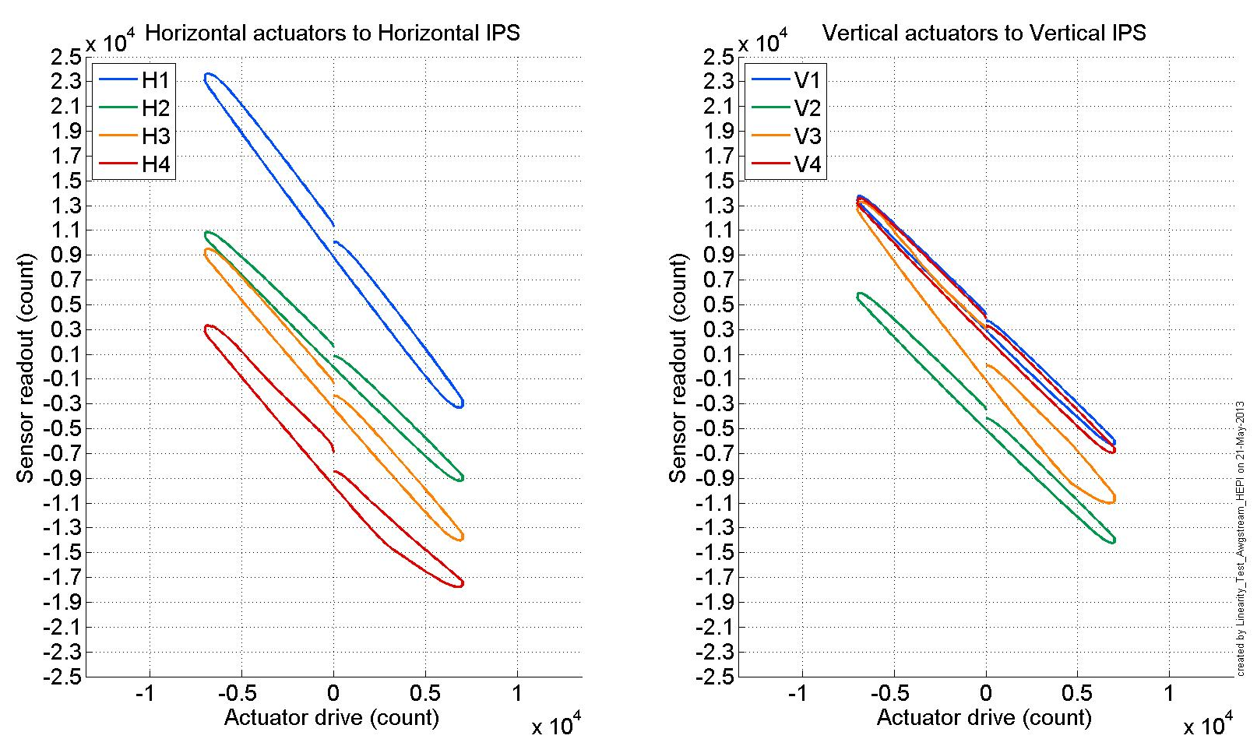
Figure 18: Linearity Test

Scripts files for processing in SVN at:
/SeiSVN/seismic/HEPI/Common/Testing_Functions_HEPI/Static_Test_Local_Basis_HEPI.m

Data in SVN at:
SeiSVN/seismic/HEPI/L1/ HAM4/Data/Static_Tests/
- L1_HPI_HAM4_Range_Of_Motion_20130520.mat

 | Positive Drive | At Rest | Negative Drive | Amplitude
H1 | 32767.00 | 1951.00 | -12020.87 | 44787.87
H2 | 22924.17 | 2641.00 | -17710.63 | 40634.81
H3 | 24146.02 | -1942.00 | -24775.31 | 48921.33
H4 | 22143.15 | -3844.00 | -27469.69 | 49612.84
V1 | 25373.23 | 3632.00 | -16713.67 | 42086.90
V2 | 17581.54 | -4367.00 | -23045.33 | 40626.87
V3 | 28309.07 | -1062.00 | -26437.02 | 54746.09
V4 | 25086.32 | 2626.00 | -18336.13 | 43422.45
Table 4: Range of Motion

Issues/difficulties encountered during this test:

Acceptance criteria:
- For the linearity test, the results in these three tables must be the same (within +/- 20% compared to the average slopes)
- For the range of motion, the sign must be positive for a positive drive and negative for a negative drive, and the amplitude must be bigger than 40000 counts.

Test result: Passed: X Failed: . Waived: . .

Actuator Plate to Shields gap

Note: Perform this test ONLY if the range of motion test failed.
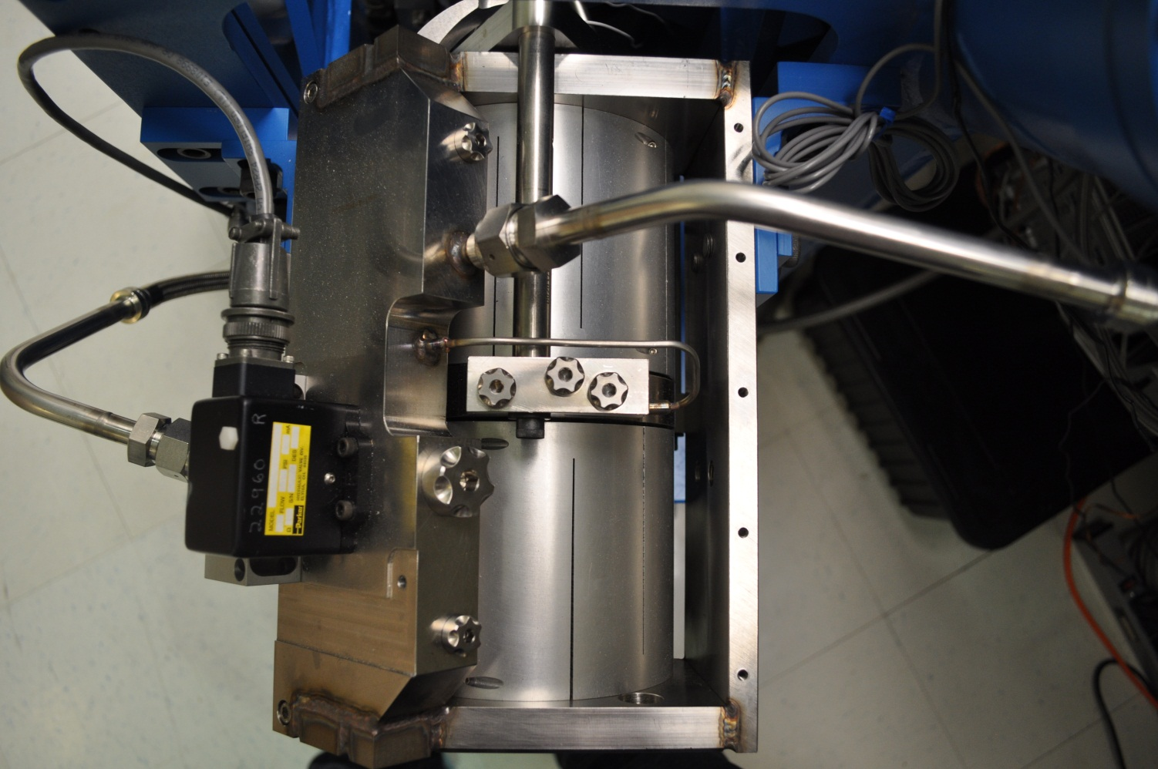
Figure 19: Locations of the actuator gaps to check if Step 1.10 Linearity Test/Range of motion in the local basis failed
Gap#3
Gap#2
Gap#1
Three gaps per actuator need to be checked as shown on Figure 19: Locations of the actuator gaps to check if Step 1.10 Linearity Test/Range of motion in the local basis failed .

 | Horizontal |  |  | Vertical
 | Gap #1 | Gap #2 | Gap #3 | Gap #1 | Gap #2 | Gap #3
Pier 1 | Go | Go | Go | Go | Go | Go
Pier 2 | Go | Go | Go | Go | Go | Go
Pier 3 | Go | Go | Go | Go | Go | Go
Pier 4 | Go | Go | Go | Go | Go | Go

Acceptance criteria:
- A 0.1” shim must fit into the gap #1
- A 0.05 shim must fit into gap #2 and #3

Test result: Passed: Failed: . Waived: . X .

Valve Check
Scripts files for processing and plotting in SVN at:
/SeiSVN/seismic/HEPI/L1/HAM4/Scripts/Valve_Check/plot_valve_check.m
/SeiSVN/seismic/HEPI/L1/HAM4/Scripts/Valve_Check

Figures in SVN at:
/SeiSVN/seismic/HEPI/L1/HAM4/Data/Figures/Valve_Check/Individual_Tests/Valve_Check_18-Jun-2013_14:19:22.fig
/SeiSVN/seismic/HEPI/L1/HAM4/Data/Figures/Valve_Check/Evolution/ L1_HAM4_IPS_Valve_Check_From_07-May-2013_Until_18-Jun-2013.fig

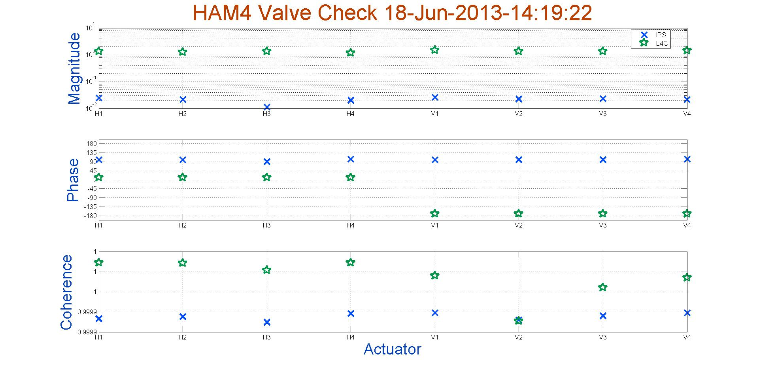
Figure 20: Valve check individual plot

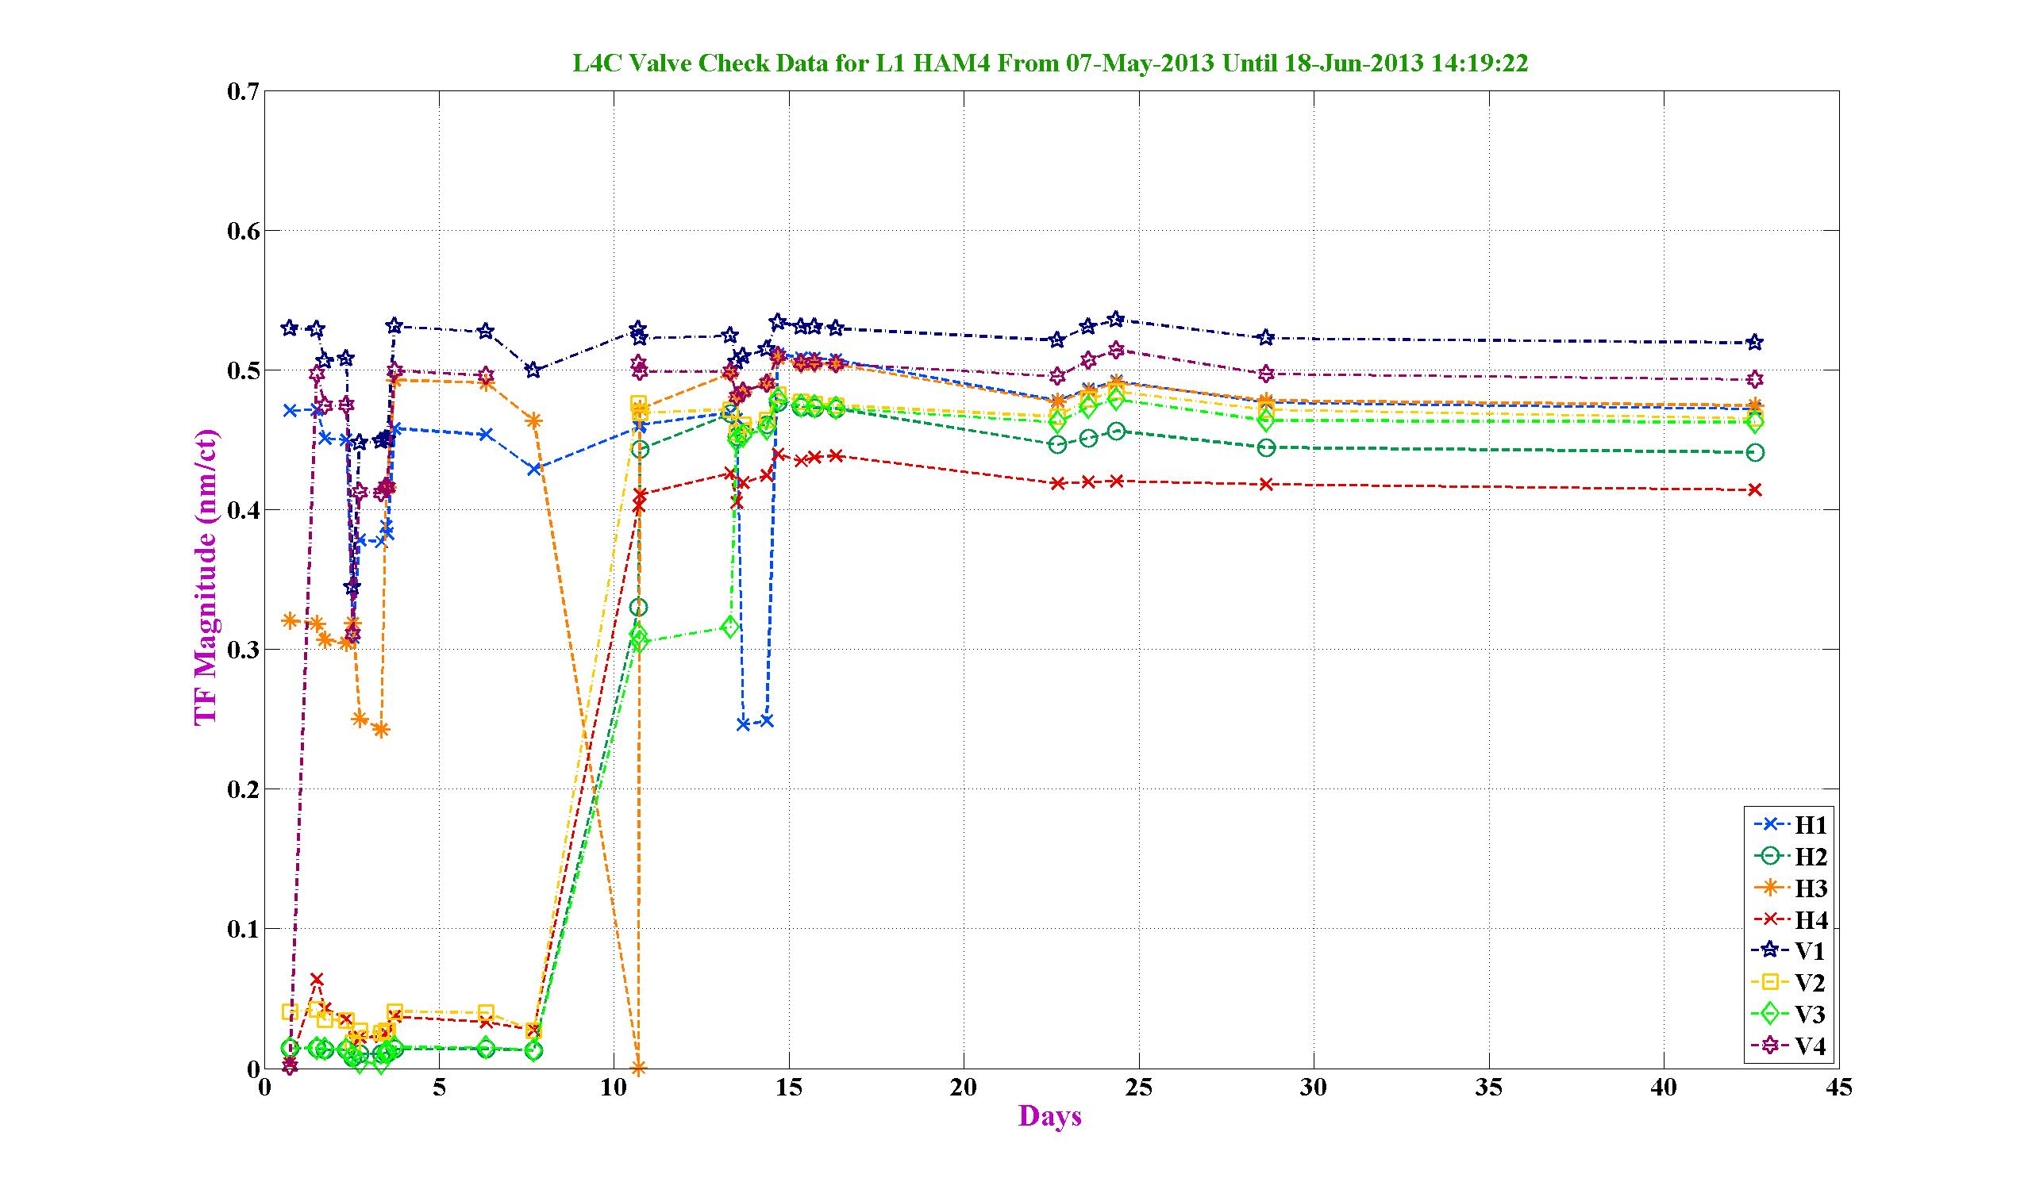
Figure 21: Valve check evolution plot

Acceptance criteria:

- Test result: Passed: X Failed: . Waived: . .

Local-to-local measurements

Band (Hz) | Resolution | Amplitude | Nreps | Time (s) | Time (min) | Time (h)
100 - 500 | 0.5 | 4000 - 4000 | 250 | 4176 | 69.6 | 1.2
10 - 100 | 0.25 | 4000 - 4000 | 200 | 6592 | 109.9 | 1.8
0.7 - 10 | 0.05 | 4000 - 4000 | 75 | 12320 | 205.3 | 3.4
0.1 - 0.7 | 0.025 | 4000 - 4000 | 30 | 10080 | 168.0 | 2.8
0.01 - 0.1 | 0.01 | 4000 - 4000 | 10 | 8960 | 149.3 | 2.5
0.002 - 0.01 | 0.002 | 4000 - 4000 | 2 | 12160 | 202.7 | 3.4
 |  |  |  |  |  | 15.1

Data files in SVN at:
/SeiSVN/seismic/HEPI/L1/HAM4/Data/Transfer_Functions/Measurements/Undamped/
- L1_HEPI_HAM4_0p05_to_0p5Hz_20130530-165220.mat
- L1_HEPI_HAM4_0p5_to_2Hz_20130529-180144.mat
- L1_HEPI_HAM4_2_to_20Hz_20130529-211023.mat
- L1_HEPI_HAM4_20_to_100Hz_20130529-230422.mat
- L1_HEPI_HAM4_100_to_250Hz_20130530-012101.mat
Data collection script files:
/SeiSVN/seismic/HEPI/Common//Transfer_Function_Scripts/
- Run_TF_L2L_10mHz_100mHz.m
- Run_TF_L2L_100mHz_500mHz.m
- Run_TF_L2L_500mHz_5Hz.m
- Run_TF_L2L_5Hz_100Hz.m
- Run_TF_L2L_100Hz_1000Hz.m
Scripts files for processing and plotting in SVN at:
/SeiSVN/seismic/HEPI/L1/HAM4/Scripts/Control_Scripts/Version_5/
- Step_1_TF_Loc_to_Loc_L1_HEPI_HAM4.m
Figures in SVN at:
/SeiSVN/seismic/HEPI/L1/HAM4/Data/Figures/Transfer_Functions/Measurements/Undamped/
- L1_HPI_HAM4_TF_L2L_Raw_from_ACT_to_IPS_2013_05_30.fig
- L1_HPI_HAM4_TF_L2L_Raw_from_ACT_to_L4C_2013_05_30.fig
Storage of measured transfer functions in the SVN at:
/SeiSVN/seismic/HEPI/L1/HAM4/Data/Transfer_functions/ Simulations/Undamped/
- L1_HPI_HAM4_TF_L2L_Raw_2013_05_30.mat

The local-to-local transfer functions are presented below.
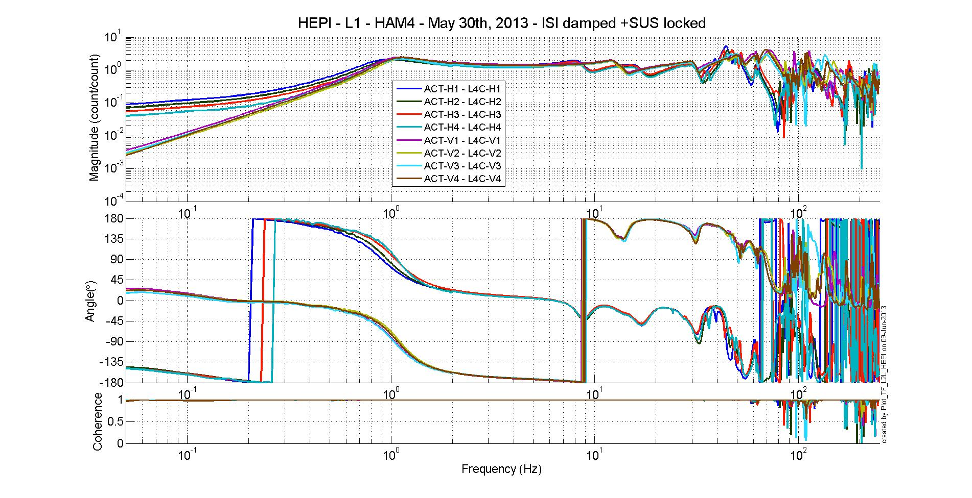
Figure 22:L1 HAM 4 HEPI Act to L4C Transfer Functions

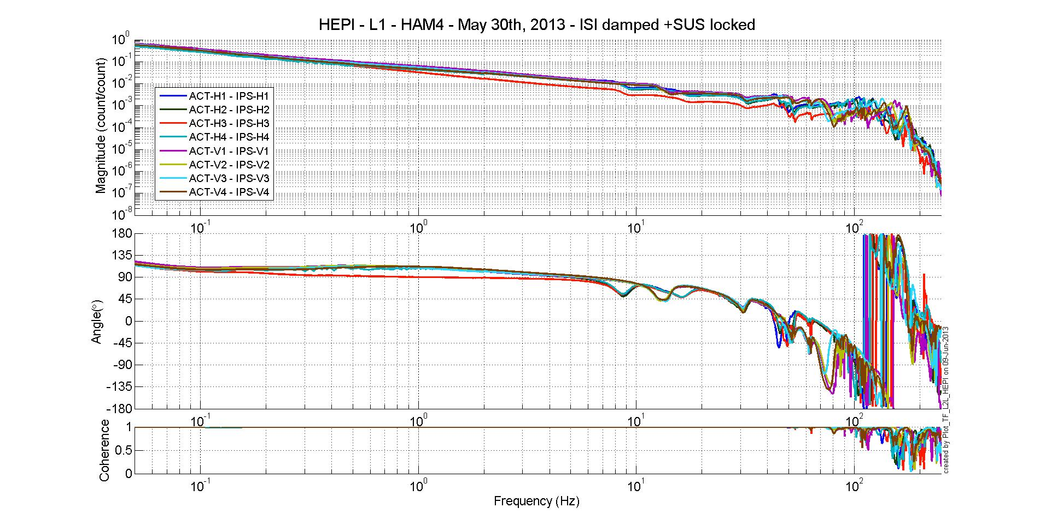
Figure 23: L1 HAM 4 HEPI Act to IPS Transfer Functions
Issues/difficulties/comments regarding this test:

Acceptance criteria:
- On IPS, the phase must be 0º at DC
- On geophones, the phase must be 90º at DC
- Identical shape in each corner

Test result: Passed: X Failed: . Waived: . .

Alignment offsets:
Those are the IPS readouts that were recorded with HEPI locked, after alignment work was performed. The opposite of those values is to be installed as offset of the IPS filter banks when the Isolation loops are turned on. This way, HEPI will be operating in its preferred alignment state.

 | IPS Readouts HEPI Locked | Offset Value
H1
H2
H3
H4
V1
V2
V3
V4

Acceptance criteria:
Offsets were recorded.

Test result: Passed: Failed: . Waived: . .

Conclusion
L1 HAM 4 HEPI seems good so far, we still have a few tests to run but should not have any issue with it. Here is a list of the tests that will be done:
- 1.1 Load Cell Assembly: the value will be recorded in this document
- 1.4 Check Stops Gaps: this test will be done when we unlock HEPI on L1 HAM 4
- 1.6 IPS Centering
- 1.9 Static Test Local Drive
- 1.14 Alignment Offsets

Some of the tests have been waived:
- 1.2 Bellows: the bellows are hard to access and tests are hard to proceed. After several discussions and brainstorming sessions, it has been decided not to measure the gaps on HEPI-HAM.
- 1.5 Gaps Check: this test can be waived if step 1.10 Linearity Test/Range of motion in the local basis passes because it means that the system has a full range of motion and is, therefore, free to move
- 1.11 Actuator Plate to Shield gap: this test was not performed because the Range of motion gave good results

So far, only 1.3 Boot Location fails, but the requirements might be a little bit too strict for this test and our results are in the ballpark, plus the other tests such as the Range of Motion and the Linearity test gives good results so this shouldn’t prevent us from approving this HEPI if the rest of the tests are good.

