LIGO Laboratory / LIGO Scientific Collaboration

LIGO- E1100285 LIGO October 31, 2013

aLIGO HEPI Control Implementation Procedure
E1300825

Fabrice Matichard, Sebastien Biscans for the SEI Team

Distribution of this document:
Advanced LIGO Project

This is an internal working note
of the LIGO Laboratory

California Institute of Technology  LIGO Project – MS 18-34  1200 E. California Blvd.  Pasadena, CA 91125  Phone (626) 395-2129  Fax (626) 304-9834  E-mail: info@ligo.caltech.edu | Massachusetts Institute of Technology  LIGO Project – NW22-295  185 Albany St  Cambridge, MA 02139  Phone (617) 253-4824  Fax (617) 253-7014  E-mail: info@ligo.mit.edu
LIGO Hanford Observatory  P.O. Box 1970  Mail Stop S9-02  Richland WA 99352  Phone 509-372-8106  Fax 509-372-8137 | LIGO Livingston Observatory  P.O. Box 940  Livingston, LA 70754  Phone 225-686-3100  Fax 225-686-7189

Contents
Contents 2
Control validation 4
1.1 Blend Filters 4
1.2 Isolation Loops 5
1.3 Sensor Correction 6

Introduction

Control validation

Blend Filters
The blend filters presented below were designed by Richard Mittleman for LASTI. The goal is to obtain a good compromise between noise injection and common rejection at low frequencies.
As an example, only one direction is plotted in this report.
The filter is commited in the SVN at:
/SeiSVN/seismic/HEPI/M1/HAMX/Scripts/Control_Scripts/release/HEPI_Blend_Filters_020713.mat
Scripts files for processing and plotting in SVN at:
/SeiSVN/seismic/HEPI/M1/HAMX/Scripts/Control_Scripts/release/
- Step_5_Blend_Filters_M1_HEPI_HAMX.m
Figures in SVN at:
/SeiSVN/seismic/HEPI/M1/HAMX/Data/ Figures/Transfer_Functions/Simulations/Super_Sensors/
- M1_HPI_HAMX_Super_Sensor_SISO_X_Blend_Freq_0.46Hz.fig
- M1_HPI_HAMX_Super_Sensor_MIMO_X_Blend_Freq_0.46Hz.fig
Storage of measured transfer functions in the SVN at:
/SeiSVN/seismic/HEPI/M1/HAMX/Data/Transfer_functions/ Simulations/Super_Sensors/
- M1_HPI_HAMX_TF_C2C_SS_Blend_03_2013p.mat
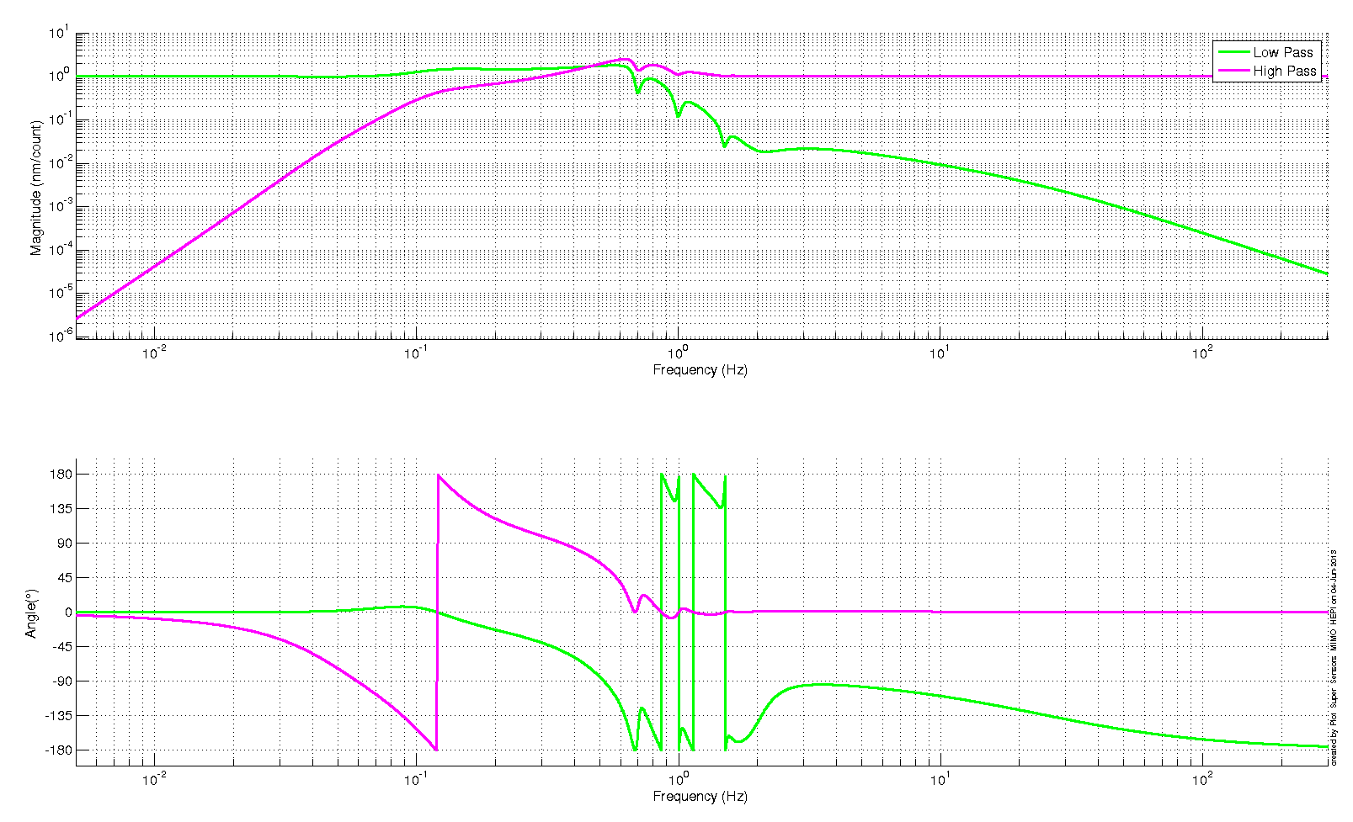

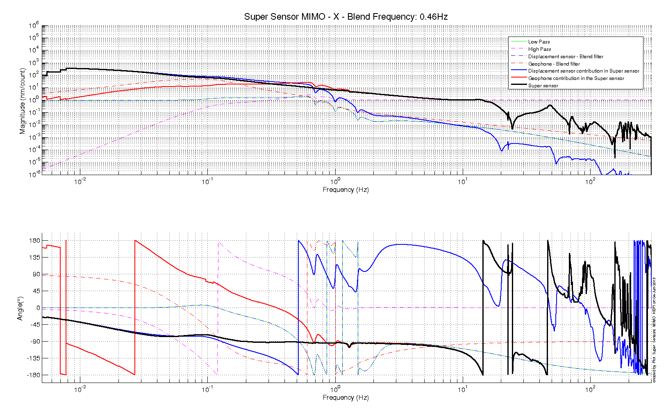

Isolation Loops
Those isolation filters (level 2 UGF ~25 Hz) were designed by Rich Mitttleman and have been used at LASTI.
As an example, only one direction is plotted in this report.

Scripts files for processing and plotting in SVN at:
/SeiSVN/seismic/HEPI/M1/HAMX/Scripts/Control_Scripts/release/
- Step_6_Isolation_Filters_Z_RX_RY_VP_M1_HEPI_HAMX.m
- Step_7_Isolation_Filters_X_Y_RZ_HP_M1_HEPI_HAMX.m
- Step_8_Loading_Sensor_Correction_Filters_M1_HEPI_HAMX.m

Figures in SVN at:
/SeiSVN/seismic/HEPI/M1/HAMX/Data/ Figures/Transfer_Functions/Simulations/Super_Sensors/
- M1_HPI_HAMX_Isolation_Loops_TF_SISO_ACT_VP_to_SS_VP_03_2013p.fig
- M1_HPI_HAMX_Isolation_Loops_TF_MIMO_ACT_VP_to_SS_VP_03_2013p.fig
Storage of measured transfer functions in the SVN at:
/SeiSVN/seismic/HEPI/M1/HAMX/Data/Transfer_functions/ Simulations/Super_Sensors/
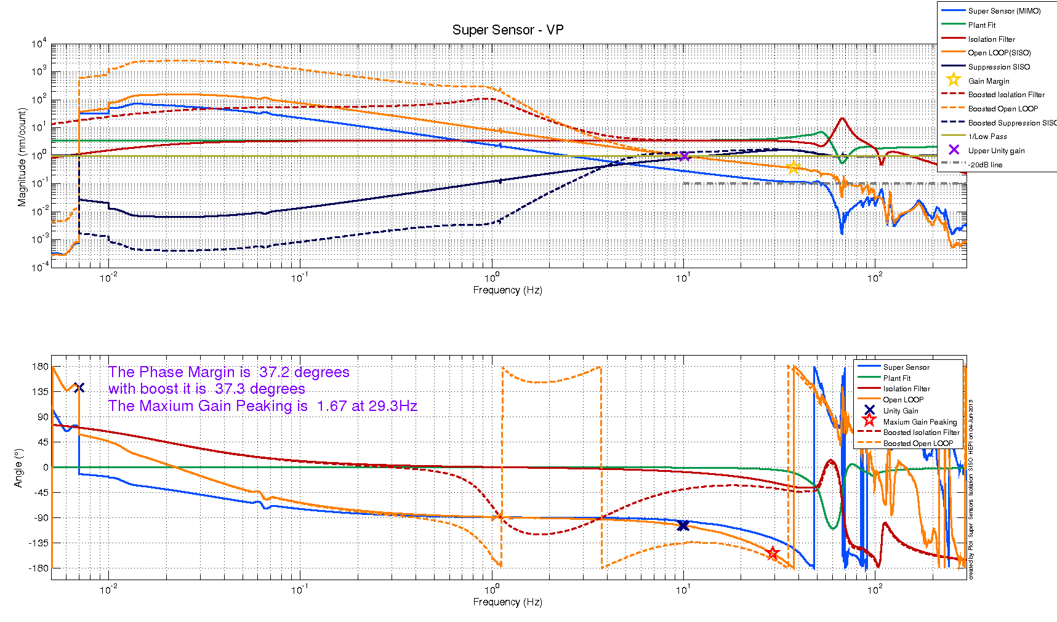
- M1_HPI_HAMX_TF_C2C_Isolation_V_H_Level_1_Blend_testmHz_03_2013p.mat

Sensor Correction

Procedure:
- Commissioning Scripts
- Validation Scripts

Appendix A

Housing Centering Procedure

