*LIGO Laboratory / LIGO Scientific Collaboration*

LIGO- E1300824 *LIGO* June 11, 2013

**aLIGO HEPI H1 HAM1**

**Assembly Validation Report**

**E1300823**

Hugo Paris, Fabrice Matichard for the SEI Team

Distribution of this document:

Advanced LIGO Project

This is an internal working note

of the LIGO Laboratory

|  |  |
| --- | --- |
| **California Institute of Technology**  **LIGO Project – MS 18-34**  **1200 E. California Blvd.**  **Pasadena, CA 91125**  Phone (626) 395-2129  Fax (626) 304-9834  E-mail: info@ligo.caltech.edu | **Massachusetts Institute of Technology**  **LIGO Project – NW22-295**  **185 Albany St**  **Cambridge, MA 02139**  Phone (617) 253-4824  Fax (617) 253-7014  E-mail: info@ligo.mit.edu |
| **LIGO Hanford Observatory**  **P.O. Box 1970**  **Mail Stop S9-02**  **Richland WA 99352**  Phone 509-372-8106  Fax 509-372-8137 | **LIGO Livingston Observatory**  **P.O. Box 940**  **Livingston, LA 70754**  Phone 225-686-3100  Fax 225-686-7189 |

Contents

1. Introduction 3

2. Sub-Components Testing 3

3. Load Cells assembly 3

4. Boot Location 3

5. Check Stops Gaps 4

6. Gaps check 5

7. IPS Centering 5

8. Sensor ASD 5

9. SUS-watchdogs interaction test 6

10. Static Test local drive 7

11. Linearity Test/Range of motion in the local basis 8

12. Actuator Plate to Shields gap 9

13. Valve Check 9

14. Local-to-local measurements 10

# Introduction

This document summarizes the steps to be done to validate HEPI assemblies. Corresponding reports must be posted in :

LIGO-E1300454: aLIGO HEPI Testing Reports

# Sub-Components Testing

* Kaman Inductive Position Sensors: calibration, linearity, factory data, noise measurements (E0900426 – HEPI Kaman Sensor Receiving Analysis - Results posted in the SVN )
* HEPI actuator linearity test (E1100338 – aLIGO HEPI Actuators Test Results)
* L4C test (Q0900007)

# Load Cells assembly

BSC HEPI load cell capacity → 3000 lbs

HAM HEPI load cell capacity → 2000 lbs

|  |  |  |
| --- | --- | --- |
|  | **Left Spring (lbs)** | **Right Spring (lbs)** |
| **Pier 1** | 1347 | 949 |
| **Pier 2** | 1458 | 1631 |
| **Pier 3** | 1267 | 1157 |
| **Pier 4** | 1142 | 1722 |

**Acceptance criteria:**

* The values must not exceed 80% of the load cell capacity (2400lbs for BSC and 1600lbs for HAM).

**Test result: Passed: Failed: X .**

# Boot Location





**Acceptance criteria:**



**Test result: Passed: -- Failed: .**

# Check Stops Gaps

The stops must not touch the boot. There is 15 stops per boot, 5 per F bracket.

|  |  |  |  |  |  |  |  |  |  |  |  |  |  |  |  |  |  |  |
| --- | --- | --- | --- | --- | --- | --- | --- | --- | --- | --- | --- | --- | --- | --- | --- | --- | --- | --- |
|  | **Bracket 1** | | | | | | **Bracket 2** | | | | | | **Bracket 3** | | | | | |
|  | **Gap1** | **Gap2** | **Gap3** | **Gap4 above** | **Gap4 under** | **Gap5** | **Gap1** | **Gap2** | **Gap3** | **Gap4 above** | **Gap4 under** | **Gap5** | **Gap1** | **Gap2** | **Gap3** | **Gap4 above** | **Gap4 under** | **Gap5** |
| **Pier 1** | Go | Go | Go | Go | Go | Go | Go | Go | Go | Go | Go | Go | Go | Go | Go | Go | Go | Go |
| **Pier 2** | Go | Go | Go | Go | Go | Go | Go | Go | Go | Go | Go | Go | Go | Go | Go | Go | Go | Go |
| **Pier 3** | Go | Go | Go | Go | Go | Go | Go | Go | Go | Go | Go | Go | Go | Go | Go | Go | Go | Go |
| **Pier 4** | Go | Go | Go | Go | Go | Go | Go | Go | Go | Go | Go | Go | Go | Go | Go | Go | Go | Go |

**Test result: Passed: X Failed:**

# Gaps check

Four particular gaps need to be check.

**Acceptance criteria:**

* a 0.08” shim must fit in these two gaps

Issues/difficulties/comments regarding this test: Gap#1 is tricky to reach. At LASTI, the solution found was to tape the shim to an extension (rod, rigid ruler, etc.).

Gap#2 should be reachable by hand.

Gap#3 and 4 are tricky, but should also be doable (no picture)

|  |  |  |  |  |
| --- | --- | --- | --- | --- |
|  | **Gap#1** | **Gap#2** | **Gap#3** | **Gap#4** |
| **Pier 1** | Go | Go | Go | Go |
| **Pier 2** | Go | Go | Go | Go |
| **Pier 3** | Go | Go | Go | Go |
| **Pier 4** | Go | Go | Go | Go |

**Test result: Passed: X Failed: .**

# IPS Centering

**Scripts files for processing and plotting in SVN at:**

/SeiSVN/seismic/HEPI/Common/Testing_Functions_HEPI/Offset_STD_IPS_HEPI.m

All the loops must be turned off during this test.

|  |  |  |  |  |  |  |  |  |
| --- | --- | --- | --- | --- | --- | --- | --- | --- |
|  | H1 | H2 | H3 | H4 | V1 | V2 | V3 | V4 |
| Mean (counts) | 5839.5 | 10365 | 187.03 | 3377.5 | -2795.2 | -5220.6 | 8743 | -3900.7 |
| Acceptance | +/- 15000 | +/- 15000 | +/- 15000 | +/- 15000 | +/- 15000 | +/- 15000 | +/- 15000 | +/- 15000 |

**Test result: Passed: X Failed:**

# Sensor ASD

**Scripts files for processing and plotting in SVN at:**

/SeiSVN/seismic/HEPI/Common/Testing_Functions_HEPI/ASD_Measurements_Local_HEPI.m

**Data in SVN at:**

SeiSVN/seismic/HEPI/M1/HAMX/Data/Spectra/Undamped/

M1_HPI_HAMX_ASD_m_IPS_L4C_2013_06_03_120859.mat

**Figures in SVN at:**

/SeiSVN/seismic/HEPI/M1/HAMX/Data/Figures/Spectra/Undamped

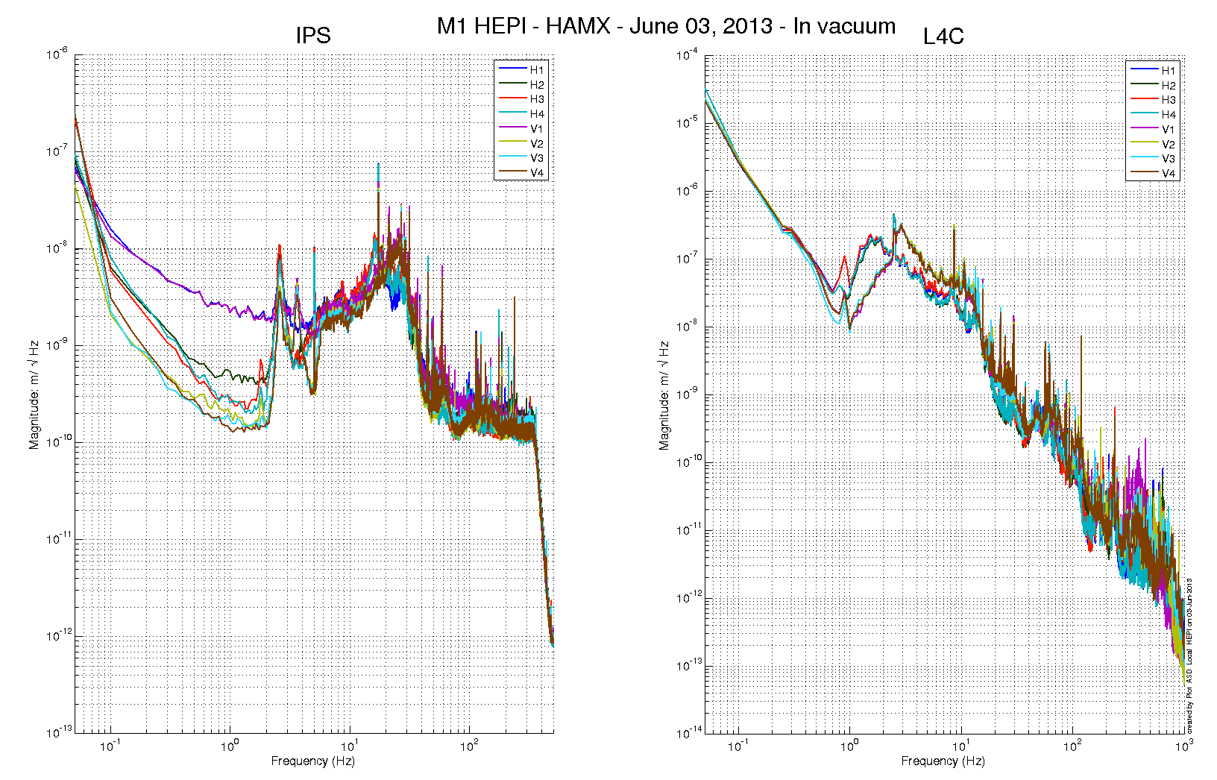

Issues/difficulties/comments regarding this test:

Measurements were performed with all PreFilters ON.

**Acceptance criteria:**



**Test result: Passed: Failed: .**

# SUS-watchdogs interaction test

. Set up a zero value on the payload watchogs.

. Check that the payload watchdog screen of HEPI tripped.

. In the payload watchdog screen, click on the OVERRIDE button and reset the watchdog.

. Do the same process for all the payloads

**Acceptance criteria:**

* The HEPI must trip when the payload watchdogs are tripped
* The HEPI watchdogs could be reset when the OVERRIDE button is ON

**Test result: Passed: X Failed: .**

When this test is done, reset everything (OVERRIDE button OFF, put back the value on the payload watchdog).

# Static Test local drive

**Scripts files for processing in SVN at:**

/SeiSVN/seismic/HEPI/Common/Testing_Functions_HEPI/Static_Test_Local_Basis_HEPI.m

. ***Drive of 100 counts (in progress)***

*Table - Main couplings and cross couplings*



. ***Drive of 1000 counts (in progress)***

*Table - Main couplings and cross couplings*



. ***Drive of 2500 counts***

*Table - Main couplings and cross couplings*



Issues/difficulties encountered during this test:

**Acceptance criteria:**

* The results in these three tables must be the same (within xxx%)

**Test result: Passed: Failed: .**

# Linearity Test/Range of motion in the local basis

**Scripts files for processing and plotting in SVN at:**

/SeiSVN/seismic/HEPI/Common/Testing_Functions_HEPI/Linearity_Test_Awgstream_HEPI.m

**Data in SVN at:**

SeiSVN/seismic/HEPI/M1/HAMX/Data/Spectra/Undamped/

M1_ISI_HAMX_ASD_m_CPS_T240_L4C_GS13_Locked_vs_Unlocked_2012_02_07.mat

**Figures in SVN at:**

/SeiSVN/seismic/HEPI/M1/HAMX/Data/Figures/Spectra/Undamped

Issues/difficulties encountered during this test:

**Acceptance criteria:**

**Test result: Passed: X Failed: .**

# Actuator Plate to Shields gap

**Perform this test ONLY if the range of motion test failed.**

Three gaps per actuator need to be checked.

**Acceptance criteria:**

* A 0.1” shim must fit into the gap #1
* A 0.05 shim must fit into gap #2 and #3

|  |  |  |  |  |  |  |
| --- | --- | --- | --- | --- | --- | --- |
|  | **Horizontal** | | | **Vertical** | | |
|  | **Gap #1** | **Gap #2** | **Gap #3** | **Gap #1** | **Gap #2** | **Gap #3** |
| **Pier 1** | Go | Go | Go | Go | Go | Go |
| **Pier 2** | Go | Go | Go | Go | Go | Go |
| **Pier 3** | Go | Go | Go | Go | Go | Go |
| **Pier 4** | Go | Go | Go | Go | Go | Go |

**Test result: Passed: X Failed:**

# Valve Check

**Scripts files for processing and plotting in SVN at:**

/SeiSVN/seismic/HEPI/M1/HAMX/Scripts/Valve_Check/plot_valve_check.m

**Data in SVN at:**

SeiSVN/seismic/HEPI/M1/HAMX/Data/Spectra/Undamped/

/SeiSVN/seismic/HEPI/M1/HAMX/Scripts/Valve_Check

**Figures in SVN at:**

/SeiSVN/seismic/HEPI/M1/HAMX/Scripts/Valve_Check

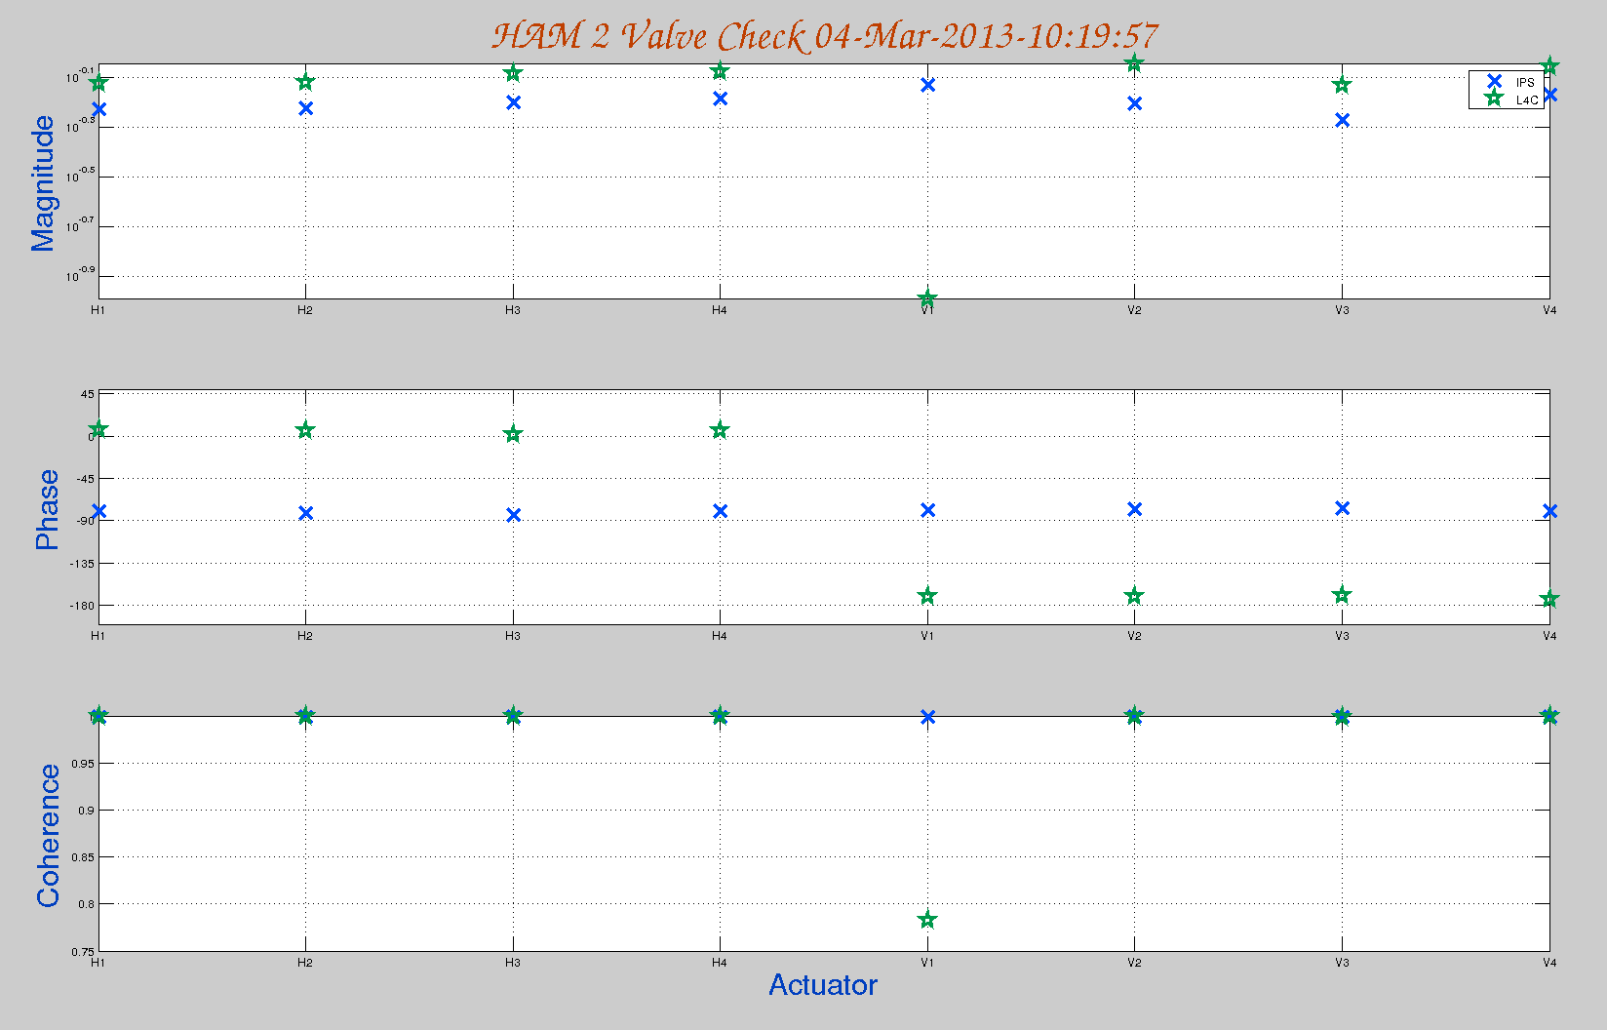

**Acceptance criteria:**

**Test result: Passed: Failed: .**

# Local-to-local measurements

|  |  |  |  |  |  |  |
| --- | --- | --- | --- | --- | --- | --- |
| **Band (Hz)** | **Resolution** | **Amplitude** | **Nreps** | **Time (s)** | **Time (min)** | **Time (h)** |
| **100 - 500** | 0.5 | 4000 - 4000 | 250 | 4176 | 69.6 | 1.2 |
| **10 - 100** | 0.25 | 4000 - 4000 | 200 | 6592 | 109.9 | 1.8 |
| **0.7 - 10** | 0.05 | 4000 - 4000 | 75 | 12320 | 205.3 | 3.4 |
| **0.1 - 0.7** | 0.025 | 4000 - 4000 | 30 | 10080 | 168.0 | 2.8 |
| **0.01 - 0.1** | 0.01 | 4000 - 4000 | 10 | 8960 | 149.3 | 2.5 |
| **0.002 - 0.01** | 0.002 | 4000 - 4000 | 2 | 12160 | 202.7 | 3.4 |
|  |  |  |  |  |  | **15.1** |

**Data files in SVN at:**

/SeiSVN/seismic/HEPI/M1/HAMX/Data/Transfer_Functions/Measurements/Undamped/

* M1_HPI_HAMX_Data_TF_L2L_200Hz_1000Hz_20120201-174407.mat
* M1_HPI_HAMX_Data_TF_L2L_5Hz_200Hz_20120201-183140.mat
* M1_HPI_HAMX_Data_TF_L2L_500mHz_5Hz_20120201-191513.mat
* M1_HPI_HAMX_Data_TF_L2L_100mHz_500mHz_20120201-202848.mat
* M1_HPI_HAMX_Data_TF_L2L_10mHz_100mHz_20120201-212025.mat

**Data collection script files:**

/SeiSVN/seismic/HEPI/Common//Transfer_Function_Scripts/

* Run_TF_L2L_10mHz_100mHz.m
* Run_TF_L2L_100mHz_500mHz.m
* Run_TF_L2L_500mHz_5Hz.m
* Run_TF_L2L_5Hz_100Hz.m
* Run_TF_L2L_100Hz_1000Hz.m

**Scripts files for processing and plotting in SVN at:**

/SeiSVN/seismic/HEPI/M1/HAMX/Scripts/Control_Scripts/release/

* Step_1_TF_Loc_to_Loc_M1_HEPI_HAMX.m

**Figures in SVN at:**

/SeiSVN/seismic/HEPI/M1/HAMX/Data/ Figures/Transfer_Functions/Measurements/Undamped/

* M1_HPI_Unit_1_TF_L2L_Raw_from_ACT_to_CPS_2012_02_02_With_3_Washers_Under_Top_Mass.fig
* M1_HPI_Unit_1_TF_L2L_Raw_from_ACT_to_GS13_2012_02_02_With_3_Washers_Under_Top_Mass.fig

**Storage of measured transfer functions in the SVN at:**

/SeiSVN/seismic/HEPI/M1/HAMX/Data/Transfer_functions/ Simulations/Undamped/

* M1_HPI_Unit_1_TF_L2L_Raw_2012_02_02_With_3_Washers_Under_Top_Mass.mat

The local-to-local transfer functions are presented below.

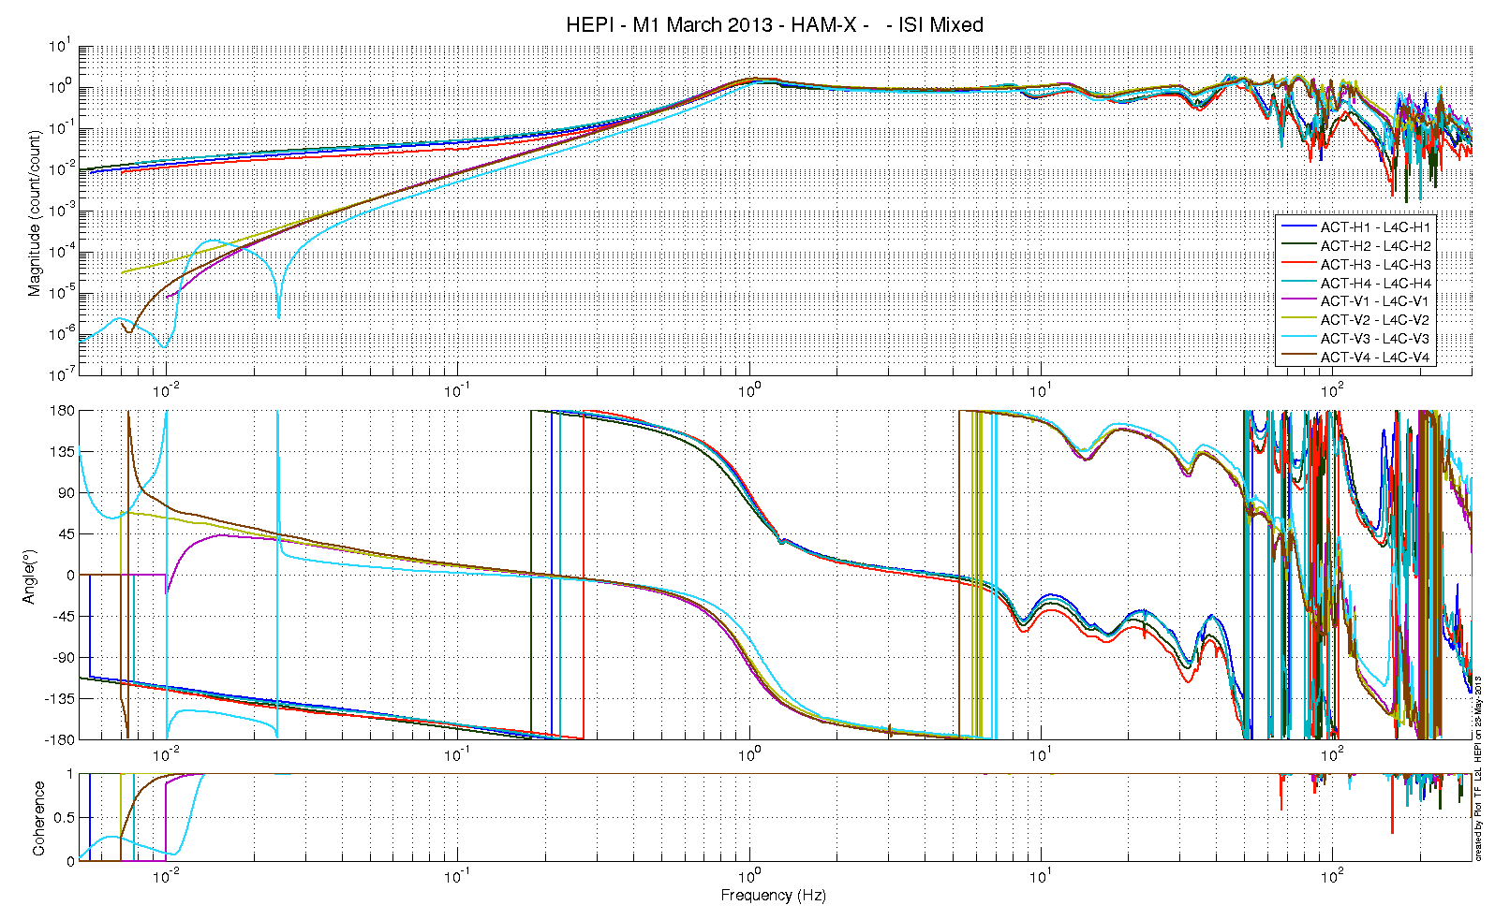

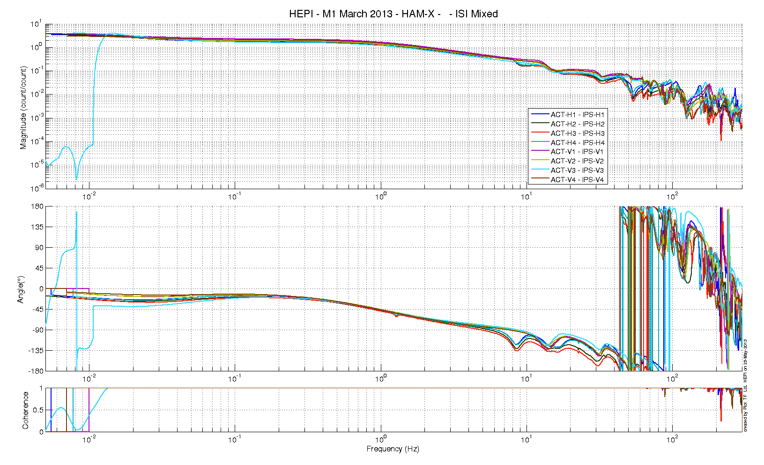

Issues/difficulties/comments regarding this test:

**Acceptance criteria:**

* On IPS, the phase must be 0º at DC
* On geophones, the phase must be 90º at DC
* Identical shape in each corner

**Test result: Passed: X Failed: .**