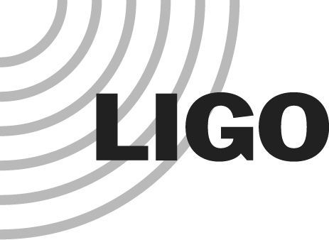
LIGO LABORATORY
MS 100-36
PASADENA CA 91125

TEL: 626.395.2129
FAX: 626.304.9834
Subject | Technical Review Board (TRB) charge:  Review of the On-line Data Characterization (ODC) System
To | Technical Review Board (TRB):  Stuart Anderson  Rolf Bork  Keiko Kokeyama  Brian Lantz  Keith Riles [chair]  Jamie Rollins  Vern Sandberg  Josh Smith  John Zweizig
cc | aligo_sys@ligo.caltech.edu, aligo_ifo@ligo.caltech.edu,  Stefan Ballmer, Duncan Brown, Ryan Fisher
From | Dennis Coyne
Refer to | L1300162-v1
Date | 8 July 2013

Background

Late last year the Syracuse group, working with various aLIGO subsystem teams, "proposed" an Online Detector Characterization (ODC) system (T1200323-v6). More recently this system has been summarized, and re-named to the Online State Vector (OSV) system (T1300542-v3). The purpose of this system is to acquire time-stamped critical interferometer status information in order to generate Data Quality (DQ) information for the analysis pipelines and as input for detector characterization work. The proposed ODC system is integral with the subsystem models (aka user apps) used for the real-time control of the interferometer systems.

The ODC system was adopted into some of the subsystem front-end, real-time code (“user apps”) without formal review. We have had some experience and success with its implementation, most notably in the PSL system (see for example G1300555-v1 and T1300564-v1). In addition, the upcoming Engineering Run #4 (ER4) will offer another opportunity for experience with the system (specifically with the PSL, ISI, SUS and to some extent IMC system).

LIGO management has two primary concerns regarding the deployment of the ODC system:
- The ODC system has been implemented without the usual formal requirements and design review process, and
- Frequent changes may be desired/required for the ODC which is not desirable for the installed, tested and change controlled front-end, real-time code.

The purpose of this Technical Review Board (TRB) is to review the OSV/ODC system and advise the project on whether we should continue with this implementation or effect changes.

In the interim, work may proceed (albeit at risk) on the OSV/ODC system. In particular some state vector information will likely be needed (or at least useful) for the IMC for the upcoming ER4. Adding some IMC ODC channels is acceptable. However any more complicated/computed "quality assessment" type bits should wait for the results of this OSV/ODC technical review.

TRB Charge
The TRB is requested to answer the following questions in a written report with their recommendations:
- Should we stick with “ODC” as the name for this system (given that there may be an investment in channel names to date using ODC) or should we switch to “OSV”?
- Are the requirements and motivation for the ODC system well established, complete and reasonable? In particular are the requirements responsive to the needs for detector characterization and data analysis groups?
- Is the proposed ODC system design a good approach to achieving the requirements? In particular should these monitoring channels be incorporated into the front end, real-time, control code or implemented separately for ease of interface and change control?
- Can/should the ODC channels be restricted so that they do not impose a significant computational load on the front-end computers (e.g. prohibit complicated or computed channels unless already part of the real-time control model)?
- In principal the ODC channels can also be used as input to interferometer Guardian processes. This approach would link top-level supervisory control of the interferometer to ODC channel definition/software. The ODC channels would need to be under strict interface and change control. Is this advisable, or should the systems be independent?
- Likewise, in principal the ODC channels can also be used as input for real-time detector status display. In particular if these displays are for operators, then the ODC channels would need to be under strict interface and change control. Is this advisable, or should the systems be independent?
- While the Detector Characterization people seem prepared to use the ODC channels, the data analysis groups, in some (perhaps many) cases are not currently prepared to use these channels and it would take some effort for them to incorporate these channels into their analysis tools. How should we control/coordinate the interfaces to DetChar and DA groups?
- Some aspects of the ODC system appear to overlap with the functions of the Data Monitoring Tool (DMT). Does ODC supplant some or all of the DMT? Are there interfaces that should be considered between the ODC and the DMT?

Please convene and provide a report on the charge by late August 2013. Of course in addition to reviewing the documentation on the ODC system (cited above), the TRB is encouraged to discuss the proposed system with the proposers and developers.

To be precise: currently only DAQ, SEI and SUS user apps have been officially been placed under change control. However, the intent is to place all real-time software (e.g. PSL, TCS, etc.) under change control as soon as possible. Please see M1300189-v1 (software change control.
Examples of other TRB reports: The CDS software code review: M1200346-v2. This is an unusually long and detailed review report. However some of the content may be interesting & useful to the ODC review. A more typical review report example is L1200053-v3

