LIGO Laboratory / LIGO Scientific Collaboration

T1300612-v1 LIGO 7/2/13

Figure measurement of 6” aLIGO Transmission Monitor Flats

GariLynn Billingsley

Distribution of this document:
LIGO Scientific Collaboration

This is an internal working note
of the LIGO Laboratory.

California Institute of Technology  LIGO Project – MS 18-34  1200 E. California Blvd.  Pasadena, CA 91125  Phone (626) 395-2129  Fax (626) 304-9834  E-mail: info@ligo.caltech.edu | Massachusetts Institute of Technology  LIGO Project – NW22-295  185 Albany St  Cambridge, MA 02139  Phone (617) 253-4824  Fax (617) 253-7014  E-mail: info@ligo.mit.edu
LIGO Hanford Observatory  P.O. Box 159  Richland WA 99352  Phone 509-372-8106  Fax 509-372-8137 | LIGO Livingston Observatory  P.O. Box 940  Livingston, LA 70754  Phone 225-686-3100  Fax 225-686-7189
http://www.ligo.caltech.edu/

Introduction
Two silver coated 6" x 1" flats were measured on the Zygo interferometer. The data were analyzed over 144 mm and 100 mm apertures and found to be at worst lambda by 12 (at 633nm) over 144 mm aperture and at best lambda by 48 on 100mm aperture.

Data were taken at only one rotational angle, so absolute accuracy is roughly of the order ± 2nm.

Results for “30 Arc Sec” flat
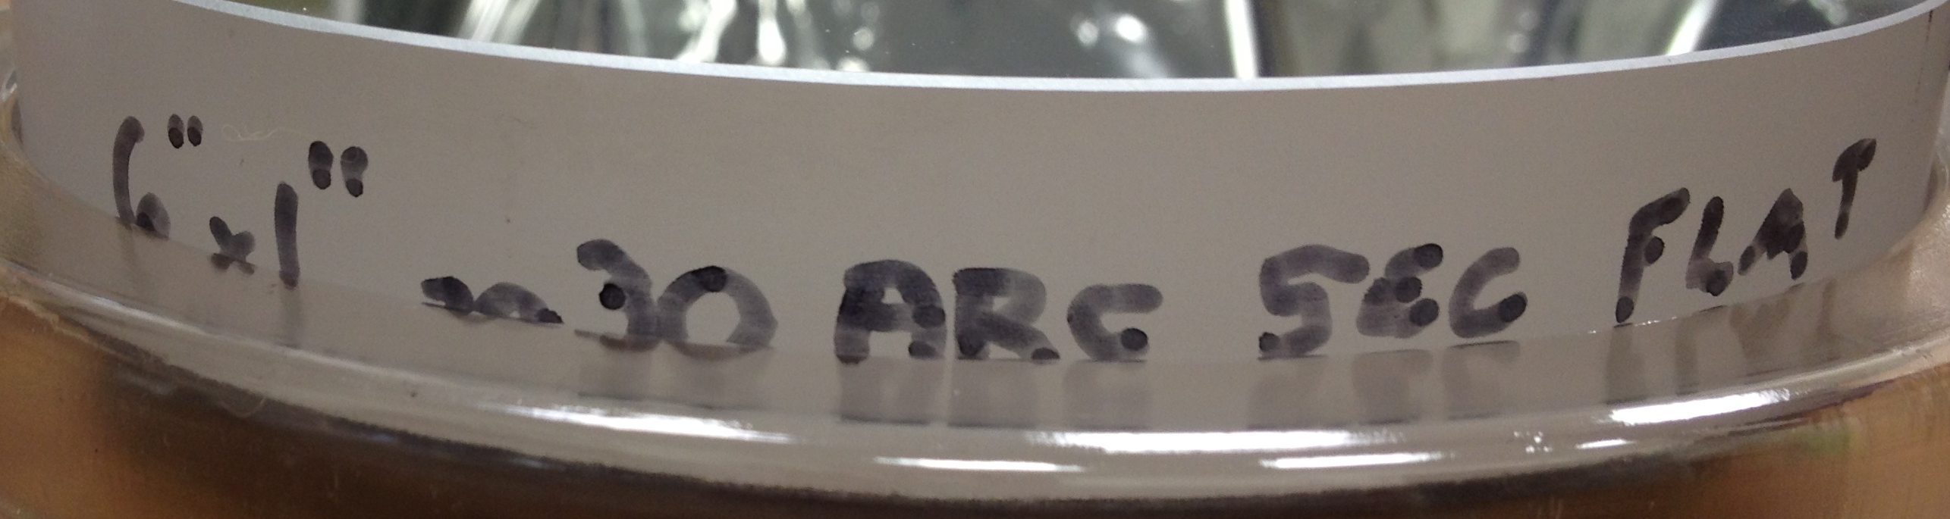

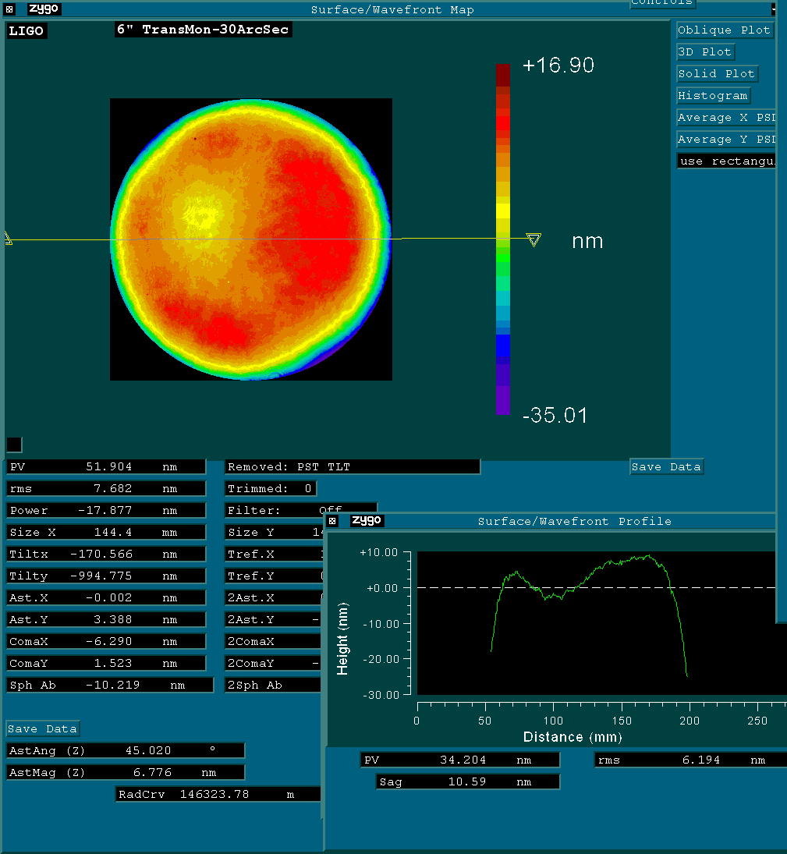
“30 arc sec” flat analyzed over 144 mm aperture.
PV: 52 nm, rms: 7.6 nm
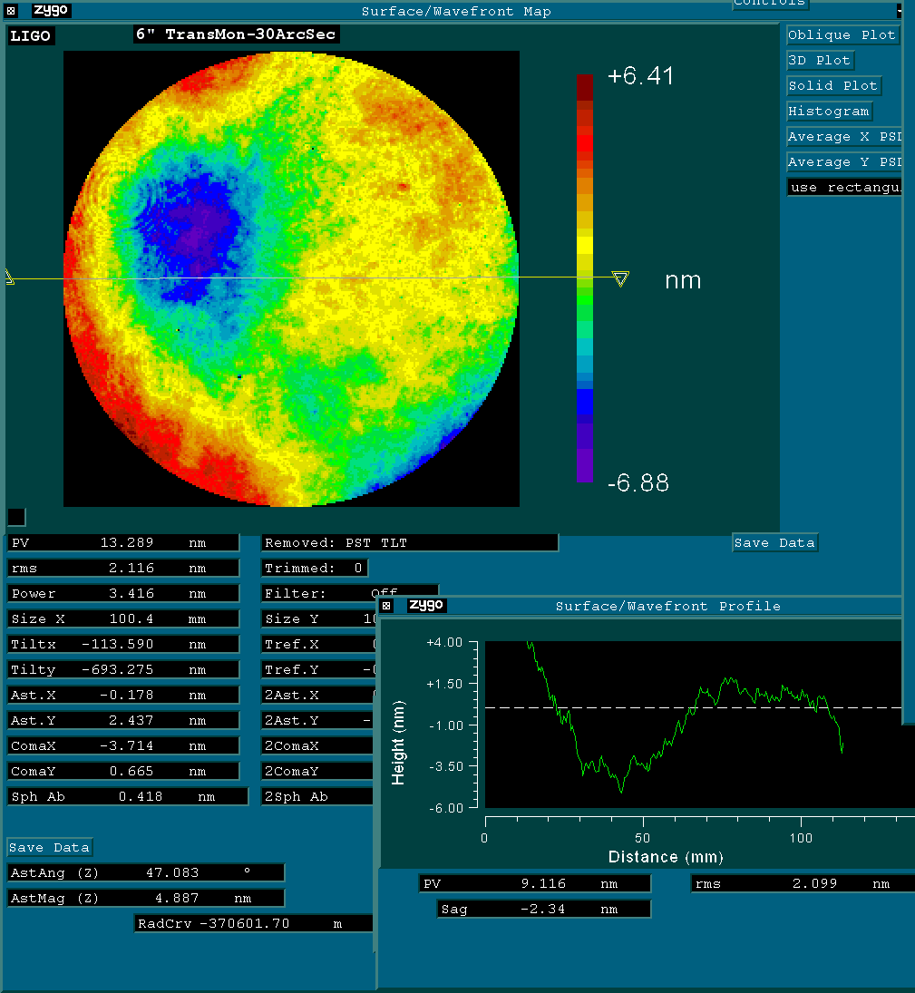
“30 arc sec” flat analyzed over 100mm aperture.
PV: 13 nm, rms: 2 nm

Results for “Edmund-paper wrapped” flat
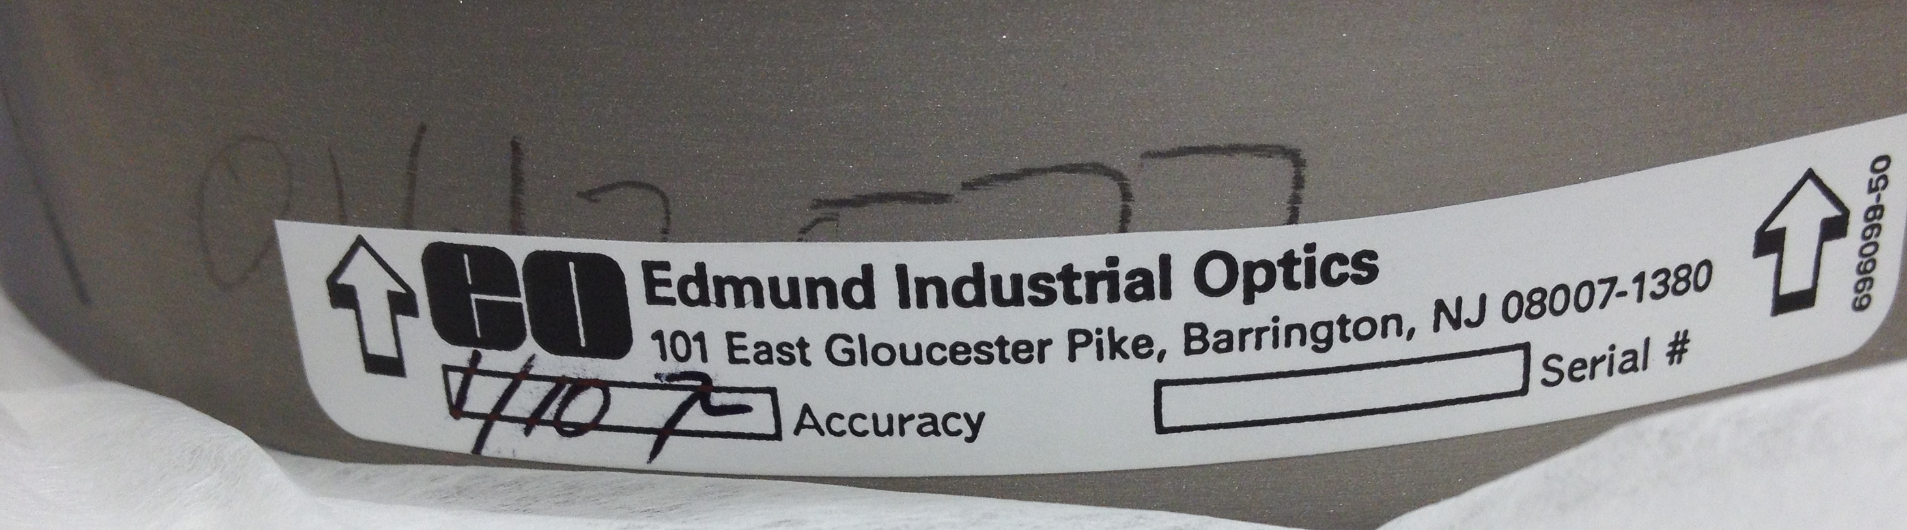
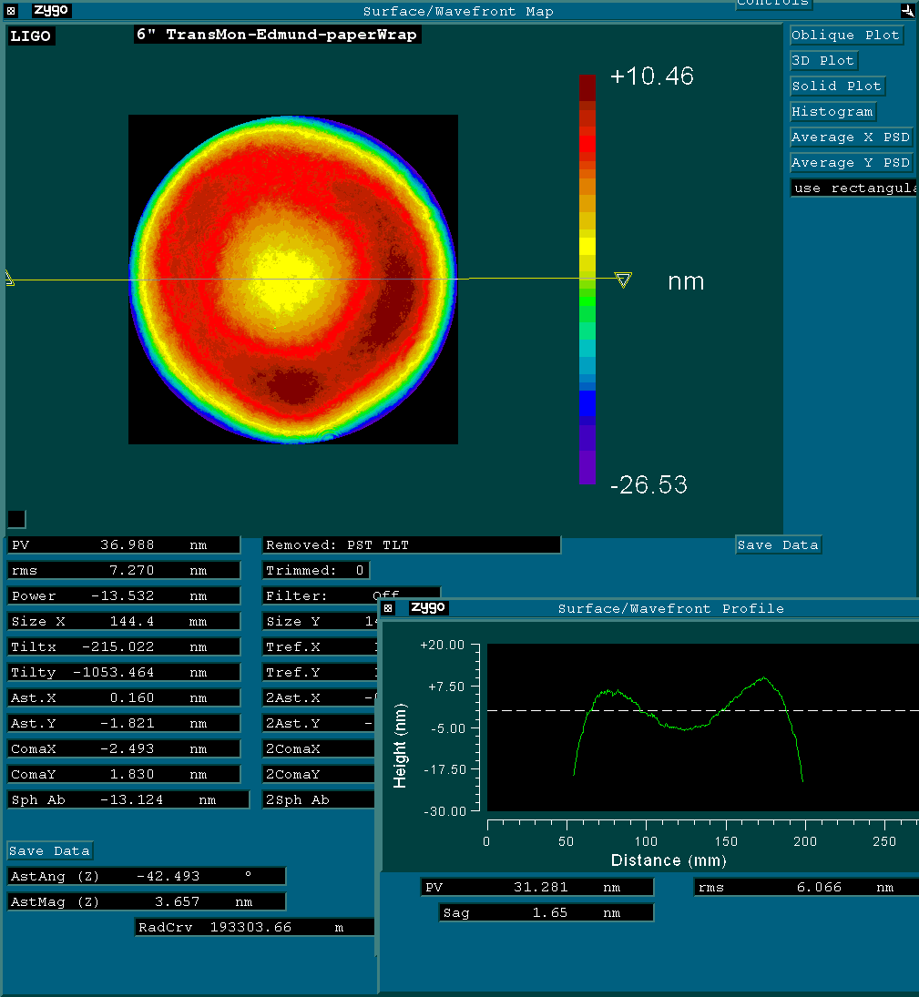
“Edmund paper wrapped” analyzed over 144 mm aperture: PV: 36.9 nm, rms: 7.3 nm
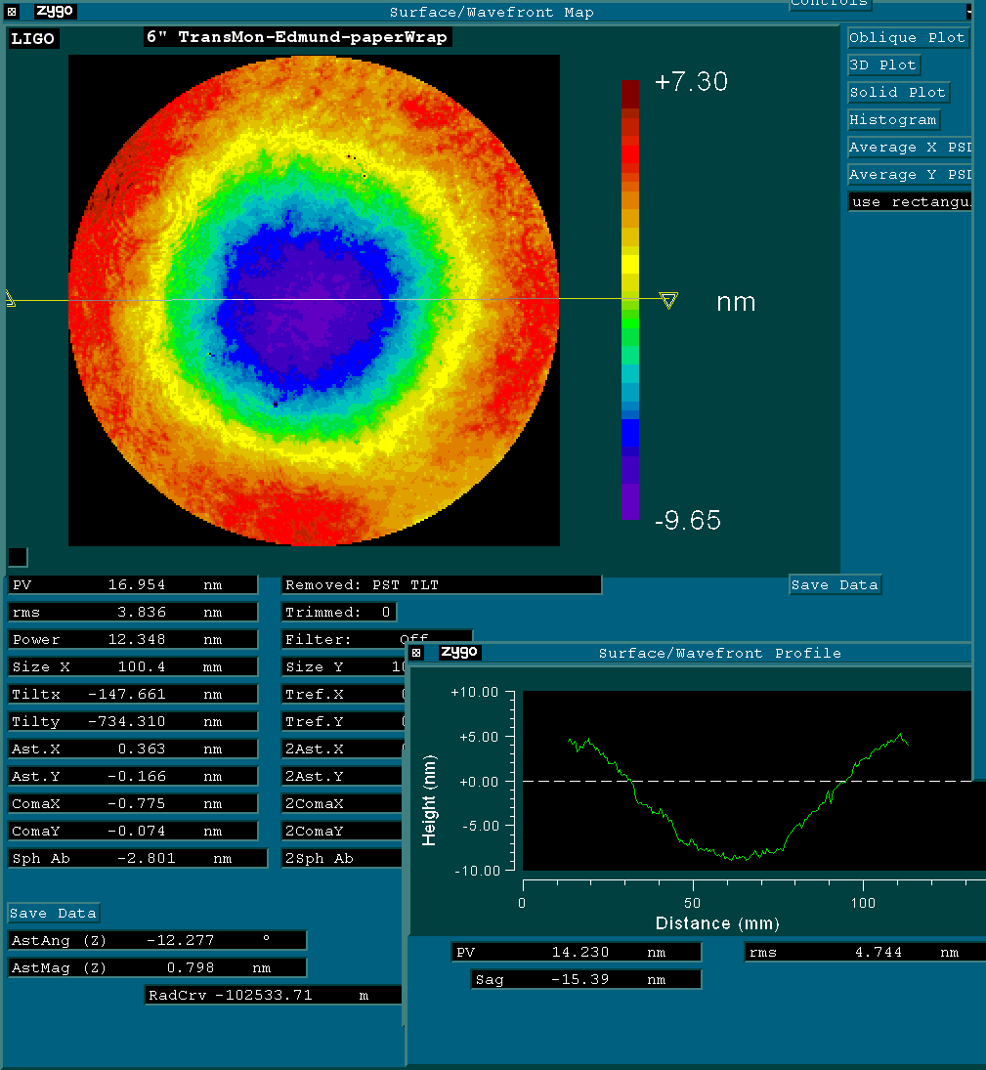
“Edmund paper wrapped” analyzed over 144 mm aperture: PV: 17 nm, rms: 3.8 nm

