LIGO Laboratory / LIGO Scientific Collaboration

LIGO- E1300566-v5 LIGO 1/21/14

aLIGO Pcal Periscope Frame Assembly Procedure

C. Conley, R. Savage

Distribution of this document:
LIGO Scientific Collaboration

This is an internal working note
of the LIGO Laboratory.

California Institute of Technology  LIGO Project – MS 18-34  1200 E. California Blvd.  Pasadena, CA 91125  Phone (626) 395-2129  Fax (626) 304-9834  E-mail: info@ligo.caltech.edu | Massachusetts Institute of Technology  LIGO Project – NW22-295  185 Albany St  Cambridge, MA 02139  Phone (617) 253-4824  Fax (617) 253-7014  E-mail: info@ligo.mit.edu
LIGO Hanford Observatory  P.O. Box 159  Richland WA 99352  Phone 509-372-8106  Fax 509-372-8137 | LIGO Livingston Observatory  P.O. Box 940  Livingston, LA 70754  Phone 225-686-3100  Fax 225-686-7189
http://www.ligo.caltech.edu/

Introduction
This procedural document outlines the assembly process for the Photon Calibrator Periscope Frame, D1200993. The process includes attention to flatness of the assembly, as it is desired for its two mirror mounting (ETM facing) surfaces to be within .01 in. [0.25 mm] flatness over their entire 70.75 in. diameter areas. The Photon Calibrator Periscope Frame serves as the basic structure of the Pre-Aligned Photon Calibrator Periscope, D1200174 (actual DCC Description: aLIGO PCAL-VIDEO CAM PERISCOPE), built per procedure E1300564.

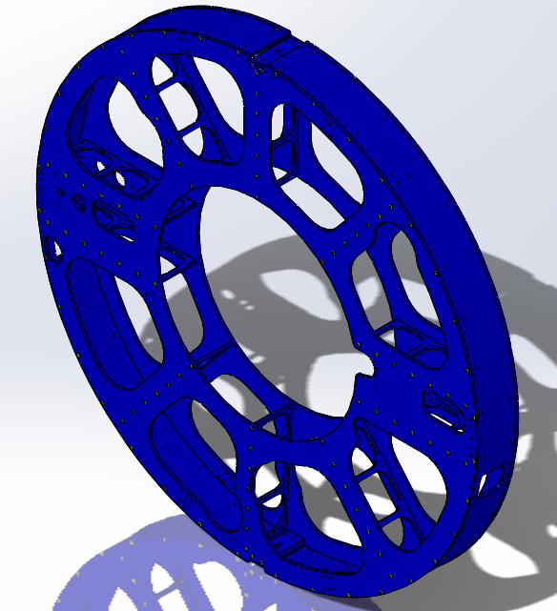
D1200993 Type -02 (X-Arm)

Procedure
- Cover an adequate build space of the H2 PSL table with Ameristat. Do not allow any wrinkles or creases, and do not overlap.
- Choose a Back Plate (D1200727). Make sure it is the desired type (-2 for X-Arm, -1 for Y-Arm). Record its S/N in the Build Record spreadsheet attached to the current D1200993 DCC file-card. Be sure to record on the correct page of the spreadsheet for the current build.
- Lay the Back Plate over the table atop three blocks, suspending it 7-8 inches above the table, with countersinks facing upward.
- Count out the number of ¼-20 x 1D heli-coils (43) to be installed in the Back Plate. Install all heli-coils in the Back Plate to a surface depth of ~.075” at the top. Push out and catch all heli-coil tangs. Before discarding the tangs, count them to make sure all are recovered.
- Select a full set of D1200725 Struts (type -1, 9 each, type -2, 1 each), D1200731 Connector Pieces (2 each), and D1102354 Ring Pieces (2 each). Record the S/Ns of all in the Build Record spreadsheet. Be sure to record on the correct page of the spreadsheet for the current build.
- Install all (4) 5/16-18 x 1D heli-coils in each Ring Piece to a surface depth of ~.03” at the outer circular face.
- Install two ¼-20 x 2D heli-coils in each Connector Piece to a surface depth of ~.075” at the outer (chamfered) face.
- Install one ¾-10 x 1D heli-coil in each Connector Piece to a surface depth of ~.05” at the outer (chamfered) face.
- While the Back Plate remains suspended, attach all Struts according to D1200993, leaving the flat head screws slightly loose.
- Repeat step 9 for the Connector Pieces, then for the Ring Pieces.
- Remove the three blocks to rest the partial assembly on the table with the Back Plate still at top.
- Make sure all screw heads are below the surface of the Back Plate.
- Using a 6’ precision straight edge, check the flatness of the Back Plate across several orientations of the full diameter. Note and record (for reference) the approximate maximum deviation observed.
- Flip the partial assembly over, resting the Back Plate on the table. If the measured flatness deviation in step 13 was > .01 in. [0.25 mm], clamp the Back Plate flat to the table using dog clamps and the table’s tapped holes, then proceed to next step. Otherwise, forgo clamping and proceed to next step.
- Select a Front Plate, D1200726, of same type (-1 or -2) as the Back Plate. Record the S/N of the Front Plate in the Build Record spreadsheet. Be sure to record on the correct page of the spreadsheet for the current build. Lay the Front Plate atop the partial assembly according to D1200993.
- Count out the number of ¼-20 x 1D heli-coils (46) to be installed in the Front Plate. Install all heli-coils in the Front Plate to a surface depth of ~.075” at the top. Push out and catch all heli-coil tangs. Before discarding the tangs, count them to make sure all are recovered.
- Install all flat head screws through the Front Plate slightly loose as in steps 9 & 10.
- Make sure all screw heads are below the surface of the Front Plate.
- With two people using torque wrenches, simultaneously torque the flat head screws of any two diametrically opposite Struts, starting each nearest the center of the Front Plate and emanating out to the edge. Torque 70 in-lb. Rotate in either chosen direction to repeat this torquing pattern for the nearest two diametrically opposite Struts, repeating through all ten Struts. Be sure to seat the hex drivers well in the flat head screw sockets before applying torque. Replace hex drivers when significantly worn.
- Torque the flat head screws of the two Connector Pieces to 70 in-lb.
- With two people using torque wrenches, in a diametrically opposite rotating pattern starting at Ring Piece ends, simultaneously torque all flat head screws of the two Ring Pieces to 70 in-lb. Each person should end at the far end of the Ring Piece on which they started.
- Dis-attach (if necessary) the assembly from the table.
- Using 6’ precision straight edge, check the flatness of the Front Plate across several orientations of the full diameter noting and recording (for reference) the approximate maximum deviation found.
- Flip the assembly over, laying the Front Plate flat on the table.
- If the measured flatness deviation in step 23 was > .01 in. [0.25 mm], clamp the Front Plate flat to the table using dog clamps and the table’s tapped holes, then proceed to next step. Otherwise, forgo clamping and proceed to next step.
- For the Back Plate, repeat steps 19-22 torquing to 70 in-lb.
- Using 6’ precision straight edge, check the flatness of the Back Plate across several orientations of the full diameter noting and recording (for reference) the approximate maximum deviation found.
- If either Plate has been found to have > .01 in. [0.25 mm] flatness deviation, go to next step. Otherwise, repeat steps 19-21 twice for the Back Plate torquing to 120 in-lb, then 160 in-lb, and similarly for the Front Plate. Then, record the approximate maximum deviation values for each Plate in the Build Record spreadsheet. Be sure to record on the correct page of the spreadsheet for the current build. Then skip to step 46.
- Flip the assembly over, laying the Back Plate flat on the table.
- Clamp the Back Plate flat to the table using dog clamps and the table’s tapped holes.
- For the Front Plate, repeat steps 19-22 torquing to 120 in-lb.
- Using 6’ precision straight edge, check the flatness of the Front Plate across several orientations of the full diameter noting and recording (for reference) the approximate maximum deviation found.
- Flip the assembly over, laying the Front Plate flat on the table.
- If the measured flatness deviation in step 32 was > .01 in. [0.25 mm], clamp the Front Plate flat to the table using dog clamps and the table’s tapped holes, then proceed to next step. Otherwise, forgo clamping and proceed to next step.
- For the Back Plate, repeat steps 19-22 torquing to 120 in-lb.
- Using 6’ precision straight edge, check the flatness of the Back Plate across several orientations of the full diameter noting and recording (for reference) the approximate maximum deviation found.
- If either Plate has been found to have > .01 in. [0.25 mm] flatness deviation, go to next step. Otherwise, repeat steps 19-21 for the Back Plate torquing to 160 in-lb, and similarly for the Front Plate. Then, record the approximate maximum deviation values for each Plate in the Build Record spreadsheet. Be sure to record on the correct page of the spreadsheet for the current build. Then skip to step 46.
- Flip the assembly over, laying the Back Plate flat on the table.
- Clamp the Back Plate flat to the table using dog clamps and the table’s tapped holes.
- For the Front Plate, repeat steps 19-22 torquing to 160 in-lb.
- Using 6’ precision straight edge, check the flatness of the Front Plate across several orientations of the full diameter noting and recording the approximate maximum deviation in the Build Record spreadsheet. Be sure to record on the correct page of the spreadsheet for the current build.
- Flip the assembly over, laying the Front Plate flat on the table.
- If the measured flatness deviation in step 41 was > .01 in. [0.25 mm], clamp the Front Plate flat to the table using dog clamps and the table’s tapped holes, then proceed to next step. Otherwise, forgo clamping and proceed to next step.
- For the Back Plate, repeat steps 19-22 torquing to 160 in-lb.
- Using 6’ precision straight edge, check the flatness of the Back Plate across several orientations of the full diameter noting and recording the approximate maximum deviation in the Build Record spreadsheet. Be sure to record on the correct page of the spreadsheet for the current build.
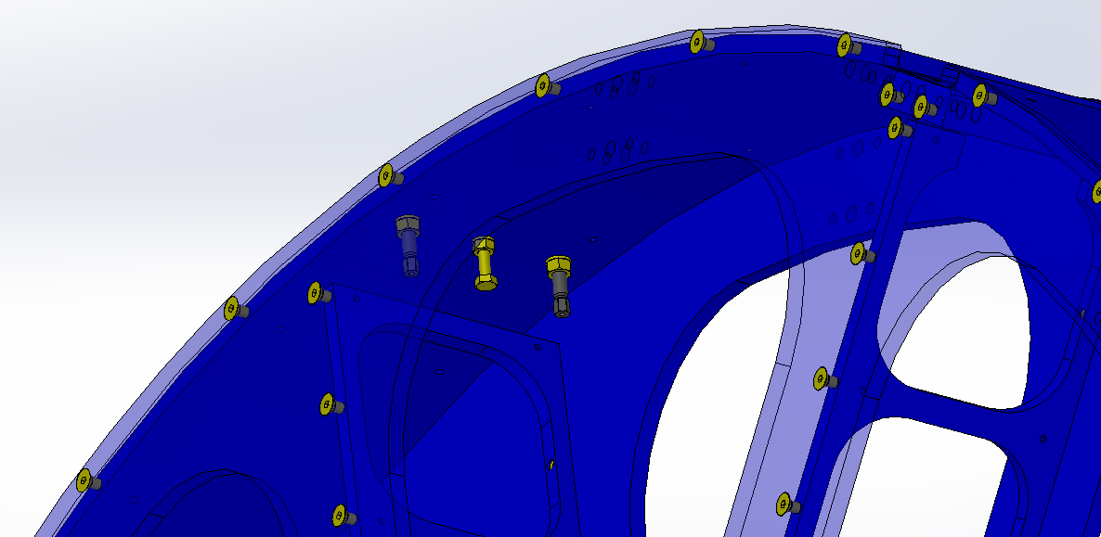
D1201408 FLEXURE SCREW
5/16-18 NUT
5/16 WASHER
8 PLACES
¼-20 X 2L HEX HEAD SCREW
¼-20 NUT
1/4 WASHER
4 PLACES
Figure 1 Flexure retention and adjustment hardware.

- Install eight D1201408 Flexure Adjustment Screws with nuts and washers according to D1200174. Screw tips should be flush with the outside surface of the Ring Pieces. Nuts should be lightly tightened to prevent loosening during shipping. See Figure 1.
- Install four ¼-20 x 2” Hex Head Screws with ¼-20 nuts and washers according to D1200174 (items 20, 21, 22). Screw tips should be flush with the outside surface of the Ring Pieces. Nuts should be lightly tightened to prevent loosening during shipping. See Figure 1.

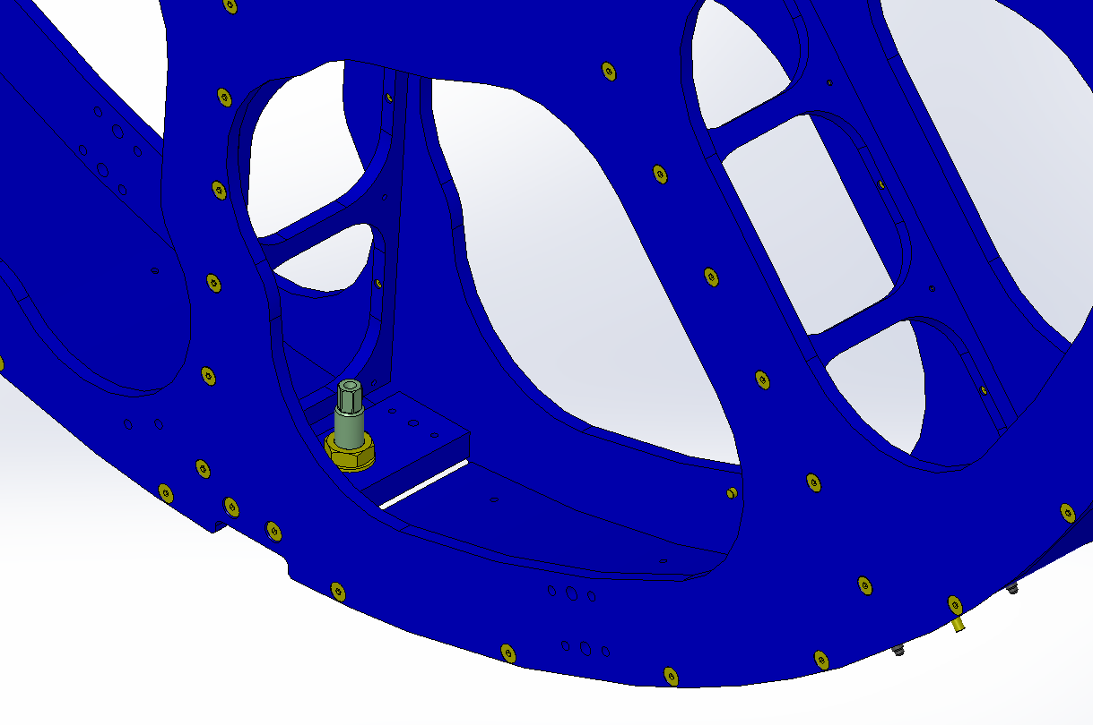
D1300228 JACK SCREW
¾-10 NUT
3/4 WASHER
2 PLACES
Figure 2 Jack Screw with jam nut and washer (temporary tooling for installation of completed Periscope Assembly D1200174).
- Install two D1300228 Jack Screws with ¾-10 nuts and washers. Jack Screw tips should be flush with the outside surface of the Connector Pieces. Nuts should be lightly tightened to prevent loosening during shipping. See Figure 2.

