Guide to Troubleshooting aLIGO RFPDs
Richard Abbott
11 July, 2013

- Overview
This note provides data and methods useful in troubleshooting aLIGO RFPDs. The inaccessibility of the in-vacuum LSC and ASC detectors necessitates a guide to permit diagnosis prior to a vacuum incursion. The LSC in-vacuum detectors are tuned to 9/45 MHz. The in-vacuum ASC detectors come in two variants: 9/45 MHz, and 36/45 MHz. Ideally, the notches of the transfer functions occur at specific frequencies that correspond to the operating frequency (or harmonics thereof) of each detector. Indeed, a transfer function taken optically by injecting AM modulated light agrees with this model. However, a transfer function taken by injecting a signal into the test input has different characteristics, and the notches appear shifted in frequency. The reason for this shift relates to the deliberately weak coupling of the test path to the detector circuitry, in conjunction with cross coupling parasitic terms present in the physical layout of the circuit. By use of the baseline transfer functions presented in this note, the user should be able to verify that the detector in question is operating properly.

Figure 1 Front view of LSC and ASC Detectors

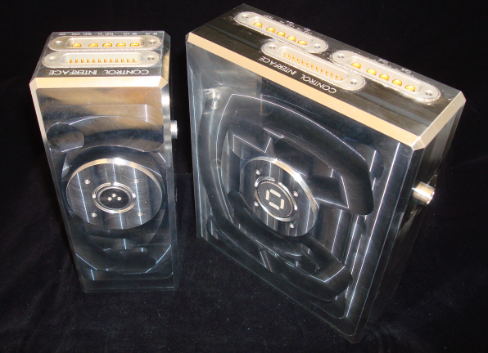

Figure 2 Rear view of ASC and LSC prior to welding

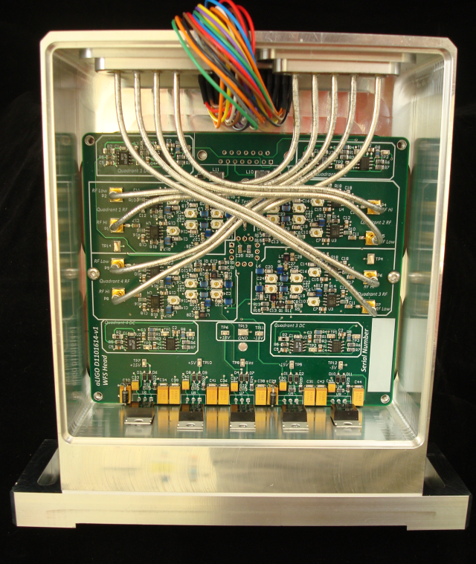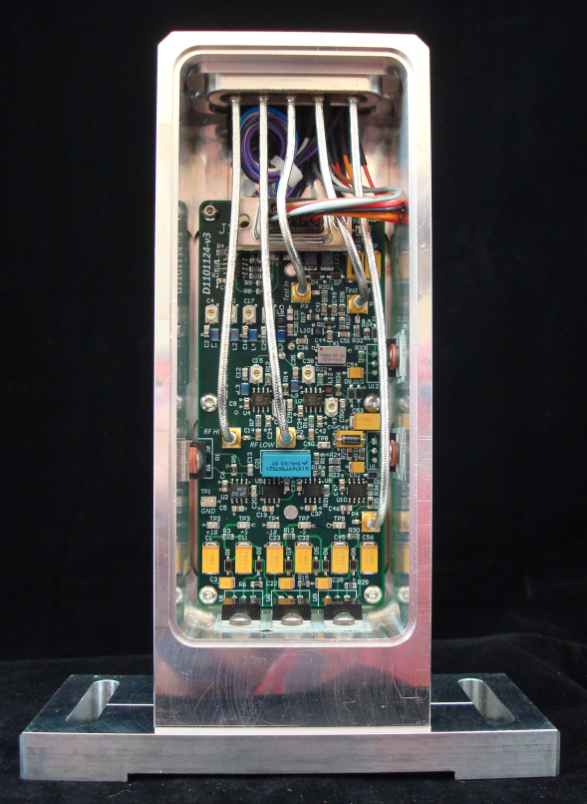

- The ASC 36/45 MHz Detector
For each of the four quadrants of the 36/45 MHz detector, a transfer function is shown for the RF LOW (36MHz), and RF HI (45 MHz) response. Plots are shown for the Test Input transfer function as well as the Optical Transfer Function.

Figure 3

Figure 4

Figure 5

Figure 6

The differing magnitudes of the optical transfer function relate to the elliptical beam pattern on the laser calibration head causing an uneven distribution of light on the quadrant photodiode.

- The LSC 9/45 MHz Detector
The 9 MHz (RF LOW) and the 45MHz (RF HI) are plotted below. The transfer function to each of these outputs is plotted as a function of an optical input (using the laser calibrator head) and the test input (an electrical input used for directly injecting a signal into the detector). As this detector also has a dedicated Test Output, the transfer function is included for that path as a function of the Test Input only.

Figure 7

Figure 8
- The ASC 9/45 MHz Detector
For each of the four quadrants of the 9/45 MHz detector, a transfer function is shown for the RF LOW (9MHz), and RF HI (45 MHz) response. Plots are shown for the Test Input transfer function as well as the Optical Transfer Function.

Figure 9

Figure 10

Figure 11

Figure 12

- Quick Reference Guide for Go No-go Checks
Table 1 gives numbers for the expected path loss from the test input to each respective RF output for convenience, and for quick checks of system response. These numbers were taken on the bench without having long cables attached. It is reasonable to estimate the round trip path loss of typical in-vacuum coaxial cables (~20 feet round trip) to be of order: 0.5 dB at 9 MHz, 0.95 dB at 36 MHz, 1.1 dB at 45 MHz, and 1.6 dB at 100 MHz. These numbers are derived from a lab test of the Gore Inc. RG316 equivalent Teflon cable. Add the frequency specific round trip path losses to numbers shown below for a detector being measured at the airside of the vacuum flange.

Table 1
Detector | Path | Expected Value
ASC 9/45 | RF HI (45MHz) | 9.6 dB
ASC 9/45 | RF LOW (9MHz) | 3.1 dB
ASC 36/45 | RF HI (45MHz) | -10 dB
ASC 36/45 | RF LOW (36MHz) | -13 dB
LSC 9/45 | RF HI (45MHz) | 20.5 dB
LSC 9/45 | RF LOW (9MHz) | 17 dB

By searching on a given RFPD’s serial number, the data relating to output noise, power supply current, and DC performance can be found. These parameters can also be compared for diagnostic purposes.

- In Situ Analysis of Cable Impedance
Modern RF network analyzers can provide complex impedance data of a one port network. By ‘looking’ into the cables attached to a remote RFPD, one can analyze the impedance and determine whether the cable is: attached properly to an RF output of an opamp, attached properly to a Test Port of an RFPD, or if the interconnecting coaxial cable has an open or short circuit fault.
In network analysis, the terms S11, S12, S21, and S22 refer to the forward and reverse complex reflection and transmission through a two port network. The standard input impedance measurement is commonly referred to as an ‘S11’ among those in the biz. The following images show the results of commonly encountered scenarios. The RF network analyzer has been setup for a measurement type S11, and format Smith Chart to display complex data. A frequency span from 1 to 100 MHz was used at an RF drive level of -10dBm. The analyzer was calibrated (S11, 1 port calibration) at the plane of the instrument’s output connector by use of an open, short, and 50 ohm load when prompted by the analyzer calibration process. Don’t use clip leads anywhere, this requires construction of a nice RF short circuit and load, not just mashing a paper clip in the output hole. If you don’t do this, you will get whacky results from erroneous calibration data.

Figure 13 shows that for a properly connected RF opamp terminated in 50 ohms, all S11 impedances over the range from 1 to 100 MHz are clustered around the center of the chart (chart center indicates 50 ohms). If the DC power supplies to the RFPD where to be turned off while looking at this display, the opamp output impedance changes markedly and the data loses the tight central cluster.

Figure 13, 50 Ohm Opamp Output
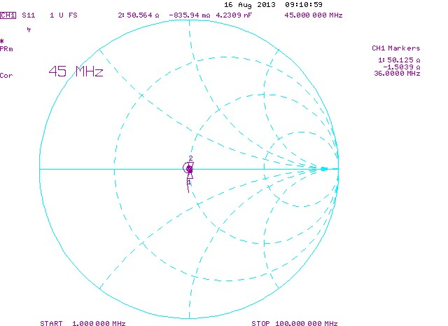

In Figure 14 the input impedance of the ‘Test Input’ can be seen. Due to the lower bandwidth of the discrete transistor input circuitry, a spiral pattern is created such that higher frequencies tend away from the center (50 ohm) point of the display. As the impedance of this input is also active in nature, this input will also change markedly if the DC power is not present.

Figure 14, Test Input Connection
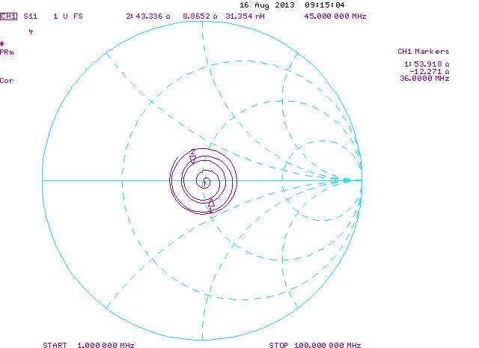

In Figure 15, the impedance data is displayed for an open cable extending nominally and intact all the way into the vacuum system, but open at the plane of the RFPD, such as might be encountered if the RFPD RF connector were faulty or not plugged in. Ideally, the open circuit presented by this cable would appear as a reflection coefficient of 1, and a phase angle that depends on frequency. In an ideal transmission line, the rings of the spiral shape would be collapse and overlay the outer most circumference of the Smith Chart. The fact that higher frequencies tend toward the center of the plot is representative of the RF loss in the cable; an infinite length of such cable would look like 50 ohms at the input for all frequencies, as no detectable energy would return from the far end of the cable. Shorter cables that terminate in an open circuit would appear as arcs of shorter length on the Smith Chart, so if an RFPD cable were open circuited at the vacuum feedthrough, one will expect a modified version of this display having a shorter path length spiral pattern. This fact, and some pieces of BNC cable, allows scenarios to be explored such that diagnostics can be performed.
It is worthy of note that a cable terminated in a short circuit will appear generally the same in terms of the arc-spiral structure, but the arc-spiral will be rotated to the opposite side of the Smith Chart. After some time playing with different lengths of scrap cable, it’s quite possible to deduce where a problem lies, and whether the problem is associated with a short circuit, open circuit, or malfunctioning detector (hope not).

Figure 15, Cable Open at Detector
