*LIGO Laboratory / LIGO Scientific Collaboration*

LIGO-E1300390-v3 *LIGO* 9/24/14

Align/Install Output Faraday Isolator LHO Test

Michael Smith

Distribution of this document:

LIGO Scientific Collaboration

This is an internal working note

of the LIGO Laboratory.

|  |  |
| --- | --- |
| **California Institute of Technology**  **LIGO Project – MS 18-34**  **1200 E. California Blvd.**  **Pasadena, CA 91125**  Phone (626) 395-2129  Fax (626) 304-9834  E-mail: info@ligo.caltech.edu | **Massachusetts Institute of Technology**  **LIGO Project – NW22-295**  **185 Albany St**  **Cambridge, MA 02139**  Phone (617) 253-4824  Fax (617) 253-7014  E-mail: info@ligo.mit.edu |
| **LIGO Hanford Observatory**  **P.O. Box 159**  **Richland WA 99352**  Phone 509-372-8106  Fax 509-372-8137 | **LIGO Livingston Observatory**  **P.O. Box 940**  **Livingston, LA 70754**  Phone 225-686-3100  Fax 225-686-7189 |

http://www.ligo.caltech.edu/

**CHANGE LOG**

|  |  |
| --- | --- |
| **Date, version** | **Summary of Changes** |
| 5/20/13, v1 | * Add hammer modal testing |
| 5/23/13, v2 | * Added figure to hammer testing |
| 8/25/14,v3 | * Added optical measurements and hammer testing graphs |

1 Introduction 5

2 Acceptance Tests 5

2.1 Transmissivity and Extinction Ratio Test 6

2.1.1 Transmissivity and Extinction Ratio Test Set-up 6

2.1.2 Transmissivity and Extinction Ratio Test Results 7

2.2 Wavefront Distortion Test 8

2.2.1 Wavefront Distortion Test Set-up 8

2.2.2 Wavefront Distortion Test Results 9

2.3 Alignment of OFI on HAM5 with aligned PSL beam transmitted through SRM AR face 9

2.4 Hammer Modal Testing of Installed OFI on HAM5 9

**Abstract**

This document presents the data for the Output Faraday Isolator LHO Align/Installation Acceptance Tests.

# Introduction

This document presents the data for the Output Faraday Isolator LHO Align/Installation Acceptance Test.

# Acceptance Tests

The following parameters will be measured: 1) Optical transmissivity in the forward direction, 2) extinction ratio in the backward direction, 3) wavefront distortion of the beam transmitted through the total OFI optical assembly, 4) alignment of OFI on HAM5 with aligned PSL beam transmitted through SRM AR face, and 5) hammer modal testing of installed OFI on HAM5.

## Transmissivity and Extinction Ratio Test

### Transmissivity and Extinction Ratio Test Set-up

PERISCOPE



BEAM DUMP

INPUT LASER

HALF-WAVE PLATE

INPUT APERTURE

INPUT POLARIZER

PD 2

50 % BS

INPUT ALIGNMENT APERTURE

PD 4

OUTPUT ALIGNMENT APERTURE

OUTPUT FARADAY ISOLATOR

RETRO MIRROR

PD 3

PD 1

Figure : Optical Layout for OFI Alignment

1. Set the power of the laser to approximately 250 mW. Calibrate the transmissivity and reflectivity of the beam splitter by placing the photodetector alternately at position PD1 and PD2 and measure the power levels. The power at PD2 will be the reference power for calculating the Transmissivity and the power extinction ratio of the OFI.
2. Place the photodetector at position PD4 and rotate the half-wave plate to minimize the power at PD4; measure the power.
3. Place the photodetector at position PD3 and measure the power.

Calculate the OFI Transmissivity as the ratio of PD3 to PD2; calculate the OFI power extinction ratio as the ratio of PD4 to PD2.

### Transmissivity and Extinction Ratio Test Results

These measurements are described in a document written by Dave Ottaway and Gerardo Moreno contained in an alog entry <https://alog.ligo-wa.caltech.edu/aLOG/index.php?callRep=10996>



## Wavefront Distortion Test

### Wavefront Distortion Test Set-up

Set up the SH test apparatus according to the optical schematic shown in Figure 2. Align the SH beam to pass freely through the entrance and exit apertures of the OFI.

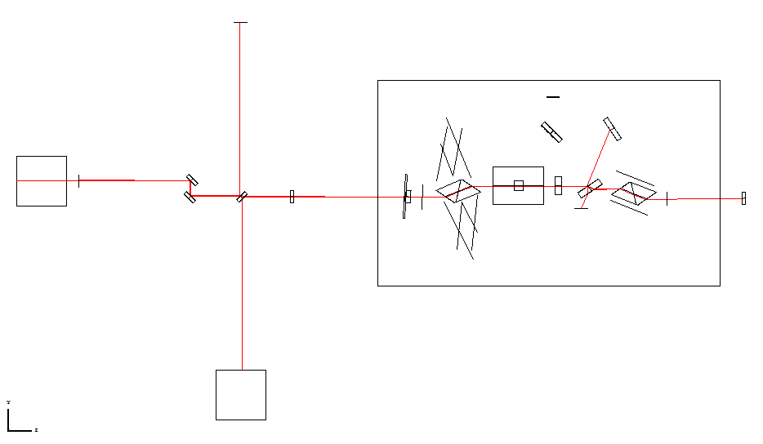

SH Sensor

Beam Dump

SH BS

Steering mirrors

SH LASER

OUTPUT FARADAY ISOLATOR

RETRO

MIRROR 2

RETRO

MIRROR 1

PD 3

Figure : Optical Layout for SH Test

### Wavefront Distortion Test Results

The OFI double-pass Zernike coefficients, in units of micron, are shown in **Error! Reference source not found.** and Table 1. Zernike Coefficients 01, 02, 03, and 05 describe the piston, Y-tilt, X-tilt, and defocus respectively; these coefficients do not affect the wavefront aberration and will be ignored.

The astigmatism coefficients 04 and 06 are the most significant because they are responsible for direct coupling loss into the OMC. The higher order coefficients > 06 describe coma and other irregularities, which may also cause coupling loss due to generation of higher order Gaussian modes in the OMC cavity.

These measurements are described in a document written by Dave Ottaway and Gerardo Moreno contained in an alog entry <https://alog.ligo-wa.caltech.edu/aLOG/index.php?callRep=10996>

Table : OFI Double-pass Zernike Test Results



## Alignment of OFI on HAM5 with aligned PSL beam transmitted through SRM AR face



## Hammer Modal Testing of Installed OFI on HAM5

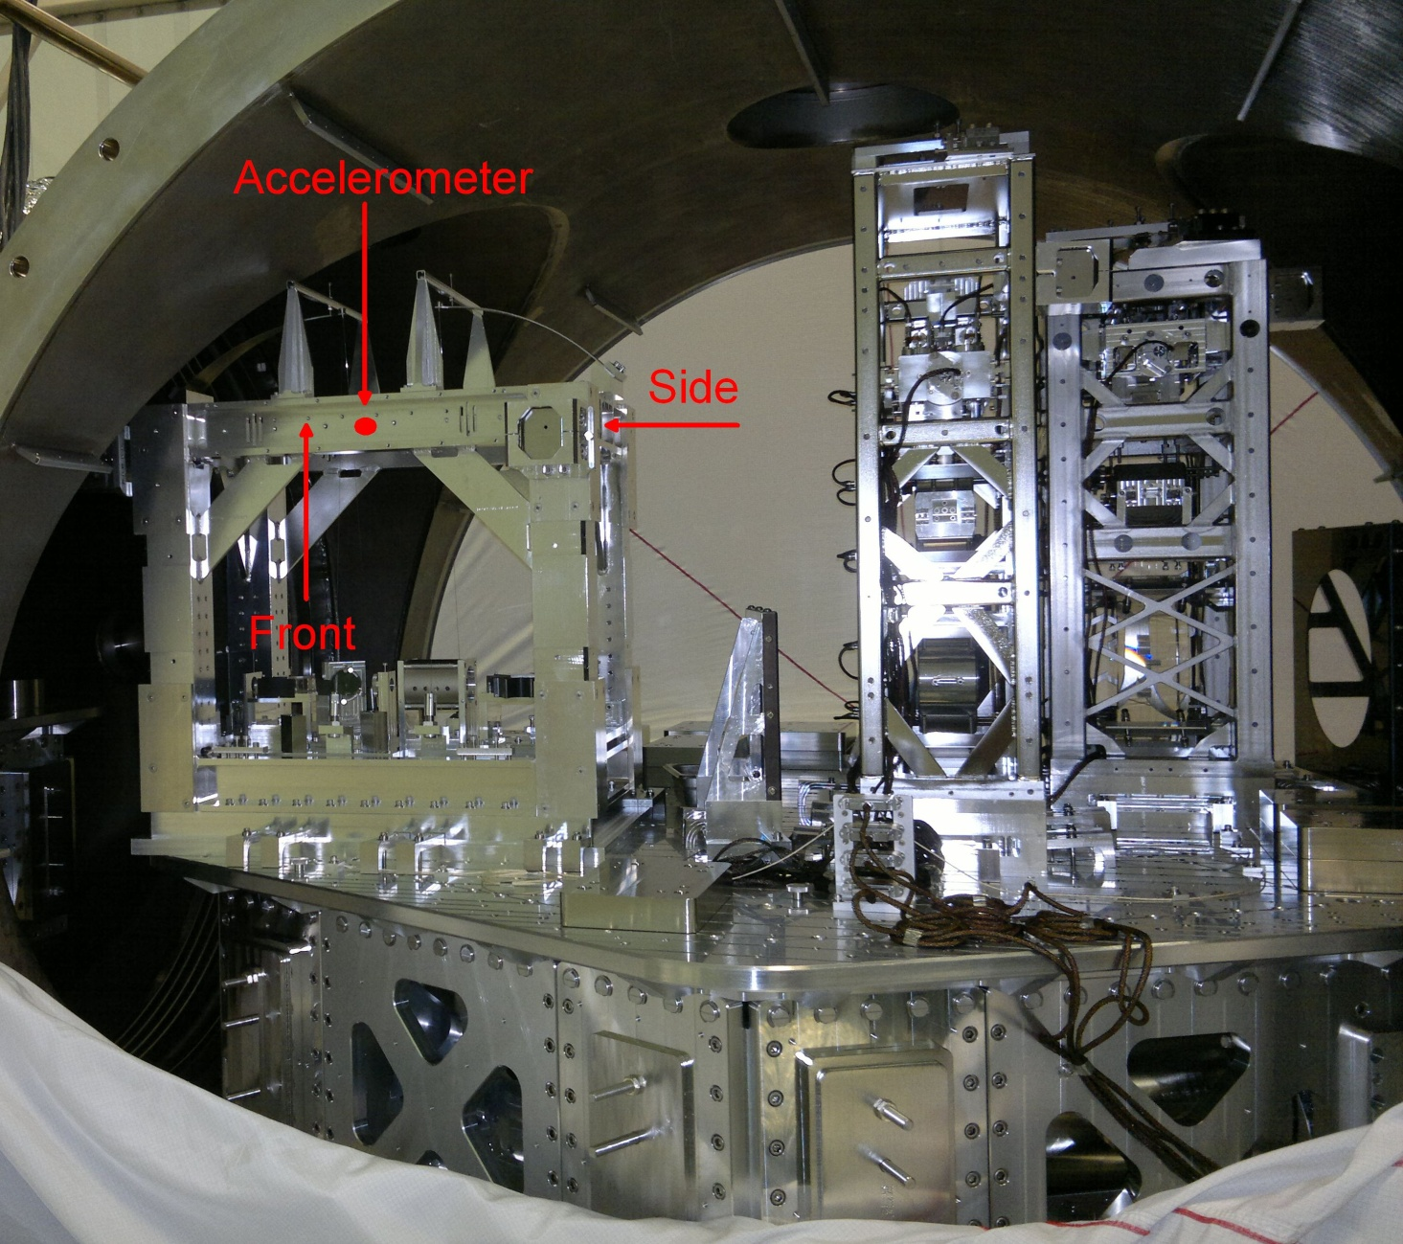

Figure : Hammer Modal Test of OFI on HAM5

The results for this measurement came from Arnaud Pele and ard described in <https://alog.ligo-wa.caltech.edu/aLOG/index.php?callRep=12175> and

Figure : Hammer Modal Test Results OFI_LLO

