LIGO Laboratory / LIGO Scientific Collaboration

LIGO- E1300368-v1 LIGO 5/14/13

Install BS Elliptical Baffle LLO BSC2 X&Y Test
Michael Smith

Distribution of this document:
LIGO Scientific Collaboration

This is an internal working note
of the LIGO Laboratory.

California Institute of Technology  LIGO Project – MS 18-34  1200 E. California Blvd.  Pasadena, CA 91125  Phone (626) 395-2129  Fax (626) 304-9834  E-mail: info@ligo.caltech.edu | Massachusetts Institute of Technology  LIGO Project – NW22-295  185 Albany St  Cambridge, MA 02139  Phone (617) 253-4824  Fax (617) 253-7014  E-mail: info@ligo.mit.edu
LIGO Hanford Observatory  P.O. Box 159  Richland WA 99352  Phone 509-372-8106  Fax 509-372-8137 | LIGO Livingston Observatory  P.O. Box 940  Livingston, LA 70754  Phone 225-686-3100  Fax 225-686-7189
http://www.ligo.caltech.edu/

1 Introduction 5
2 Acceptance Tests 6
2.1 X-Arm 6
2.1.1 Chamber Optical Alignment Test & Exit Check List 6
2.2 Y-Arm 6
2.2.1 Chamber Optical Alignment Test & Exit Check List 6

Abstract
This document presents the data for the BS Elliptical Baffle LLO BSC2 Installation Acceptance Test.

Introduction
This document presents the data for the BS Elliptical Baffle LLO BSC2 Installation Acceptance Test.

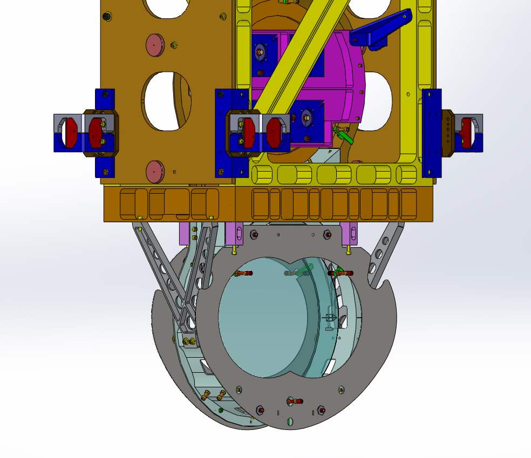
Figure 1: Model of BS Elliptical Baffles Installed on the BS SUS

Acceptance Tests

X-Arm

Chamber Optical Alignment Test & Exit Check List

Y-Arm

Chamber Optical Alignment Test & Exit Check List

