Test Date | Apr. 29-30, 2013
Author(S) | Liyuan Zhang, Margot Phelps, GariLynn Billingsley
Approval(s)
Specification Doc. | LIGO-E0900068 | Specification | < 500 ppm
Procedure Doc. | LIGO-E1000863 | Mean ± Error* | 230 ± 5 ppm
Conclusion | Qualified
* Error is the calibration error, which is ~2%.
Discussions and Comments:
The scan was carried out over aperture of 160 mm in diameter with the beam and step sizes of 1 mm. The calibration is done by normalizing the AR reflection signal to the signal with a 1” HR mirror (T=70 ppm) and the variation of power during scan is monitored and corrected, the result is summarized in Fig.1.
The shallow fringes seem to be caused by interference between the AR reflection and the tail of strong reflection of HR. Since the wedge angle is only 0.07~0.1º (D080658), the separation of the two beam was not large enough at the measurement.

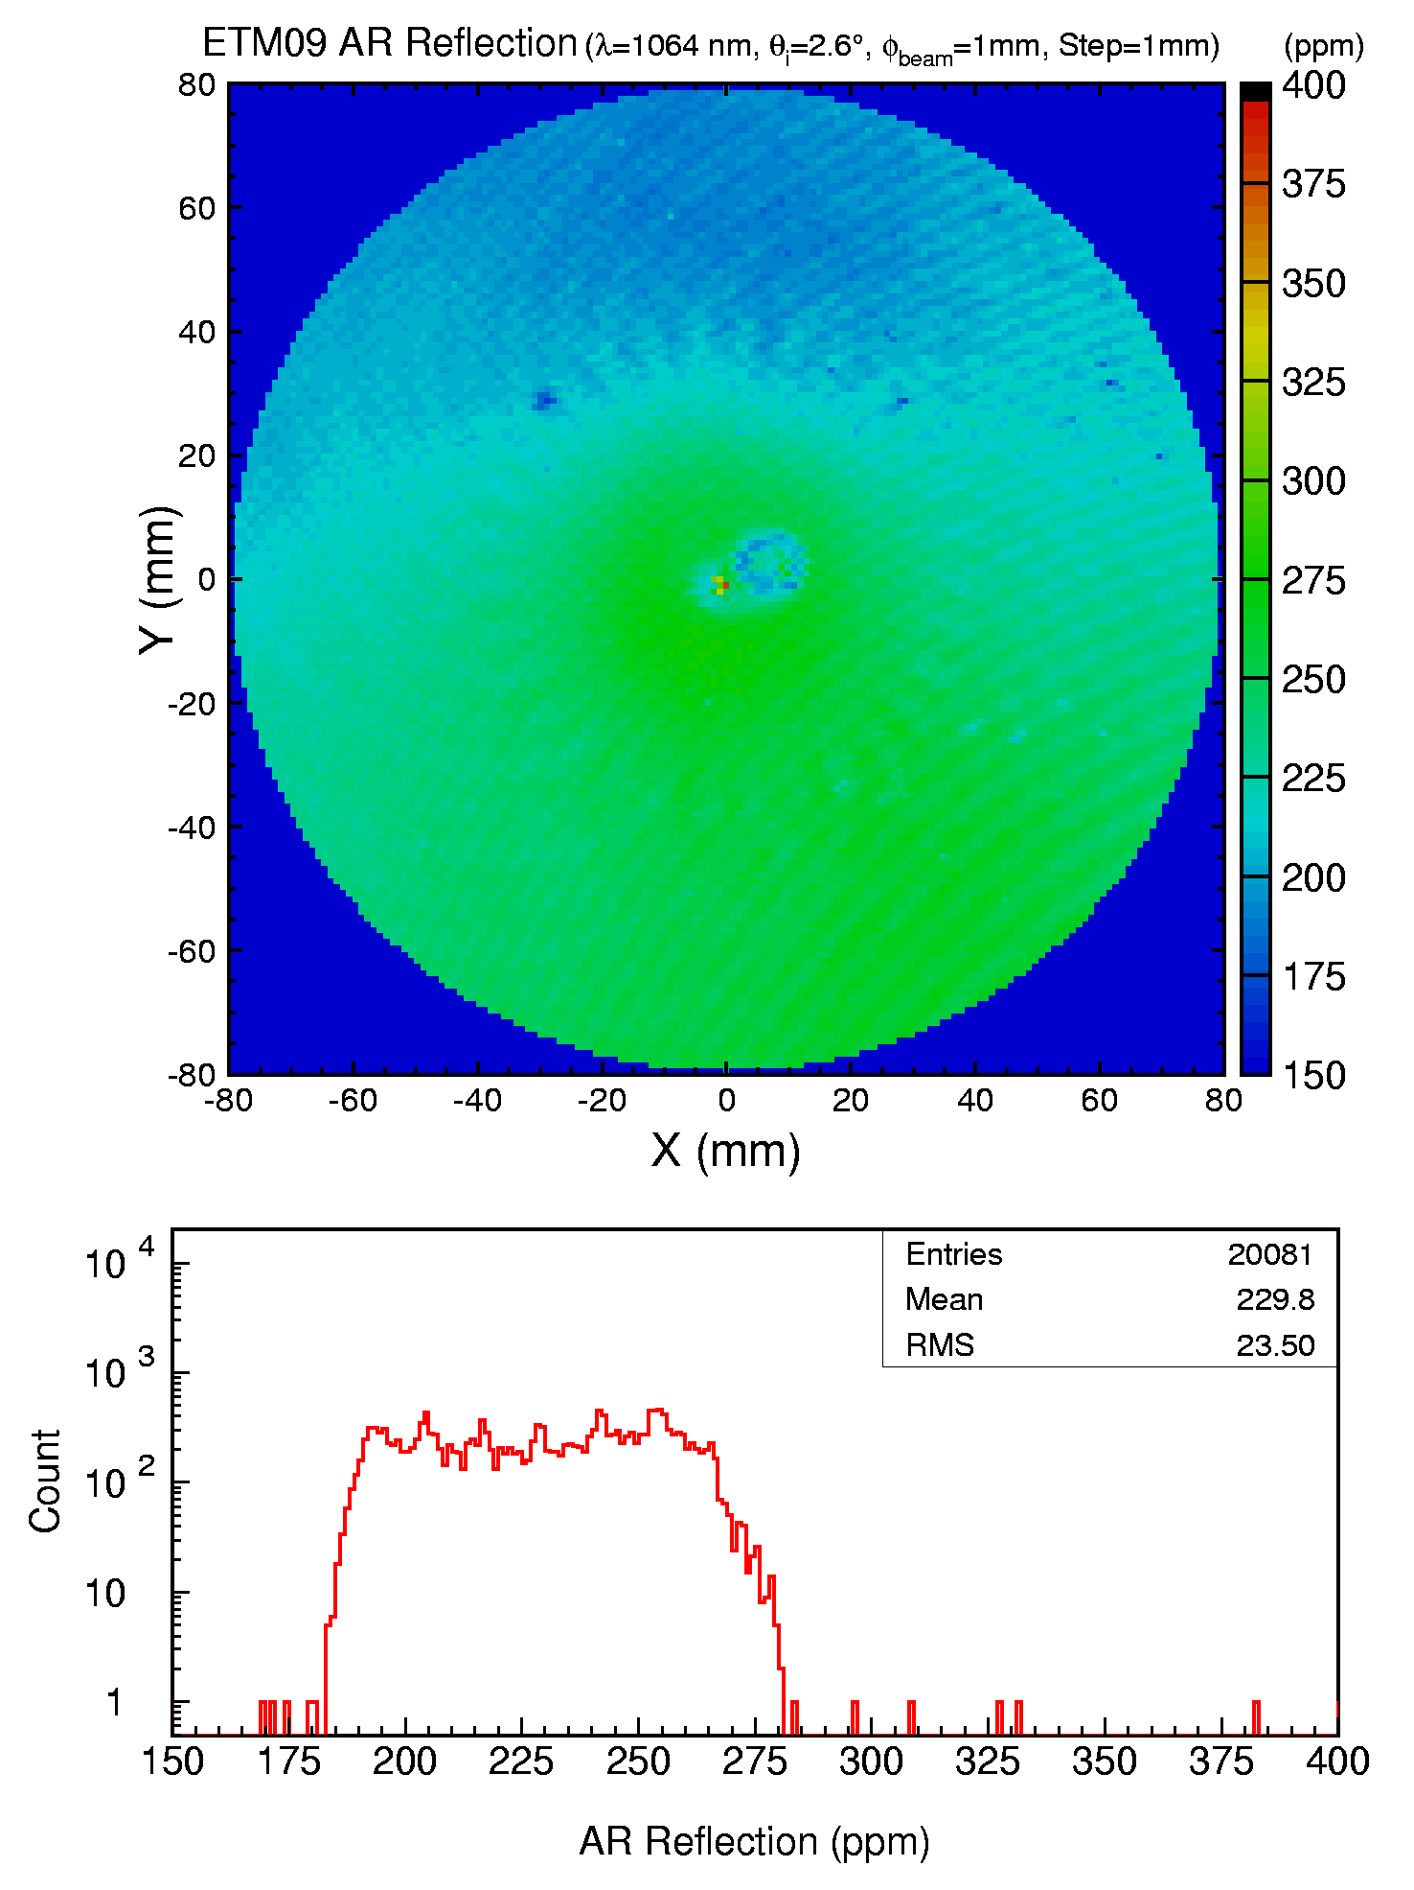
Fig. 1 ETM09 S2 AR reflection over an aperture of 160 mm in diameter.

