BS Elliptical Baffle

6/6/12

Michael Smith

BS Elliptical Baffles will be attached to opposite side of the suspension structure in the same manner as the FM Elliptical baffle is attached. The BS X Elliptical Baffle and the BS Y Elliptical Baffle have slightly different hole openings; the openings define the 210mm x 260 mm recycling cavity beam profile in the X and Y directions.

The ITM Elliptical Baffle hole will be enlarged to 224mm x 274mm, which provides a stay clear margin around the power recycling cavity beam of 7mm. 0.8 W will hit the ITM Elliptical baffle, and the scattered light displacement noise is 6.3E-26 m/rtHz.

The power that is not caught by the double baffle arrangement is the portion of the arm power that transmits through the 7 mm wide annuli from both arms, 3.7 W; this light will hit the barrel of the BS mirror. We will assume that all of the light that hits the BS barrel will reflect onto the chamber walls and scatter back into the IFO mode; the scattered light displacement noise is 6.5E-27 m/rtHz.

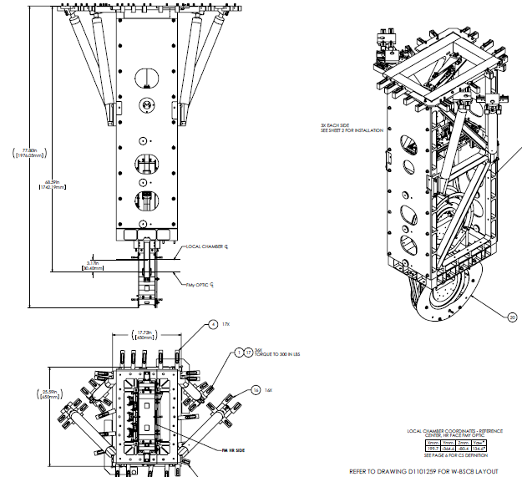

BS elliptical baffle-4.wmf

BS elliptical baffle-4.wmf

BS elliptical baffle-4.wmf