LIGO Laboratory / LIGO Scientific Collaboration

LIGO-E1300283-v3 LIGO 7/9/13

OFI Assembly & Installation Hazard Analysis

Michael Smith

Distribution of this document:
LIGO Scientific Collaboration

This is an internal working note
of the LIGO Laboratory.

California Institute of Technology  LIGO Project | Massachusetts Institute of Technology  LIGO Project
LIGO Hanford Observatory | LIGO Livingston Observatory
http://www.ligo.caltech.edu/

Table of Contents

1 Scope 5
2 Summary of Hazards for Output Faraday Isolator (OFI) Assembly and Installation 5
3 Overview of OFI 5
4 Related Documents 7
5 Hazard Analysis 7
5.1 Impact/Shock Hazards to Personnel and Equipment during Transport 7
5.2 Strain from lifting assembly 8
5.3 Sudden Release of Tensioned Blade Springs 9
5.4 Stray Laser beams 10
5.4.1 Pre-alignment 10
5.4.2 Installation Alignment 11
5.5 TGG Crystal Damage 11
6 Output Faraday Isolator Hazard Analysis Severity Table 12

Table of Figures
Figure 1: Suspended Output Faraday Isolator Assembly 6
Figure 2: OFI mounted to Installation Arm 8
Figure 3: OFI on Genie Lift Ready for Transport to HAM 9
Figure 4: Suspension Wires Could Break, Suddenly Releasing Tension in Blade Springs 10
APPROVAL SIGNATURES

___________________________________________________________
Michael Smith, SLC Date

___________________________________________________________
Lisa Austin, SLC Subsystem Leader Date

___________________________________________________________
Dennis Coyne, LIGO Chief Engineer Date

___________________________________________________________
Richard Oram, LLO Operations Manager Date

___________________________________________________________
John Worden, LHO Operations Manager Date

__________________________________________________________
Brian O’Reilly, Advanced LIGO LLO Installation Lead Date

__________________________________________________________
Michael Landry, Advanced LIGO LHO Installation Lead Date

__________________________________________________________
David Shoemaker, aLIGO Leader Date

__________________________________________________________
David Nolting, LIGO Lab Safety Officer Date

__________________________________________________________
Albert Lazzarini, LIGO Directorate Date

CHANGE LOG

Date, version | Summary of Changes
V2, 5/28/13 | - Corrected signature page  - Added reference to: E1201074-v5 Advanced LIGO Output Faraday Isolator Assembly and Alignment Procedure and E1300056-v4 Advanced LIGO Output Faraday Isolator Installation Procedure  - Updated sec. 4.0
V3, 7/9/13 | - Changed Hazard Table Item 1: “At least two people of approximately equal strength must lift assembly”

Abstract
This document covers safety concerns related to the assembly and installation of the Output Faraday Isolator (OFI) assembly in the HAM5 chamber for Advanced LIGO. It must be read before beginning the assembly and installation of the OFI, and used in conjunction with E1201074-v3 Advanced LIGO Output Faraday Isolator Assembly and Alignment Procedure and E1300056-v1 Advanced LIGO Output Faraday Isolator Installation Procedure.

Scope
This document covers safety concerns related to the assembly and installation of the Output Faraday Isolator (OFI) assembly into the HAM5 chamber for Advanced LIGO. It must be read before beginning the assembly and installation of the OFI, and used in conjunction with the E1201074-v5 Advanced LIGO Output Faraday Isolator Assembly and Alignment Procedure and E1300056-v4 Advanced LIGO Output Faraday Isolator Installation Procedure.

Summary of Hazards for Output Faraday Isolator (OFI) Assembly and Installation
The major hazards to be aware of in the assembly and installation of the OFI suspension include:
1) Moving a heavy, delicate and valuable assembly with various types of lifting and moving equipment, with potential for shock/impact if dropped or bumped, leading to the following potential failures/hazards:
a) personnel injury (crushing, pinching)
b) damage to equipment (impact), such as: failure/stretching of wires, misalignment of suspension elements, and misalignment of optical elements
2) Strain from lifting the assembly
3) Sudden release of tensioned springs
4) Laser hazard
5) Damage to TGG crystal
Each hazard is described in detail later in the document.

Overview of OFI
A Solid Works model of the Faraday Isolator suspension is shown Figure 1. The Output Faraday Isolator Assembly and Alignment Procedure is described in E1201074. The Installation Procedure is described in E1300056-v4 Advanced LIGO Output Faraday Isolator Installation Procedure.
The optical components on the optical table are isolated by a two-wire pendulum suspended from vertical blade springs. The suspended table is damped by an eddy current damping plate that mounts to the frame below the Faraday Isolator optical table. The total weight of the assembly is approximately 55 lbs.
This assembly and installation requires overall common sense and good lab practices. Personnel must have good working knowledge of how to safely use the tools associated with the build. This work also involves working in the same area as the vacuum system and lasers. All personnel must have appropriate safety training to work at a LIGO facility.
The Advanced LIGO Output Faraday Isolator Installation Procedure is described in E1300056. The procedure requires one person outside the HAM, one person inside, and one person to operate a lifting mechanism. The access door is removed from the HAM chamber side closest to the SR3 mirror. The Output Faraday Isolator is inserted through the chamber door using the HAM Installation Arm. The Output Faraday Isolator is mounted to the HAM optical table and aligned to the signal recycling cavity optical centerline by flashing the aligned PSL laser.
During the assembly and installation of the OFI, a task leader should be assigned to supervise all activities. The task leader needs to be experienced with suspensions and their accompanying hardware, and have a working knowledge of the OFI optical bench and its attached optics and hardware.
Once the installation is complete, the alignment of the OFI will be performed. Final optical alignment of the OFI requires that the PSL laser be flashed through the SRM. The OFI input and output apertures will be aligned with the IFO output beam by moving the suspension frame of the OFI and by adjusting the lengths of the suspension wires.

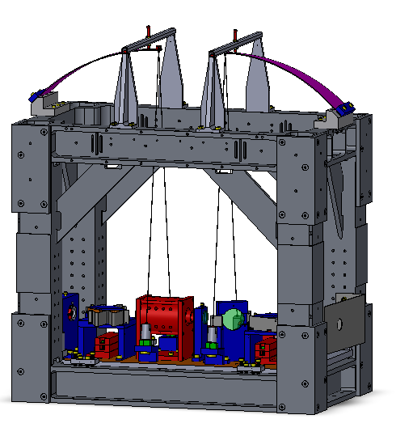
Output Aperture
Suspension Frame
Suspension Wires
Input Aperture
Tensioned Blade Spring
Blade Guard

Figure 1: Suspended Output Faraday Isolator Assembly

Related Documents
E1201074-v5 Advanced LIGO Output Faraday Isolator Assembly and Alignment Procedure
E1300056-v4 Advanced LIGO Output Faraday Isolator Installation Procedure
Advanced LIGO Safety: Processes and Guidelines (LIGO-M070360)
LIGO Project System Safety Plan (LIGO-M950046)
LIGO Contamination Control Plan (LIGO-E0900047)
aLIGO Chamber Entry/Cleaning/Exit Checklist (LIGO-E1201035)
LLO Safety Procedure documents (http://www.ligo-la.caltech.edu/contents/internalmain.htm)

Hazard Analysis

Impact/Shock Hazards to Personnel and Equipment during Transport
The complete OFI assembly, including the frame, the suspension, and the optical bench weighs approximately 100 lbs; it will be lifted from an optics table where it has been assembled and pre-aligned and hand-carried by two people to a suitable material handling device (e.g. a Genie Lift), which will be used to transport the OFI to within reach of the HAM Installation Arm; this procedure may cause a strained back. Safety Hazards when using the HAM Installation Arm are addressed in E1000252, which must be read before installing the OFI. In particular the user should take care to minimize the risk of pinching or crushing fingers.
In order to prevent injury to personnel while using the HAM Installation Arm it is also important that the Arm only be moved using the handles provided.
During transport there is a risk that the OFI might be bumped or dropped, particularly if transported in haste, or without following proper procedures for use of the material handling equipment.

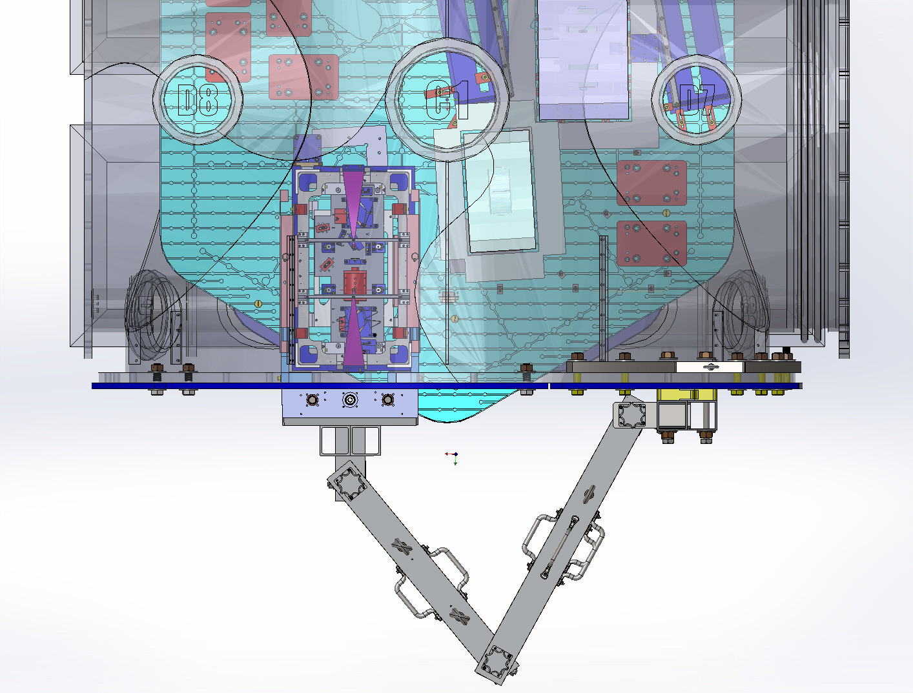
Figure 2: OFI mounted to Installation Arm

Strain from lifting assembly
See section 5.1.

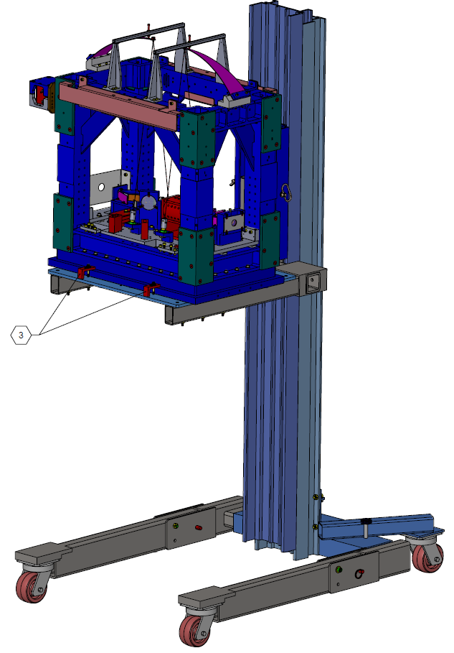

Figure 3: OFI on Genie Lift Ready for Transport to HAM

Sudden Release of Tensioned Blade Springs
The OFI utilizes two blade springs that are placed under tension during its assembly. The two springs are each loaded with approximately 12 lbs by the suspended components. In the event that the tension in the springs should suddenly be released, the blade guards on top of the OFI, shown in Figure 1, will prevent the springs from traveling upward by more than a fraction of an inch. However, safety glasses must be worn at all times when the springs are under tension to prevent injury in the unlikely event that a wire breaks or a wire clamp slips, resulting in the release of a fast moving wire end or shrapnel. Laser safety glasses may be worn in lieu of regular safety glasses when a laser hazard is present.

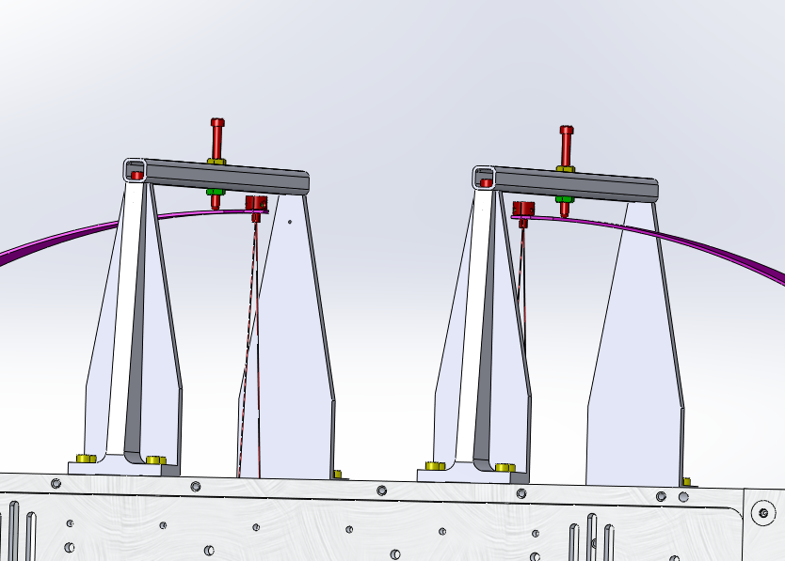
Figure 4: Suspension Wires Could Break, Suddenly Releasing Tension in Blade Springs

Stray Laser beams

Pre-alignment
The OFI optical table with its installed components will be pre-aligned in a clean optics lab at the IFO site, as described in Output Faraday Isolator Assembly and Alignment Procedure (E1201074). The alignment will require the use of an alignment laser and various steering mirrors and other optical devices for positioning and detecting the reflected and transmitted laser beam through the Faraday Isolator. The alignment laser presents a laser eye hazard, and an appropriate laser safe operating procedure must be followed. See LIGO-M080108 NPRO Laser Operating in the OSB Optics Lab.

Installation Alignment
The OFI suspension frame will be located initially on the HAM optical table by the use of positioning templates. The OFI optical table will be aligned subsequently in situ in the IFO by using well-aligned light from the IFO PSL beam to provide an aligned output beam through the SRM; this can be single arm lock, bright Michelson, or single-bounce misaligned—only 10 mW are necessary. Refer to the Advanced LIGO Output Faraday Isolator Installation Procedure (E1300056).
The signal beam presents a laser eye hazard. Follow standard LIGO laser safety procedures.

TGG Crystal Damage
Steel tools, and potentially steel fasteners and steel suspension wires, represent a continuing hazard when in proximity to the OFI, and must not be used in the vicinity of the Faraday Rotator magnet housing because the intense magnetic field may attract the tool through the opening of the housing and damage the TGG crystal. Titanium Allen wrenches must be used for attaching all items to the OFI optical bench.
Likewise, avoid inserting any object through the opening of the magnet housing because that may damage the TGG crystal.

Output Faraday Isolator Hazard Analysis Severity Table

Item # | Hazard | Cause | Effect | Unmitigated  Severity | Unmitigated  Probability  Level | Unmitigated Risk Index | Comment | Mitigation | Mitigation Severity | Mitigated Probability Level | Mitigated Risk Index
1 | Strain from lifting heavy assembly | Lifting heavy assembly without support | Injury to personnel, damage to equipment | marginal | occasional | 3C | Total assembly weighs 96 lbs | At least two people of approximately equal strength must lift assembly | minor | improbable | 4E
2 | Failure of HAM Installation Arm | Failure to inspect equipment | Injury to personnel, damage to equipment | critical | occasional | 2D |  | Inspect equipment prior to use | minor | remote | 4D
3 | Sudden release of tensioned springs | spontaneous failure of wire, wire releasing from wire clamps | Injury to personnel, damage to equipment | critical | remote | 2D | Blade springs are loaded with 12 lbs of tension each | Guards installed above springs limit their movement when not under tension, safety glasses will prevent eye injury in the case of fast moving wire end or shrapnel | minor | remote | 4D
5 | Laser hazard | Direct or reflected laser beam entering eye | Retinal damage | critical | occasional | 2C |  | Follow standard LIGO laser safety procedures | minor | remote | 4E
6 | Damage to TGG crystal | Magnet attracting magnetic tools | Damage to TGG crystal | critical | occasional | 2C |  | Use Titanium allen wrench | minor | remote | 4E

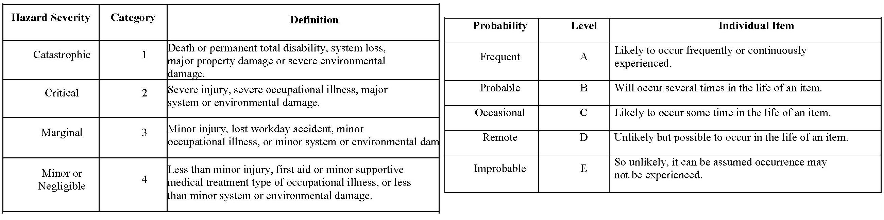

 |  |  | PROBABILITY
SEVERITY OF | E | D | C | B | A
CONSEQUENCE | Improbable | Remote | Occasional | Probable | Frequent
1
Catastrophic
2
Critical
3
Marginal
4
Negligible
Hazard Risk Index |  |  | Risk Code Criteria
1A, 1B, 1C, 2A, 2B, 3A |  | Unacceptable
1D, 2C, 2D, 3B, 3C |  | Undesirable (Directorate decision required)
1E, 2E, 3D, 3E, 4A, 4B |  | Acceptable with review by Directorate
4C, 4D, 4E |  | Acceptable without review

