LIGO Laboratory / LIGO Scientific Collaboration

LIGO-T1300175-v3 Advanced LIGO 10/14/2013

Installation of TwinCAT Targets

Daniel Sigg

Distribution of this document:
LIGO Scientific Collaboration

This is an internal working note
of the LIGO Laboratory.

California Institute of Technology  LIGO Project – MS 18-34  1200 E. California Blvd.  Pasadena, CA 91125  Phone (626) 395-2129  Fax (626) 304-9834  E-mail: info@ligo.caltech.edu | Massachusetts Institute of Technology  LIGO Project – NW22-295  185 Albany St  Cambridge, MA 02139  Phone (617) 253-4824  Fax (617) 253-7014  E-mail: info@ligo.mit.edu
LIGO Hanford Observatory  P.O. Box 159  Richland WA 99352  Phone 509-372-8106  Fax 509-372-8137 | LIGO Livingston Observatory  P.O. Box 940  Livingston, LA 70754  Phone 225-686-3100  Fax 225-686-7189
http://www.ligo.caltech.edu/

Introduction
This document describes the installation of a PLC target on a LIGO TwinCAT computer. This is facilitated by a set of powershell scripts. Some knowledge of the coding standard described in LIGO-E1200225 may be required, in particular, the directory structure.

Subversion Archive
All source code and configuration scripts are located in a subversion archive. In order to keep track of the program changes, the subversion number is transferred into the running code and made available to the user. This requires that the source code archive, which is usually located at C:\SlowControls is fully checked out prior to compiling the target code. The installation script will enforce this rule.

Code Organization
The source code is organized in two major directory trees: the library tree and the slightly misnamed source tree. Both are located within the C:\SlowControls\TwinCAT directory. The PLC projects are located within the Source\Current\Interferometer. For each PLC usually only two project files are required for the corner and end stations, respectively. The corner PLC projects are located in Interferometer\Corner, whereas the end station projects are found in Interferometer\End.
PLC projects are numbered, i.e., PLC1, PLC2, PLC3 and PLC4. The associated project files are named PLC1.pro and similar. Each PLC has set of external global variables which are defined in Interferometer\Version.exp to support exporting the source code subversion number and in Interferometer\Corner\IfoVar.exp for including target and location information. A corresponding file for the end stations can be found in Interferometer\End\IfoVar.exp. These are specific files intended for testing only. By default the interferometer constant is set to T1 and the end station is set to X.
The generic import files are located in Source\Current\Import. They are not directly readable by the project but have to be parsed by the installation script first.

Scripts
The installation scripts are located in C:\SlowControls\Scripts\Common. These are powershell scripts to copy the source code into the target director, to compile, activate and run the project, as well as generate the EPICS database.

Configuration
The target configuration uses a number of configuration scripts which are located in C:\SlowControls\Scripts\Configuration. The scripts themselves are also written in powershell. However, the Configuration directory also requires a subdirectory for each target. The target names are of the form H1ECATX1 and describe the computer which is running the PLC. Each target directory requires a subdirectory for each PLC as well as one for the system. The names are PLC1, PLC2, PLC3, PLC4 and SYS. Only the PLC directories which have an associated project should be defined. The subdirectory structure in the Configuration directory is used by the installation scripts to determine what targets are available and which are valid. One should not add other directories within this structure.
The Configuration directory contains a setup_all script which is run first as part of the configuration. Generally, this script does not need to be changed. It sets up the various top level paths for source and installation.
Each target directory must contain setup_target scripts which is ran as part of the target configuration. This scripts contains information specific to the target and must be updated for each target individually. It is also possible to define setup_plc scripts in each PLC subdirectory to run a PLC specific setup scripts. But, in general this is not required, since the PLC number is sufficient to separate the individual PLCs.

The TwinCAT system file
Each computer that runs TwinCAT requires a system configuration file, the .tsm file. The system configuration file contains the information about the attached hardware and it links the hardware to the PLC variables. The system configuration is target specific—even so it should be nearly identical between the same targets on different interferometers. However, there can be differences in the hardware such as firmware reversions. Therefore, the system configuration file for each target computer is located in the SYS directory of the target. For instance, the system configuration file for H1ECATX1 is located in Configuration\H1ECATX1\SYS and typically named H1ECatX1.tsm.

Target Installation
The files for each target are getting installed in the target path which is C:\SlowControls\Target. Each target has its own subdirectory in the target installation path. In turn each PLC has its own subdirectory within the target installation path. The subdirectory in the target installation path reflects the directory structure in the Configuration directory. However, only targets that have been previously installed on the system will have their subdirectory generated in the installation path.
The installation path is not under subversion control. No permanent non-deletable file shall be stored in the target installation path. Any file in the target installation directory must be generated from the source, or copied from the source archive.

Changes applied to system and project files in the installation target path will be overwritten the next time the installation scripts are running!

Configure a Target
An excerpt of the top level setup_all script is shown below:

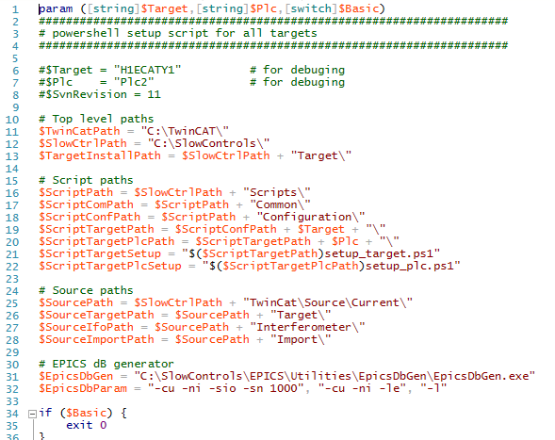

It shows the setup for most of the paths and files used by the installation. This script is run for all targets and there should be no reason to change it.

Each target contains a setup_target scripts which defines target and location. A typical setup-target script is shown below:

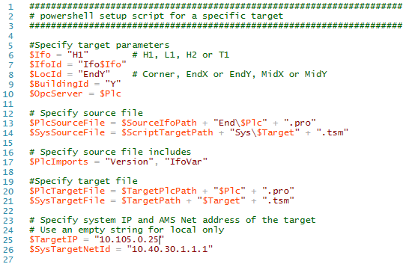
If a new target is created, this script can be copied from another target. But, the parameters need to be updated to reflect the actual target. As a minimum the $Ifo, $LocId, $PlcSourceFile, $PlcImports, $TargetIP and $SysTargetNetId parameters need to be set.
The $TargetIP is the IP address of the system on the external network.
The $SysTargetNetId parameter is the AMS net ID of the system. It can be interrogate using the TwinCAT Configure tool. If the system is remote, the AMS routes on both systems have to be set correctly as well.

Installation
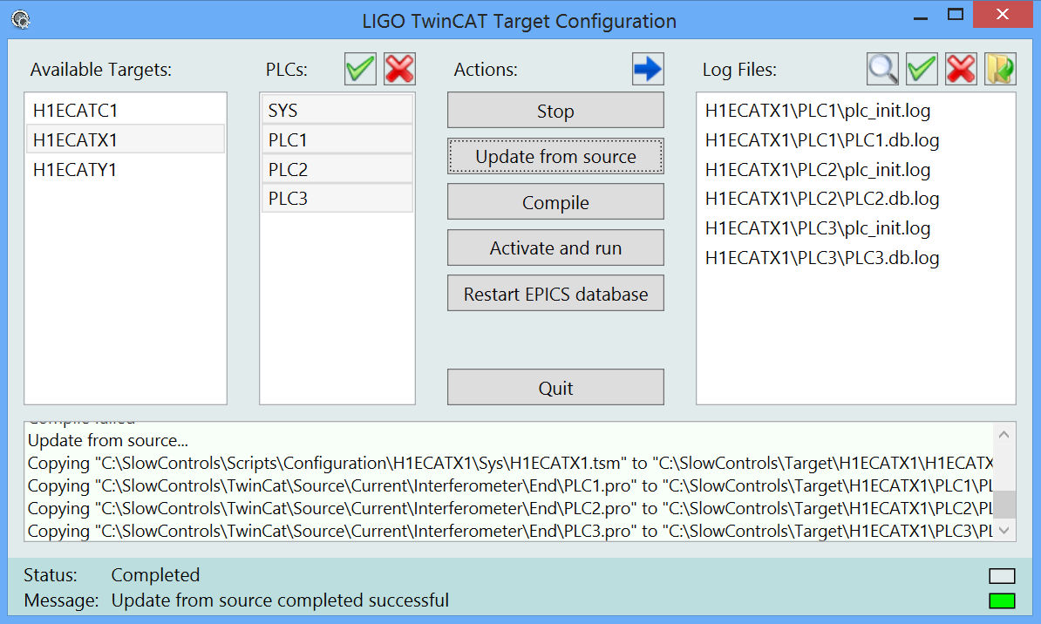
A graphical user interface is available to guide the user through the installation of a target.

Status Information
The bottom of the window contains a textbox which shows the outputs of the recently run installation scripts. A scrollbar lets the user page back. At startup this textbox is empty.
At the very bottom there are status and message lines. The status lines describes the current action. If a script is running, the color box on the right changes to green. A red box indicates an error. It will typically disappear after 10 seconds and be replaced by the grey box indicating an inactive state. The message line is used to indicate the result of the most recently run installation script. If the color box is red an error has occurred. A successful action is indicated with a green box.

Target and PLC Selection
To the left one has to choose the target and PLC(s). Only one target can be selected at a time, but multiple PLCs are allowed. The buttons above the PLC listbox select and deselect all of the available PLCs, respectively. Only targets and PLCs which have a corresponding subdirectory entry defined in the Configuration directory are shown.

Actions
Available actions are Stop, Update from source, Compile, Activate and run, and Restart EPICS database. If an action button is pressed, the requested action is applied to the selected target with the selected PLCs. Each action will run a corresponding powershell script which is located in the Scripts\Common directory. The output of the script is shown in the textbox below.

Stop
This action stops all tcIoc shells. It is preferred to type exit in the command window to cleanly terminate the tcIoc shell.

Update from Source
Copies the source files into the target directory.

Compile
For PLCs this action sets the global variables in the source project to reflect the actual target. It compiles the project, writes a local boot project file. For SYS this generates the startup files for the tcIoc shell. The target directory contains a start.bat file which can be called manually at boot time. Channel lists for DAQ, burt restore, etc. are generated automatically when the tcIoc is started.
The toggle button with the blue arrow allows the user to proceed with compilation, even if the subversion archive has not been fully checked out or committed. This is for testing and debugging only, and the subversion number of the compiled PLC will be set to 0. Production code requires a fully checked out subversion archive to allow source code tracking.

Activate and run
This will activate the configuration and restart the system manager when the Sys target is selected. For the PLC targets the action performs a login and creates the target boot project.

Restart EPICS database
This will stop all tcIoc shells for the selected target prior of restarting them. The tcIoc shell when started scans the target tpy files and generates the EPICS database and the channel lists for DAQ, burt request, opc and users. Only one tcIoc is started for each target.

Quit
This button quits the GUI immediately. Any running actions will be aborted.

Log Files
Some actions generate a log file. These are shown in the list box to the right. They can be opened in a text editor by double clicking on the name, or by selecting one or multiple names and then press the file open button just above. There are also buttons to select and deselect all log files at once. When the toggle button with the magnification glass is pressed, only log files associated with the selected target and PLCs are shown in the listbox.

Dependencies
The installation process will try to make sure that a correct code is loaded into the target PLC. To facilitate correct order the following dependencies are enforced:

Stop | None.
Update from source | None
Compile | The project file target directory is newer than the one in the source path.
Compile | The subversion archive has to be fully checked out unless the blue arrow button is toggled on.
Activate and run | The boot file generated by the compile process is newer than the project file.
Restart EPICS database | None.

Boot Initialization
During the activation of a PLC project a boot project gets created. The boot projected is used for initializing the PLC when the computer is restarted and when it is enabled in the TwinCAT System Property.

TwinCAT System Properties
Start the TwinCAT System Property dialog box by calling C:\TwinCAT\TCATSysCtrl.exe or through the TwinCAT tray icon. First, open the AMS Routing tab and check the AMS Net Id of the local computer. The designated Net Id is listed in LIGO-E1101144. It should look like the top left snapshot in the table below. If you change the Net Id, the computer has to be rebooted. Next, set up the routing information for the other TwinCAT remote computers on the network.
Secondly, go to the PLC tab and enable the run-time systems for both the boot project and the retain data. The enabled run-time systems must correspond to the PLCs which are running on the system. In the example below these are PLC1, PLC2 and PLC3.
Thirdly, open the system tab and enable auto-boot. Finally, check auto-logon and provide the user credentials. LIGO typically runs the PLCs from the controls account.
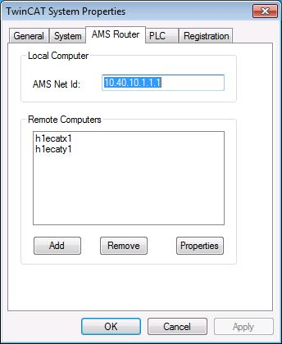 | 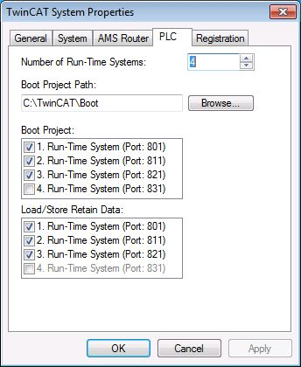
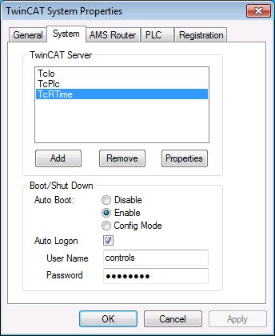

Starting the TwinCAT Ioc
Compiling the SYS “PLC” generates the ‘st.cmd’, the ‘start.bat’ and ‘start_tcioc.ps1’ files as well as the ‘start_tcioc’ shortcut in the target installation directory. It should look like
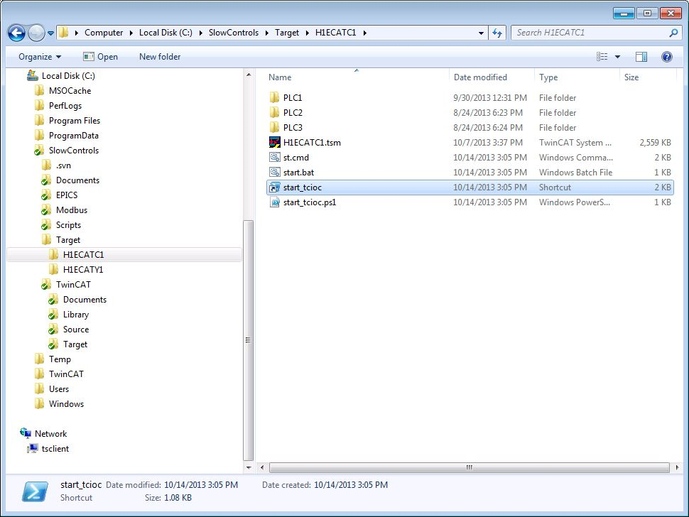
Use the start_tcioc shortcut to start the TwinCAT ioc by hand, after making sure that any previously running TwinCAT ioc has been terminated. To automatically start the TwinCAT ioc upon booting the system, copy this shortcut into the Startup folder.
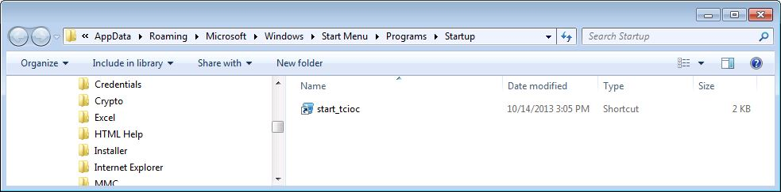
Test the configuration by rebooting the system and checking that the system manager, all active PLCs and the TwinCAT ioc are all running. Finally, check if EPICS channels are accessible from the control room workstations.

