LIGO Laboratory / LIGO Scientific Collaboration

LIGO- E1300146-v1 advanced LIGO 2/22/2013

TECController Library Documentation

Sheila Dwyer

Distribution of this document:
LIGO Scientific Collaboration

This is an internal working note
of the LIGO Laboratory.

California Institute of Technology  LIGO Project – MS 18-34  1200 E. California Blvd.  Pasadena, CA 91125  Phone (626) 395-2129  Fax (626) 304-9834  E-mail: info@ligo.caltech.edu | Massachusetts Institute of Technology  LIGO Project – NW22-295  185 Albany St  Cambridge, MA 02139  Phone (617) 253-4824  Fax (617) 253-7014  E-mail: info@ligo.mit.edu
LIGO Hanford Observatory  P.O. Box 159  Richland WA 99352  Phone 509-372-8106  Fax 509-372-8137 | LIGO Livingston Observatory  P.O. Box 940  Livingston, LA 70754  Phone 225-686-3100  Fax 225-686-7189
http://www.ligo.caltech.edu/

Library
Title | TECController
Version | 1
TwinCAT version | 2.11.2230
Name space
Author | Sheila Dwyer
Description | Controls the temperature of an SHG oven, using Beckhoff modules EL3692 to measure the temperature using a 10kOhm thermistor (epcos PN: B57861S0103F040), EL3102 to sense the temperature and a TEC from Laird technologies, HOT20, 31, F2A, 0909 and EL4132 for TEC outputs.  The TEC is installed in the SHG with the wider side facing upwards, as shown in the picture. This is because the data sheet indicates that the narrower side should be the cool side.  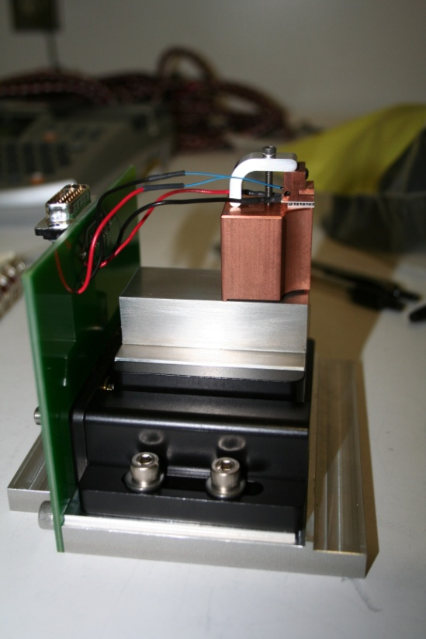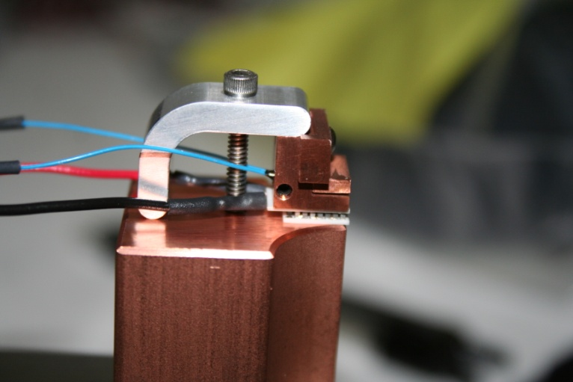  With the unity gain frequency of the servo set to 5Hz, the overshoot is about 20%, so this is a good nominal setting.
Error Codes | 0x0001 – Thermistor resistance too high (open)  0x0002 - Thermistor resistance too low (short)  0x0003 - TEC Voltage too high  0x0004 – TEC Current is too high  0x0005 – TEC power dissipated if too high  0x0006 – Integrator limit is exceeded (currently integrator limit is 100V)  0x0007 – Thermistor data invalid  0x0008 – Thermistor measurement error
Library Dependencies | SaveRestore, Error, ReadADC, WriteADC

Hardware Input Type
TYPE TECControllerInStruct :
STRUCT
ThermStatus: ThermStatusStruct;
ThermValue: REAL;
TECVoltageReadback: INT;
TECCurrentReadback: INT;
END_STRUCT
END_TYPE
Type name | TECControllerInStruct
Description | Hardware inputs
Definition
Element | Name: ThermStatus  Type:ThermStatusStruct  Description: Structure of status indicators for resistance measurement module EL3692
Element | Name: ThemValue  Type: REAL  Description: resistance of thermistor
Element | Name: TECVoltageReadback  Type: INT  Description: readback of voltage across the TEC

Hardware Input Type
{copy type definition here}
Type name
Description
Definition
Element | Name:  Type:  Description:
Element | Name:  Type:  Description:
Element | Name:  Type:  Description:

Hardware Output Type

TYPE TECControllerOutStruct :
STRUCT
ThermControl: ThermControlStruct;
TECVoltageSet: INT;
END_STRUCT
END_TYPE
Type name | TECControllerOutStruct
Description | Hardware outputs
Definition | STRUCT
Element | Name: ThermControl  Type: ThermControlStruct  Description: Structure of control bits for EL3692
Element | Name: TECVoltageSet  Type:INT  Description: voltage sent to the TEC (in units of volts over the TEC, the gain of the controller board is taken out in the code)

User Interface Type
TYPE TECControllerStruct :
STRUCT
Error: ErrorStruct;
ThermistorTemperature: LREAL;
(*~(OPC : 1 : Make variable visible for OPC-Server) (OPC_PROP[005] : 3 : OPC_PROP_RIGHTS)
(OPC_PROP[0100] :C: Unit) (OPC_PROP[0101] :Temperature measured by thermistor: Description)
(OPC_PROP[0102] :40: HOPR)
(OPC_PROP[0103] :15: LOPR)*)

TECVoltageBack: LREAL;
(*~(OPC : 1 : Make variable visible for OPC-Server)
(OPC_PROP[005] : 1 : OPC_PROP_RIGHTS)
(OPC_PROP[0100] :V: Unit)
(OPC_PROP[0101] :Readback of voltage across TEC: Description)*)
TECCurrentBack: LREAL;
(*~ (OPC : 1 : Make variable visible for OPC-Server) (OPC_PROP[005] : 1 : OPC_PROP_RIGHTS)
(OPC_PROP[0100] :Amps: Unit)
(OPC_PROP[0101] :Readback of current across TEC: Description) *)
TECVoltsOut: LREAL;
(*~ (OPC : 1 : Make variable visible for OPC-Server) (OPC_PROP[005] : 3 : OPC_PROP_RIGHTS) (OPC_PROP[0100] :V: Unit)
(OPC_PROP[0101] :Voltage across TEC setting: Description)*)
Fault: BOOL;
(*~(OPC :1: Make variable visible for OPC-Server)
(OPC_PROP[005] :1: OPC_PROP_RIGHTS)
(OPC_PROP[0101] :Fault: Description)
(OPC_PROP[0106] :Fault: ONAM)
(OPC_PROP[0107] :None: ZNAM)*)
SetTemp: LREAL:=35;
(*~ (OPC : 1 : Make variable visible for OPC-Server)
(OPC_PROP[005] : 3 : OPC_PROP_RIGHTS)
(OPC_PROP[0100] :C: Unit)
(OPC_PROP[0101] :Set Temperature: Description)*)

Servo: BOOL;
(*~(OPC :1: Make variable visible for OPC-Server)
(OPC_PROP[005] :3: OPC_PROP_RIGHTS)
(OPC_PROP[0101] :PI Servo: Description)
(OPC_PROP[0106] :On: ONAM)
(OPC_PROP[0107] :Off: ZNAM)*)
UnityGain: LREAL:=5;
(*~ (OPC : 1 : Make variable visible for OPC-Server) (OPC_PROP[005] : 3 : OPC_PROP_RIGHTS)
(OPC_PROP[0100] :: Unit)
(OPC_PROP[0101] :Proportional term of PI controller: Description) *)
ClearInt: BOOL;
(*~ (OPC : 1 : Make variable visible for OPC-Server)
(OPC_PROP[005] : 3 : OPC_PROP_RIGHTS)
(OPC_PROP[0106] :Clear: ONAM)
(OPC_PROP[0107] :Integrator On: ZNAM) *)

OldControlSig: LREAL;
(*~ (OPC : 1 : Make variable visible for OPC-Server)
(OPC_PROP[005] : 3 : OPC_PROP_RIGHTS ) (OPC_PROP[0100] :: Unit)
(OPC_PROP[0101] :Control Signal from last servo cycle: Description)*)
END_STRUCT
END_TYPE
Type name | TECControllerStruct
Description | User interface inputs and outputs for TECController
Definition | STRUCT
Input tags | Name: Error  Type: ErrorStruct  Description: for use by error handler
Input tags | Name: ThermistorTemperature  Type: LREAL  Description: Temperature (in C) measured by thermistor
Input tags | Name: TECVoltageBack  Type:LREAL  Description: Voltage readback, in units of volts over TEC
Output tags | Name: TECCurrentBack  Type:LREAL  Description:TEC Current readback
Output tags | Name: TECVoltsOut  Type:LREAL  Description:Volts sent to TEC, in units of volts over TEC
Output tags | Name: Fault  Type:BOOL  Description: Is there an error condition that required output voltage to go to zero?
Output tags | Name:SetTemp  Type:LREAL  Description: Temperature setting for servo
Output tags | Name:Servo  Type:BOOL  Description: Is the servo on?
Output tags | Name:UnityGain  Type: LREAL  Description: unity gain setting for servo
Output tags | Name:ClearInt  Type:BOOL  Description: Allows the user to clear the integrator, in case the servo gets into a bad state where the integrator value is too high.
Output tags | Name:OldControlSig  Type:LREAL  Description: TECVoltsOut from last cycle in which the servo was on. This is saved so that when the servo is turned on again, it will initialize with the old value.

Type
TYPE ThermStatusStruct :
STRUCT
UnderRange: BOOL;
OverRange: BOOL;
ExtenRange: BOOL;
DataInvalid: BOOL;
RangeInvalid: BOOL;
AutoRangeDis: BOOL;
Error: BOOL;
SteadyState: BOOL; (*if last 4 values no more than x/1024 of end value apart, this is true*)

END_STRUCT
END_TYPE
Type Name | ThermStatusStruct
Description | Status inputs from EL3692
Definition
Element: | Name: UnderRange  Type:BOOL  Description: the resistance is under the range
Element: | Name: OverRange  Type:BOOL  Description: the resistance is over the range
Element: | Name: ExtenRange  Type:BOOL  Description: the EL3692 is using its extended range
Element: | Name: DataInvalid  Type:BOOL  Description:
Element: | Name: RangeInvalid  Type: BOOL  Description: the range specificed is invalid
Element: | Name: AutoRangeDis  Type:BOOL  Description: disable autorange
Element: | Name: Error  Type:BOOL  Description:
Element: | Name: SteadyState  Type: BOOL  Description: The last four measurements are all within x.1% of the end value

Type
TYPE ThermControlStruct :
STRUCT
DisableAutoRange: BOOL;
Mode: BYTE;
Range: SINT;

END_STRUCT
END_TYPE
Type Name | ThermControlStruct
Description | Structure that controls EL3692
Definition
Element: | Name: DisableAutoRange  Type:BOOL  Description: disables autorange
Element: | Name: Mode  Type:BYTE (maos to 4BIT)  Description: indicates mode, 2 resistor measurement or 1, single shot or continuous measurements
Element: | Name: Range  Type:SINT  Description: Allows user to set the range

Function Block
FUNCTION_BLOCK TECControllerFB
VAR_INPUT
Request: SaveRestoreEnum;
TECControllerIn: TECControllerINStruct;
END_VAR
VAR_OUTPUT
TECControllerOut: TECControllerOutStruct;
END_VAR
VAR_IN_OUT
TECControllerInit: TECControllerStruct;
TECController: TECControllerStruct;
END_VAR
VAR
ErrorHandler: ErrorHandlerFB;
ConvertRtoT: RtoTempFB;
ErrorCheck: ErrorCheckFB;
PIServo: PIServoFB;
END_VAR
Name | TECControllerFB
Description | Main temperature controller function block
Input argument | Name: Request  Type:SaveRestoreEnum  Description: Request for save/restore/safemode or noop.
Input argument | Name: TECControllerIn  Type: TECControllerInStruct  Description: Hardware inputs
Output argument | Name: TECControllerOut  Type: TECControllerOutStruct  Description: Hardware outputs for TECController
In/Out argument | Name: TECController  Type: TECControllerStruct  Description: User interface
In/Out argument | Name: TECControllerInit  Type: TECControllerStruct  Description: User interface variables to initialize to if power is lost

Visual
{copy screen snapshot here}
Name
Description
Placeholder | Name:  Type:  Description:
Placeholder | Name:  Type:  Description:
Placeholder | Name:  Type:  Description:

