Pcal Photodiode Head (D1300210-v6)
The board is meant to fit in the existing Pcal photodiode head housings.

Changes from D1300210-v5
This board revision has the following explicit changes from the previous version.
- Solder pad for the AD590 temperature transducer sensing element.
- A (mostly) isolated pad around the 3mm photodiode is connected to the solder pad for the AD590. Hopefully this might give a better indication of the photodiode temperature rather than the temperature of the whole circuit board.
- A guard ring is placed around the inputs of U1. This might help reduce any offsets caused by currents from VEE.
- U2 is configured as a non-inverting buffer in case extra gain is required.
- The power supply bypassing for U1 has changed.

Top view

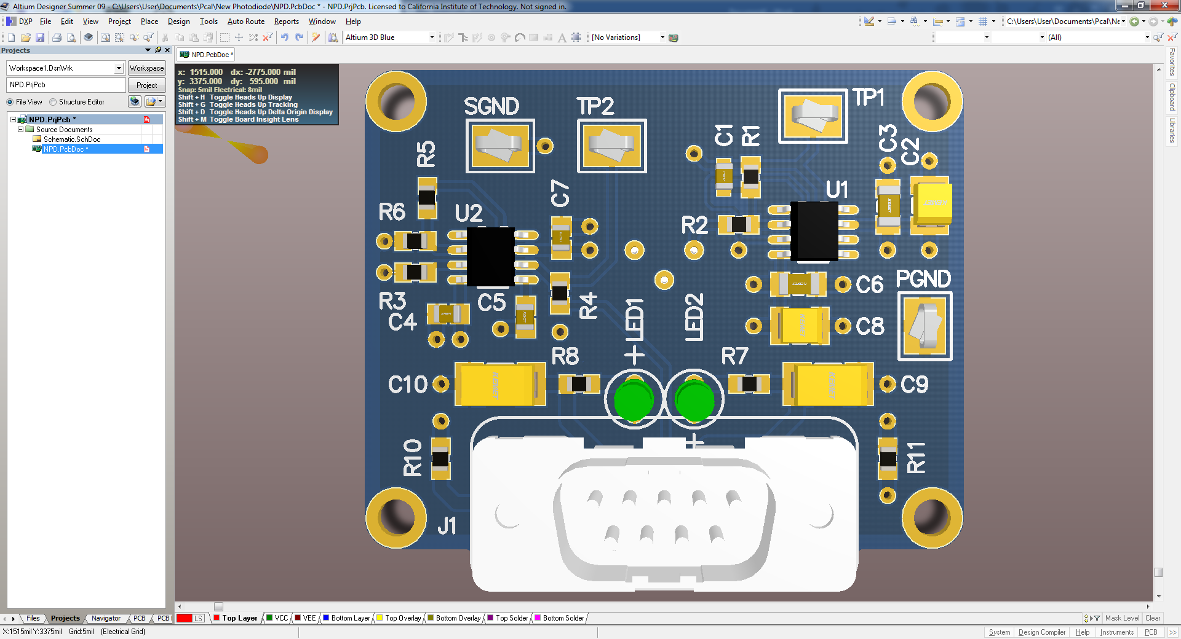
Figure 1. Top view of the board.

Guard ring

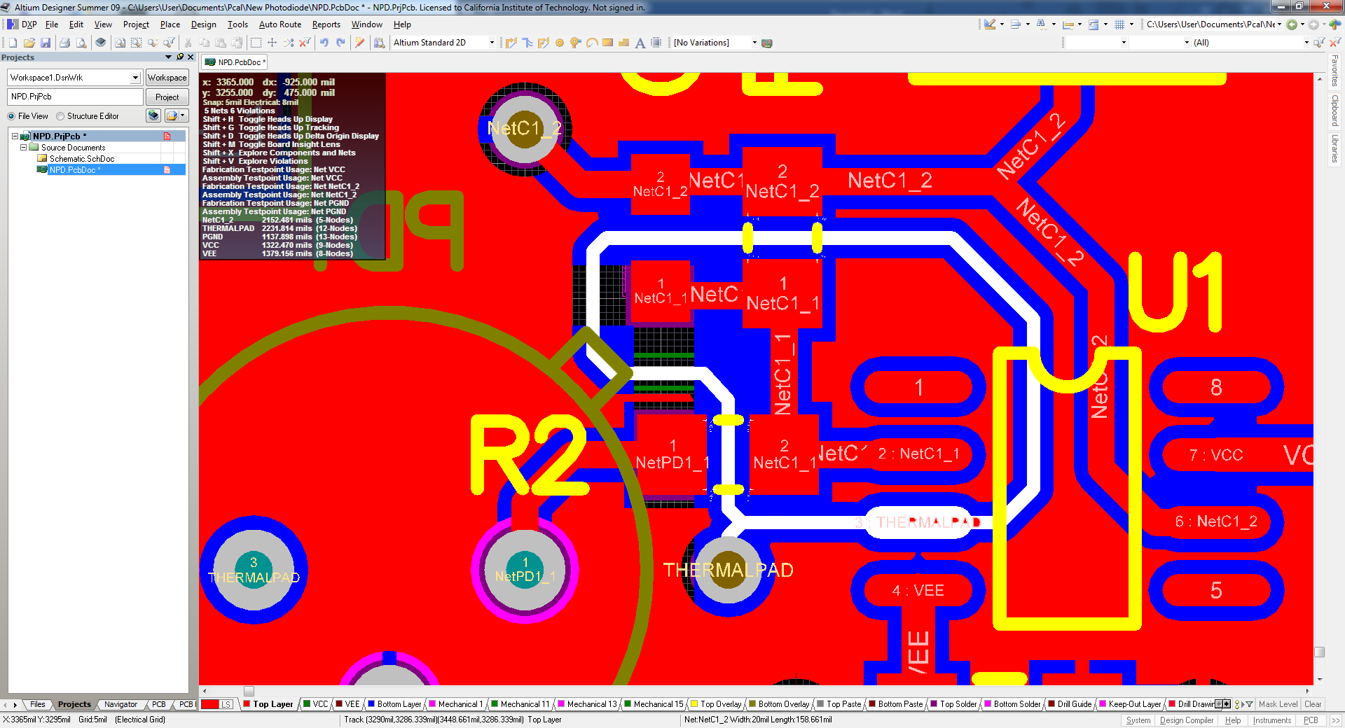
Figure 2. The guard ring around the inputs to U1 is shown in white.

Bottom view

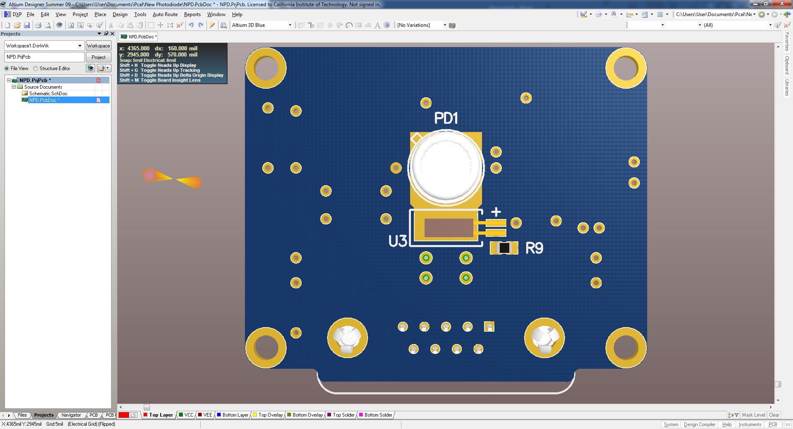
Figure 3. Bottom view of the board.

Thermal pad around photodiode

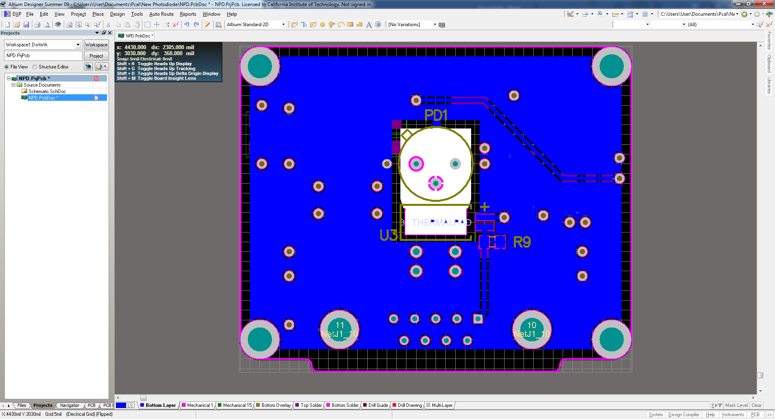
Figure 4. The thermal pad around PD1 is shown in white. This is electrically connected to signal ground plane by a trace at the top of the pad.

Miscellaneous views
The following views should give a rough idea of what the assembled board should look like.
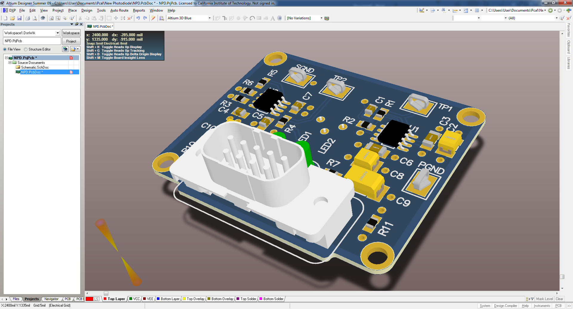
Figure 5. Oblique view of the top side.
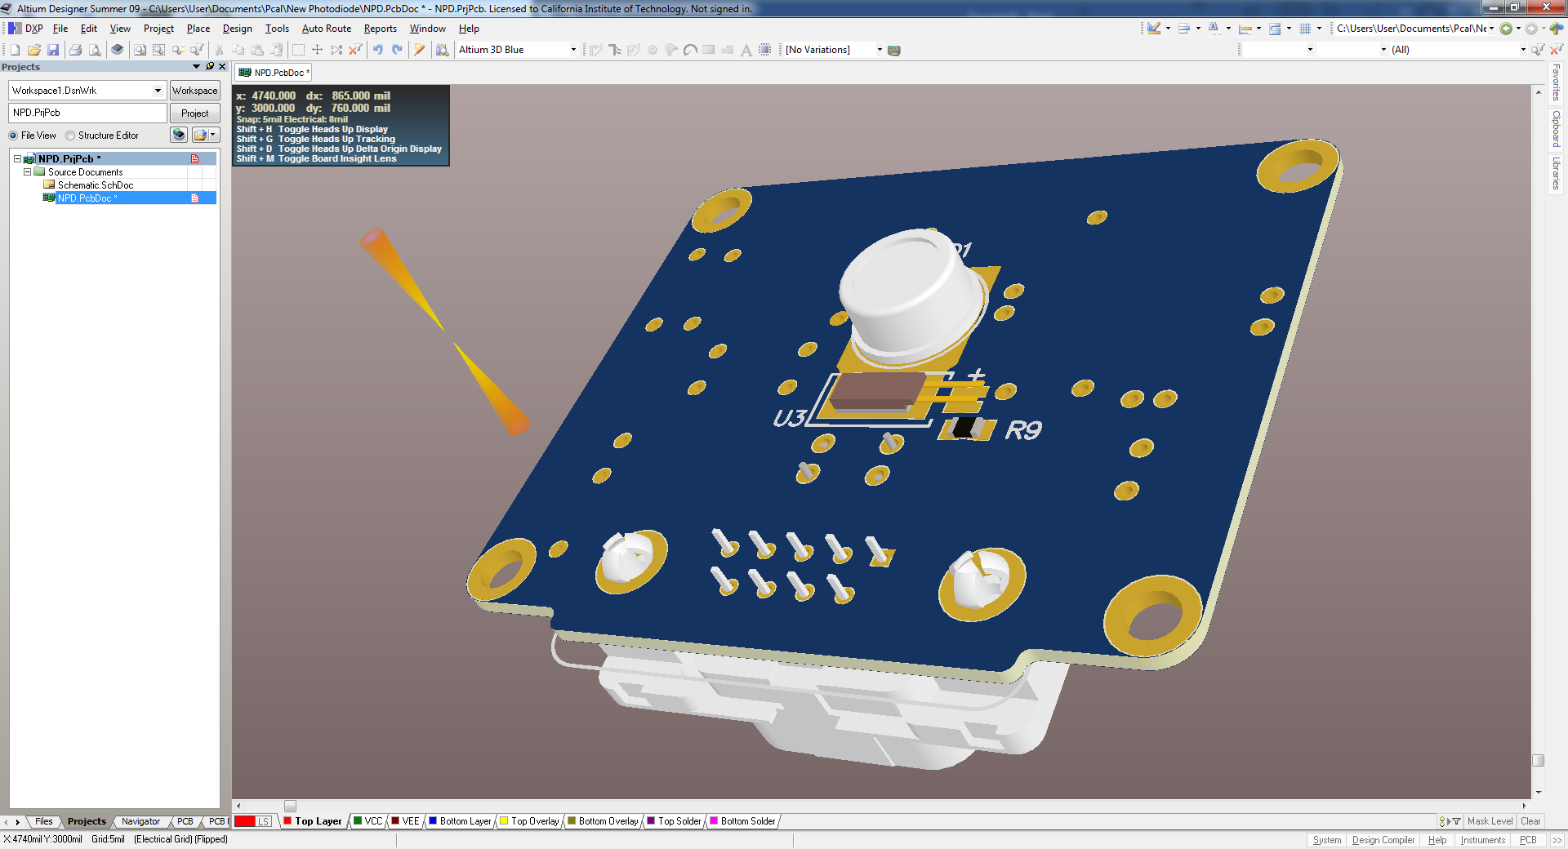
Figure 6. Oblique view of the bottom side.

Board dimensions
Figure 7 shows the dimensions of the board, which might save some time if another version of the board is done.
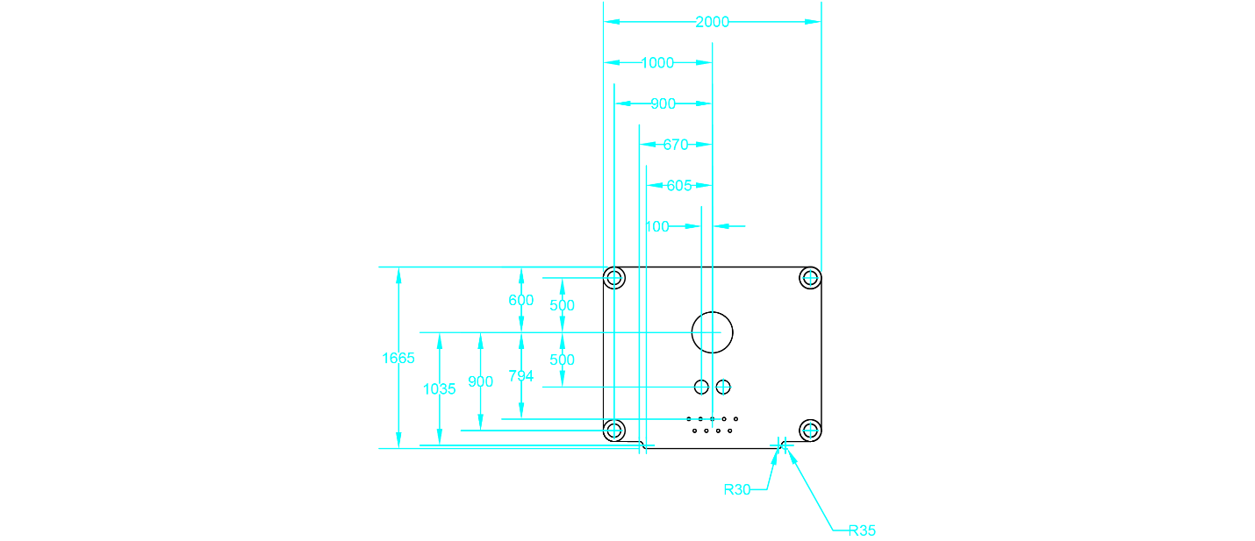
Figure 7. The board dimensions with the center of the photodiode as the reference point.

